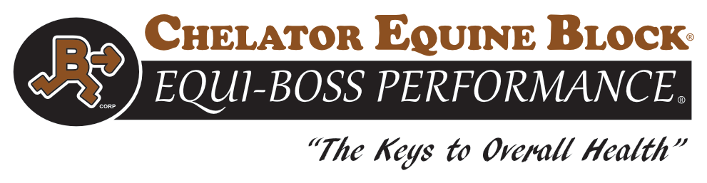
Chelator Minerals-Equine Mineral & Vitamin Block

Guaranteed Analysis

All Natural Plant Based Protein
Protein Maximum 30%
Protein Minimum 20%
Calcium Minimum 10.9 %
Calcium Maximum 13 %
Phosphorus Minimum 6 %
Salt Minimum 4 %
Salt Maximum 5 %
Magnesium Minimum 0.3 %
Potassium Minimum 0.7 %
Sulfur Maximum 0.7 %
Copper Minimum 1,615 ppm
Zinc Minimum 4,842 ppm
Manganese Minimum 4,072 ppm
Selenium Minimum 35.2 ppm
Vitamin A Minimum 150,000 IU/LB
Vitamin D Minimum 15,000 IU/LB
Vitamin E Minimum 500 IU/LB

Ingredient Statement
All Natural Plant Protein Products, Monocalcium Phosphate, Dicalcium Phosphate, Calcium Carbonate, Salt, Chelator Manganese Chelate, Zinc Chelate, Zinc Sulfate, Manganese Sulfate, Selenium Yeast, Copper Chelate, Vitamin E supplement, Sodium Selenite, Basic Copper Chloride, Vitamin A Acetate, Ethylenediamine Dihydriodide, Cobalt Sulfate, Vitamin D Supplement

Feeding Directions: Feed Free Choice Until Gone. Avoid rain & moisture

20% Protein | 30% Protein

CAUTION: Do not feed to Sheep due to high Chelated Copper – This block is however safe for all types of cattle!

Manufactured For and By:
Equi-Boss Performance
Roundvalley UT 84038
Office: 435-695-3990
