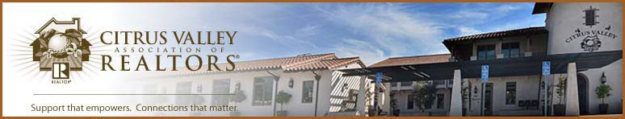

Citrus Valley Association of REALTORS®

REALTOR® of the Year Award Nomination Form
The recipient will be notified on Thursday, December 3, 2026.
I hereby nominate as a candidate for REALTOR® of the Year.

Office Affiliation

Give a brief description of why, in your opinion, this person deserves the REALTOR® of the Year Award.

Please complete the information below to the best of your knowledge.
Association Related Activities:

Participation in C.A.R. and N.A.R.:

Participation in Community Services/Activities:

Other:

Submitted By: Date:

E-mail:

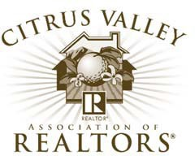

The REALTOR® of the Year Committee is accepting nominations for the 2026 REALTOR® of the Year Award. The purpose of this prestigious award is to recognize a member of our Association who has provided outstanding service to the real estate profession and to the community through their membership in the Citrus Valley Association of REALTORS®.

The Committee is requesting each member submit the name of a member they believe deserves this recognition, including a brief outline giving reasons why the Committee should select the candidate.

The Committee has established the following eligibility requirements and standards expected of the individuals considered for this Award.

- Nominee must be a member in good standing of the Association, paying dues as a REALTOR® member.
- Any member may nominate one or more candidates as REALTOR® of the Year; however, the final decision will be up to the Committee.
- The Committee shall be comprised of seven REALTOR® members appointed by the president. Three members will be past recipients of the award, two members from the Board of Directors, and two members from the membership-at-large. At least five of the seven Committee members must be present at the selection meeting.
- The current president and past recipients are not eligible to receive the award.
- The Committee has suggested five areas to determine the recipient of the high honor.
  - REALTOR® Spirit: High principles, faithfulness to laws and regulations of the Code of Ethics and local association, furtherance of principles of good real estate practice among other brokers and the general public.
  - Local Association Activity: Association offices held and committee work; special assignments; seminar and education work; membership and offices in local chapters of institutes, societies, etc.
  - State and National Association Activity: Participation at the state and national association levels.
  - Community Involvement/Civic Activity: Local, state and national level participation in civic and services clubs, charitable activities, political action, fraternal or religious groups, etc.
  - Business Accomplishments: Recognized good business conduct; service to clients; imaginative and creative advertising programs; rehabilitation work, land utilization, etc.
- In the opinion of the Committee, if there is no one deserving of the award, no award will be given.

If you know of a REALTOR® member of CVAR who is deserving of and qualifies for this prestigious award, please complete and return the nomination form to the association office by e-mail to noakley@cvar.net. Forms must be submitted on or before October 23, 2026.

