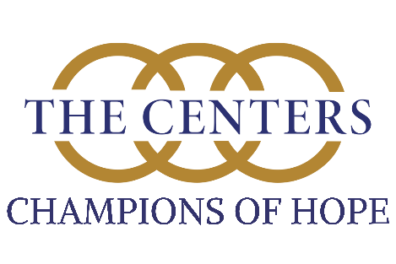
Champions of Hope 2025-2026 Roster
Service * Philanthropy * Leadership

Gabriel Aldea, Catholic High School, 11th, Son of Rebecca and Ivan Aldea
Bryson Allen, Catholic High School for Boys, 11th, Son of Allison and John Allen
Hudson Allison, Pulaski Academy, 11th, Son of Amanda and Scott Allison
Slater Anderson, Lonoke High School, 11th, Son of Elizabeth and Jamie Anderson
Grant Atkinson, Catholic High School for Boys, 11th, Son of Deanna and Jim McGill
Andrew Berkshire, Pulaski Academy, 11th, Son of Erin and Michael Berkshire
Jude Bradshaw, Catholic High, 12th, Son of Melanie and Michael Bradshaw
Luke Burdine, Catholic High School, 11th, Son of Marie and Lyle Burdine
Evan Cadorette, Catholic High School for Boys, 11th, Son of Amanda and Adam Cadorette
Pate Capps, Catholic High School for Boys, 11th, Son of Natalie and Barry Capps
Emilio Carrillo, Catholic High School for Boys, 11th, Son of Nancy Morales
Luke Chandler, Pulaski Academy, 11th, Son of Angela and Benjamin Chandler
Trey Cochran, Catholic High School for Boys, 12th, Son of Leslie and Richard Cochran
Lucas Coldiron, Catholic High School for Boys, 12th, Son of Ashley and David Coldiron
John Craiglow, Catholic High School for Boys, 11th, Son of Barry and Dana Craiglow
Davis Crow, Catholic High School for Boys, 11th, Son of Julia and Adam Crow
JD Cruse, Catholic High School for Boys, 11th, Son of Alice Marie and Joseph Cruse
Luke Edwards, Pulaski Academy, 11th, Son of Grace and Matthew Edwards
Leo Garrison, Central Arkansas Christian, 11th, Son of Dana and Robert Garrison
Ty Gibbons, Catholic High School for Boys, 11th, Son of Lisa and Floyd Gibbons
Johnathan Gibson, Catholic High Schol for Boys, 11th, Son of Amanda Gibson and Jesse Gibson
Chase Gwynne, Cabot High School, 11th, Son of Janet Gwynne
Matthew Henry, Catholic High School for Boys, 11th, Son of Shannon and Daniel Henry
Harrison Horton, Catholic High School for Boys, 11th, Son of Sarah and Johnathan Horton
Harrison Hughes, Catholic High School, 11th, Son of Emily and Christopher Hughes
Sam Hurtado, Pulaski Academy, 11th, Son of Cassie and Alejandro Hurtado
Trevor McGraw, Beebe, 11th, Son of Hope and Larry McGraw
Jack Melton, Catholic High School for Boys, 11th, Son of Katherine and Mark Melton
Ross Mounts, Central Arkansas Christian, 11th, Son of Ashley and Jason Mounts
Will Parker, Catholic High School for Boys, 11th, Son of Ashley and Jason Parker
Vatan Paydak, Pulaski Academy, 11th, Son of Ayse and Hakan Paydak
Silas Priest, Catholic High School for Boys, 11th, Son of Jennifer and Aaron Priest
McConnell Robertson, Catholic High School for Boys, 11th, Son of Angie and Wade Robertson
Tyler Scaife, Pulaski Academy, 11th, Son of Rebecca and Jeremy Scaife
Tucker Sims, Catholic High School for Boys, 11th, Son of Natalie Huggins and David Sims
Owen Smith, Pulaski Academy, 11th, Son of Lori and Allan Smith
Gray Taylor, Catholic High School, 11th, Son of Monica and Steve Taylor
Hayden Williams, Catholic High School for Boys, 11th, Son of Karen and Dennis Chudy
Harrison Willis, Catholic High School for Boys, 11th, Son of Holly Beth and Nicholas Willis
Ralph E. “Win” Wilson III, Pulaski Academy, 11th, Son of Dr. Brooke and Ralph E. “Win” Wilson III
Cruz Wolf, Pulaski Academy, 11th, Son of LeAnn and Russell Wolf
Jack Yates, Catholic High School for Boys, 11th, Son of Charlotte and John Yates

