Trust in Climate Communication
How to build trust with your audience,
helping them to feel open to listening to your message

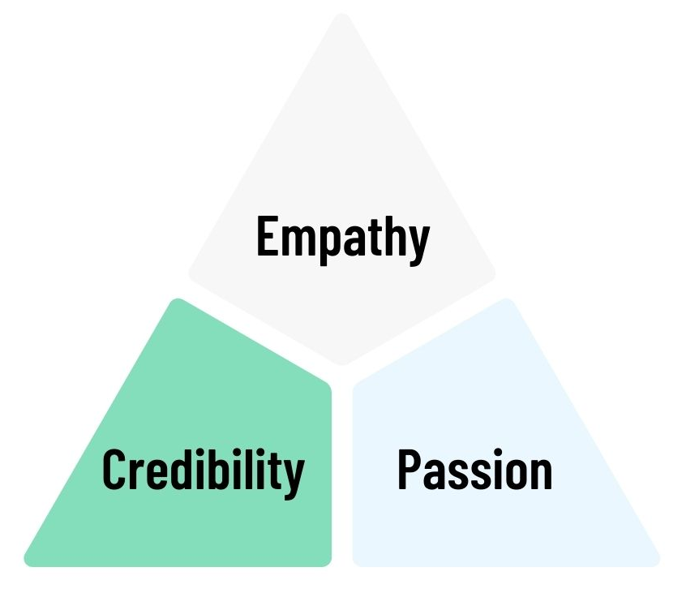
Passion: This person really cares about the issue and they’re clear on why they are talking about it.
Adapted from the great work at Climate Outreach
Empathy: This person understands that people have different perspectives. They’re not lecturing or attempting to talk down to me.
Passion: This person really cares about the issue and they’re clear on why they are talking about it.
Credibility: I believe this person knows what they are talking about – they aren’t making this up on the spot.

