



Your leadership potential
Connecting with your purpose and desired profile to create a 5 year career strategy

Welcome

A good career strategy gives you the clarity to figure out what impact you want to have through your work, the motivation to push through the hard times, and a pathway to achieving your goals, in work and in life.
This clarity can then inform the projects you take on (and the ones you don’t), the roles you apply for (and the ones you turn down), and the skills, experience and contacts you need to cultivate to fulfil your full potential.
The endgame is a career and life you love where you’re fully expressing your skills and talents, and having the impact you were born to make, with the resilience required to push through adversity.
In the context of Lift, your career strategy provides a focusing document for conversations with your sponsor about how they can best support your career potential.
As the model below captures, we’re going to craft a career strategy that is deeply anchored in your purpose and supports your leadership profile. To support that end, this workbook comprises stacks of self-reflection questions to work through before we meet in October.
Please dedicate a few hours to luxuriate in the impact you can have in the world. You’re all in important roles and on impressive career trajectories in one of the most influential industries in the world. You owe it to yourself and others to really dig deep on what this means for the work you will do and how you will balance that with the life you want to lead.
Enjoy the process! I can’t wait to see what you come up with.



Yolanda Beattie
Director

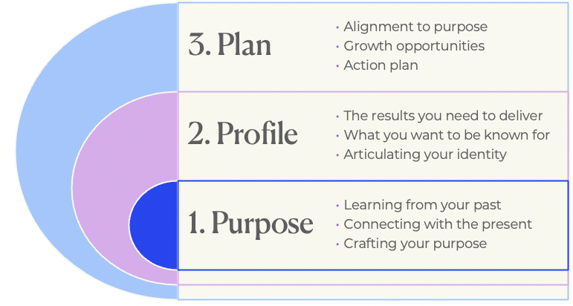
Our approach to cultivating your leadership potential

Purpose

Becoming clear about the impact you want to have through the work you do is at the heart of building a career you love. Loving what you do can become a powerful life force that, when balanced well, creates meaning and supports our wellbeing.
Discovering your leadership purpose is also another way of elevating your consciousness. When we reflect on what brings us joy and what doesn’t, we explore our intentions, values, motivations, skills and talents, as well as fears and insecurities. New insights and mentals models emerge that expand our perspective, allowing us to see and act on new possibilities.
We have structured this reflection in three stages:
- Learning from your past
- Connecting with the present
- Defining your purpose to shape your future
The following self-reflection questions and activities invite you to go deep and think big. They have been drawn from a range of wonderful sources, which are all detailed if you want to dig into these references further.
Grab a tea or coffee, or wine, and enjoying spending the time with your inner-self.

Discovering your purpose
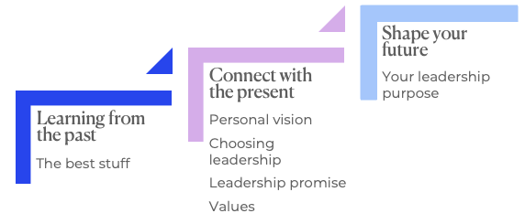

Learning from your past

The best stuff

The memorable accomplishments or experiences that have shaped your life and your leadership
This exercise is based on the work of Jim Warner and was sourced from The Conscious Leadership Group. In this exercise you will identify and then describe eight specific accomplishments or experiences across your entire life that you:
- Enjoyed doing (it was fun and satisfying)
- Believe you did well (you provided high quality)
These may be related to work, home, leisure, projects, or relationships. Things to keep in mind:
- Focus on the highlights in your life, regardless of when they occurred. Perhaps all your memorable experiences occurred before you were twenty years old, or after you were married. You don’t need to spread them out.
- Identify what was important to you, not what other people might think was important.
- Relate specific achievement experiences, not general ones.
Write a short summary statement in the table a few pages over about each of the eight achievements or experiences:
- How did you get involved?
- Elaborate on what you did.
- What was particularly enjoyable, fulfilling, or satisfying?
- What skills, abilities or talents did you use?

What was the achievement or experience and how did you get involved? | What did you do? | What did you most enjoy? | What skills or talents did you use? How does your personality profile reflect these?

Look at your notes.
Do you see any common threads? (ie being in the public eye, adventure, diversity, newness, enduring relationships, leadership, risk taking, troubleshooting, giving, selling or motivating, seeing other people grow from your mentoring, a tough task you addressed and conquered, creative acts, altruism).
From these common threads, make a first pass at naming what you believe are your gifts. (ie inspiration, leadership, dealing with the power brokers of the world, serving the downtrodden, intuition, relationship building, intensity, ability to focus, decision-making, conflict resolution, planting seeds, nurturing small plants, harvesting the crop).
You may also consider sharing your eight experiences with others and asking for their reflection on the themes they hear.
How you can integrate more of the best stuff into your work and life.

Connecting with your present

Personal fulfilment review
Now that you’ve reflected on your past, let’s connect with the present.
What am I doing right now with my life, personally and professionally. Does it make me happy? Do I feel fulfilled?
What do I keep gravitating toward? Is it different from what I am currently doing?
What of my best stuff activities that I identified in the earlier exercise still bring me satisfaction? Do these things still bring me satisfaction? Am I still doing any of them?
What fills my soul and lights me up? Am I making enough time for that activity?
Source: Adapted from Stephen Covey’s 7 Habits of Highly Effective People.

Why I choose leadership
In most organisations, leading people comes as you move up the organisation hierarchy. As a result, many people default to leadership when their skills and temperament are better suited to technical mastery. Consciously choosing leadership and the path required to master it, is essential for aligning your purpose with this commitment. Aligning purpose with effort becomes an abundant source of energy and inspiration.
- How do you want to spend your leadership life?
- What is the work you feel called to do?
- What is your dream?
- How do you want to leverage your special gifts and interests to make the world a better place?
- What does having a positive impact mean to you?
- What is your quest?
- What inspires you?
- What are you working towards?
- What are the 2-5 things you would want someone to say at your eulogy?
- What is the legacy you want to leave?

Reflecting on these prompts, why do you choose leadership?
Based on these prompts, finish this sentence.
I choose leadership because
Source: Why I choose leadership, my leadership promise and values exercises come from Douglas Conant and Amy Federman’s book The blueprint: 6 practical steps to lift your leadership to new heights.

What is my promise?
Your leadership promise defines what people can expect from you. Here are some prompts to inspire that reflection. Your email feedback will be helpful inspiration too.
- What makes me different?
- What do people most value about me?
- What qualities am I not willing to compromise on?
- What parts of my personality do I leverage most in my leadership?
- Who are the key stakeholders who I make this promise with?
Write down everything that comes to mind.
Note which of the traits and qualities you’ve described above reflect your competence (skills, knowledge, capability) vs your consciousness (character traits)?

Take a moment to reflect on how these traits and qualities inform your identity. How, when and where might you need to shift or soften them to support your adaptive challenge?

Leadership values
Values guide our behaviours and help us be consistent, especially when we’re tested. Can you think of a time where you took a principles stance on something when it might have been risky, inconvenient or damaging to your career to do so? Describe it below. What was the principle you were defending?
Describe a time when you had to make a difficult decision or have an uncomfortable conversation out of integrity with what you believe and value. What was so important that it was worth defending despite the discomfort?

Now think of a time, when you know you could have taken a stand on something but you didn’t. What was the situation, why didn’t you and what were the consequences?
The values that govern your leadership choice are most likely found in these answers. Values play a massive role in how we see the world and the decisions we make. That’s why values work is so important for the inner game. Intentionally connecting with our values and making choices that align with them can boost our leadership and career confidence, while helping us craft a career and life we love.
Write down your leadership values and why they’re important to you. For example, I value candour because I find it frustrating and time wasting when people don’t say what they really mean. The next page provides a comprehensive values audit that may spark your thinking.

Value 1
Value 2
Value 3
Value 4
Value 5

Values inventory
Beliefs and values | Values in relationships | Values at work | Values for life
Honesty  Integrity  Wisdom  Autonomy  Loyalty  Abundance  Kindness  Charity  Respect  Courage  Generosity  Gratitude  Openness  Accountability  Compassion  Success  Self-love  Spirituality  Justice  Forgiveness  Caring  Faith  Beauty  Spirituality  Wealth  Beauty  Acceptance  Humour  Intuition  Prosperity  Change  Gracefulness  Peacefulness  Harmony  Balance  Joy/Fun  Independence  Efficiency  Promise-keeping  Fairness  Sincerity  Accuracy  Goodness  Hope  Honour  Humility  Insightfulness  Influence  Decisiveness  Knowledge  Lawfulness  Calmness  Bliss  Clarity  Cleanliness  Boldness  Optimism  Bravery  Friendliness  Selflessness | Trust  Affection  Listening  Thoughtfulness  Deep Connections  Patience  Reciprocity  Appreciation  Fidelity  Faithfulness  Clear Communication  Playfulness  Romance  Passion  Patience  Confidence  Affection  Quality Time  Dedication  Reliability  Empathy  Stability  Tolerance  Emotional Intelligence  Gentleness  Warmth  Cooperation  Sweetness  Intimacy  Gift-Giving  Showing Appreciation  Mutual Support  Equal Relationship  Traditional Gender Roles | Timeliness  Persistence  Dedication to the Excellence  Growth Mindset  Diversity  Teamwork  Work-Life Balance  Innovation  Ingenuity  Work Smarter, Not Harder  Professionalism  Fame  Power  Hard Work Ethic  Leadership  Entrepreneurship  Self-Development  Dynamic Responses  Tidiness  Organization  Quality  Responsibility  Credibility  Encouragement  Adaptability  Self-Motivation  Service to Others  Profit  Constructive Criticism  Management  Consistency  Enthusiasm  Achievement  Transparency  Dependability  Fast Pace  Trial and Error  Positive Impact  Resourcefulness  Coaching  Mentorship  Problem-Solving  Charisma  Learning From Mistakes | Self-Discipline  Family First  Friendship  Positive Attitude  Freedom  Creativity  Happiness  This Too Shall Pass  Adventure  Balance  Wellness  Health and Fitness  Personal Development  Spontaneity  Extraordinary Experiences  Travel  Exhilaration  Exploration  Financial Security  Saving Money  Self-Control  Restraint  Consciousness  Conformity  Non-Conformity  Modesty  Liveliness  Vivaciousness  Curiosity  Understanding  Anti-Racism  Social Justice  Environmental Protection  Animal Rights  Reliability  Protecting Others  Self-Preservation  Chasing Your Dreams  Awareness  Calmness  Community  Artistry  Experimentation  Imagination  Originality  Cleverness  Stewardship  Wit  Comedy  Change the World  Inspire Others  Personal Expression  Finesse  Open-Mindedness  Natural Living  Religion  Tradition  Strength  Entertainment  Pride in Your Work  Trust Your Gut  Harmony  Implementation  Free Time  Leisure  Socializing  Laughter  Peace of Mind  Alone Time  Going with the Flow  Planning  Inner Truth  Righteousness  Non-Violence  Tolerance  Patience  Altruism  Sustainability
Source: Science of people

Shape your future

Crafting your purpose statement
Before you craft your purpose statement, let’s reflect on life outside of work and return to Stephen Covey’s personal mission statement questions.
Imagine it’s 10, 20 or 30 years from now (you choose the time horizon) and you’ve achieved all that you hoped to in life and at work. What is your list of achievements? What do you want to be, do and have?
I’ve provided mine in italics below to help prompt your thinking. I’ve based it on 10 years ahead and found it easier to start with the ‘have’ and work back from there.
Be | Do | Have
I will be continuing my path of deep consciousness work that supports my passion for lifelong learning and growth, and allows me to live a life of joy, playfulness, and appreciation, so that I can help others do the same. | I will be working around 20-30 hours a week, and taking 2-3 months off a year to travel and study.  My work is focused on public speaking and writing books.  This balance allows me to maintain a regular exercise and mindfulness practice, while creating plenty of space to spend time with family and friends. | I will have a happy, well and balanced family who come together regularly for family meals and holidays, and support each other during the inevitable ups and downs.  I have my health and vitality, which are essential for sustaining my professional endeavours and personal adventures.  My partner and I have a comfortable home that we own, filled with stuff the brings us joy and captures the memories of our life.

Incorporating the insights above, articulate your leadership purpose, using leadership in the broadest terms (ie beyond paid work). I’ve provided mine below, to help you get started.
I help people build fulfilling and flourishing careers and lives by elevating their consciousness, boosting their confidence and connecting them with opportunities.

Profile

Your leadership profile or brand is your identity and distinctiveness as a leader. It manifests your purpose by communicating the value you offer and what people can expect from you.
The impact you have and the opportunities you receive is a function of your leadership profile. Any mismatch between your leadership brand and the roles you aspire to will act as a hand-break on your aspirations. Knowing your current leadership brand and crafting one that supports your future ambition is critical.

In this section, we’re exploring:
- The importance of cultivating an authentic leadership profile with the right stakeholders to support your leadership journey.
- How to build a leadership profile that supports your future ambitions.
- How your adaptive challenge can support your leadership profile.
To navigate this topic, we’re adapting the work of HBR regular contributor and strategic HR expert, Norm Smallwood. Smallwood’s 5 steps help you clearly articulate what you want to be known for, how you’re currently perceived and what steps you can take to close that gap.
Let’s dive in…

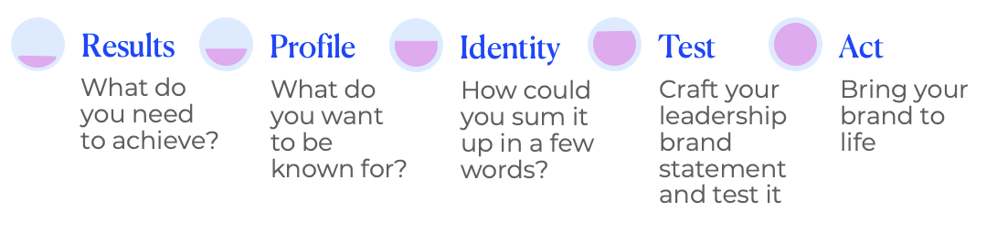
Defining your leadership brand

Step 1: What results do you want to achieve over the next year?
In the next 12 months, what are the major results you want to deliver at work? This is much more than your skills and strengths; it’s an outward focussed expression of the results you want to be known for. Feel free to lift this directly from what you shared in your leadership journal.

Now let’s break that down into different stakeholder groups eg the fund, my team, my manager, the industry, clients. How do the results you want to deliver differ across these groups?
Stakeholder group | Results I want to deliver in the next year

Step 2: What do you wish to be known for?
What are the traits and skills you’re currently known for? How do these reflect your personality preferences (see perception cards below for reference)?
As you consider your leadership potential, what are the traits and skills that you need to be known for to succeed in your next role? The personality perception cards below might help here too. How much of gap is there between what you’re currently known for, and what you need to be known for? The feedback you’ve received from colleagues might provide helpful insight.

Step 3: Define your identity
Combine the traits articulated above into a series of two-word statements. Consider a range of identities that might be relevant in different contexts to build your identity flexibility.

Step 4: Construct your leadership brand statement then test it
Using the insights above, construct your leadership brand as a statement, or several statements.
I want to be known for
So I can deliver
For

I want to be known for
So I can deliver
For
Who will you test it with by asking these questions:
- Is this the brand identity that best represents who I am and what I can do?
- Is this brand identity something that creates value in the eyes of my organisation and key stakeholders?
- What risks am I taking by exhibiting this brand? Can I live this brand?

Step 5: Make your brand identity real
What actions do you need to take to bring your leadership brand to life?

How does the adaptive challenge you’re working on support this leadership brand?
How else do you need to adapt at the level of mindset and identity to achieve your leadership profile? What other adaptive challenge might you need to embrace?
Explore your new adaptive challenge and what needs to change with a new Immunity to Change X-Ray.

Plan

Crafting a 5-year career plan that brings your purpose and profile to life and guides your actions

“Clarity breeds mastery. And the goals you set drive the actions you’ll take”
Robin Sharma, author
Your 5 year career plan is a fluid articulation of the actions you might take to fulfil your leadership purpose and bring your leadership brand to life.
We’re going to explore:
- Alignment check: How well your current role reflects your purpose and desired profile
- Growth opportunities: What you could do to craft a role that better reflects your purpose and desired profile (new responsibilities, projects or roles)
- Action plan: What skills, experience and contacts you need to be successful in those new responsibilities, projects or roles

Alignment check
Working in alignment with your purpose and being true to your leadership brand is the key to career and personal fulfilment. Let’s start with an assessment of how well the key components of your current role deliver against the major elements of your purpose and brand.

Step 1
Start by breaking down your purpose and brand elements into its components. Eg my purpose is:
I help people build fulfilling and flourishing careers and lives by elevating their consciousness, boosting their confidence and connecting them with opportunities.
My leadership brand is:
I want to be known for facilitating powerful conversations, and creating and curating thought-provoking ideas, via high-energy learning experiences that change people
They key components of my purpose and profile are: (1) Impacting careers and lives,
(2) Inner work / consciousness focus, (3) Having powerful conversations / sharing ideas that matter, (4) Working with people who are ready to grow.

Step 2
Breakdown the components of your role. These could be KPIs and / or roles and responsibilities. For me, I have 7 key components, see table below.

Step 3
Assess how well each role component fulfils your purpose and profile. I’ve used a simple traffic light assessment.

Step 4
Explore ways you can shape your role and career to be in greater alignment with your purpose and profile:
- Perfect alignment is not necessarily the outcome - no job is perfect. Which points of misalignment are you happy to accept?
- Which points of misalignment cause the greatest amount of friction for your inner or outer game? Eg
- What causes the most stress or upset?
- Where do you feel you’re not playing to your strengths?
- How might you recraft those components within your current role?
- What future role might you aspire to that better aligns with your purpose and profile?
- What new skills, experience or contacts do you need to attain that future role? And how will you attain them?

Step 5
Develop an action plan that captures the steps you will take to evolve your current role for greater alignment and attain the skills, experience and contacts for a future role.

Sample: My alignment check

 | Purpose and profile elements
Role components | Impacting careers and lives | Inner work / consciousness focus | Having powerful conversations / sharing ideas that matter | People who are ready to grow
Facilitation
Business development
Team management
Content development
Future IM/Pact
Systems improvement
Administration

My insights
- I’m happy accepting some aspects of my role ie systems improvement and admin are enablers to me fulfilling my purpose and therefore will always be orange. I also have an excellent team in place that reduce that burden on me. Finding tech solutions to improve our efficiency is a priority.
- I’m evolving my business to focus on talent who are ready to grow and deeper consciousness work. This program is part of that evolution! And this analysis has helped me clarify that strategic vision.
- While Future IM/Pact hasn’t historically focus on inner work, it’s probably the most impactful work I do because of the impact it has on careers and lives, and the women we reach are in the sweet spot for growth. Deeply connecting with that has helped me shift my mindset on that program and created a new energy level for me to direct at that work. The end result is a major strategic review that will move me more into my purpose zone.

Your turn…
My leadership purpose
My leadership brand

Alignment test

Purpose and profile elements
Role components

Insights and implications
Which points of misalignment are you happy to accept?
Which points of misalignment cause the greatest amount of friction for your inner or outer game? Eg what causes the most stress or upset? Where do you feel you’re not playing to your strengths?
How might you recraft those components within your current role?

What future role might you aspire to that better aligns with your purpose and profile?
What new skills, experience or contacts do you need to attain that future role? How might you attain them?
What limiting mindsets are arising that you might need to overcome?

Action plan
Be as specific as you can with your action planning.

Actions to take | By when? | Who can support you? | How will you hold yourself accountable?



Yolanda Beattie

