


Communicating with impact
Elevating the impact of your communications to secure support for your ideas and initiatives

Welcome

Does this sound familiar? Days or weeks spent working up a plan or proposal, to find it underwhelms in delivery. Objections come flying, resistance mounts and the project is soon dead in the water. Or perhaps it dies a slower, more passive death of change resistance?
If this doesn’t apply to you now, it may one day, especially if you plan to have a career advocating for new ideas and change improvements.
There’s no magic formula for preparing and pitching the perfect proposal, but with better planning and positioning, we can increase our powers of persuasion, and increase the chance of our projects being supported.
For this session on communicating with impact, we’re integrating consciousness tools (personality preferences, SCARF and threat v trust) into Jay Conger’s persuasion model.
Conger, who has taught leadership at business schools worldwide including Harvard Business School, INSEAD and London Business School, offers a simple four step process:
- Establish credibility
- Frame goals with common ground
- Use of vivid language and compelling evidence
- Connect emotionally
We’ll work with a current or upcoming project or initiative you need to get across the line. Ideally, we'll workshop an early stage project so we have more scope to influence. If there's nothing new on the horizon, we can always work with a current or past project and explore how you could have improved communication to have more impact.


Yolanda Beattie
Director

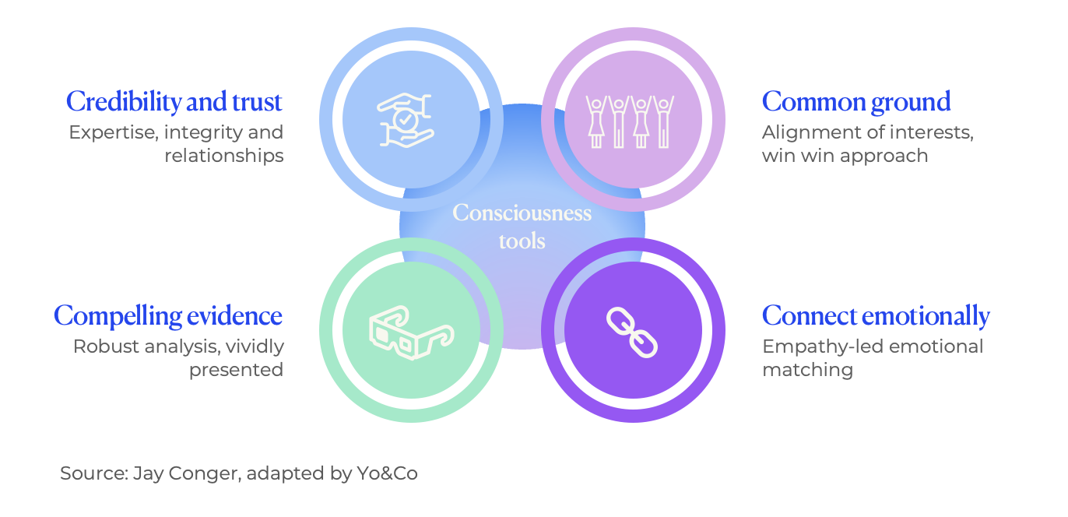
Conscious persuasion

Check-in

New insights and progress

Adaptive challenge and your zone of genius
- What progress have you made with your adaptive challenge?
- What new examples do you have of achieving this challenge? When did you find yourself stuck in behaviours that work against this goal? What stories did you make up about that ie did you make yourself wrong or could you accept yourself?
- How has making progress on your adaptive challenge helped you operate from your zone of genius more often?

Your integrity gap
- How did you go across the four pillars of integrity over the holidays – feelings, agreements, responsibility and candour? Did you notice areas where you were out of alignment? How did you go closing the gap?

Your stakeholder conversations
- How did you go with the stakeholder conversation you mapped in our last session?
- If it hasn’t happened yet, what has stopped you? When will you line it up?

Your powers of persuasion
Anyone with a bit of red energy in them knows this thought… “why won’t people just get on board and do what I ask?!”. And yes, that’s almost all of us.
Gone are the days when leaders could command and control their employees into submission. Now, getting things done takes relationships and influence. Communicating persuasively is key for both.
Persuasion is about so much more than having the best argument. And it’s definitely not about manipulating emotions or brow-beating people into agreement (although we all go there sometimes…particularly in our personal lives!).
Persuasion is about influencing others to change their beliefs or behaviours. For some, that can feel like a dirty game. For some, it is. By grounding our approach in above the line principles, we can increase our impact and effectiveness, and preserve our integrity.
Here’s how:
- Establishing credibility and trust through expertise, integrity and relationships.
- Identifying and pursuing areas of alignment and common interest to pursue genuine win win outcomes.
- Doing the work together to build an evidenced-based and rigorous proposition, and presenting insights vividly so that it appeals to the range of communication preferences
- Crafting a proposal that captures the hearts and minds of relevant participants through empathy-led emotion matching, informed by consciousness insights
Persuasion moments are big and small. From major strategic changes, material investments and structural overhauls, to small projects that when not communicated well, can quickly get off track. Because it starts with credibility, powers of persuasion take time, talent and trust to build. That’s why building a habit of conscious persuasion increases our influence over time as it becomes second nature.
Before we unpack the components of conscious persuasion, let’s start by reflecting on your powers of persuasion…
- Describe a time when you influenced someone or a group of people to follow, adopt or fund your idea/proposal? What drove the success of that outcome? How did you apply each of the four steps above?
- Describe a time when you were unsuccessful in influencing someone or a group of people to follow, adopt or fund your idea/proposal? What undermined the success of that outcome? How did you struggle to apply each of the four steps above?

Your high stakes project
Before we work through how to improve our impact and influence with respect to this project, let’s sketch out some more detail on the project and the stakeholders who influence its outcome.

About the project

Project overview

Key points of contention

Status
Eg: early stage, being scoped, project pitched / decision waiting

Stakeholder (1)

Name

Role in project

Personality and communication preferences
Referring to Clarity 4D table below:
- What is this stakeholder’s personality preference?
- How does that impact their decision-making style?
- How might you adapt your communications accordingly?

Threat v trust
- Generally, are they above or below the line on this project?
- How are they / you playing out victim, villain and hero?
- How can you help them shift to creator, challenger and coach?

SCARF insights around project
- What are their status fears? How can their status be enhanced through the project?
- What certainty threats exist? How can they be managed?
- What autonomy do they have in the project? How can it be increased?
- How connected are people feeling in the project? How can you create a greater sense of relatedness?
- Does this stakeholder have any concerns around fairness? How can they be addressed?

Stakeholder (2)

Name

Role in project

Personality and communication preferences
Referring to Clarity 4D chart below:
- What is this stakeholder’s personality preference?
- How does that impact their decision-making style?
- How might you adapt your communications accordingly?

Threat v trust
- Generally, are they above or below the line on this project?
- How are they / you playing out victim, villain and hero?
- How can you help them shift to creator, challenger and coach?

SCARF insights around project
- What are their status fears? How can their status be enhanced through the project?
- What certainty threats exist? How can they be managed?
- What autonomy do they have in the project? How can it be increased?
- How connected are people feeling in the project? How can you create a greater sense of relatedness?
- Does this stakeholder have any concerns around fairness? How can they be addressed?

Personality insights
Blue  Reflective, observing, analytical, cautious, formal, exacting  Communication preferences  - Focus on facts by provide robust data-driven, evidence-based insights and recommendations  - Use credible sources  - Provide materials as pre-reads and get to the point quickly  - Follow agreed procedures | Red  Focused, decisive, direct, challenging, assertive, action-oriented  Communication preferences  - Focus on outcomes and how they’ll be achieved  - Be bold  - Get to the point  - Be prepared for them to make quick decisions
Green  Empathic, concerned, informal, supportive, patient, easy-going  Communication preferences  - Connect with their personal values  - Appreciate their thoughtfulness; find ways they can lend their support  - Demonstrate your appreciation of people implications and the importance of fairness  - Be mindful of non-verbal cues to build warmth  - Give them the opportunity to voice concerns in a non-confrontational forum | Yellow  Talkative, expressive, light-hearted, sociable, flamboyant, enthusiastic  Communication preferences  - Focus on ideas and avoid getting bogged down in detail  - Involve them in the ideation process  - Provide creative options that excite their innovative thinking style  - Demonstrate your enthusiasm for the proposal

Cultivating conscious persuasion
The following section provides reflection questions and pointers for improving your ability to communicate with impact through conscious persuasion.

Credibility and trust
Expertise, integrity and relationships are the key ingredients of credibility and trust. How do you rate on all three with respect to this project?
If this project is stretching you, you might need to up your game.
How might you improve expertise by:
- Learning more or gaining specific experience or exposure
- Recruiting more credible sources eg internal or external experts who can back your proposal
- Sourcing well-respected, independent studies
- Launching a pilot project that tests the concept on smaller scale

How might you improve integrity by:
- Feelings - Creating space for yours and other’s feelings.
- Agreements – setting clear agreements, keeping or resetting them, and clearing up when you don’t.
- Responsibility – taking responsibility for your emotions and defensive postures, and shifting to curiosity and learning.
- Communication – listening deeply, speaking unarguably and clearly, and revealing authentically

How might you improve your relationships by:
- Having 1 on 1 conversations to understand the position and perspective of key stakeholders
- Speaking with other trusted sources who can provide insights into your key stakeholders
- Tailor your approaches and messages to address SCARF and trust v threat insights

Common ground
What are your stakeholders’ imperatives (for the business, and their personal and professional interests)? SCARF insights might be useful here.
How does this project help them fulfil their imperatives?
How can you structure and frame the project so that it supports their imperatives, and they can see and believe that it will?

Evidence
Outline top 3 points of evidence
How can you use stories, metaphors, models and analogies to bring this evidence to life?

Emotional connection
How are your key stakeholders feeling about the project and the business in general? Are they optimistic and excited, or concerned and threatened?
How are you / can you match their emotional energy or acknowledge it?

Insights
What are three things you will do differently to bolster the impact of your communications?



Yolanda Beattie

