
Baselining your
sponsorship impact

Levels of sponsorship

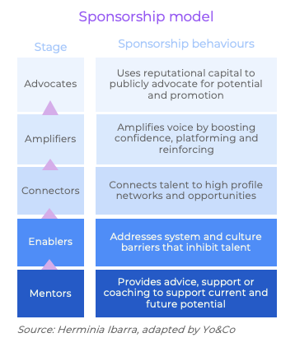

All great leadership stories feature tales of mentors, advocates and supporters who provide access to game-changing career opportunities, words of wisdom and support in times of failure and challenge, and valuable feedback that helped them grow.
“Sponsorship is rarely something you simply turn on and off. Rather, it’s a relationship, one that has evolved from lesser to greater trust and public commitment.”
Herminia Ibarra
Charles Handy Professor of Organisational Behaviour at London Business School
In short, great leaders have powerful sponsors that enable their potential.
As distinct from mentoring, sponsorship is about taking action to enable talent, in addition to advice and support. Ultimately, that action involves publicly advocating for a protégé’s (ie sponsee’s) promotion. In that process, there are many actions sponsors can take to support their sponsee’s promotion potential.
Over the page we detail these sponsorship practices in more detail and pose questions for you to reflect on.

Sponsorship self-assessment
Practice area | Behaviours | Impact on talent | Impact on organisation | Your reflections…  How effective are you at this practice? What barriers do you face? How might you overcome them?
Advocates | - Identifies sponsee promotion potential  - Is attune to promotion opportunities for sponsee  - Uses reputational capital to effectively advocate for sponsees potential and promotion readiness | - Implied transfer of reputational goodwill and standing  - Defend and neutralise perceived limitations  - Accelerated development and promotion | Diverse leadership; meritocracy
Amplifiers | - Provides opportunities and platforms where talent can demonstrate their ability  - Amplifies their impact by backing up their position or argument in public forums, and boosting their self-belief with positive encouragement  - Calls out voices that dominate or drown out others | - Create or increase positive impression of talent  - Boosts talent’s confidence  - Ensure talent’s voice and ideas are heard, credited, and incorporated in decision making  - Dominant voices are managed | Diverse perspectives brought to the table to solve problems and capture opportunities
Connectors | - Builds deep understanding of talent needs, interests and aspirations  - Understands limits of own expertise and knowledge  - Provides warm introductions to beneficial groups and contacts, especially those outside their expertise | - Talent has access to key stakeholders and knowledge to upskill and get the job done at the highest standard, most efficiently  - Expanded circle of influence and networks  - Elevated profile among important decision-makers | Improve employee performance and engagement
Enablers | - Connects with talent to understand what’s stopping them from reaching their potential  - Works with them to address the barriers within their control  - Works with others and the organisation to address barriers outside their control | - Understands and addresses barriers that are in their control  - Accepts and/or works around / with barriers that are outside their control  - Feels equipped to fully express skills and talents | Higher productivity and engagement

Mentors | - Provides advice and support on how to develop skills and gain experience to advance to the next level  - Provides insight into the often unwritten rules of career advancement  - Provides constructive feedback on development opportunities | - Sounding board and trusted confidant to discuss workplace issues outside immediate team/manager  - Build meaningful relationships and feel valued and supported | Higher levels of confidence and wellbeing

