



Your sponsorship impact
Elevating your sponsorship impact, from the inside out

Welcome

Welcome to Lift - a sponsorship and advocacy program enabling diverse talent to aspire for leadership roles while equipping leaders to support their leadership potential.
Over the next seven months we’re exploring ways you can effectively support talent to reach their full leadership potential, with a particular eye to talent who are outside the leadership archetype at your fund.
While we’ll focus on your specific sponsee / sponsor relationship, we’ll also discover ways you can amplify your impact by applying new ways of leading other colleagues, and inspiring your peers to do the same.
The program is anchored by four sponsorship levels – mentoring, connecting, amplifying and advocating – which increase in impact and challenge as you ascend the ladder.
We explore these levels as adaptive challenges requiring adaptive leadership. As distinct from technical challenges, adaptive challenges can’t be solved by acquiring new skills and knowledge. We need to evolve at the level of mindset and identity. This is the inner game of leadership that mediates the outer game.
To train your inner game and support your adaptive leadership journey, we’ll unpack three core elements:
- Your personality – how you show up, your incredible strengths and how they are overplayed to reveal your growth edge
- Your perspective – broadening your perspective by understanding how your ego, mindset and identity shapes your view and drives your behaviour
- Your practice – developing new sponsorship habits to achieve your adaptive challenge
This is not a linear process. We will jump around from personality, to practice to perspective back to personality and so on.
This program is designed to be as much of a development experience for you as it is for the sponsees. Expect to be inspired, challenged and taken outside your comfort zone! Be sure to reach out to me at any point for support, coaching and guidance.


Yolanda Beattie
Director

Sponsorship as an adaptive challenge

Levels of sponsorship

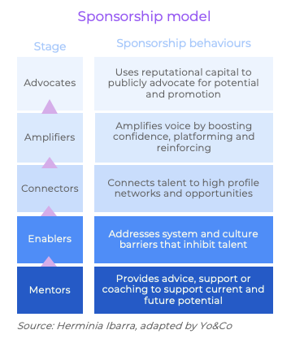

All great leadership stories feature tales of mentors, advocates and supporters who provide access to game-changing career opportunities, words of wisdom and support in times of failure and challenge, and valuable feedback that helped them grow.
“Sponsorship is rarely something you simply turn on and off. Rather, it’s a relationship, one that has evolved from lesser to greater trust and public commitment.”
Herminia Ibarra
Charles Handy Professor of Organisational Behaviour at London Business School
In short, great leaders have powerful sponsors that enable their potential.
As distinct from mentoring, sponsorship is about taking action to enable talent, in addition to advice and support. Ultimately, that action involves publicly advocating for a protégé’s (ie sponsee’s) promotion. In that process, there are many actions sponsors can take to support their sponsee’s promotion potential.
Over the page we detail these sponsorship practices in more detail and pose questions for you to reflect on.

Sponsorship self-assessment
Practice area | Behaviours | Impact on talent | Impact on organisation | Your reflections…  How effective are you at this practice? What barriers do you face? How might you overcome them?
Advocates | - Identifies sponsee promotion potential  - Is attune to promotion opportunities for sponsee  - Uses reputational capital to effectively advocate for sponsees potential and promotion readiness | - Implied transfer of reputational goodwill and standing  - Defend and neutralise perceived limitations  - Accelerated development and promotion | Diverse leadership; meritocracy
Amplifiers | - Provides opportunities and platforms where talent can demonstrate their ability  - Amplifies their impact by backing up their position or argument in public forums, with discernment (if we amplify everything we hear nothing)  - Calls out voices that dominate or drown out others | - Create or increase positive impression of talent  - Ensure talent’s voice and ideas are heard, credited, and incorporated in decision making  - Dominant voices are managed | Diverse perspectives brought to the table to solve problems and capture opportunities
Connectors | - Builds deep understanding of talent needs, interests and aspirations  - Understands limits of own expertise and knowledge  - Provides warm introductions to beneficial groups and contacts, especially those outside their expertise | - Talent has access to key stakeholders and knowledge to upskill and get the job done at the highest standard, most efficiently  - Expanded circle of influence and networks  - Elevated profile among important decision-makers | Improve employee performance and engagement
Enablers | - Connects with talent to understand what’s stopping them from reaching their potential  - Works with them to address the barriers within their control  - Works with others and the organisation to address barriers outside their control | - Understands and addresses barriers that are in their control  - Accepts and/or works around / with barriers that are outside their control  - Feels equipped to fully express skills and talents | Higher productivity and engagement
Mentors | - Provides advice and support on how to develop skills and gain experience to advance to the next level  - Provides insight into the often unwritten rules of career advancement  - Provides constructive feedback on development opportunities | - Sounding board and trusted confidant to discuss workplace issues outside immediate team/manager  - Build meaningful relationships and feel valued and supported | Higher levels of confidence and wellbeing

Your adaptive challenge
Adaptive leadership is an evolutionary process of taking the best from your past into the future, discarding what no longer serves and creating new ways of being that allows you to flourish in more challenging and complex environments.

Adaptive leadership is the practice of building the capacity of individuals and organisations to change so they can tackle challenges and thrive through a process of evolution. The father of adaptive leadership, Ron Heifetz, describes this evolutionary process as taking the best from your past into the future, discarding what no longer serves and creating new ways of being that allows you to flourish in more challenging and complex environments.
Adaptive challenges are different to technical challenges because they require us to change. We can’t just learn new skills or gain more knowledge to solve an adaptive challenge. Instead, we need to fundamentally change at the level of identity and mindset before we can change the behaviour.
Shifting at the level of identity requires us to first see and let go of the filters that currently shape our worldview. Because these filters are self-protection mechanisms, they provide a portal into our ego and therefore unlock the biggest barrier to growth (and freedom).
This insight is the basis of Harvard developmental psychologists Kegan and Lahey’s Immunity to Change model. By wrapping it up into a neat process, their tool provides a framework for leaders to do the transformational development work that improves leadership impact. The mental complexity of leaders also increases by training their truth-seeking and truth-telling capacity while nurturing their ability to handle contradictions and paradoxes.
We’re using this framework to unlock how you can adapt and grow to improve your sponsorship effectiveness.

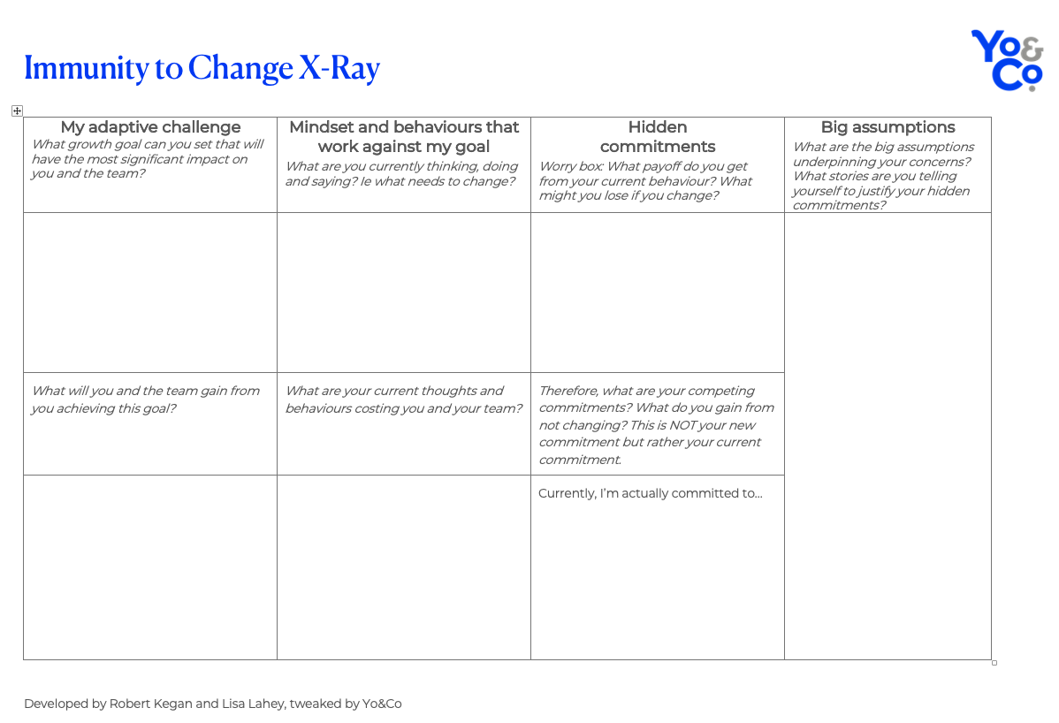

What of your past should you retain? What are your greatest sponsorship strengths that you can build on?

What needs to be discarded? What mindsets and behaviours don’t serve your role as sponsor?

What new ways of being do you need to practice?
These are big questions that we’re spending seven months playing with across three domains:
- Your personality – how you show up, your incredible strengths and how they are overplayed to reveal your greatest growth edge
- Your perspective – broadening your perspective by understanding how your ego, values, beliefs, mindset and identity shape your view and drive your behaviour
- Your practice – developing new habits to achieve your adaptive challenge

Personality

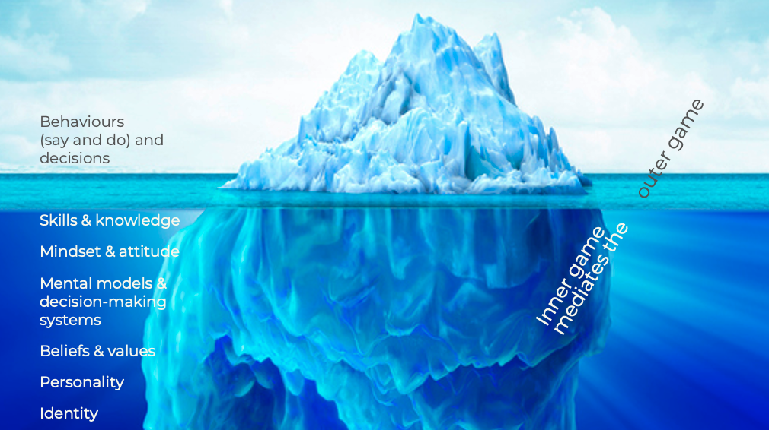
How you show up, your incredible strengths and how they are overplayed to reveal your growth edge

Personality preferences shape our perceptions and behaviours (what you say and do). If sponsorship is a conversation, understanding your personality preferences and how they interact with others, provides an essential window into how you show up as a sponsor and how you might adapt to improve your sponsorship impact.

In pairs, reflect on your personality and what aspects of sponsorship come naturally to you given your personality preferences? What might not come as naturally to you?

Now let’s have some fun with the power of perception. The lists below capture the two sides of the four colour energy personality types. Take a moment to have a chuckle at your flip side traits (there will be some that really resonate) and then mark which ones most relate.
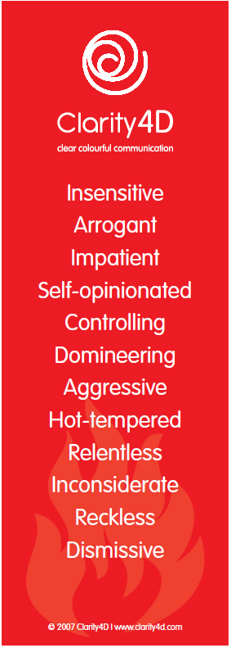
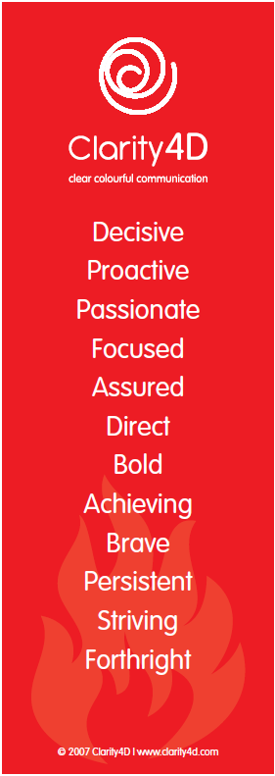
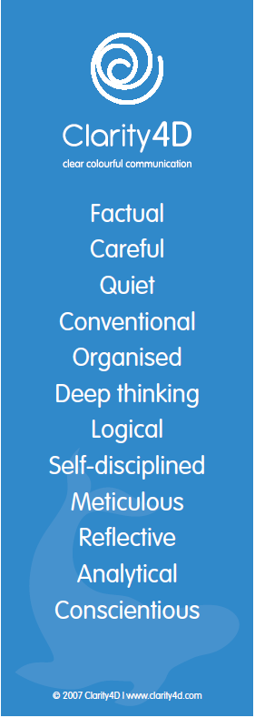
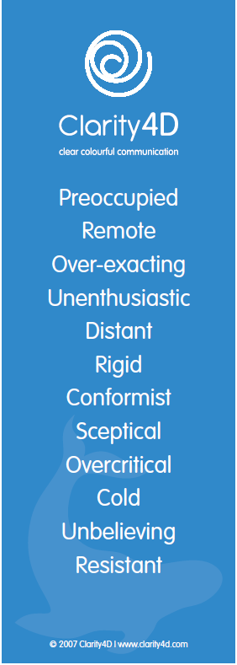

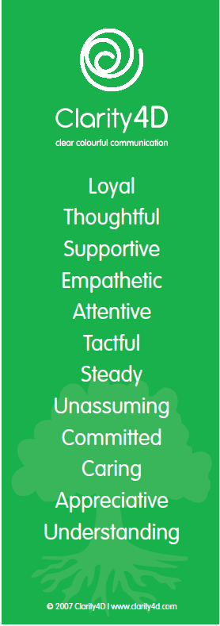
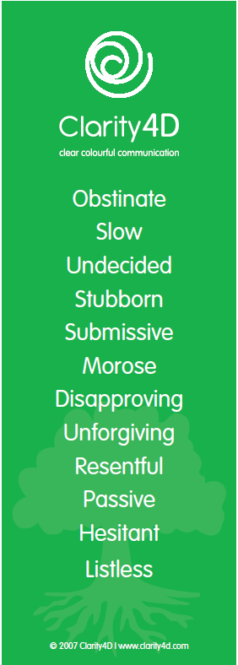
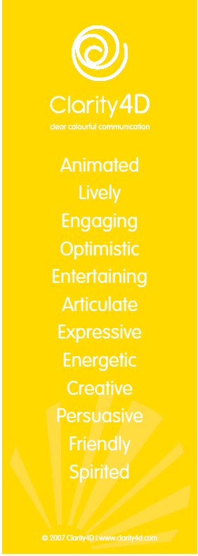


How might these flip side traits impact your sponsorship effectiveness? What might you set as an adaptive challenge to improve your effectiveness?

Perspective

Broadening your perspective by understanding how your ego, mindset and identity shapes your view and drives your behaviour

Achieving adaptive challenges require us to evolve at the level of ego, mindset and identity before we can effectively master new behaviours. That means we need to see in ourselves what we haven’t seen before. We need a new, wider perspective.
In the context of the Immunity to Change X-Ray, connecting with our ego or identity reveals:
- the behaviours that work against our goals
- our hidden commitments
- assumptions that drive our current behaviour
- our progress map - what we can do over time to achieve our adaptive challenge.
We have three main tools to broaden your perspective: the line, drama triangles and fact v story.

The Line
I use The Line as a playful and powerful tool to reveal how our ego works. Follow the steps over the following pages to see when your ego is triggered and you go below the line, and what you can do to get back above it.

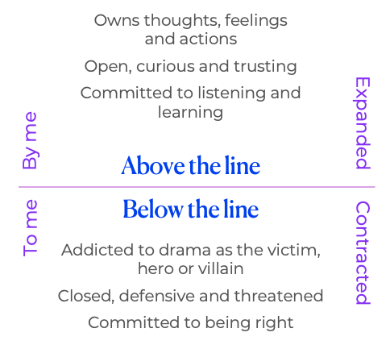

Step 1
The first step of seeing how you go below the line is to pick any relationship issue or persistent complaint. Preferably it is one that you have struggled with for some time and has “juice” for you. Name the person and your core complaint about them, or the issue.

My biggest complaint is about ________________________ is _____________________________.
(name)
Example: My biggest complaint about Sarah is that she doesn’t listen to me.
My biggest complaint about the sales team is they don’t value our work.
My biggest complaint about leadership is they don’t respond to our
feedback.
My biggest complaint about customers is they’re rude and ungrateful.
If you’re having trouble finding a complaint about someone or something, refer to page 6 and the ways we go below the line. See what connects.

Step 2
As you think about this issue, “Where are you?” Above the line ___ or below the line ___?

Step 3
What do you do when you go below the line on this issue?
___ I gossip / vent with others
___ I withdraw and / or avoid the person or avoid confronting the issue
___ I blame this person / believe they are wrong and I am right
___ I become critical
___ I become angry / become aggressive / anxious
Other:

Step 4
Acknowledge the payoﬀs that you are getting from keeping this issue going below the line.
___ I get to avoid my core feelings, especially the feelings of (fear, sadness, anger)
___ I get to stay connected
___ I get enlivened by adrenaline
___ I get to stay in the familiar and avoid the unknown
___ It gives me something to do or a compelling story to tell
___ I get to avoid taking responsibility for my issues
___ I get to be right about the following:

Step 5
Can you accept yourself for being just where you are? Yes ______ No ______

Step 6
Are you willing to shift? Ask yourself these willingness questions to ﬁnd out. Your learning moment comes from the questions you answer ‘no’ and the questions that are hard to answer ‘yes’. These will reveal how you go below the line.
- Are you willing to end all blame regarding this issue? | Yes |  | No
- Are you willing to let go of being right? | Yes |  | No
- Are you willing to feel your (sadness, anger, fear) related to this issue? | Yes |  | No
- Are you willing to see that the opposite of your story is as true? | Yes |  | No
- Are you willing to reveal anything you’re withholding about this issue? | Yes |  | No
- Are you willing to stop all gossip about this issue? | Yes |  | No
- Are you willing to clean up all broken agreements related to this issue? | Yes |  | No
- Are you willing to shift from entitlement to appreciation about this issue? | Yes |  | No
- Are you willing to let go of taking this issue seriously? | Yes |  | No

Based on your responses above, are you willing to shift? (any No above is a No)
Yes ____ No _____
If yes, move on to step 6 and 7. For most of us, getting above the line on relationship conflict takes further work. Head to the deep dive section to keep going, then revisit if you’re willing to shift.

Step 6
Based on your current commitment in this moment regarding this issue, complete this sentence.

Today is _____________ and I am committed to _________________________________________.

Step 7
If you are willing to shift, “How will you shift?” What is one action step you can take and by when will you take it?

My measurable action is: ____________________________________________________________
I will do it by: _______________________ at _________________________
(Date) (Time)

Drama triangles
Unpacking your drama triangles provides rich new perspectives into how your ego, identity and insecurities hold back your evolution. They come out in all forms of conflict ie inner-conflict with yourself and conflict with others.
When we’re in conflict, well-worn scripts of victims, villains and heroes drag us below the line. Shifting our perspective on the conflict by seeing how we create our dramas is a game-changing tool that supports our creativity, curiosity and connection.
I invite you to map out your drama triangle for this relationship issue / persistent complaint. Refer to your drama cards for inspiration. I encourage you to be as dramatic as you can be!

My personas | Shift moves
My victim personas are | From victim to creator
My villain personas are | From villain to challenger
My hero personas are | From hero to coach

Persona interview
Chose a persona that you think is running the issue. Take on the posture, voice and attitude of this persona, and give it a name. Then answer the following:
[Persona name], What is the most important thing to you?
[Persona name], What are you most proud of in how you served (person's name) in his/her life?
[Persona name], When did you make your first appearance in (person’s name)’s life?
[Persona name], Who did you learn your style from?
[Persona name], What are you most afraid of?
[Persona name], In your heart of hearts, what do you MOST want?
[Persona name], What is your gift?

Fact v story

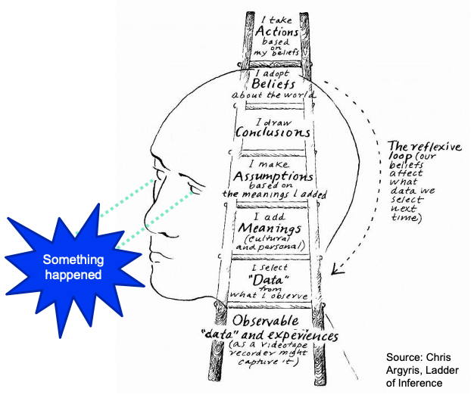
How we adopt beliefs and take actions based on our beliefs

Believing our stories are true is one of the most common ways we go below the line. Indeed, it’s the source of most human suffering. That’s a big call! Let me explain.
Neuroscientists and developmental psychologists have shown the human brain adopts beliefs or stories about the world by applying their personal and cultural meanings to the data they select from what’s observed. We then take action and tend to collect more data that confirms our beliefs. This is how confirmation bias occurs.
Suffering and conflict occurs when the stories we tell ourselves are critical and negative – about ourselves, others or our environment. The tighter we hold onto those stories, the more suffering and conflict created.
You might be asking: What if those stories are objectively or morally true? Like people shouldn’t be racist? Or bullying is bad? Or that manager really is incompetent (insert list of evidence)?
The problem arises when we tightly hold onto these beliefs and so engage with that person or issue from a place of being right, setting ourselves up for a war that no-one wins.
See how our beliefs create stories that narrow our thinking, opens up new perspectives, allowing for deeper levels of curiosity, creativity and relational connection.

Seeing the opposite of your story
Let’s apply this concept now to the issue you’re working with by following the steps below.
Step 1 Define a recurring issue that you are willing to shift
Step 2 Write down all the facts related to the issue. Facts are what a video camera would record (without music and interpretation of tone)
Step 3 Write down all the stories you have about the facts. These are what you make up about the facts. Look for ‘shoulds’, judgements, interpretations and emotions.

The issue is _____________________________________________________

Facts | Stories
What a video camera records | What you make up about the facts

The next step follows The Work of Byron Katie. Katie (as she is known), encourages a meditative approach where we reflect on a limiting belief we’re currently holding onto.
Pick one of the stories above that resonates the most and write it down here:
Close your eyes, take a few deep breaths and contemplate that statement. Then ask yourself four questions:
- Is it true?
- Can you absolutely know it’s true?
- How do you react, what happens when you believe that thought?
- Who would you be if I could erase that thought from your mind?
Once you connect with how much being right is costing you, it becomes easier to see how a whole range of opposites might be equally as true, not necessarily more true, but equally as true. This is where the turnaround comes in. Here’s how turnarounds work:
Current belief: Jill is unkind to me. Alternate stories: I am unkind to Jill. Jill is kind to me. I am unkind to me.
Write down all of the opposites of your story and any evidence you can find that supports these alternate views. There won’t always be four opposites and sometimes there may be more than four.
Alternate stories | Evidence of alternate stories
This exercise helps us let go of limiting beliefs by constructing a range of new ones, which in turn dissolves our commitment to being right, helping us to shift above the line.

Practice

Developing new habits to achieve your adaptive challenge

Adaptive leadership is a process of experimentation; there will be failures along with great successes. We have developed a practice pack to support new sponsorship habits by working on the inner and outer game. These habits comprise our three core perspective tools, our sponsorship levels, and other tools that finetune your inner and outer game.
You’ll be invited to pick a new practice area to concentrate on each month throughout the program, and share your experiences with each other, and others in your team, organisation and personal life.

Here are the practices:
- Location – where am I? Above or below the line.
- Drama and presence
- Mentor
- Connector
- Amplifier
- Advocate
- Feedback
- Curiosity
- Active listening
- Appreciation
- Mindfulness

Feedback
Receiving constructive feedback on how you currently enable talent is critical for understanding your strengths and where you can improve. Asking for it routinely and acting on what’s shared, is one of the most powerful ways to build credibility and trust in your leadership.
We have prepared an electronic form for you to capture feedback from a range of people on the sponsorship levels, and we invite you to request feedback from everyone you have managed, mentored or sponsored. Here’s a draft for you to edit.
Hi X
I’m participating in the Lift sponsorship and advocacy program where I’m learning ways to improve my ability to sponsor talent. Feedback is an important part of this process and I’d appreciate your perspective.
Specifically, I’d like to know how well I mentor, connect, amplify and advocate for talent. Please provide your feedback via this form, which includes detail about these sponsorship behaviours so you can provide specific feedback on what I do well and where I can improve.
I’d be grateful for that feedback by XX. Thanks for taking the time.

Regards
XY

Other habits
Progress area | Inspiration
Accountability and feedback | In addition to your sponsor, who can you share your adaptive challenge and Immunity to Change X-Ray with?  What feedback can you request?  How can they hold you accountable to progress?
Conversations | The more you discuss and explore the topic, the more you internalise and adapt to this extraordinary way of living and leading.  Who can you talk to about adaptive challenges, ego threats and drama triangles?  Perhaps your intimate partner, children, a friend who’s into personal and leadership development?
Self-reflection | Research shows leaders and teams who self-reflect are more productive. Yet most don’t. The key is to identify a few important questions that stimulate higher order thinking and diarise the time either at the end of the day or week. Ten minutes is a good starting point, longer will take you deeper and yield more insight.  Here are some good questions to get you started:  When did I go below the line today? What pay-off did I get? Can I accept myself for going below the line? Am I willing to shift? What do I need to do to shift?  What am I avoiding / not facing? What’s the hardest thing to accept? What do I really want? What do I choose now? What’s an easy step I can take to start creating what I really want?
Reading | What can you read to immerse yourself in these ideas? Here are some pointers:  Immunity to Change: How to Overcome It and Unlock the Potential in Yourself and Your Organization  The 15 commitments of conscious leadership  Chatter: The Voice in Our Head, Why It Matters, and How to Harness It  Transcend: The new science of self-actualisation
Listening | Podcasts are an excellent way to absorb new ideas. Here are some of my favourite episodes on leadership and personal growth that you might find inspiring:  Jim Dethmer: Leading from above the line  Jim Collins: Relationships v transactions  Kris Cordle: Releasing the ego  Caroline Webb: How to have a good day during a global pandemic
Mindfulness | Everything we feel, think, say and do is a function of our mind. Everything we have discussed in this workbook requires us to be present to how we’re thinking, feeling and behaving, before we can shift.  That’s why observing and training your mind is arguably the most valuable gift you can give yourself and others. This is the art and science of mindfulness.  The Waking Up app by Sam Harris offers a range of great meditations and inspiring talks. He also puts lots of talks in front of his paywall. Here are some of my favourites:  The science of meditation  Meditation in an emergency  The science of happiness



Yolanda Beattie

