Report for

CEATI INTERNATIONAL Inc.
3 Place Ville Marie, Suite 400
Montreal, Quebec, Canada H3B 2E3
www.ceati.com

XXXXXX INTEREST GROUP (XXIG)

CEATI REPORT No. T2XX700-XXXX

TITLE

Prepared by
Company
City, State/Province, Country

Principal Investigator
Name, credentials (ex. John Smith, P.Eng, PhD, credentials are optional)

Technical Advisor
Name, credentials (ex. John Smith, P.Eng, PhD, credentials are optional)

Month 20XX*
*this date will be changed to reflect the publishing date, not the date you submit your report.

NOTICE
This report was prepared by the CONTRACTOR and administered by CEATI International Inc. (“CEATI”) for the ultimate benefit of CONSORTIUM MEMBERS (hereinafter called “MEMBERS”). Neither CEATI nor the MEMBERS necessarily agree with the opinions expressed herein.
Neither the MEMBERS, CEATI, the CONTRACTOR, nor any other person acting on their behalf (a) makes any warranty, express or implied, or assumes any legal responsibility for the accuracy of any information contained in this report or for the completeness or usefulness of any apparatus, product or process disclosed in the report, (b) accepts any liability for the use of, or damages resulting from the use of this report or any apparatus, product or process disclosed in this report or (c) represents that the use of such apparatus, product or process would not infringe upon the rights of third parties.
Furthermore, the MEMBERS, CEATI and the CONTRACTOR HEREBY DISCLAIM ANY AND ALL WARRANTIES, EXPRESSED OR IMPLIED, INCLUDING THE WARRANTIES OF MERCHANTABILITY AND FITNESS FOR A PARTICULAR PURPOSE, WHETHER ARISING BY LAW, CUSTOM, OR CONDUCT, WITH RESPECT TO ANY OF THE INFORMATION CONTAINED IN THIS REPORT. In no event shall the MEMBERS, CEATI or the CONTRACTOR be liable for any direct, special, indirect, incidental, punitive or consequential damages resulting from the use or alleged use of any information contained in this report.
Any reference in this report to any specific commercial product, process or service by tradename, trademark, manufacturer or otherwise does not necessarily constitute or imply its endorsement or recommendation by the CONTRACTOR, MEMBERS or CEATI.

Copyright © 2025 CEATI International Inc. All rights reserved.

ABSTRACT
Insert a basic overview of the report - approximately 200 words. This should provide the report’s background and your objectives, as well summarizing what was done. Please be sure not to give away the results of your research in the abstract.
Keywords:
Xxx, Xxxx, Xxxxx…

ACKNOWLEDGEMENTS
The investigators are grateful to CEATI for the opportunity to work on this interesting issue. The constant support and guidance by the CEATI Technical Advisor NAME, as well as Project Monitors NAME of COMPANY, NAME of COMPANY and NAME of COMPANY, were greatly appreciated by the investigators.
The authors also wish to express their gratitude for the support of…

EXECUTIVE SUMMARY
Background
The Report Background section should be approximately 250 words and should detail the reasons the work was conducted.
Summary
The Summary section should be approximately 850 words. It must provide a general description of the work program.
Conclusions
The Conclusions section should be about 300 words and should provide a general outline of the key results (do not include specifics).
Recommendations
The Recommendations section should be about 200 words and should include a description of the potential applications of the results.

TABLE OF CONTENTS
Page
NOTICE 2
ABSTRACT 3
ACKNOWLEDGEMENTS 4
EXECUTIVE SUMMARY 5
TABLE OF CONTENTS 6
LIST OF TABLES 7
LIST OF ILLUSTRATIONS 8
1.0 HEADING 1 9
1.1 Heading 2 9
1.1.1 Heading 3 9
2.0 HEADING 1 10
2.1 Heading 2 10
2.1.1 Heading 3 10
2.1.1.1 Heading 4 10
3.0 CONCLUSIONS AND RECOMMENDATIONS 12
4.0 Bibliography 13
APPENDIX A. HEADING 7 14
A.1 Subheading - Heading 8 15
A.1.1 Heading 9 15
APPENDIX B. HEADING 7 17

LIST OF TABLES
Page
Table 1-1: Insert caption here 9
Table 2-1: Insert caption here 10

Table B-1: Naming a table using Insert Caption - Appendix Table 17

LIST OF ILLUSTRATIONS
Page
Figure 1-1: Caption styles as seen in the Styles gallery 9
Figure 2-1: Result when “Insert Caption” is used 10

Figure A-1: Normal Caption option dialog box 14
Figure A-2: Updated Caption option for CEATI report appendix figures 14
Figure A-3: Using Cross-reference to a figure in an appendix 15
Figure A-4: A second figure in the appendix with caption 15
Figure A-5: Dialog box for insertion of appendix equation Cross-reference 16

HEADING 1
Please make sure each Heading 1 starts at the top of a new page. This can be done by using the 1.0 Heading 1 style, found in the Styles gallery in Home (See Section 1.1.1). With that style, inserting page or section breaks should not be necessary.

Heading 2
Table, Figure, and Equation captions can be inserted by going into the toolbar, then References, Captions, Insert Caption, and selecting the appropriate Label (see Figure 2-1). Doing this instead of writing Figure X-Y manually allows them to maintain their numbering automatically, for example automatically re-numbering Figure X-1 to Figure X-2 if another figure is inserted before it.
It is not necessary to keep the full caption or section title in a cross-reference. For figure and table captions, select “only label and number” under “Insert reference to:”. For sections, select “Paragraph number (no context).” See Figure A-3 for an example.
Table 1-1: Insert caption here
Item | Measurement
First | 12,233
Second | 12,232
Third | 13,453

Heading 3
Authors may use the Figure, Figure Caption, Table Caption, Equation, and Equation Label styles to format items and their captions quickly and consistently, as well as maintaining appropriate spacing between them.
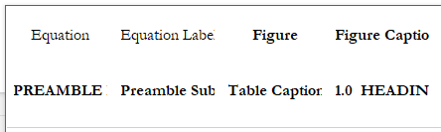
Figure 1-1: Caption styles as seen in the Styles gallery

HEADING 1
Insert text here....
The following is a bulleted list:
- Bullet 1
- Bullet 2
  - Sub-Bullet
- Bullet 3
- Bullet 4

Heading 2
Insert text on a sub area of the above text.
Table 2-1: Insert caption here
Table Heading | Table Heading
Table text | Table text
Table text | Table text
Table text | Table text

Heading 3
Insert text here…
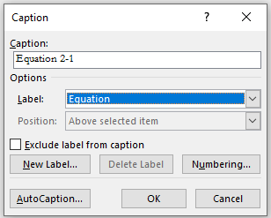
Figure 2-1: Result when “Insert Caption” is used

Heading 4
Insert text here...
Please refer to Equation 2-1 when calculating the area A of a circle of radius r:
$$A=πr^{2}$$
Equation 2-1
When the area is known, the radius can be computed from Equation 2-2:
$$r=\sqrt{\frac{A}{π}}$$
Equation 2-2
Authors may use the Equation and Equation Label styles to automatically manage alignment and spacing for equations. Equation labels can be inserted just like figure and table captions with Insert Caption. Keep equations and their labels on separate lines to make sure the Cross-reference feature works as intended.
One can reference appendix figures, tables, and equations in the main text by using the Appendix Figure, Appendix Table and Appendix Equation reference type. Please refer to Figure A-2, Equation A-1, and Table B-1.

CONCLUSIONS AND RECOMMENDATIONS
Insert text here....

Bibliography

[1] | D. Vines, title, Montreal: CEATI, 2019.

HEADING 7
Introduction to appendix…
Authors will need to build three new Label Options: Appendix Figure, Appendix Table and Appendix Equation. Use the Insert Caption feature under References to reach the following dialog box:
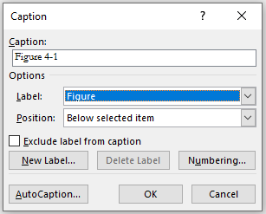
Figure A-1: Normal Caption option dialog box
Click on New Label and define it as Appendix Figure. Then, Click on Numbering and adjust the pointer for the Appendix Figure from Heading 1 to Heading 7. After completing this, the Insert Caption function has a new Appendix Figure option:
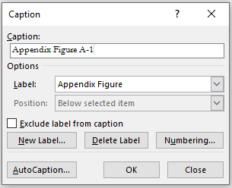
Figure A-2: Updated Caption option for CEATI report appendix figures
When completed, the author can now refer to the appendix figure in the text, using the Word Cross-Reference function. Note that the word “Appendix” should be manually deleted from each cross-reference made this way.
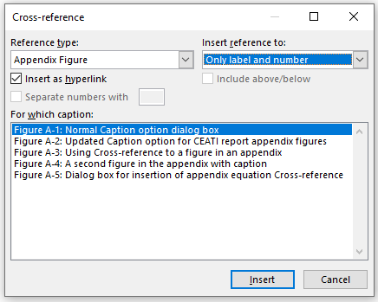
Figure A-3: Using Cross-reference to a figure in an appendix
This means that Figure A-2 will be automatically re-numbered if a new figure is inserted, and that the appendix figures can now be used in the main text.

Subheading - Heading 8
Text on subheading 1…

Figure A-4: A second figure in the appendix with caption

Heading 9
The same process is used to introduce Appendix Table and Appendix Equation options. As with the Equation option in the main text, equations and their labels should be kept on separate lines with the Equation and Equation Label styles applied to each respectively. Note that the word “Appendix” should be manually deleted from each cross-reference made this way.
$${\left(x+a\right)}^{n}=\sum_{k=0}^{n}{\left({n \atop k}\right)x^{k}a^{n-k}}$$
Equation A-1
We may now make a reference to the equation above as Equation A-1, just like in the document’s main body.
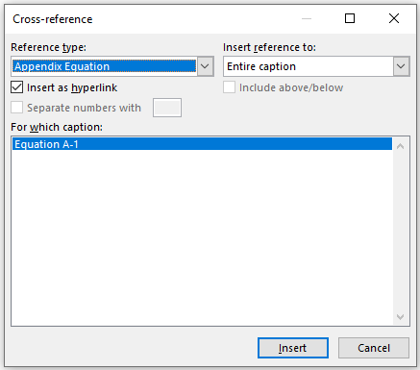
Figure A-5: Dialog box for insertion of appendix equation Cross-reference

HEADING 7
Introduction to appendix…
Automatically updated references to tables in the main and appendix text are established by assigning a new “Appendix Table” option.
Table B-1: Naming a table using Insert Caption - Appendix Table
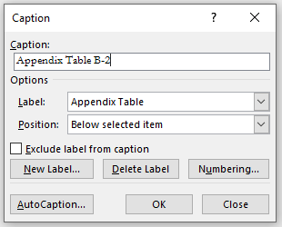 | 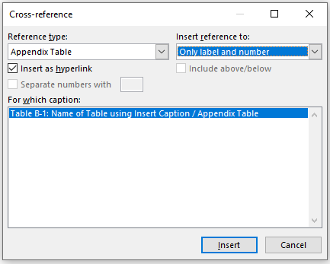
Dialog Box for Inserting Caption | Dialog Box for Inserting Cross-Reference
References to appendix tables such as Table B-1 can also be linked in the main text. Note that the word “Appendix” should be manually deleted from each cross-reference made this way.

This is a footnote.

