To ALL SSSA Members:
Eric Freedman is the Contact Person for our MTA paid Met Life insurance plans we, as supervisors, currently have including Life, Supplemental Life, AD & D, Dependent Life and Supplemental Life Insurances.
Feel free to reach out to Eric to discuss any questions, concerns, or perhaps do a review of your current insurance policies.
Please note all the other services he provides as well.
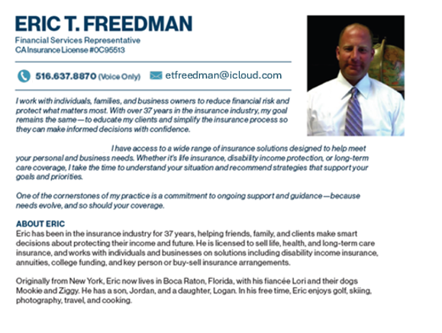
All consultations are FREE OF CHARGE.
Please see the attached flyer with his contact information.

I work with individuals, families, and business owners
to reduce financial risks and protect what matters
most. With over 37 years in the insurance industry,
my goal remains the same-to educate my clients and simplify
the insurance process so they can make informed decisions with confidence.

I have access to a wide range of insurance solutions designed to help meet your personal and business needs. Whether it’s life insurance, disability income protection, or long-term care coverage. I take the time to understand your situation and recommend strategies that support your goals and priorities.

One of the cornerstones of my practice is a commitment to ongoing support and guidance - because needs evolve, and so should your coverage.
516-637-8870 (Voice Only)

