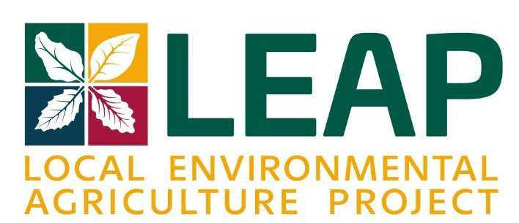
1027 Patterson Ave SW Roanoke VA 24016
www.leapforlocalfood.org
540.632.1360

LEAP Pledge Form
Donor Information ☐ Personal Gift ☐ Corporate Gift ☐ Foundation Gift
Name (s): _______________________________________________________________________________
Foundation Name or Business Name (if applicable): _____________________________________________
Preferred Address: ________________________________________________________________________
Preferred Phone: ___________________
Preferred Email:
Annual Donation Amount (circle one)
$25,000 $10,000 $5,000 $2,500 $1,000 $500 $___________
For (circle one) 1 3 5 10 _____ (other) years
The due date for each pledge year is December 31. Pledge reminders will be sent annually.
Total Pledge $____________________
Gift Purpose
Pledges help LEAP create equitable food and farming systems which prioritize health and abundance by supporting community initiatives, food access, markets, farms, and farmers. The Pledge, unless otherwise specified, will be directed to LEAP’s unrestricted funds that support all programs and organization operation.
Optional: Funding restricted for _________________________
Method of payment for the current year’s gift:
☐ cash ☐ check (please make checks payable to LEAP) ☐ online (leapforlocalfood.org/donate)
☐ credit card (circle one) Visa MC AMEX Discover
Card #:____________________________________ Exp. Date: _____/_____ CVC: _________
Authorized Signature: ____________________________________ Date: ___________________
☐ stock (a representative from LEAP will contact you)
Other Options
☐ I/we wish to remain Anonymous.
☐ Matching Gift; gift will be matched by: ______________________________________________
☐ Planned Gift (please contact me/us about making an estate or planned gift)
☐ Tribute Gift; gift is in HONOR / MEMORY of ________________________________________
To whom should we send acknowledgement? (Please provide name & address)

Donor Signature
Signature(s): Date:

Local Environmental Agriculture Project is a 501(c)3 nonprofit recognized by the IRS. All donations made to LEAP are tax-deductible in accordance with IRS regulations.

Thank you for your generosity. Your support will nurture our food community for years to come.
For questions, please contact: Maureen McNamara Best, LEAP Executive Director, maureen@leapforlocalfood.org, 540.339.6266.

