Below is a sample of the level of detail required for a client’s product codes and descriptions. These codes will be mapped into DeepTarget product categories.

Sample Loans:

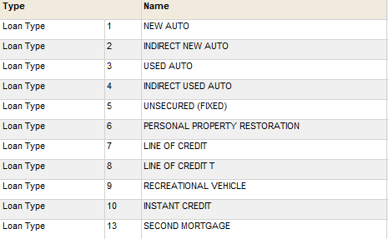

Sample Deposits:

