THE GOSPEL:
A PROPOSAL OF MARRIAGE,
A WEDDING INVITATION

The Invitation:
A Covenant of Love
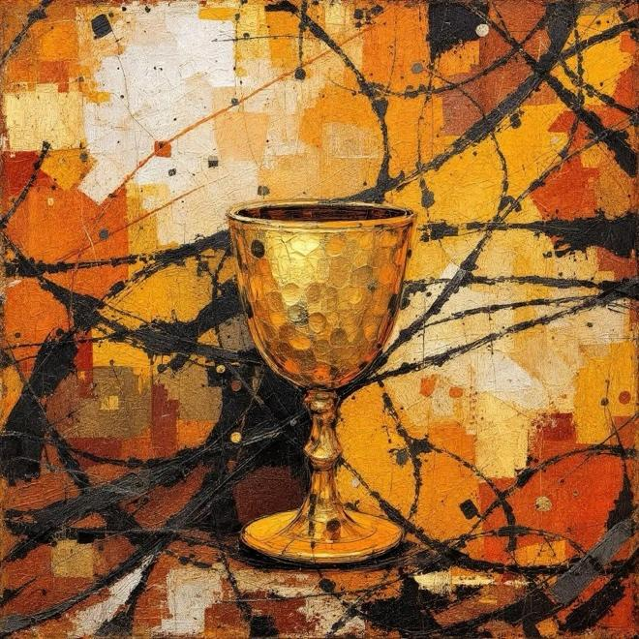

The Request:
Jesus, the King of Kings, requests the honor of Your presence at the restoration of His household. We have been sought out, we have been bought, and we are now being called home.

The Background: Our Common Condition

We were not created to be alone. In the Garden, humanity lived in a perfect union with the Creator. But we turned away, choosing self-worship over His love.
- The Divorce: Our rebellion became a "bill of divorce," casting us out of our true Home.
- The Widowhood: We became a people bereft—robbed of our protection, silenced by our shame, and fatherless in a wandering world.

The Proposal: The Groom’s Sacrifice

Knowing we could never pay the debt of our own unfaithfulness, the Son of God came to the wilderness to find His "Widowed Bride."
- The Mohar (The Bride Price):
He did not pay with silver or gold. He paid the Mohar with His own life on the Cross to redeem us from our debts.
- The Ketubah (The Contract):
He has written a New Covenant, not on stone, but on the heart. It is a legal promise that He will never leave us nor forsake us.
- The Cup of Redemption:
At the table, He offers the Cup. This is His marriage proposal. When we drink, we are saying "Yes" to the Groom and “We do" to His Kingdom.
- Erusin (The Engagement Period)
a legally binding act that establishes a marriage commitment. The couple is considered consecrated to each other and forbidden to others, but they do not yet live together.

The Interim: The Waiting Bride

While the Groom has gone to His Father’s house to "prepare a place" for us, He has not left us empty-handed.
- The Dowry (The Gift):
He has given the Holy Spirit as a pledge—a divine dowry to provide for us, protect us, and beautify us while we wait.
- The Vow:
Every time we share the Cup, we are not attending a funeral; we are practicing for a Wedding. We are renewing our vows until He returns. In other words, when we come together to share the “Cup” it should be a celebration and not a dirge.

The Acceptance
- "The Spirit and the Bride say, 'Come!'" (Revelation 22:17)
- Will we accept the Cup?
Accepting the Gospel is more than joining a religion; it is becoming a Bride. It is the end of our widowhood and the beginning of an eternal marriage.
- The Marriage Supper of the Lamb is prepared. Your seat has been reserved, your place card has been written.

Key Hebrew Terms Explained:

- Mohar: The price paid by the Groom to prove the Bride’s worth.
- Ketubah: The marriage contract ensuring the Bride's protection.
- The Kos HaGeulah: The cup of redemption, the third cup of the Passover feast; the moment of the Bridegrooms Sacrifice, The moment of His proposal.
- Erusin: Our current state—betrothed, legally His, and awaiting the Home-taking.

