
CARBON REDUCTION PLAN JANUARY 2026

Supplier name: DKP Consulting Limited

Publication date: 26 January 2026

Commitment to achieving Net Zero

DKP Consulting Ltd is committed to achieving Net Zero emissions by 2050.

Baseline Emissions Footprint

Baseline emissions are a record of the greenhouse gases that have been produced in the past and were produced prior to the introduction of any strategies to reduce emissions. Baseline emissions are the reference point against which emissions reduction can be measured.

Baseline Year: 2023
Additional Details relating to the Baseline Emissions calculations
We did not record emissions prior to 2023.
Baseline year emissions:
EMISSIONS | TOTAL (tCO₂e)
Scope 1 | 11.558
Scope 2 | 1.848
Scope 3 (Included Sources) | 16.632
Total Emissions | 30.038
Current Emissions Reporting
Reporting Year: 2025
EMISSIONS | TOTAL (tCO₂e)
Scope 1 | 11.871
Scope 2 | 2.081
Scope 3 (Included Sources) | 14.051
Total Emissions | 28.003

Emissions reduction targets

In order to continue our progress to achieving Net Zero, we have adopted the following carbon reduction targets.

We project that carbon emissions will decrease over the next five years to 25 tCO₂e by 2030. This is a reduction of 10.7% from 2025, or 16.8% from the baseline year.

Progress against these targets can be seen in the graph below:

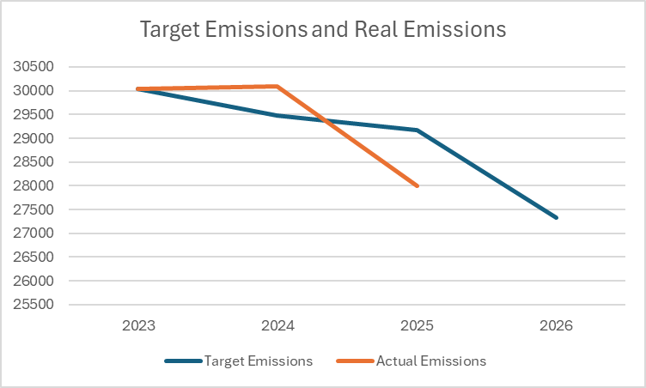

Carbon Reduction Projects

Completed Carbon Reduction Initiatives

The following environmental management measures and projects have been completed or implemented since the 2023 baseline. The carbon emission reduction achieved by these schemes equate to 2.035 tCO₂e, a 6.8%ge reduction against the 2023 baseline and the measures will be in effect when performing the contract.
Below is a short summary of the measures currently in place and continuing to be adopted:
- A policy was put in place to use public transport for business trips, over cars.
- Significant reductions of paper usage due to digitisation of the workplace and a low-paper policy.
- Usage of a significantly greener waste collection method and company.
- Installed and adopted LED lights and an energy policy to reduce electricity consumption.

Future carbon reduction initiatives

In the future we hope to implement further measures such as:

- New windows to reduce gas consumption.
- Commuting policy review and improvement, to reduce commuting emissions.
- Continued increased use of public transport over company car.
- More remote working opportunities for staff to reduce commuting emissions.

Declaration and Sign Off

This Carbon Reduction Plan has been completed in accordance with PPN 006 and associated guidance and reporting standard for Carbon Reduction Plans.
Emissions have been reported and recorded in accordance with the published reporting standard for Carbon Reduction Plans and the GHG Reporting Protocol corporate standard and uses the appropriate Government emission conversion factors for greenhouse gas company reporting.
Scope 1 and Scope 2 emissions have been reported in accordance with SECR requirements, and the required subset of Scope 3 emissions have been reported in accordance with the published reporting standard for Carbon Reduction Plans and the Corporate Value Chain (Scope 3) Standard.
This Carbon Reduction Plan has been reviewed and signed off by the board of directors (or equivalent management body).

Signed on behalf of DKP Consulting Limited:


Nick Molyneux – Managing Director
Date: 26 January 2026

https://ghgprotocol.org/corporate-standard
https://www.gov.uk/government/collections/government-conversion-factors-for-company-reporting
https://ghgprotocol.org/standards/scope-3-standard

