
PAULSON FAMILY
ENTERPRISE HANDBOOK

Cambridge Apartments · Est. 1958
A Legacy Founded by John R. Paulson
PRIVATE & CONFIDENTIAL
For the exclusive use of Paulson family shareholders
Working Draft — 2026

Table of Contents
Table of Contents 3
OUR HISTORY & LEGACY 4
Cambridge / John R. Paulson Timeline 4
VISION & FOUNDATIONS 6
Paulson Family Vision 6
Gratitude 7
KEY LEGACY ITEMS 9
Cambridge Dividend Policy 13
Family Employment Policy 14
GOVERNANCE CHARTERS 16
Family Council Charter 16
Education Fund Charter 18
Charitable Fund Charter 20
SECTIONS COMING SOON 22

OUR HISTORY & LEGACY
The Cambridge / John R. Paulson Timeline

Cambridge / John R. Paulson Timeline
1943
- Graduated from Vocational High School
- Enlisted in Army
- Wounded and awarded the Purple Heart
1946
- Worked with Grandpa Johnny
- Roofing/remodeling contracts
- He had a partner — they had enough business that they split
1949
- John R. Paulson Builders
- Building houses
1958
- Started Cambridge Apartments
- Named that because Mom liked Cambridge, England
- First building “Cambridge Apartment”
- Built 1,000's of apartments across the Twin Cities between 1958–1985
- Last building built was “The Crystal” in 1985
- Sold 75% of what he built. He also built some commercial properties — Happy Chef, Embers, Patio Doors building in Osseo, Doyle's Bowling, etc.
1969
- Offered caretaker positions to G2 — Debbie and Steve, John Reid and Connie, Lisa and Bob
- Economic decision — helped save money for newlyweds
- Learn from the ground up
- Entry point for G2 into the business — Mary Jo oversaw building in Park Rapids, Lisa managed property in Hutchinson 92–98 then moved into 320 Edgewood office
1976
- Created stock and gave a small amount to G2
- Philanthropy started to show up more and more (personally from JRP, not Cambridge Apts.)
- First scholarship — Golden Valley High School (then Hopkins)
- Calvary Lutheran Scholarship
- Private and anonymous
- Merged the two scholarships in 2010
1985
- Focused on operating/management/investments
- 1st person to support a building project through Calvary Lutheran Church to support the growing Hmong population — financed the first few houses
- Neighborhoods started to change and the market was shifting, leading to selling some apartments
- Began to buy commercial buildings — 1031 exchanges (tax strategy)
2000
- LVP Management formed
- Cost savings (tax strategy) to pay ourselves a management fee
- 5 G2 owners
2003
- Dave started to work for Cambridge
- 75% of properties have been traded up since 2003 — better returns
2007
- JRP featured as part of The Greatest Generation display at MN Historical Society
2012
- Grandpa's passing (June 7, 2012)
- He gave away most of his remaining stock (11%) to kids and grandkids
- Dave officially became President
- Without JRP's direct involvement — clarified the process for G2 decision-making
- Began meeting as a group going forward
- Spent the next three years sorting through the estate plan and implementing John and Norma's estate plan wishes
- Over a million dollars each contributed to Augsburg, American Swedish Institute, and Calvary
- Commercial buildings now approximately 75% of the portfolio

VISION & FOUNDATIONS
Why we steward this enterprise together

Paulson Family Vision
Steward the family enterprise to sustain and grow the impact we have supporting the current and future generations, along with the communities where we live and work.
Conditions of Satisfaction
- Don't kill the “Golden Goose”
- Pride to be part of the family enterprise
- Support tenant/resident success
- Creating a process to be part of a family enterprise
- Philanthropic entity exists
- Process/path for employment and involvement for family members
- Education platform and process
- Continued connection across the family
- Make deliberate efforts to connect with family members
Steward
- Working with a sense of gratitude
- Growing the resources
- Protect resources — manage risk and make wise decisions
- Act as a servant
- Come from a place of supporting something bigger than yourself
- Give
Impact
- Has a positive effect on family members
- Goes beyond the money
- Personal growth
- Helps others
- Philanthropy
- Paving the way for future generations

Gratitude
Gratitude moves through the family enterprise in three stages — Respect, Appreciation, and Generosity — applied to both what we exchange (people, opportunities, things, experiences, nature, and ideas) and how we invest ourselves (time, energy, attention, and resources).
Why it matters: gratitude is what turns ownership into stewardship. It's the difference between family members who see the enterprise as something owed to them and family members who see it as something they've been entrusted to grow and pass on.
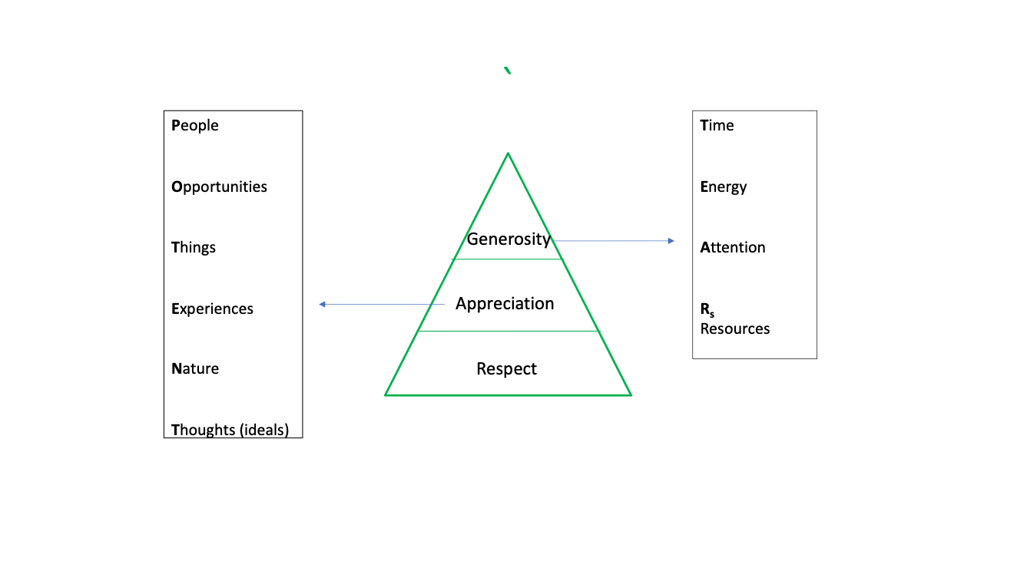
Gratitude in Practice
- Acknowledge contributions out loud at family and business meetings, not just in private.
- Send a handwritten note when someone goes out of their way for the family or the business.
- Open family gatherings by naming one thing you're grateful for.
- Publicly thank outgoing committee and Council members for their service.
- Mark milestones — work anniversaries, retirements, first years in the business — as a family, not just privately.
- Tell the next generation what you appreciate about the generations before them.

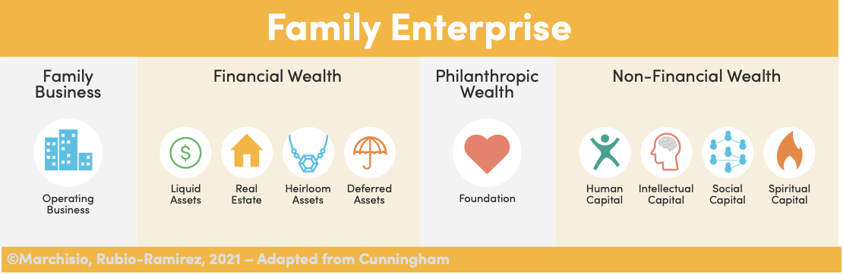
Key Differences Between a Family Business and a Family Enterprise

Family Business | Family Enterprise
- Focus is the operating business — business value and profit  - Expects family members to fit into existing business  - Investment in the business — time and resources | - Engages the whole — integrates all types of wealth above  - Leverages capabilities of family members to create new possibilities  - Investment in the whole — time and resources  - Engages concerns of all roles in the 3 Circle model  - Creates collaboration across generations

The Three Circle Model
The Three Circle Model frames the Family Enterprise as the intersection of three overlapping systems — Family, Ownership, and Business — with each role and decision considered in light of all three.
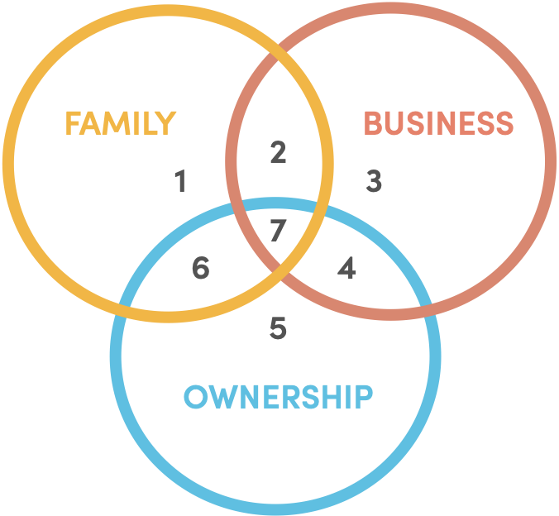

KEY LEGACY ITEMS
The values we carry forward
1. The Golden Goose
Definition
- Represents two core concepts:
  - The financial foundation/safety net of the business — the core assets that should be protected and not entirely depleted through distribution.
  - The need for these core assets/the business itself to grow and scale proportionally with the family's growth to remain impactful over time.
Key Objectives
- Preserve the core capital/asset base of the family enterprise.
- Ensure the business/portfolio grows sufficiently to provide meaningful support/distributions to a larger family in the future (e.g., distributions in 100 years being relatively as impactful as today's).
- Manage assets and growth thriftily and thoughtfully, aligning with JRP's values.
Actions to Achieve Objectives
- Develop a clear, agreed-upon methodology or calculation for determining dividend/distribution payouts (balancing payouts vs. reinvestment/retention).
- Establish a target future value or size for the “Golden Goose” (total assets/portfolio) needed to support the family long-term.
- Create a strategic plan to achieve that growth target.
- Determine a fair and sustainable process for transferring ownership (shares/units) to upcoming generations.
2. Family
Definition
- Encompasses the strong social connection and frequent gatherings characteristic of the Paulson family.
- Acknowledges the challenge of maintaining this connection as the family grows, disperses geographically, and younger generations form their own core family units.
- Based on the principle that the operating company exists to support the family, not vice-versa.
Key Objectives
- Maintain meaningful family connection and involvement, especially engaging younger generations (G4+).
- Ensure the operating company and its resources remain relevant and supportive to the evolving needs of family members.
- Effectively communicate family needs and priorities upwards (e.g., through the Family Council) to inform ownership/business decisions.
- “Make the F (Family) care about the B (Business) so they can be good O's (Owners).”
Actions to Achieve Objectives
- Continue fostering social connections, adapting methods as needed for a larger, dispersed family
- Utilize the Family Council as a primary channel for communicating family needs.
- Identify and implement ways the family/business resources can support individual family members at key life stages (e.g., education, career exploration, internships, tapping into family network/contacts).
- Develop clear pathways/processes for transitioning younger generations into engaged ownership roles.
3. Future Generations
Definition
- Includes blood relatives (G4, G5, etc.) and those marrying into the family.
- Also considered to start with G3 members who are not currently employees, viewing them as potential future contributors/employees within the business structure.
Key Objectives
- Set up future generations for success and connect them meaningfully to the family legacy.
- Ensure they understand and see the value provided by the family business entities (Cambridge, PF Properties, etc.).
- Provide tangible support, potentially mirroring JRP's historical practices (like loans).
- Maintain ongoing engagement and communication.
Actions to Achieve Objectives
- Establish specific funds (potentially loan-based with repayment expectations to teach responsibility) inspired by past family support, such as:
  - Education Fund
  - Car Fund
  - House Fund
  - Entrepreneurial Fund (requiring applications/plans)
- Maintain open and active communication channels with G4/G5.
- Clearly articulate how these support structures connect back to the family legacy and business entities.
4. Education
Definition
- Broadened definition including:
- Formal Learning: support for traditional paths like college, vocational school, apprenticeships, internships.
- Business Learning: developing a curriculum or structured way for family members (especially next-gen) to learn about the family business operations, history, and values.
- Self-Discovery: providing resources to help younger members understand their strengths, weaknesses, and interests to find fulfilling career/life paths (e.g., through assessments, guidance).
Key Objectives
- Support family members in their formal educational pursuits.
- Ensure future generations are knowledgeable about the business they own/steward.
- Equip younger family members with tools for self-awareness and career planning to foster life satisfaction.
Actions to Achieve Objectives
- Create a formal curriculum about the family business.
- Establish dedicated funds, such as a scholarship fund (for formal education) and a loan fund (e.g., for family entrepreneurs with a solid business plan).
- Develop a mentorship program within the family/business network.
- Offer access to resources for career assessment and guidance.
5. Hard Work, Sacrifice
Definition
While not formally defined, the discussion centered on:
- Investing personal time and energy into meetings and business involvement to ensure future generational success.
- Potential financial sacrifice, such as delaying personal dividends/distributions to allow for reinvestment in business growth, G4 education, or other initiatives.
- Focus was primarily on the family/ownership level commitment, rather than employee work ethic within the business itself.
Key Objectives
- Maintain family involvement, buy-in, and commitment across generations.
- Ensure sufficient resources (time, potentially capital) are allocated for future growth and generational needs.
- Gain clarity on how company growth and reinvestment strategies impact potential dividends for owners.
Actions to Achieve Objectives
- Clearly communicate the relationship between reinvestment, growth, and dividend expectations.
- Foster a culture where family members understand and value the need to invest time and potentially accept delayed financial gratification for long-term sustainability.
6. Using Money Wisely (Save a Little, Spend a Little, Give a Little)
Definition
- Expanded beyond just monetary resources to include time as well (save time for self, spend time on family, give time to causes/family).
- Recognized as somewhat vague, potentially interpreted differently by individuals.
- Applies to both individual/family finances and collective/business financial decisions (e.g., business saving for taxes, spending on assets, giving via support/charity).
Key Objectives
- Instill and practice principles of financial responsibility and balanced resource allocation (time and money).
- Promote financial literacy within the family.
- Ensure awareness of future financial needs (personal and collective).
Actions to Achieve Objectives
- Implement personal/family budgeting practices.
- Provide financial education opportunities for family members.
- Actively apply the “save, spend, give” framework to decisions regarding both time and money.

Cambridge Dividend Policy
July 2025
Background
John Paulson started paying dividends to his children as a way to share the success of his company with them. The payments were random and varied from year to year and some years, not at all. His payments were totally discretionary and usually paid at Christmas. Over the years a pattern emerged and the timing became a little more predictable, but they were always related to the business cash flow needs and timing of ongoing investments. John liked to pay a dividend around IRS tax time (4-15) and then another when the year-end accounting books were completed in December. He strongly preferred to hold payment until the first week in January so recipients would have the use of the money for 16 months before they had to pay tax on it (versus December payment and then paying tax on it 4 months later).
Decision Factors
Given this history, we have decided to proceed as follows:
- Cash flow needs: the first factor to consider are the cash flow needs of the business (see attached monthly cash flow analysis report). Our experience has taught us we need to keep 3 to 5 million of cash readily available to meet the ongoing needs of operation and investment.
- Year-end profitability: the second factor is the year end profitability of the business. Is net operating income increasing as per plan, flat or decreasing?
Current Dividend Determination
Based on these factors, we have decided to pay a $3.00 dividend in May ($195,000) because we should always have that much cash readily available.
We will also pay another dividend, based on the year end financials we receive in December, even though the check will not be handed out until the first week in January. The total amount of dividend paid over the past 5 years has been between $8.00 to $9.00 per year. There is no guarantee we can maintain that every year and some years could certainly be more or less.
Growing Future Dividends
The best way to pay more dividends is to make sure that the company's net income continues to grow at a faster rate than inflation and we manage our cash flow wisely so we never need to rely on a bank loan to fund our operating needs for things like tenant improvements for a major new tenant or to cover the cash flow needs if a major tenant leaves and the building sits empty.

Family Employment Policy
LVP Management — Family Employment Policy and Guidelines
Employment Philosophy
While ideally LVP Management would be a family owned and operated business, it is also important that the company strives to have the most qualified employees — whether they are family members or not. A position with LVP Management is neither a birthright nor an obligation.
Every decision regarding family employment will be given careful, deliberate consideration, with the needs of the business taking precedence over individual or family priorities.
Employees of LVP Management are expected to embrace and embody the company's mission and values:
Mission
- To provide real estate products and services of superior value, delivered in a locally responsive manner. Our clients will know they are dealing with a business that demonstrates family values.
Values
- Honesty: we will be honest in all our dealings with clients and vendors. Period!
- Integrity: to the best of our ability we will do what we say we will do, when we say we will do it. If mistakes come to our attention, we will take full ownership of them and endeavor to create appropriate rectification and solution as soon as possible.
- Excellence: we will pursue excellence as a standard to drive every action and step that we take. We will seek out and choose to work with employees, contractors, and suppliers who have demonstrated a commitment to excellence as well.
- Relationship: we acknowledge that the strength of our business is our commitment to establishing and maintaining mutually beneficial relationships with our customers and suppliers.
- Family: we are a family owned and operated business. We will treat our customers and suppliers as we would expect family members to respectfully treat each other. We will run our business by the “Golden Rule.”
- Value: we will provide superior value (price/service) to our customers so they continue to choose us over their other options.
Applying for a Position
- Any family member interested in employment should contact the President to discuss the Family Employment Policy and Guidelines.
- Family members interested in an open or soon-to-be-open position are required to submit a resume and cover letter specific to the job opening, just as any non-family applicant would.
- Family members are required to meet the same position requirements as any other applicant, including but not limited to education and outside work experience.
- Compensation levels will be based on the fair market value of a position.

Conditions of Employment
- Family employees will be held to a higher standard in regard to dedication and conduct than non-family employees.
- Once hired, family members are expected to meet the same levels of performance and follow all procedures as non-family employees.
- Family members will be subject to the same standards and performance reviews as non-family members.
- The benefits and responsibilities of ownership are separate from the benefits and responsibilities of employment, and will be treated as such.
- Compensation will be a fair market wage according to the job description and level of responsibilities.
- There is no guarantee that a family employee will be promoted into top management positions simply because they are a member of the family.
- To contribute to the development and advancement of family members, each family employee will have a career path “development plan,” which should encompass training, continued education, coaching, mentoring, special projects, and assignments.
- When possible, immediate family members (parents, children, siblings, and spouses) should not report to each other.
- Final decisions on hiring, rejecting, and firing any family employee rest with the Board.
Definitions
- Family members: direct descendants of John R. Paulson, their spouses, and their children and step-children.
Governance & Review
- Annual review: this policy will be reviewed annually by the Board to ensure it continues to reflect the family's values and the needs of the business.
Cross-reference: the roles of the President and the Board referenced in this policy will be defined in full as part of the Governance Structure section (see Sections Coming).

GOVERNANCE CHARTERS
Family Council · Education Fund · Charitable Fund

Family Council Charter
Purpose
The purpose of the Family Council is to support family members, nurture relationships, build trust, and create a platform for collaboration. The Council will be a forum to discuss issues relevant to the family, identify and support common family goals, and serve as a liaison between the family and Cambridge.
Objectives
- Increase communication — serve as a communication link between family and Cambridge, including the Advisory Board members.
- Utilize the many skills and capabilities of family members — get input from family on future “family business” matters, such as policies relevant to family employment or philanthropy policy.
- Facilitate a path towards employment and education for G4 (i.e., development of family members).
- Be leaders and show effective decision-making that is in the family's best interests.
- Pave the path for Gen 4 & beyond — teach & inspire the youngest generations to be active participants.
- Further Paulson family properties for the next 100 years — build leaders, unify us, philanthropy, and education.
- Facilitate regular communication for the extended family.
- Coordinate and facilitate educational opportunities and events for the extended family.
- Coordinate opportunities and events to nurture relationships among members of the extended family and among generations.
- Create committees as needed to help plan and execute family events and any other projects that may come up.
Membership
Membership will be determined by the following:
- Past participation on the Impact team
- Past participation on a committee
- Commitment to standards and participation requirements
Skills Desired
- Willing to be open to other perspectives and willing to communicate your own
- Desire to help the family
- Willing to contribute your time and effort
- Win-win attitude
- Respectful to other members
- Willing to collaborate and build trust
- Have empathy and listen
- Have the best interest of the whole, not an individual
Benefits
- Opportunity to contribute and add value to family
- Be part of the decision-making
- Develop your own personal goals
- Personal growth
- Stronger family bonds
- Sense of accomplishment and pride
- Being part of something bigger than yourself
Behavior Standards
- Respond to emails/calls in a timely manner
- Follow up appropriately and timely
- Deliver on your promises
- Be kind and respectful
- Be an active participant
- Attend meetings
Meeting Frequency
Meetings will be held 6–9 times per year, unless otherwise needed.

Education Fund Charter
Purpose
- Invest in the education of the next generations of the family.
- Reinforce the family's value of education as a pathway to opportunity, growth, and contribution.
- Create a consistent, fair process that works today and remains viable for future generations.
- Strengthen connection across the Family Enterprise by including all branches of the family.
Guiding Principles
- Equity across branches: caps are set per child, not per family — no household is penalized for size.
- Inclusivity: lineal descendants.
- Personal accountability: applicants must articulate the importance of the education to their life and goals.
- Field-neutral: funding is not restricted by chosen field of study (e.g., liberal arts vs. business vs. trade).
- Performance expectation: renewal requires meeting a minimum academic standard.
Eligibility Criteria
Eligible Recipients
- Lineal descendants of family shareholders
- [TBD] Continuing education benefit for G3 members and their spouses — pending direct feedback from those individuals on interest and design.
Eligible Programs
- Accredited post-secondary education, including four-year colleges, trade schools, and graduate/professional programs.
- No restriction by field of study
Renewal Requirements
- Recipient must remain in good standing with the institution to be eligible for renewal in subsequent years.
Application & Decision Process
Applicant Responsibilities
- Submit an application articulating the importance of the education to their life and goals.
- Provide proof of enrollment and acceptance from an accredited institution.
- Renewal eligibility will be verified by the scholarship committee.
Committee Review
- Verify the applicant meets eligibility and academic criteria.
- Confirm grant amount is within the per-child cap and annual budget.
- Communicate decisions and disburse funds.
Funding & Grant Policy
- Annual budget: 2026 — pay out of Cambridge operating budget.
- Grant per applicant: $5,000 per year (working figure).
- Cap structure: maximum is set per child, not per family.
- Duration of support [TBD]
- Funding strategy [TBD]: whether to invest more heavily now (while payouts are low) to compound and protect future grant value, vs. pay-as-you-go.
Roles & Responsibilities
Education Fund Committee
- Maintain application forms and process
- Review and verify submissions
- Track disbursements and renewals (money in/out)
- Communicate opportunities to eligible family members
- Steward the long-term financial model
Applicants (Family Members)
- Submit complete applications and renewals on time
- Maintain academic standards required for renewal
Ownership Council / Business Leadership
- Approve the annual budget and any structural changes to the charter
- Provide oversight and final approval at launch
Governance & Stakeholder Engagement
- Year 1 mindset: first year is a learning year. Track what works, surface gaps, and refine.
- Annual review: charter is reviewed annually against the long-term model and family needs.

Charitable Fund Charter
Purpose
- Create connection and shared purpose within the Family Enterprise.
- Continue to build on the family's values of giving and gratitude.
- Match the donor's contribution based on criteria and maximum match amount.
- Support family members to have “skin in the game” to increase learning and impact.
- A-political / a-religious focus: gifts should be non-political and non-divisive.
Giving Categories
Gifts must align with one of the following priority areas:
- Basic Human Needs — housing, food security, and similar.
- Education — trade schools, school foundations, and similar.
Eligibility Criteria
Recipient Organization Must
- Be a registered 501(c)(3) nonprofit
- Be listed on the Charity Navigator site with a minimum score of 3.
Donors Eligible to Nominate
- Shareholders
- Spouses
- Direct descendants and stepchildren
Decision-Making Process
Donor Responsibilities
- Research the charity and share the Charity Navigator score.
- Apply explaining how the charity fits the value criteria, and why it is important to them.
- Report back on the experience: what worked, what didn't, and what they would do differently.
Committee Review
- The committee's role is primarily verification — confirming the submission meets all objective criteria.
- Incomplete submissions are returned to the donor for more work.
Matching Policy
- Budget: $10,000 per quarter, resetting each quarter.
- Match: $250 to $1,000 per shareholder per year.
- Gift limit: one matched gift per shareholder per year.
- Youth match: $25 minimum for donors age 25 and under.
Funding Evaluation
- Per-gift reporting: who, what, where, when.
- Quarterly: interim reporting after each quarter.
- August Family Retreat: deeper review — what's working, what could be better.
- Fall Family Enterprise Meeting: final annual report.
- Year 1 mindset: treat 2026 as an experiment. Adjust criteria, budget, or process based on what we learn.
Roles & Responsibilities
Committee Duties
- Tracking and administration; maintain a spreadsheet of money in/out
- Communicate opportunities to the family
- Maintain the submission forms
- Reviewing/verifying submissions
- Communicating decisions
Communication
- Direct outreach: communicate the program directly to family members and to parents of younger kids directly.
- Learning-year framing: be explicit that 2026 is a learning year and that the process will evolve.
- August working session: use the family retreat to ask — What worked? Where can we improve? What shifts are needed?

SECTIONS COMING SOON
This handbook is a living document
This handbook will continue to grow as additional governing documents are finalized and incorporated. Planned additions include:
- Conflict resolution process

If you have questions or would like to contribute to a future section, please reach out to the Family Council.

