LSA Secure Medical Ltd

Carbon Reduction Plan

Carbon Reduction Plan
Supplier name: LSA Secure Ltd
Publication date: 13/06/2024
Review period: Annually
Review date: 13/06/2025

Commitment to achieving Net Zero
LSA Secure is committed to achieving Net Zero emissions within the timeframe of 2050. Within our Policy document we have set an ambitious target of achieving Net Zero operations by 2045 mapped against the five priorities for the company. These are:
- Vehicle Carbon Reduction
- Going paperless: transition to digital operations
- Properties and business activities
- Safer Recruitment from local areas
- Monitoring and reporting processes

The plan will focus on the five priorities up to April 2030. During this focus period, the plan will be reviewed annually to identify any changes in the prioritisation focus and/or initiatives that may achieve Net Zero more efficiently.

Baseline Emissions Footprint
Baseline emissions are a record of the greenhouse gases that have been produced in the past and were produced prior to the introduction of any strategies to reduce emissions. Baseline emissions are the reference point against which emissions reduction can be measured.
Baseline Year: 2023
This data set is the first emissions data collated by the LSA for publication and will represent the baseline by which we measure our success.

Baseline year emissions:
EMISSIONS | TOTAL (tCO2e)
Scope 1 | 14
Scope 2 | 0.7
Scope 3 (Included Sources) | 62.7
Total Emissions | 74.7

LSA are currently sourcing an accredited company to support the data capture and analysis of our plans and achievement, so we are able to provide updated reports and assurance to Commissioners of our commitment to achieving Net Zero by 2050.
Our current plans signed off by the Board and set out in our Policy, will have the following expectations in reduction over the next 5 years:
EMISSIONS | TOTAL (tCO2e) | Target Reduction range
Scope 1 | 14 | 10%
Scope 2 | 0.7 | 2%
Scope 3 (Included Sources) | 62.7 | 10%
Total emissions | 74.7 | 59.76

We project that carbon emissions will decrease over the next five years to 59.76 tCO2e by 2029. This is a reduction of 20%.
Progress against these targets can be seen in the graph below:
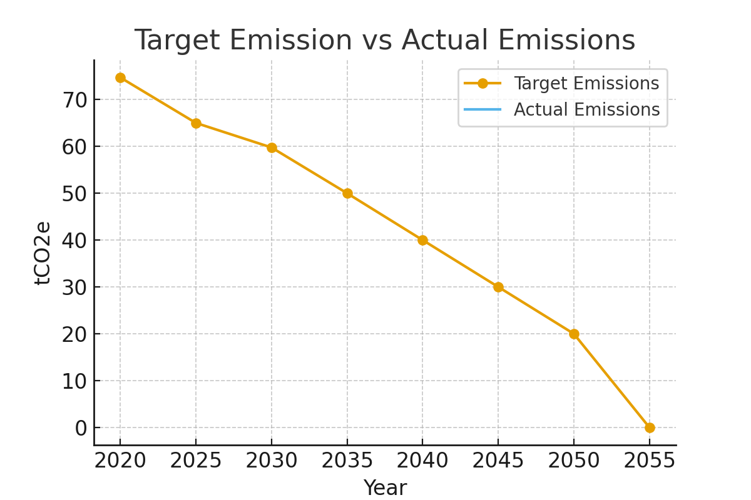

Carbon Reduction Projects
Completed Carbon Reduction Initiatives
• Our location on a working farm gives us opportunity to plant trees and provide habitat for wildlife
• As our operation grows, we will invest in more solar for powering buildings
• We will investigate and integrate electric or hybrid vehicles

Declaration and Sign Off
This Carbon Reduction Plan has been completed in accordance with PPN 06/21 and associated guidance and reporting standard for Carbon Reduction Plans.
Emissions will be reported and recorded in accordance with the published reporting standard for Carbon Reduction Plans and the GHG Reporting Protocol corporate standard and uses the appropriate Government emission conversion factors for greenhouse gas company reporting.
Scope 1 and Scope 2 emissions will be reported in accordance with SECR requirements, and the required subset of Scope 3 emissions have been reported in accordance with the published reporting standard for Carbon Reduction Plans and the Corporate Value Chain (Scope 3) Standard.
This Carbon Reduction Plan has been reviewed and signed off by the board of directors (or equivalent management body).
Signed on behalf of the Supplier: |  | Following review:
M. Fullick – Director | Signed: | Date: 13/06/2025
K. Burns – Director | Signed: | Date: 13/06/2025

