**Diocese of Nottingham**



**Compliance & Support Property Officer**

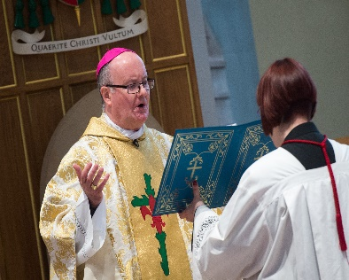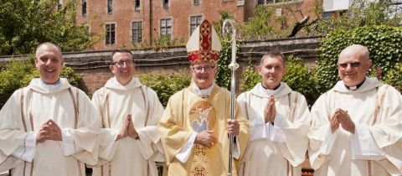**Job Application Pack**

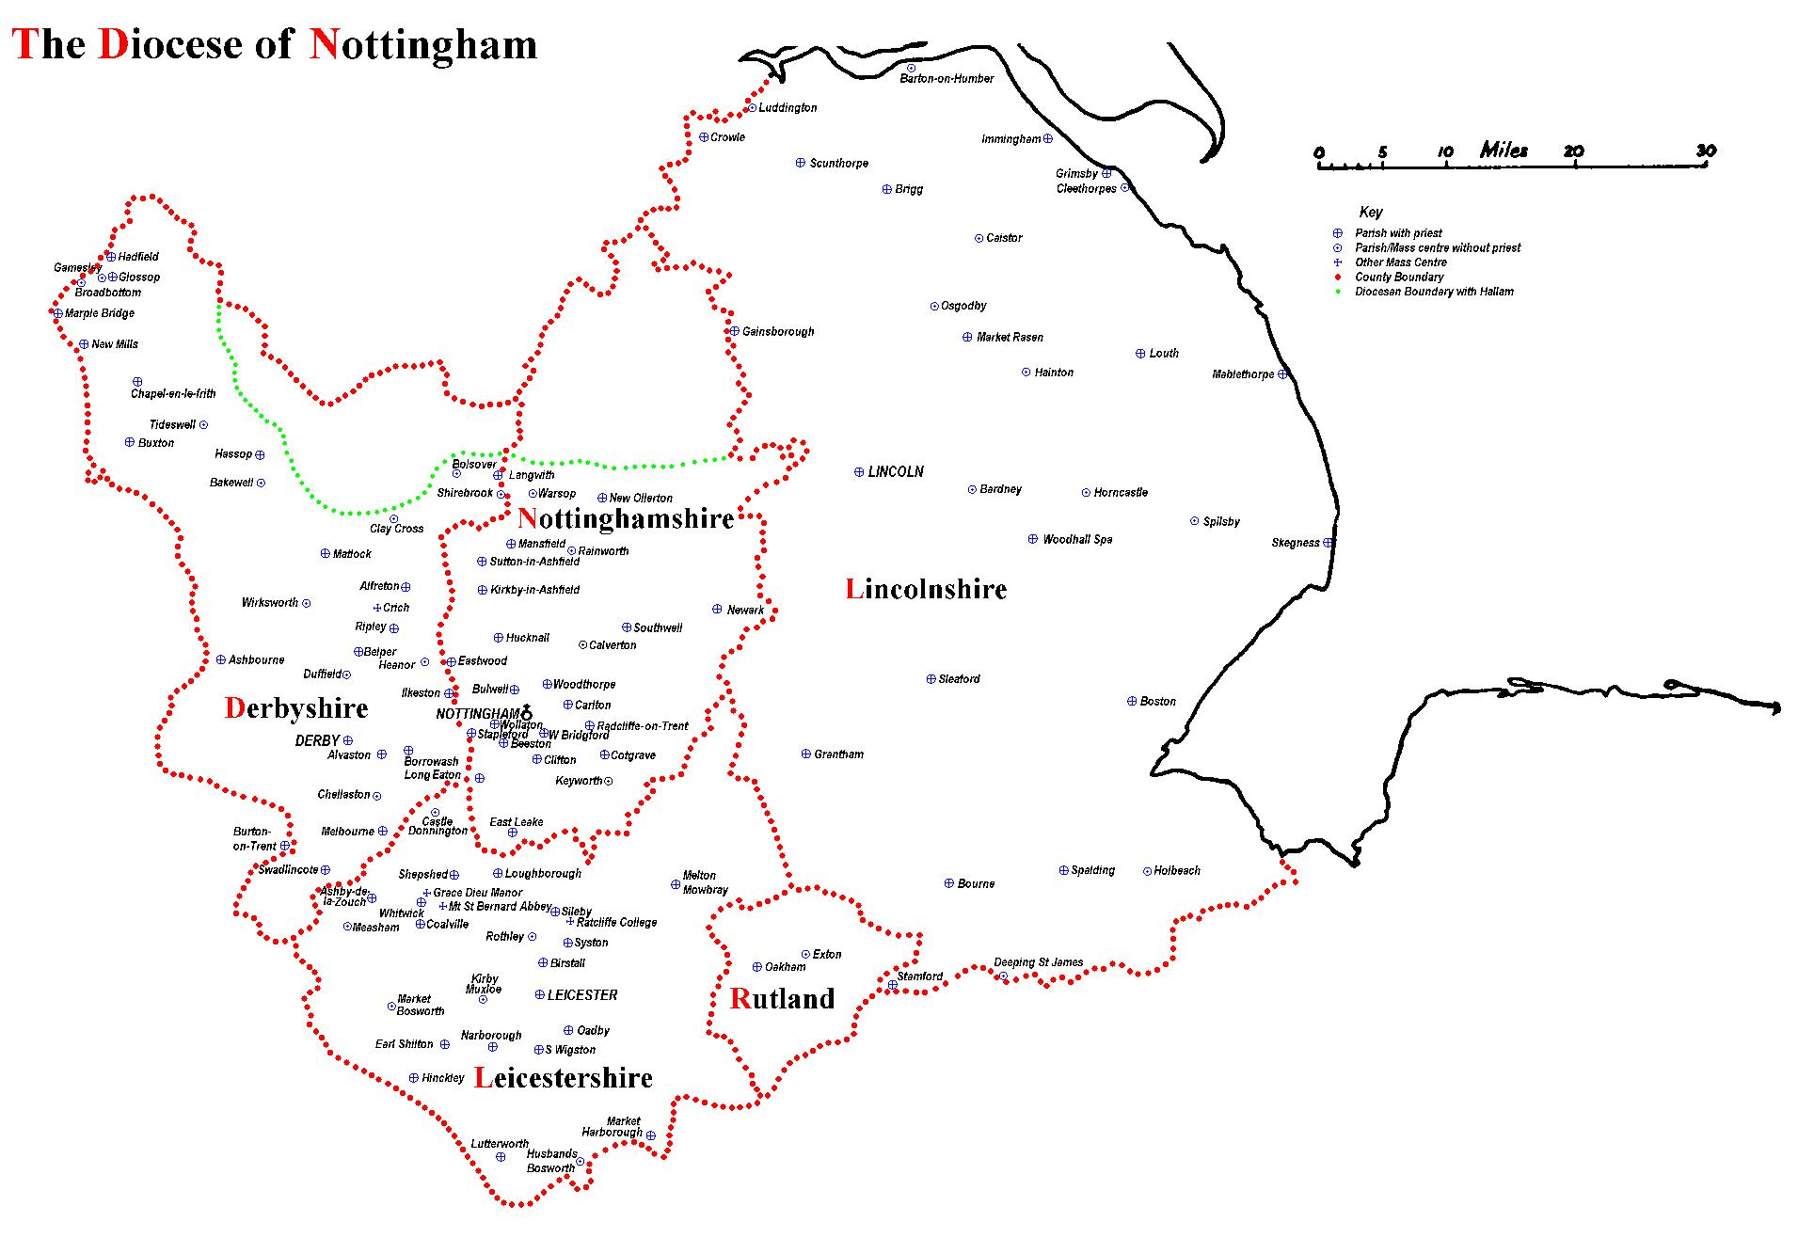

The Diocese of Nottingham covers a large geographical area covering Lincolnshire, Leicestershire, Rutland, most of Derbyshire and Nottinghamshire and parts of Cheshire and Staffordshire, making it the largest in the country. It is varied in its demography as it encompasses one of the most ethnically diverse cities in the country, Leicester, and some of the most rural territory, Lincolnshire, with its villages and market towns. Consequently, the people of the diocese come from all backgrounds imaginable, giving the diocese a rich and varied life.

We are led by Bishop Patrick McKinney and have 122 priests and 57 deacons, including those who are in active ministry, retired, working here or elsewhere. They serve 107 parishes and 87 primary and secondary schools. Over any given weekend, there are approximately 30,000 people attending Mass in the diocese.

Job Description

**Roman Catholic Diocese of Nottingham: Job Description Form**

**Department/Parish:** Curia - Property Department

**Job title:** Compliance & Support Property Officer

**Based at:** Various locations throughout the diocese and the diocesan curial office (DCO), Castle Quay, Nottingham. Following induction at DCO the post holder will initially be required to work in parishes in Leicestershire. Once the Leicestershire parishes are up to date, the post holder will move to support parishes in different area of the diocese.

**Hours of work:** 37.5 hrs per week

**Band & Salary:** Band 4c £25.9k

**Line Manager:** Head of Stewardship

___________________________________________________________________

**Purpose of the role:**

To proactively monitor and assist parishes with compliance, relieving the burden from parish priests where possible, and ensuring deadlines are met. Proactively monitor unoccupied buildings and insurance precedents assisting parishes as necessary. Creating and updating a supplier database in liaison with the Property Manager and Parishes. Proactively monitor progress of quinquennial repairs in relation to deadlines. Proactively liaise with letting agents about let properties (residential and commercial). Act as point of liaison for property management software.

**Main responsibilities:**

**Assist parishes with compliance, relieving the burden from parish priests where possible:**

* Proactively monitor and follow up compliance matters in liaison with the Property Team where necessary, utilising the property management database and supporting parishes to meet deadlines.
* Point of contact for property management database.
* Compile and proactively maintain list of unoccupied buildings.
* Compile, and keep updated a supplier database to assist parishes when trades and professions are required, including evidence of insurance, testimonials etc.
* In liaison with the Property Manager record progress of quinquennial inspection repairs within recommended timeframe and escalate as necessary.
* Proactively manage insurance precedents and ensure parishes are aware of these (in liaison with property team as necessary), condition precedents, required frequency of certain inspections, dangerous works, contractors providing evidence of correct level of insurance cover, unoccupied buildings risk mitigation measures etc.

**Act in a professional and helpful manner at all times, with internal and external people at all levels:**

* Respond to enquiries in a timely manner.
* Take care when dealing with disputes, legal notices, etc. - liaise with Head of Stewardship.
* Seek professional advice as necessary, obtain approval, for the bearing of costs being agreed in advance.
* Maintain comprehensive records and ensure the Property Database is updated and maintain as necessary. (H&S Property Officer to deal with Buildings and Sites and HCC records).
* Safe storage of Deeds
* Ensure the Head of Stewardship, other appointed professionals and colleagues are kept up to date as necessary.

**Proactively oversee Lettings including but not limited to:**

* Liaison with lettings agents and parishes about repairs, rent payments, etc.
* Dates of leases are reviewed prior to notice needing to be served, or leases being renewed
* Property management database is kept up to date with relevant information

**In liaison with the Property Manager and Head of Stewardship ensure that Canon law is adhered to in all property matters:**

* Keep a watching brief on usage of property to ensure compliance with Canon Law, civil law and avoid risk of reputational damage.
* Ensure that Canon Law procedures are followed in relation to closures and alienation (disposals).

**In liaison with the Property Manager and Head of Stewardship ensure that civil law and statutory regulations are adhered to in all property matters including disposals and acquisitions:**

* Liaise with solicitors, and the Head of Stewardship. Check all documents prior

to obtaining signatures.

**In liaison with the Property Manager and Head of Stewardship ensure that the Charities Act is complied with:**

* Refer to the Act as updated from time to time and seek advice as necessary.
* Liaise with solicitors, chartered surveyors, Head of Stewardship as necessary.

Includes all property disposals including the granting of leases.

**In liaison with the Property Team ensure all buildings have insurance in place.**

* Including any purchases from exchange of contracts

**Assist Head of Stewardship**

* Generally, and take on ad hoc projects as and when required.

**Key Internal Contacts:** Line Manager (see above), Property Team, Curial Leadership Team, Parish Priests, Parish staff, Parish volunteers e.g. Chairs of Parish Finance Committees.

**Key External Contacts:** Solicitors, Architects, Surveyors, Diocesan insurers and loss adjusters, Statutory Bodies, Land Registry, appointed agents and advisers, suppliers and contractors, communications and equipment support specialists, and diocese-wide professional services providers.

**Experience and qualifications required for role:**

The post of Compliance & Support Property Officer requires an experienced administrator who is adaptable, good at problem solving and prioritising and remaining calm under pressure. The following are the key requirements.

**Essential**

* Good communications skills, both written and verbal; good and accurate written English.
* Good analytical ability.
* Ability to draft clear and accurate documents/reports for various audiences.
* Excellent organisational skills.
* Excellent IT skills, including word-processing, spread-sheets, databases, photographs, pdf files.
* Capacity to relate appropriately to a wide range of people, in person, by telephone or by e-mail.
* Ability and willingness to work collaboratively with the Head of Stewardship, Curial Leadership team, Chief Operating Officer (COO), Episcopal Vicar (EV) for Finance & Administration, Parish Priests and other colleagues.
* Relevant experience including prioritising an often heavy and urgent workload.
* Initiative and able to work with minimal supervision.
* Ability to focus under pressure and meet deadlines while working with good attention to detail.
* Sound judgement to determine what should be referred to the Head of Stewardship for approval, agreement or information and what can be dealt with independently.
* Flexibility and adaptability to changing priorities.
* Ability to understand and apply formal and legal procedures correctly
* Understanding of and commitment to the principles and practice of confidentiality.
* Willingness to be involved in continuing personal and professional development.
* Awareness of the hierarchy of the Catholic Church and its priorities
* Full driving licence and access to a vehicle for travel

**Desirable**

* Educated to ‘A’ level or equivalent qualification or experience in an appropriate discipline.
* Some knowledge of property, facilities management, office management, and / or legal agreements would be helpful
* Ability to see how this role fits into the bigger picture of the work of the Diocese.

**Personal attributes:** There is no occupational requirement for the person appointed to be Catholic. A commitment to the ethos of the Catholic Church is essential.

**Way of working:** Within a creative and enthusiastic team, to serve the Parishes, Curia and outside agencies supporting efficient operation of the Diocese of Nottingham.