**Diocese of Nottingham**

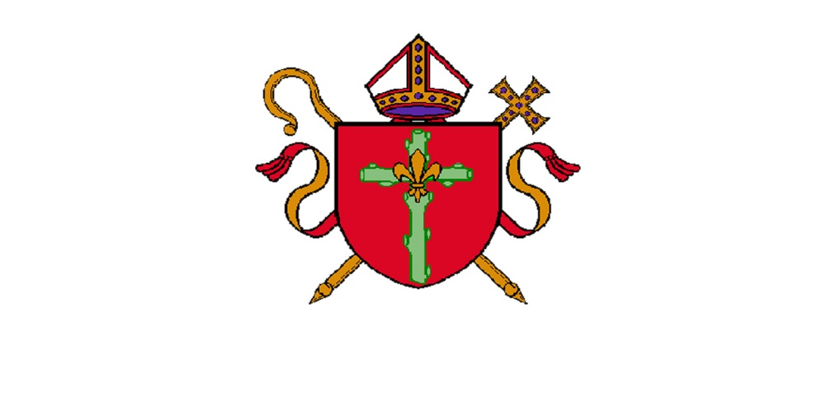

**IT & GDPR Assistant**

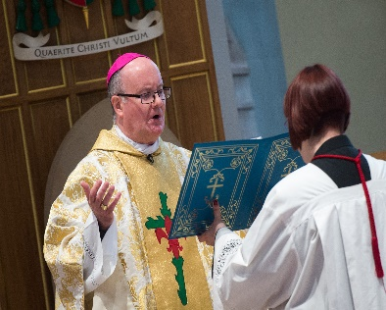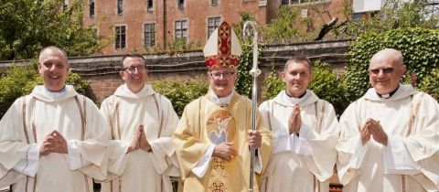**Job Application Pack**

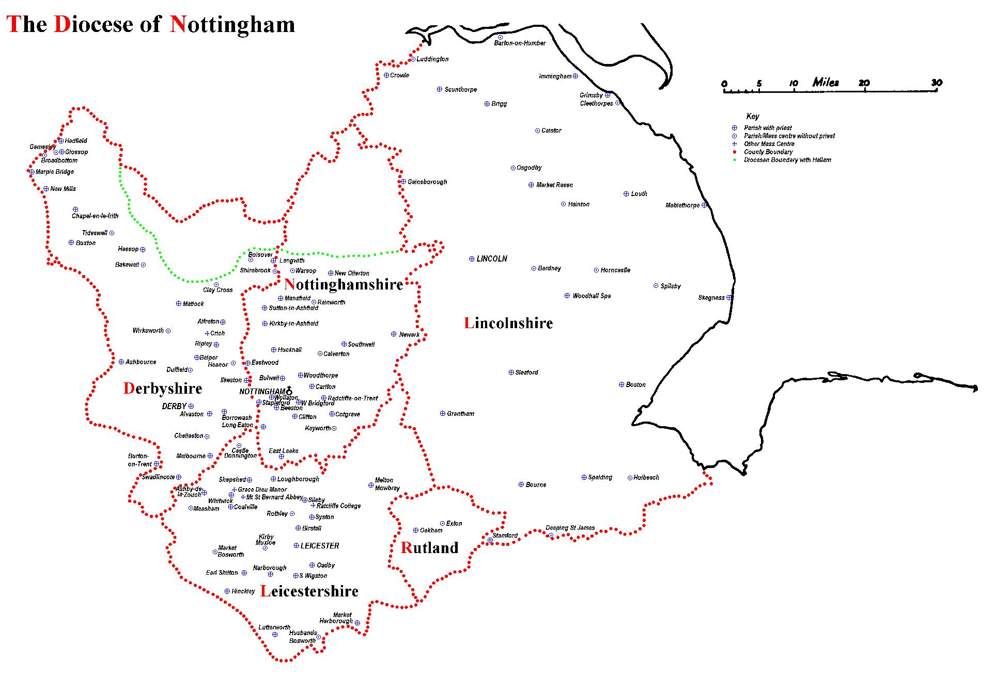

The Diocese of Nottingham covers a large geographical area covering Lincolnshire, Leicestershire, Rutland, most of Derbyshire and Nottinghamshire and parts of Cheshire and Staffordshire, making it the largest in the country. It is varied in its demography as it encompasses one of the most ethnically diverse cities in the country, Leicester, and some of the most rural territory, Lincolnshire, with its villages and market towns. Consequently, the people of the diocese come from all backgrounds imaginable, giving the diocese a rich and varied life.

We are led by Bishop Patrick McKinney and have 122 priests and 57 deacons, including those who are in active ministry, retired, working here or elsewhere. They serve 107 parishes and 87 primary and secondary schools. Over any given weekend, there are approximately 30,000 people attending Mass in the diocese.

Job Description

**Roman Catholic Diocese of Nottingham: Job Description Form**

**Department/parish:** Curia – IT & GDPR Department

**Job title:** IT & GDPR Assistant

**Purpose of role:** To support the work of the IT & GDPR Officer and departments of the curia in their service to the parishes of the diocese; always maintaining a professional, friendly, and high-quality service-oriented environment, focus on leading provider of innovative technology solutions using 365 Microsoft Ecosystem Apps and ensuring the highest standards of data privacy and cybersecurity.

**Based at:** St Hugh’s House,1 Castle Quay, Nottingham, NG7 1FW. Post holder will be required to work at any other DCO location.

**Hours of work:** Part-time - 25 hours per week.

**Salary:** £17,017.00 (Band 3)

## **Line Manager:** IT & GDPR Officer

___________________________________________________________________

**Purpose of the role:**

To support the IT & GDPR Officer to provide a professional service to all employees, clergy and volunteers in the curia team and parishes within the diocese, applying guidance as directed and providing advice on a wide range of IT & GDPR queries and issues.

Co-ordinate support of IT & GDPR processes for all curial departments and parishes, including:

**IT solutions and support**

* Provide first-line technical support to diocesan staff, clergy, parish staff and volunteers resolving hardware, third-party software, and connectivity issues.
* Assist users with basic issues within our Microsoft 365 ecosystem (SharePoint, PP, Word, Excel, Forms), account set-ups and Adobe to users via phone, email, ‘Teams’ videocall or chat.
* Escalate complex issues to the IT outsourcing service and follow up the outcomes.
* Liaise with the IT outsourcing provider to develop and implement new solutions to help our users improve their productivity.
* Request quotes for hardware, software, communication systems, contactless donation systems and any IT equipment.
* Update the 365 Microsoft directory and other diocese databases.
* Maintain an accurate list of IT and Communications assets.
* Help maintain and update IT and data protection policies, procedures, and training materials to ensure ongoing compliance.
* Keep the IT & GDPR SharePoint site organise and updated.

**GDPR support**

• Assist in the development, implementation and maintenance of GDPR compliance policies, procedures and measures.

• Ensure data protection policies are being followed.

• Assist in responding to GDPR enquiries and requests.

• Maintain records of data processing activities and ensure they are up-to-date.

• Provide support in data protection impact assessments (DPIAs) and risk assessments.

• Stay updated on changes in data protection laws and regulations and advise the team accordingly.

• Collaborate with various departments and parishes to ensure data protection compliance across the organisation.

**Learning & development**

* Assist in the development and delivery of GDPR & IT training programs for staff.
* Supporting training programmes, workshops and seminars.
* Continuously learn the latest Cybersecurity, IT and GDPR best practices to improve workplace efficiency.

**General Administration**

* Support IT & GDPR Officer with special projects as required.
* Attend internal, external and networking meetings.
* Visit parishes to deliver training to clergy and volunteers.
* Place stationery orders and other consumables.
* Prepare and draft monthly reports for the IT & GDPR Officer.
* Ensure that all information is stored correctly and in accordance with GDPR regulations, the Data Protection Act, and cybersecurity standards.

**Key Internal Contacts:** Line manager (IT & GDPR Officer), curial departments & colleagues, parish priests, parish staff and volunteers e.g. lay chair of pastoral council

**Key External Contacts:** IT and communications providers, other dioceses and diocese-wide professional services providers.

**Experience, skills and qualifications required for this role:**

* Good communication skills, both written and verbal; good accurate written English.
* Strong understanding UK GDPR and data protection principles.
* High level of discretion and compliance with strict confidentiality.
* Excellent attention to detail.
* Excellent IT skills in 365 Microsoft (Teams, OneDrive, SharePoint, Outlook, Forms, Booking, PP, Excel, Word) and Adobe.
* Capacity to relate appropriately to a wide range of people, in person, by telephone, or by email.
* Good administration and diary management skills.
* Demonstrate ability to build and maintain excellent and credible relationships with priests, managers and employees and willingness to work collaboratively with curia colleagues.
* Ability to draft clear and accurate documents/reports.
* Initiative and ability to work under supervision of senior colleagues.
* Ability to focus under pressure and meet deadlines.
* Sound judgement to determine what should be referred to the IT & GDPR Officer.
* Flexibility and adaptability to changing priorities.
* Aptitude and willingness to learn, develop and appropriately apply learning.
* Willingness to work within the ethos of the Catholic Church.

**Desirable**

* Educated to ‘A’ level or equivalent qualification or experience in an appropriate discipline.
* Knowledge of Microsoft 365 administration and cloud-based systems.
* Familiarity with safeguarding and compliance frameworks.
* A commitment to the ethos of the Catholic Church

**Personal attributes:** There is no occupational requirement for the person appointed to be Catholic.

**Way of working:**

We operate in a fast-paced, collaborative environment where attention to detail and proactive problem-solving are key. The IT & GDPR Assistant will work cross-functionally to ensure data protection compliance and seamless IT support. We value continuous learning, clear communication, and a commitment to upholding the highest standards of data integrity and security.