**Diocese of Nottingham**



**University of Lincoln and Bishop Grosseteste University**

**Catholic Chaplaincy**

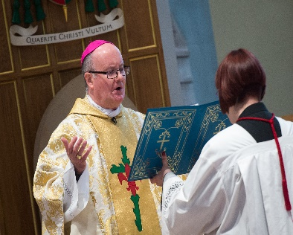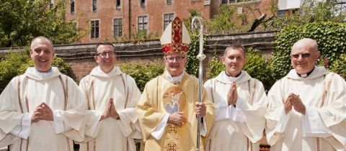**Job Application Pack**

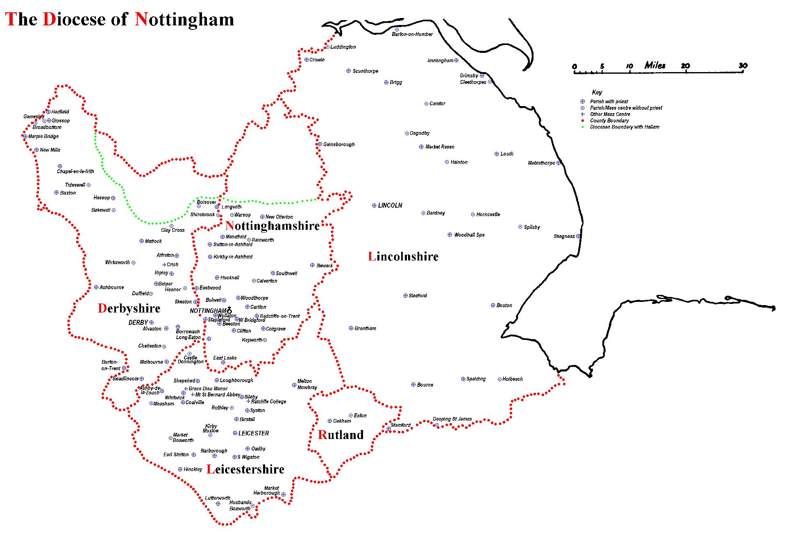

The Diocese of Nottingham covers a large geographical area covering Lincolnshire, Leicestershire, Rutland, most of Derbyshire and Nottinghamshire and parts of Cheshire and Staffordshire, making it the largest in the country. It is varied in its demography as it encompasses one of the most ethnically diverse cities in the country, Leicester, and some of the most rural territory, Lincolnshire, with its villages and market towns. Consequently, the people of the diocese come from all backgrounds imaginable, giving the diocese a rich and varied life.

We are led by Bishop Patrick McKinney and have 122 priests and 57 deacons, including those who are in active ministry, retired, working here or elsewhere. They serve 107 parishes and 87 primary and secondary schools. Over any given weekend, there are approximately 30,000 people attending Mass in the diocese.

Job Description

**Roman Catholic Diocese of Nottingham:**

**Department/parish:** Curia – University Lay Chaplaincy

**Job title:** Lay Catholic Chaplain to the University of Lincoln and BGU.

**Date of appointment:** Tba

**Purpose of role:** To provide pastoral, social and non-sacramental spiritual care for the Catholic students and staff at the University of Lincoln and BG University, and for a wider chaplaincy to all students and staff as part of the service to both institutions.

**Based**: St Hugh’s of Lincoln, 34 Broadgate, Lincoln, LN2 5AQ & above universities

**Hours of work:** 21-hours per week, to include Sunday in Parish and Tuesday on campus, plus being available at agreed times to offer pastoral support and attend services and event out-of-hours. Contract is for 52 weeks per year.

**Salary:** Band 3, £13.09 per hour

**Line Manager:** University Chaplain (Canon Eddy Jarosz) and to the Episcopal Vicar for Education (Fr Simon Gillespie)

| **Main Responsibilities** |
| --- |
| Pastoral care of the Catholic students, including:   * Spiritual care apart from sacramental - this includes regular group prayer, especially the Prayer of the Church and praying the scriptures, the Rosary and other devotions. * Opportunities to experience different methods of personal prayer. * Opportunities to develop understanding of the Scriptures and Faith and to explore contentious areas in a safe environment. * Organising retreats and pilgrimages suitable for the students. * Preparation for Baptism, Confirmation, and discernment of vocation. * Welcoming of and hospitality to home students and overseas students alike, identifying loneliness, homesickness and cultural displacement. * To make contact, especially by attendance at parish Masses on Sundays, which is a significant part of the ministry of welcome. * To listen, to be open and to be welcoming as well as to encourage more settled students to exercise a peer ministry of hospitality and encouragement. * Clear sense of professional boundaries. * Signposting students to professional help where required. * Facilitating peer-to-peer support and ministry, including individual meetings and of the Catholic Society, and undertaking training with the Catholic Students’ Network. * Support student initiatives and encourage student involvement in practical works of charity as well as in wider justice and peace organisations. * Publicity: Making the chaplaincy and chaplaincy activities known in the university and the parish. * Contributing to the maintenance and development of the Chaplaincy webpages and social media.  Creating a positive and wholesome social media ethos and moderating content. * Outreach to Catholic staff, arranging social opportunities for them to meet, and responding to needs. * Arranging regular and special events during the holidays, including the Catholic Student Network Leadership Summit for training leaders in the CathSoc, also attending if possible. * To work in collaboration with the parish, encouraging students to be integrated into parish life through volunteering as readers, welcomers, choir members and for social gatherings. * To liaise appropriately with the Deanery, Diocese, and fellow chaplains at other educational establishments, including attendance at regional and national conferences/seminars. * To liaise and work with the chaplaincy arrangements of other Christian denominations and with other faith groups in the promotion of better understanding and spiritual care. |
| **Management and administration**   * Keeping full accounts and preparing them for the annual audit. * Budgeting for the year.  Apply for grants e.g. from the National Coordinator. * Taking the required safeguarding training. * Compliance with Health and Safety regulations - fire, gas and electrical safety laws; risk assessment requirements |
| **Relationship to the whole University Community:**   * Working on campus with the University chaplaincies as part of a Multifaith team of chaplains serving the whole community. * Attending meetings as required. * Offering some time to joint events and also contributing the Catholic perspective to the University schools as required, e.g. Spirituality in Healthcare for nursing and midwifery students. * Undertaking the university in-house training courses on safeguarding and data protection etc. * To be part of co-ordinated faith-related Fresher’s events, working with the Student Unions and University teams. * To exercise vigilance over the recruitment and evangelistic activities of faith groups outside of the University and to work to discourage harmful radicalisation of students. * At BGU (Lincoln Bishop University from 2025/6), to liaise with the Chaplain and with Fr Alex Adkin the retired Catholic priest supporting students on campus. * To support and work with community networks across the University. * To work within the University’s framework for promoting equality of treatment of all students and staff regardless of race, nationality, ethnic origin, gender, age, marital or parental status, dependants, disability, sexual orientation, religion, political belief or social origins. |

Specific duties and responsibilities may vary from time to time. This will not change the general character of the duties and responsibilities of the role.

**Key Requirements:**

**Essential:**

* There is an occupational requirement for the post holder to be a practising Catholic, with good faith formation and the ability to discern situations.
* A developed understanding of the responsibility of representing the Catholic Church.
* An appreciation of, and willingness to engage in social situations.
* Experienced in working with young people and able to communicate easily with them.  Ready to lead, with word, suggestion and example, and to stand back and allow students to take real responsibility under his/her oversight.
* To take on the role of leader and to have a clear vision for the Chaplaincy.
* Capable of independent and lone working.
* Willing to work in a team and to cooperate with the Diocesan teams.
* Good managerial and administrative skills.
* Excellent computer skills, including Microsoft Word, PowerPoint, Excel, Outlook, and social media.
* Experience of initiating and writing correspondence
* Experience of working in a confidential environment and manner.
* Excellent interpersonal skills (to be assessed during interview).
* Ability to work without close supervision and as part of a team
* Excellent organisational skills with a methodical approach to planning and execution.
* Excellent attention to detail.
* Flexible and positive approach.

**Desirable:**

* Trained in spiritual direction.
* Interest in, or experience of, chaplaincy administration and able to use Excel and banking IT etc.
* Experience of managing and coordinating events.
* Experience of monitoring budget expenditure.
* A good understanding and sympathy with the work of the Chaplaincy.
* Theology or Biblical Studies degree
* An understanding of the process of vocation, discernment and the prayer life.