**Diocese of Nottingham**



**Clergy Health & Well-Being Assistant**

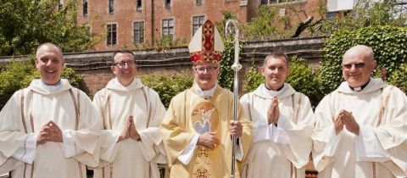**Job Application Pack**

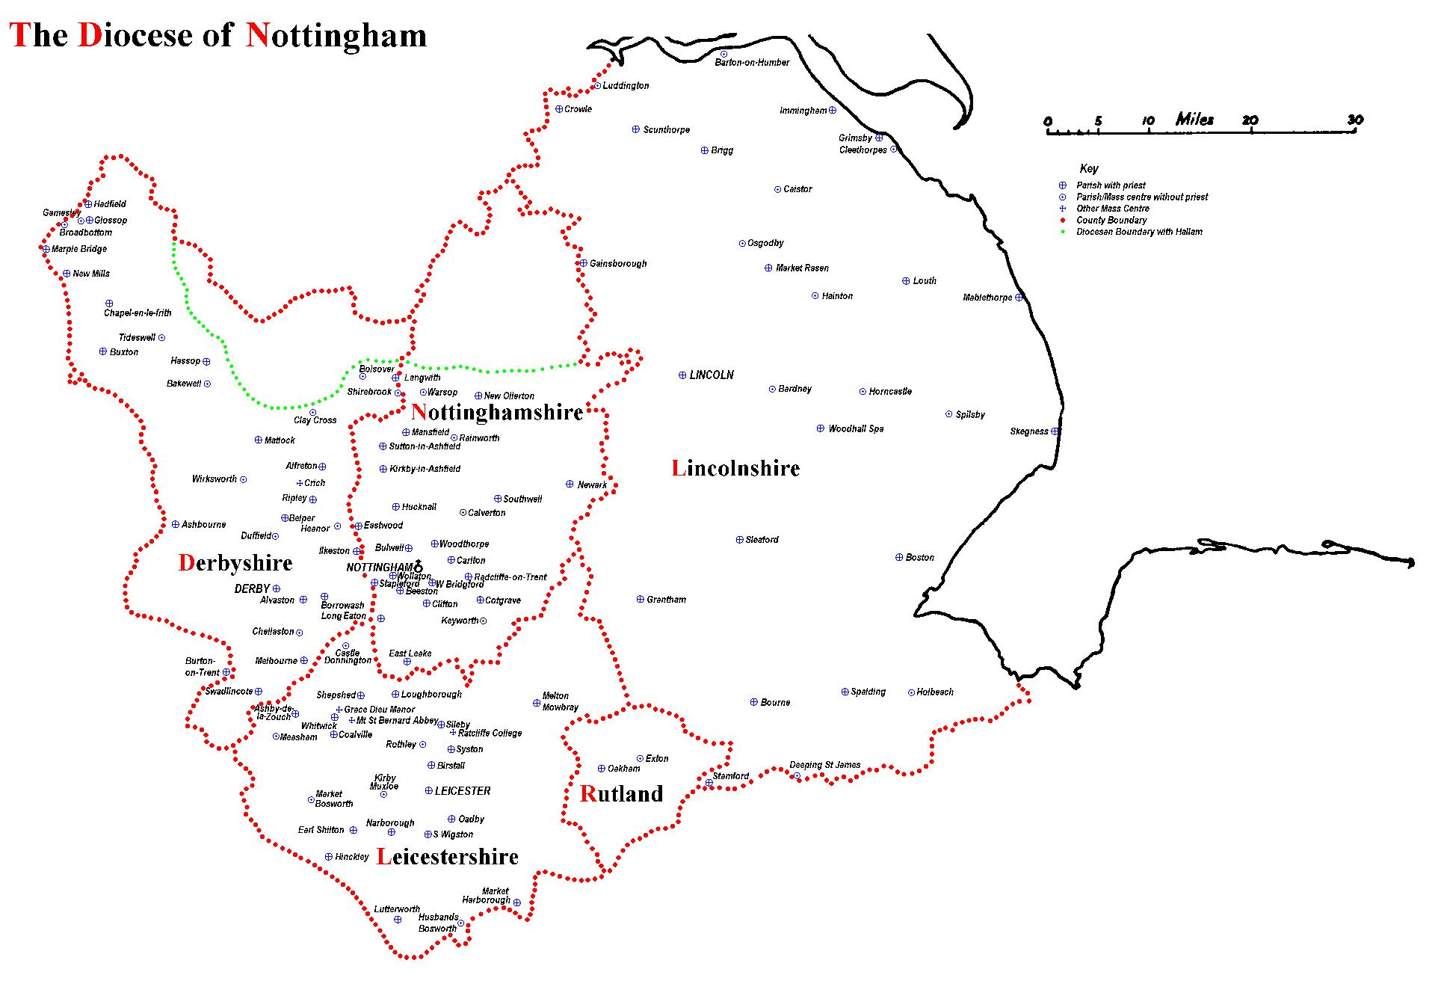

The Diocese of Nottingham covers a large geographical area covering Lincolnshire, Leicestershire, Rutland, most of Derbyshire and Nottinghamshire and parts of Cheshire and Staffordshire, making it the largest in the country. It is varied in its demography as it encompasses one of the most ethnically diverse cities in the country, Leicester, and some of the most rural territory, Lincolnshire, with its villages and market towns. Consequently, the people of the diocese come from all backgrounds imaginable, giving the diocese a rich and varied life.

We are led by Bishop Patrick McKinney and have 122 priests and 57 deacons, including those who are in active ministry, retired, working here or elsewhere. They serve 107 parishes and 87 primary and secondary schools. Over any given weekend, there are approximately 30,000 people attending Mass in the diocese.

Job Description

**Roman Catholic Diocese of Nottingham: Job Description Form**

**Department/Parish:** TheClergy Health & Well-Being Service

**Job title: Clergy Health & Well-Being Assistant**

**Purpose of Service:**  The Diocese of Nottingham places great importance on the care of priests in their active ministry, in illness and in retirement. The Clergy Health and Well-Being Service led by the Co-ordinator, aims to support priests in ministry and those who have retired to maintain their good health and well-being. We do so by:

* Promoting access to Occupational Health checks for those in active ministry and supporting priests with any treatment outcomes from these checks.
* Supporting those in illness to a full recovery and return to ministry or to transition to a fulfilling retirement.
* Where return to ministry is not possible or when retirement is considered, this service supports priests to access appropriate accommodation and services. In doing so we liaise with diocesan property and finance departments.
* Maintaining and enhancing priests’ standard of living and health & well-being throughout their lives.
* Providing a confidential service respecting each priest’s individual needs and referring on to other specialist services as required.
* Supporting Permanent Deacons, particularly those who have limited or no social support.
* Offering bereavement support and an advisory role for clergy spouses, family members, carers and housekeepers.
* Developing and amending policies to support a framework of health and social care for priests throughout their ministry.

**The Health & Well-Being Assistant** will play a key role in supporting the Co-ordinator and the Clergy Health & Well-Being Team to discharge and evolve their operational mission to clergy by:

* Communicating well and appropriately with clergy utilising active listening skills and by having a working understanding of confidentiality and GDPR.
* Communicating to a high standard by telephone, letter, email and other publications.
* Working responsibly and productively in the absence of the Co-ordinator. Supporting clergy to access the support they need by referring on to the Vicars General and others appropriately.
* Assisting the Co-ordinator to evolve online and paper resources and communications for Clergy about their Health & Well-Being.
* Developing appropriate and confidential databases to produce timely data for on-going clergy support and recognition.
* Supporting the Co-ordinator in organising venues and refreshments for meetings, conferences, retired gatherings etc.
* Attending Clergy Health & Well-Being Committee Meetings quarterly, taking minutes and providing these to committee members in a timely manner.
* This is a developmental role, which in time, and following appropriate training, may require in person visits with clergy at their place of residence, to provide a contact point for the service and to assist with relevant form completion. In taking on these responsibilities and for the safeguarding of our clergy, the successful candidate will require DBS checking.

**Line Manager:** TheClergy Health & Well-Being Co-Ordinator

**Based At:** You will be based the Curia offices, Castle Quay, Nottingham. A combination of home and office (hybrid) working may be available – subject to agreement and review. An encrypted laptop and secure e-mail will be provided.

**Hours of Work:**

Following a period of induction, the role will entail working 22.5 hrs over 3 days a week. Annualized hours contract, which will be monitored by a time sheet and monthly review. Out of-hours working may be necessary on occasion when events occur. Time off in lieu will be given.

**Review:** Role and hours to be reviewed after a 6-month probationary period. You must be prepared to undertake training to meet the needs of the service.

**Band & Salary:** Band 3 Circa £15,000 per annum

|  |  |
| --- | --- |
| **Key Responsibilities:** | **Standards expected/**  **How achievement will be measured:** |
| **Confidentiality & relationships:** |  |
| Maintenance of strict confidentiality regarding sensitive data. | No breach of confidentiality |
| Be able to engage regularly with clergy on the telephone or by email in a caring and supportive manner | Observations and being well received by others. |
| Develop and maintain relationships with clergy and carers as well as other departments and stakeholders to ensure effective communication in accordance with their needs | The ability to empathise.  Observations and being well received by others. |
| **Keeping up to date:** |  |
| Undertaking necessary training to enhance your role and the needs of the service | Service needs are met |
| Update changes to policy documents as needed and ensure the updated policy is uploaded to the Diocesan website independently or in liaison with the Communications Department. | Accessibility and consistency of content |
| Ensuring that the Diocesan Website content for the Clergy Health & Well-being Service is up-to-date, accurate, and engaging. | Content and presentation remain accurate and of a high standard. |
| **Planning meetings & events:** |  |
| In consultation with the Co-Ordinator to:  Manage and update the CHWB Team and Committee event calendar. Assisting in the organization and advertising of CHWB Service Events. | The event calendar for the CHWB team and committee is kept up to date with all CHWB team events. |
| **Key Responsibilities:** | **Standards expected/**  **How achievement will be measured:** |
| Book meeting venues and arrange refreshments for conferences e.g., Pre- Retirement Conferences for those in ministry, Retired Priest Gatherings as required, including liaising with attendees.  Provision of hospitality at service meetings. | Meetings, conferences and ‘retired gatherings’ are conducted in a professional and courteous manner, ensuring attendees are welcomed and are provided with the required resources and hospitality. |
| Administration of events; online, via paper documents and in person, including promotion, co-ordination, registration, confirmation, delivery, note-taking, and evaluation. | Events are arranged and advertised to priests. Responses are received and acknowledged as required and chased up as necessary.  Success of events. |
| Create documents, adverts, and booking forms as required for events. | All documents for events follow diocesan publishing guidance are available in a timely manner and contain concise and accurate information in a suitable format. The CHWB Co-Ordinator, team and committee members are liaised with as required.  High standard of content and presentation  Evaluation of take-up |
| **Developmental** |  |
| Assist with developing an internal  e-magazine for priests that can also be printed and posted out to both priests in ministry and the retired. | Standard of content and presentation  Evaluation of take-up |
| Develop appropriate and confidential databases to produce timely data for on-going clergy support and recognition.  Maintain databases of recipients in accordance with data protection law, good practice, and diocesan policies. | Standard of content and presentation.  Integrity of databases |
| Prepare draft copy for publication of content written by the Co-ordinator or Team for lay communication, including reports on service initiatives. | Standard of content and presentation |
| **Key Responsibilities:** | **Standards expected/**  **How achievement will be measured:** |
| **Regular tasks** |  |
| Taking messages and assisting where possible when the CHWB Co-Ordinator is not available. | Messages taken are clear. If urgent and unable to contact the CHWB Co-Ordinator, to take appropriate action and escalate contact to the Vicars General |
| Update the Co-ordinator on a regular basis and highlight any issues promptly to agree course of action. | The Co-ordinator is kept up to date with current workload and is made aware of any issues as they arise. |
| Assist the CHWB Team generally and taking on ad hoc projects as and when required in agreement with the CHWB Co-ordinator and Team | Project support is timely, accurate and responsive to the needs of the team. |
| **Review & progression** |  |
| Participate in a performance appraisal process and undertaking any learning & training identified. | Engagement is positive and collaborative, receptive, cooperative, and responsive. |

**Key Internal Contacts:** Clergy Health & Well-Being Co-Ordinator, Vicars General, Episcopal Vicar for Clergy, Episcopal Vicar for Finance & Administration, Director of Safeguarding, Property Manager, Diocesan Accountant

**Key External Contacts:** **(Re care)** NHS & Private Care Service providers, Care Homes, Nursing Homes, Occupational Health Providers, Healthcare Trust Providers, Social Services, Personal Alarm providers, Religious Communities. **(Re Property)** Estate Agents, Surveyors. **(Re Events)** Parish Administrators re Hall Hire, Conference Venue sites, Caterers.

**Experience and qualifications required for role:**

The post is varied and requires a variety of skills and knowledge, including, an understanding of caring and support with an ability to communicate with empathy. This may have been gained in administration in support of a caring role e.g., health, social work, caring service, local authority. The successful candidate will be a highly organised and flexible individual with excellent written and oral communication skills who is adept in the use of computer databases. Familiarity with the mission of the Catholic Church and a strong desire to support the priests and clergy of our diocese while respecting their confidentiality is a priority.

**Person Specification:**

**Essential:**

* ‘A’ Level, an equivalent qualification or relevant experience.
* Excellent oral and written communications skills with the ability to relate appropriately to a wide range of people.
* Ability to work independently and collaboratively using strong interpersonal skills to engage others.
* Excellent attention to detail - record facts accurately, produce reports & minutes from notes to a high standard.
* Excellent time management and organisational skills.
* Previous administration, office management and diary management experience.
* Working knowledge of Microsoft Office 365 packages.
* Excellent record keeping skills including paper and electronic filing.
* Ability to work with minimal supervision while understanding own limitations and referring to colleagues as appropriate.
* There is a genuine occupational requirement for the post holder to have a robust understanding of the Catholic faith.
* Subject to DBS check
* Clean valid driving Licence and access to a car.

**Desirable:**

* Experience of and training in ‘active listening’ and communication skills
* Relevant work experience in administration in a public service or local government charity or NHS environment.
* Experience of working collaboratively.
* Experience of organising events.
* Working knowledge of GDPR guidelines.
* Working knowledge of Safeguarding regulations.
* Very occasional evening or weekend working**.**