**Diocese of Nottingham**

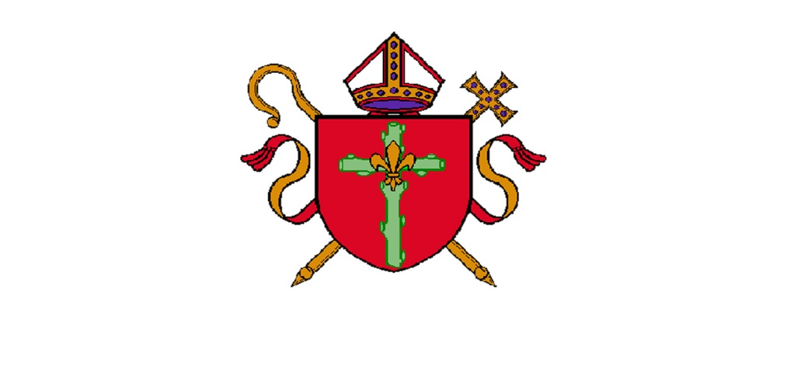

**Deanery Administration Manager**

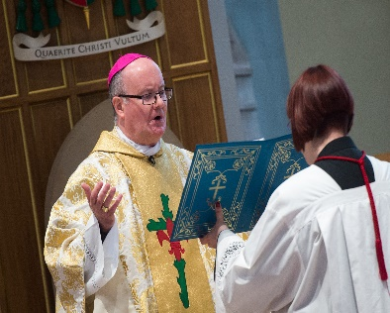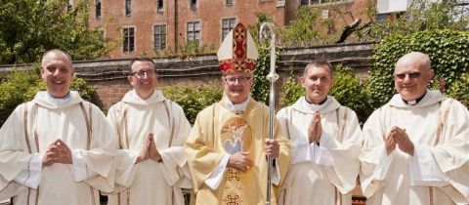**Job Application Pack**

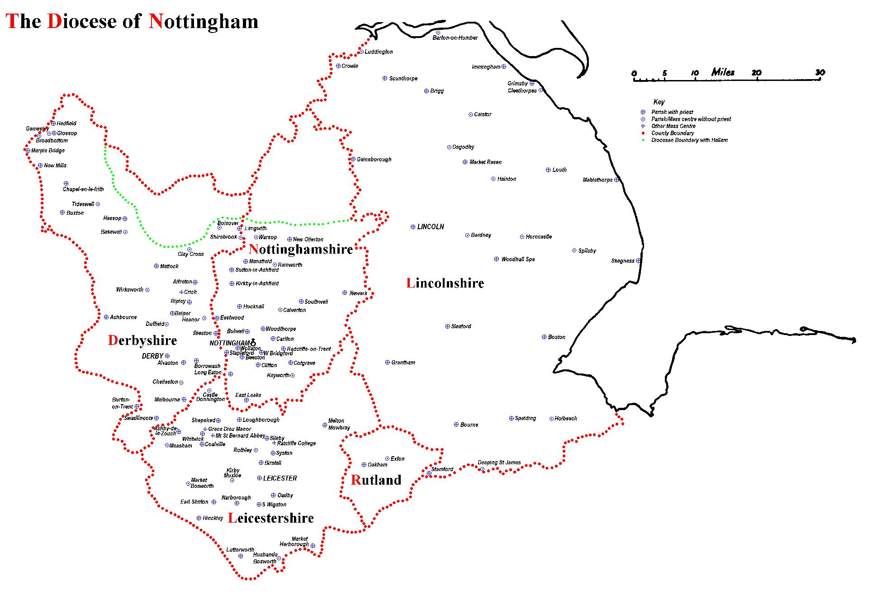

The Diocese of Nottingham covers a large geographical area covering Lincolnshire, Leicestershire, Rutland, most of Derbyshire and Nottinghamshire and parts of Cheshire and Staffordshire, making it the largest in the country. It is varied in its demography as it encompasses one of the most ethnically diverse cities in the country, Leicester, and some of the most rural territory, Lincolnshire, with its villages and market towns. Consequently, the people of the diocese come from all backgrounds imaginable, giving the diocese a rich and varied life.

We are led by Bishop Patrick McKinney and have 122 priests and 57 deacons, including those who are in active ministry, retired, working here or elsewhere. They serve 107 parishes and 87 primary and secondary schools. Over any given weekend, there are approximately 30,000 people attending Mass in the diocese.

Job Description

**Roman Catholic Diocese of Nottingham:**

**Department/parish:** North Lincolnshire Deanery Service Hub

**Job title:** Deanery Administration Manager

**Date of appointment:** Tba

**Purpose of role:** The Deanery Administration Manager is responsible for leading, managing, actioning and overseeing the daily administrative operations of collective parishes within a designated geographical area. This role ensures the delivery of efficient, effective, and professional administrative support to clergy and parishes, aligning with governance, compliance, and legal requirements.

The role requires an individual who is a strong leader, adept in operational and financial management, and committed to improving administrative services within the Deanery. The manager will work closely with clergy, parish administrators, and the central curia team to advise, enhance processes, streamline workflows, and foster a positive working environment across multiple locations. The role also includes defining, tracking, and reporting on Key Performance Indicators (KPIs), aligning operational objectives with the Diocesan Pastoral Plan.

**Based**: The role is office based within the LN7 area, with regular travel required to other parish locations in the North Lincolnshire Deanery.

**Hours of work:** 37.5 hours per week, with flexibility required, including some evening and weekend commitments.

**Salary:** Circa £34k depending on experience

**Line Manager:** Dean of North Lincolnshire Deanery

| **Main Responsibilities** |
| --- |
| **Leadership & Management**   * Lead, coordinate, and have oversight of a team of parish administrators. * Distribute tasks effectively, ensuring an equitable workload across the team. * Provide clear direction, motivation, and professional development opportunities. * Foster a culture of continuous improvement and excellence in service delivery. * Set and review KPIs for team members in line with deanery objectives. |
| **Administrative Operations**   * Support the daily operations of the administrative hub, working collaboratively, ensuring consistency across multiple parish locations and, ensuring regular deadlines are met. * Implement improvements that increase efficiency and streamline workflows. * Ensure activities comply with diocesan policies and legal requirements. * Manage crisis and risk scenarios effectively. |
| **Stakeholder Engagement & Communication**   * Build and maintain effective relationships with clergy, curia staff, and external agencies. * Share and implement best practices across the deanery. * Ensure timely communication and collaboration. * Integrate feedback to improve service and relationships. |
| **Financial Oversight**   * Monitor budgets and financial processes to ensure administrative activities remain within budgetary constraints. * Ensure diocesan financial compliance & deadlines * Liaise with the central curia team to align financial and operational objectives. |
| **Strategic Development**   * Contribute to the delivery of the Bishop’s Diocesan Pastoral Plan, aligning administrative work with the wider diocesan strategy. * Identify areas for improvement within administrative functions and implement sustainable solutions. * Drive innovation in digital and technology-based administrative processes. * Support the Diocese in implementing new policies and procedures to enhance service delivery. |
| Participate in performance appraisal process and undertake any learning & training identified |

Specific duties and responsibilities may vary from time to time. This will not change the general character of the duties and responsibilities of the role.

**Key Requirements:**

**Essential:**

* Proven experience in team leadership and line management.
* Strong financial acumen, including budgeting and cost management.
* Excellent organisational skills with the ability to manage multiple priorities.
* Effective problem-solving, negotiation, and conflict-resolution skills.
* Ability to develop and implement efficient administrative processes.
* Strong interpersonal skills and ability to engage with clergy and parish teams.
* High proficiency in Microsoft Office Suite and other digital administrative tools.
* Ability to work independently and collaboratively within a structured environment.
* Commitment to maintaining confidentiality and data protection standards.
* Full UK driving license and access to a vehicle for travel.

**Desirable:**

* Degree or professional qualification in business administration, management, or a related field.
* Experience working in or with a faith-based organisation.
* Understanding of the Catholic Church’s structures and governance.
* Experience in digital transformation of administrative processes.

**Additional Information:**

Ability to work flexibly, including occasional evenings and weekends / Commitment to professional and personal development / Adherence to the ethos and values of the Catholic Church

While there is no occupational requirement for the post-holder to be Catholic, an understanding of and commitment to the ethos of the Catholic Church is essential.