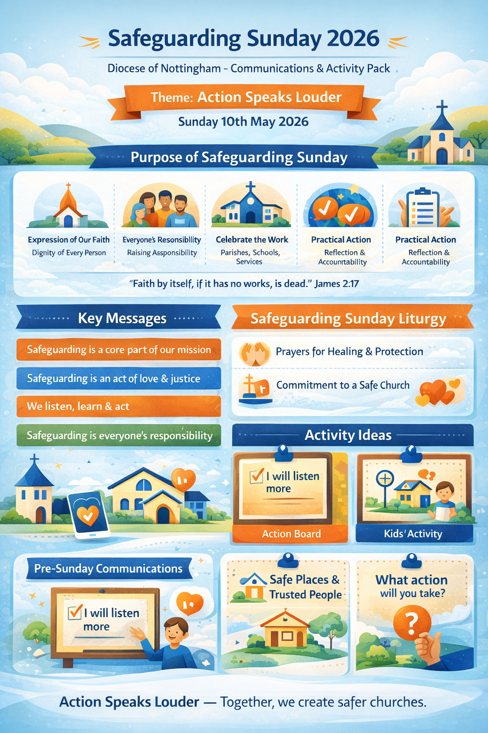
Safeguarding Sunday 2026
Diocese of Nottingham – Communications & Activity Pack
Theme (national): Action Speaks Louder – Safeguarding Sunday takes place nationally on Sunday 10th May 2026, though parishes may choose an alternative date that fits their liturgical calendar.

1. Purpose of Safeguarding Sunday
Safeguarding Sunday is an opportunity to:
- Affirm that safeguarding is an expression of our Catholic faith and commitment to the dignity of every person
- Raise awareness that safeguarding is everyone’s responsibility, not just designated roles
- Celebrate the work already being done in parishes and diocesan services
- Encourage practical action, reflection and accountability
“Faith by itself, if it has no works, is dead.” (James 2:17)

2. Key Messages (for consistent use)
Use or adapt the following messages across all communications:
- Safeguarding is a core part of our mission as Church
- Safeguarding is an act of love, justice and protection
- We are committed to listening, learning and acting
- Safeguarding is everyone’s responsibility
- Support is available, and concerns are taken seriously

3. Pre-Sunday Communications (2–3 weeks before)
Parish Newsletter / Website (short notice)
Safeguarding Sunday – 10th May 2026
This year our parish will mark Safeguarding Sunday, a national awareness day supported by the Diocese of Nottingham. The theme, Action Speaks Louder, reminds us that safeguarding is not just about policies, but about how we act to protect and respect one another.
During Mass we will reflect on our shared responsibility to create a safe and welcoming Church for all, especially children and adults at risk. Please keep this important intention in your prayers.
Social Media Post (suggested)
This May we mark #SafeguardingSunday2026.
Safeguarding is not just something we talk about – it’s something we live out.
Action Speaks Louder. #CreatingSaferChurch
Poster Notice (church porch / hall)
- “Safeguarding Sunday 2026
- “Safeguarding is everyone’s responsibility”
- Include parish safeguarding contact details

4. Safeguarding Sunday – Liturgy & Worship
Introduction at Mass (short)
Today we mark Safeguarding Sunday. We give thanks for those who work to keep others safe in our parish and diocese, and we recommit ourselves to creating a Church where every person is treated with dignity, respect and care.
Universal Prayer (example)
- For the Church, that our commitment to safeguarding may be lived out through our actions and choices, not only our words. Lord, hear us.
- For children, adults at risk and all who have been harmed, that they may experience healing, justice and compassionate support. Lord, hear us.
- For parish safeguarding representatives and volunteers, that they may be strengthened in wisdom, courage and perseverance. Lord, hear us.

5. Activity Ideas (Practical & Inclusive)
A. “Action We Will Take” Board
- Set up a simple display board
- Invite parishioners to write one action they can take to make the parish safer (e.g. listening better, being welcoming, speaking up)
- Display responses during the week
B. Children & Young People’s Activity
- Theme: “Safe places and trusted people”
- Invite children to draw or name:
  - Places where they feel safe
  - Adults they trust
- Reinforce the message that it is always okay to tell a trusted adult
C. Parish Reflection Moment (5 minutes)
During or after Mass, invite a brief pause:
- One sentence shared by the priest or safeguarding representative on what safeguarding looks like in everyday parish life
- Quiet reflection: “What is one action I can take?”

6. After Safeguarding Sunday: Continuing the Action
Safeguarding Sunday should be a starting point, not a one-off. Consider:
- Highlighting safeguarding contacts regularly in newsletters
- Offering volunteer safeguarding refresher sessions
- Reviewing how safeguarding information is displayed in church buildings
- Sharing diocesan safeguarding updates with parish councils

7. Diocesan Context (Localising the Message)
Parishes are encouraged to:
- Refer to the Diocese of Nottingham safeguarding structures
- Publicise parish and diocesan safeguarding contact details
- Reinforce that concerns can be raised safely, respectfully and confidentially
(Insert parish-specific and diocesan safeguarding contact details here.)

8. Closing Message for Parish Use
Safeguarding is not an added extra to our faith – it flows from it. When we protect others, listen well, challenge harm and act with courage, we live out the Gospel in practical ways.
Action speaks louder – together, we create safer churches.

