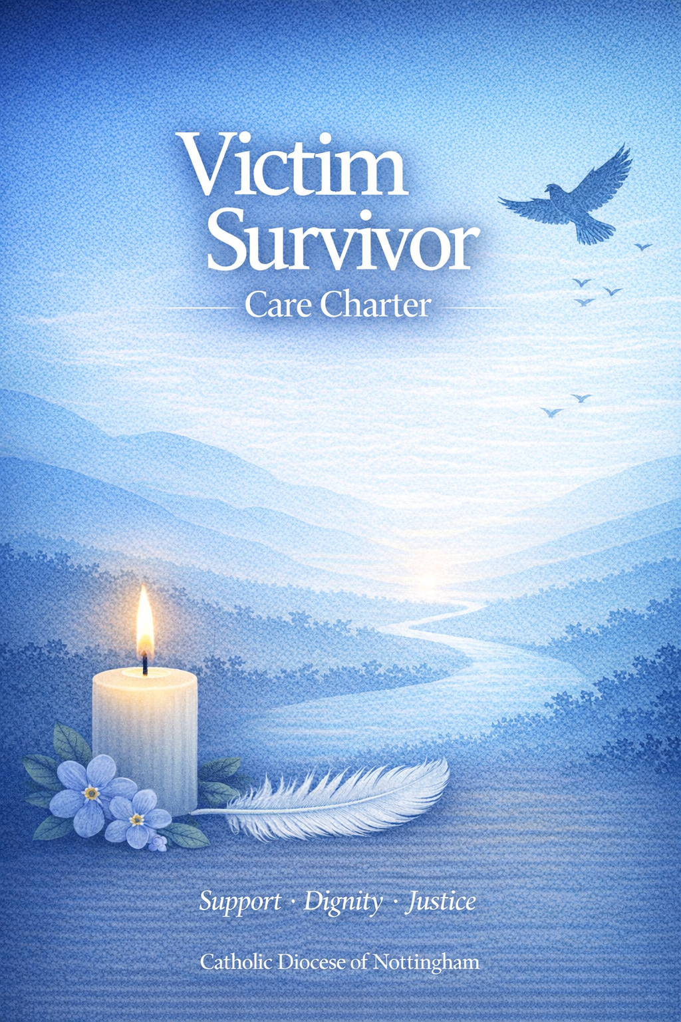

Index Page

1. Introduction
2. Communication and Transparency
3. Support Person
4. What the Support Person is Not
5. Safe Spaces Referral and Support
6. Spiritual and Pastoral Support
7. Disclosures
8. Managing Online Disclosures
9. Responding to Concerns or Allegations Involving 5-6 Children or Young People
10. Mental Capacity
11. Aligning with Criminal Justice Processes
12. Building Relationships with Other Services
13. Feeding Back on How We Do Things
14. Apology

1. Introduction
The Diocese of Nottingham is committed to fostering a compassionate, transparent, and safe culture that encourages disclosures and supports victims and survivors of abuse. Safeguarding is not only about following policies and procedures, but about how these are lived out in practice and how people are treated with dignity, respect, and care.
We recognise that disclosing abuse—whether recent or non-recent—is extremely difficult and can take immense courage. We are committed to responding thoughtfully, sensitively, and without judgement, putting the needs of victims and survivors at the centre of all safeguarding activity.
All reasonable efforts will be made to ensure that support is offered confidentially, promptly, and effectively. When a disclosure of abuse is reported to the Safeguarding team, we aim to respond within 24 hrs (not including weekends) to any initial reporting and arrange a personal visit within 5 working days. Support will always be focused on the best interests and welfare of children and adults and delivered in a way that respects individual dignity, privacy, safety, and autonomy. We commit to addressing, wherever possible, specific needs relating to race, culture, age, language, religion or belief, gender, sexual orientation, disability, and care or support needs.
The Bishop, Trustees, clergy, employees, and volunteers of the Diocese share responsibility for creating and maintaining safe church communities and preventing abuse through healthy cultures. These environments are also essential to ensuring compassionate responses to abuse, including high-quality care and support for victims and survivors. Everyone serving the Diocese must be adequately trained to recognise disclosures, respond appropriately, and demonstrate empathy and understanding.

2. Communication and Transparency
We will provide clear, accessible, and consistent information about:
- How victims and survivors can report abuse within the Church
- The support available following a disclosure
- What processes will be followed if abuse or risk of abuse is disclosed
- How personal information will be used and shared
- When and how statutory services may be involved
- How victims and survivors can contact statutory services directly
- National and local support services for victims and survivors
- The Safe Spaces service for those affected by Church-related abuse
Information will be shared through multiple channels across the Diocese, including parishes and community spaces. Safeguarding information must be understandable,

welcoming, and clearly convey that victims and survivors will be believed, listened to, and supported.
Victims and survivors must be able to access safeguarding information without needing to identify themselves. The Diocese and parishes will support this by:
- Displaying safeguarding posters and leaflets in visible and accessible locations
- Including safeguarding information in newsletters, notices, and parish communications
- Ensuring information is inclusive, accessible, and available in relevant languages
- Providing easy-read materials for people with learning disabilities
- Maintaining a dedicated safeguarding section on diocesan and parish websites
- Including messages about listening to disclosures in sermons and public worship
- Observing an annual Safeguarding Sunday
- Consulting victims and survivors on how safeguarding information is presented and shared

3. Support Person
Following a disclosure, the Diocese will offer victims and survivors a Support Person, where appropriate.
The Support Person is independent of safeguarding investigations and provides emotional, pastoral, and practical support. Their role is to listen, offer compassion, and help victims and survivors feel supported and connected, if they so wish.
The role of the Support Person will be agreed on a case-by-case basis and may include:
- Providing emotional support and a consistent, trusted point of contact
- Listening without judgement and acknowledging the impact of abuse
- Offering pastoral or spiritual support, if desired by the victim or survivor
- Explaining support options and helping individuals make informed choices
- Facilitating communication between the victim or survivor and the Diocese
- Accompanying victims or survivors to meetings with statutory agencies, where appropriate
- Supporting reflection on longer-term wellbeing, spiritual, and practical needs
- Signposting to Safe Spaces and other specialist services
- Supporting confidence-building and reconnection with community life if wanted

4. What the Support Person Role Is Not
The Support Person is not a confidant in the sense of holding information that could place others at risk. They must act responsibly and share information with appropriate authorities where necessary, including:
- When there is risk of harm to the victim or others
- When there is a disclosure of intent to self-harm
- When safeguarding information must be shared with statutory services or the police
The Support Person does not investigate allegations, determine outcomes, or influence safeguarding or disciplinary processes.

5. Safe Spaces Referral and Support
The Diocese works with Safe Spaces, an independent, confidential support service for adults (18+) who have experienced abuse connected with the Catholic Church.
Safe Spaces is delivered nationally by First Light, offering remote support via helpline, live chat, and online services. Support is tailored to individual needs and provided for as long as required. This may include emotional support, advocacy, information about Church and criminal justice processes, and help developing a personal support plan.
Where face-to-face support is needed, referrals will be made to appropriate local services.
Referrals can be made by the Director of Safeguarding with consent, or individuals may self-refer.

6. Spiritual and Pastoral Support
Spiritual and pastoral support can be an important part of recovery for some victims and survivors. Such support will always be offered sensitively and never imposed.
Support pathways include the completion of a Support and Safety plan which will include:
- Therapeutic support coordinated by the Director of Safeguarding
- Support Person arrangements facilitated and overseen by the Director of Safeguarding
- Spiritual and pastoral support organised in accordance with individual wishes
- Safe Spaces and other independent services
All support is available to people who disclose Church-based abuse.

7. Disclosures
Disclosures will be listened to in a safe, respectful environment, chosen as far as possible by the victim or survivor. Privacy will be protected, and interruptions avoided.
An accurate record of the disclosure will be made, explained to the individual, and stored securely. Next steps will be clearly outlined.
The Diocese where the reported abuse has taken place, has the responsibility for coordinating support, regardless of where the victim or survivor now lives.
Where allegations involve religious orders, multiple dioceses, or external bodies, coordination will take place to ensure seamless and timely support.
Written consent will always be obtained before arranging support or sharing information, and consent may be withdrawn at any time.
If support is initially declined, the option will be revisited periodically as agreed in the individual’s safety and support plan, unless the victim or survivor requests no further contact. The victim or survivor is welcome to make contact at any time.
All responses to disclosures will be survivor-centred and trauma-informed.

8. Managing Online Disclosures
Disclosures made via email, social media, or other digital platforms will be handled with care and confidentiality. Victims and survivors will be contacted to discuss how they wish to continue communication. Their preferences will be respected wherever possible.

9. Responding to Concerns Involving Children and Young People
If a child or young person discloses abuse, we will:
- Listen carefully and take them seriously
- Allow them to speak freely and at their own pace
- Ask only clarifying questions
- Reassure them they have done the right thing
- Explain what will happen next
- Never promise confidentiality
Statutory services will be involved as required. Consent and capacity for young people aged 16–17 will be assessed on a case-by-case basis.

10. Mental Capacity of an Adult
Where there are concerns about mental capacity, advice will be sought from adult safeguarding professionals. Capacity is always presumed unless assessed otherwise, and every effort will be made to support individuals to make their own decisions.

11. Aligning with Criminal Justice Processes
Support will align with investigations while ensuring that therapeutic care is not unnecessarily delayed. We follow national guidance that therapy should not be postponed due to criminal proceedings.

12. Building Relationships with Other Services
The Diocese will work with statutory and voluntary agencies, including ISVAs, IDVAs, SARC services, Victim Support, and specialist counselling providers, to ensure coordinated and effective support.

13. Feedback and Continuous Improvement
We welcome honest feedback and learning. Survivors may provide feedback directly to the Safeguarding Team or through our confidential messaging service on the Diocese of Nottingham website safeguarding page.
Learning reviews will follow significant cases, and feedback will inform service improvement. Reviews of feedback will occur at least every six months.

14. Apology
The Diocese of Nottingham offers its sincere apology to anyone who has experienced abuse through the Church where:
- A criminal conviction has been made
- Abuse has been established through civil or canonical processes
- Failures in response or investigation are identified
We are committed to ongoing improvement in safeguarding practice and survivor care.
This Charter will be reviewed annually or following external audit or review.

Date first approved by Trustees September 2022
First Review Date February 2024
Second Review Date February 2025
Third Review Date April 2026
Next review date April 2027
Author Rachael Campion

