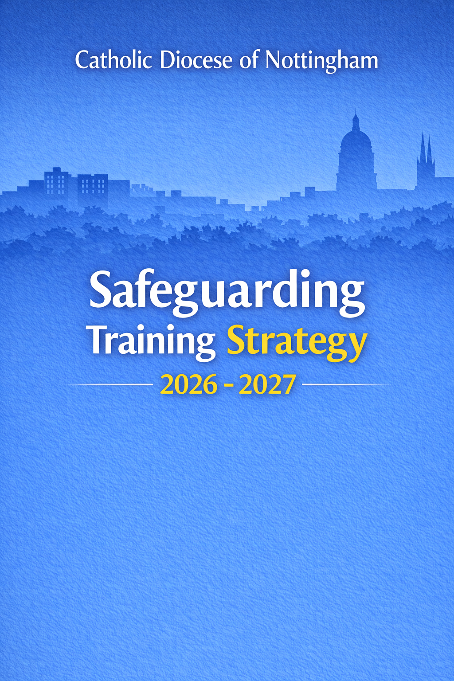
Index
- Content
- Training Arrangements
- Mandatory Minimum Requirements
- Evaluation and Review
- Current Courses
- Safeguarding Training Matrix

- Content
Safeguarding training is focused on building healthy Church communities with a strong culture of safety, accountability and care, in which the wellbeing of every person is actively protected and promoted. Training modules align with national safeguarding standards across all dioceses and reflect current best practice in preventing abuse, recognising risk, and responding appropriately and compassionately to victims and survivors of abuse within a Church context. Training emphasises the importance of close cooperation with the Diocesan Safeguarding Team and timely engagement with statutory agencies in all safeguarding matters.
Safeguarding training for all Church roles includes safer working practices that reinforce the importance of clear professional and pastoral boundaries, transparency and appropriate conduct. A culture of respectful vigilance is promoted, in which concerns are raised and challenged constructively, and safeguarding is understood as a shared responsibility rather than the sole remit of designated roles.
While safeguarding was previously understood primarily in terms of child protection, it is now recognised as having a much broader scope. It encompasses safeguarding children and young people, as well as adults who may be at risk due to disability, ill health, age, social isolation, trauma, or other personal or situational factors. Within a Church context, vulnerability may also arise from pastoral or institutional power imbalances, including relationships of trust between clergy, ministers and those in their care.
The Church is a place of welcome for all, including those who may present a level of risk. In many circumstances, Clergy, employees and volunteers may be unaware of such risks. The Church therefore faces the ongoing challenge of balancing hospitality with responsibility, ensuring safe environments for all who participate in Church life—particularly children, young people and adults at risk—while maintaining dignity, fairness and compassion for everyone.

- Training Arrangements
Safeguarding training must be delivered by experienced and appropriately qualified trainers with a strong understanding of statutory safeguarding requirements for children and adults, and with the ability to apply these requirements effectively within a Catholic Church context.
Nationally developed safeguarding modules will be delivered by the Diocese using a blended learning approach. This will include in-person training, virtual webinars and online learning accessed through the diocesan learning portal. In-person sessions will normally accommodate up to 50 participants. Webinars will be limited to smaller groups, typically up to 20 participants, to support effective engagement and discussion.
Diocesan safeguarding training will be grounded in the practical realities of parish and diocesan life. Core training will focus on safeguarding children and adults, safer working practices, risk assessment and the creation of safer Church environments. Specialist safeguarding training will also be offered in response to identified needs and emerging safeguarding themes. Final participant numbers for any session will be determined by venue capacity and the availability of appropriate resources.
Training sessions will provide opportunities for participants to reflect with trainers and peers on the complex and sensitive safeguarding challenges encountered in Church settings. It is recognised that some participants may have lived experience of abuse or trauma. Training will therefore be delivered in a trauma-informed manner, with clear ground rules, appropriate support arrangements, and provision for any participant who becomes distressed during a session.
Safeguarding learning is most effective when integrated into personal values, behaviour and Church culture. Participants will therefore be encouraged to reflect on the relationship between safeguarding practice and faith, including theological understanding, pastoral responsibility and discipleship.
The lead trainer for safeguarding sessions must have experience across a broad range of safeguarding matters and be a trained and competent facilitator. As good practice, safeguarding training will normally be delivered by two trainers. This supports variation in pace and approach and ensures appropriate support for participants and trainers, recognising the emotionally demanding nature of safeguarding work.

- Mandatory Minimum Requirements
The Bishop and Trustees of the Diocese of Nottingham have established mandatory minimum safeguarding training requirements for all clergy, employees and volunteers. These apply to anyone appointed by, or acting on behalf of, the Church in any role, whether ordained or lay, paid or unpaid.
Core Safeguarding Training is required for:
- All clergy exercising ministry within the Diocese, including deacons, newly ordained priests, and members of religious orders appointed to parish roles
- Those in senior leadership or management positions within the diocesan curia
- Children’s and youth workers, whether employed or volunteering within diocesan or parish settings
- Parish Safeguarding Representatives
- Any other individual whose Church role involves significant contact with children, young people, or adults who may be at risk of abuse or exploitation, or where a DBS check is required to undertake duties for the Diocese or a parish
A Bishop will not issue a celebret card unless satisfied that the individual has completed appropriate safeguarding training in relation to children and adults at risk.
This requirement is consistent with national statutory guidance, including Working Together to Safeguard Children, which states that all staff and volunteers must receive mandatory safeguarding induction training, including clear information on safeguarding responsibilities and procedures to follow where concerns arise.
Safeguarding training is a high priority within the Diocese of Nottingham. All employees and volunteers are expected to complete mandatory safeguarding training and to understand their personal responsibility in contributing to a safe Church environment. Individuals who fail to attend required safeguarding training within their three months of due date may be unable to continue in their role until training requirements have been met.
For new clergy, employees and volunteers, safeguarding training forms a core part of role induction and must be completed before duties commence.

- Evaluation and Review
The Diocesan Safeguarding Office will maintain a central record of safeguarding training attendance and completion. Reminder notifications will be issued to individuals who have not met minimum training requirements, to support timely compliance.
The safeguarding training strategy will be subject to routine evaluation and will be formally reviewed on an annual basis. Reviews will take account of:
- Changes in legislation and statutory guidance
- National Catholic safeguarding standards
- Emerging diocesan priorities
- Feedback from participants and trainers
Where necessary, the strategy will be updated to ensure it remains effective, relevant and responsive to developing safeguarding expectations.
In line with the agreed approach of the Diocese of Nottingham, increased safeguarding training requirements will be supported by appropriate investment in diocesan resources. Safeguarding training will continue to evolve in response to cultural change within the Catholic Church and will be fully integrated into ministerial and parish life. Parishes and diocesan departments are expected to work collaboratively with the Diocese to ensure that appropriate safeguarding training is delivered to all those who require it.

- Current Courses
The annual safeguarding training programme is set by the Director of Safeguarding, in consultation with the Trustees’ Safeguarding Subcommittee and the Diocesan Bishop.
Safeguarding training is delivered through a blended approach, combining national and diocesan safeguarding training.
Training may be delivered in person or virtually by the diocesan safeguarding team or a commissioned professional, at accessible venues across the Diocese or online.
The following table lists courses available as part of the Diocesan Safeguarding Training Strategy for 2026–2027, reflecting the needs of different role groups. It is anticipated that during the timeframe of this Training Strategy a new national safeguarding training framework may be implemented and changes could be made to reflect those requirements.

- Safeguarding Training Matrix
Role / Responsibility | Required Training | Delivery Method | Frequency / Renewal | Notes
All Clergy exercising ministry  Required | National Core Safeguarding Training (Children and Adults at Risk) | Diocesan (in-person or virtual) | On appointment and every 2 years | Completion required before ministry commences; required for issue or renewal of celebret
Required | Clergy safeguarding induction training | Diocesan in person or virtual | Within 4 weeks of ministry in the Diocese | Initial Induction
Bishops  Required | National Core Safeguarding Training | Diocesan / National | On appointment and refreshed as required | Reflects episcopal safeguarding accountability
Diocesan Trustees  Required | Trustee Safeguarding Training | Diocesan / National | On appointment and every 3 years | Focus on governance, oversight and assurance
Senior leaders / managers (diocesan)  Required | Core Safeguarding Training | Diocesan / National | On appointment and every 2 years | Includes leadership responsibilities
Diocesan central services staff  Required | Level 3 core safeguarding training | National/Online or Diocesan | On appointment/Every 3 years | To understand and support parishes

All DBS required roles  Required | Level 3 Core Safeguarding Training - online | National | On appointment and every 3 years | Must be completed before role begins
Parish Safeguarding Representatives (PSRs)  Required | Level 3 Core Safeguarding Training and Role-Specific PSR Training | On line/ Diocesan | On appointment and every 3 years (or as updated) | Role-specific updates may be required
Required | PSR induction training | Diocese/virtual | On appointment
All Clergy, PSR’s  Recommended | Managing sex offenders in church communities | Diocesan/Virtual | Not mandatory | Not mandatory
All volunteer roles  Required | Issued with Safeguarding pocket guide | On appointment/ recruitment | On appointment | Updates with any national changes
DBS volunteer roles – additional learning needs | Safeguarding training – additional learning needs version | Diocese | On appointment/3 years
Safeguarding Team staff  Required | Advanced Safeguarding Training (Children and Adults)  Professional development training. | Diocesan / Specialist provider | Ongoing / as required

Diocesan safeguarding training will be advertised on the diocesan website and bookings managed through the Eventbrite system. National online safeguarding training is accessed via the designated learning portal.
Diocesan courses will normally require a minimum of 12 participants.
All clergy, staff and volunteers will be informed of training opportunities through email communication, the diocesan website, safeguarding newsletters and appropriate Bishop’s House publications.

