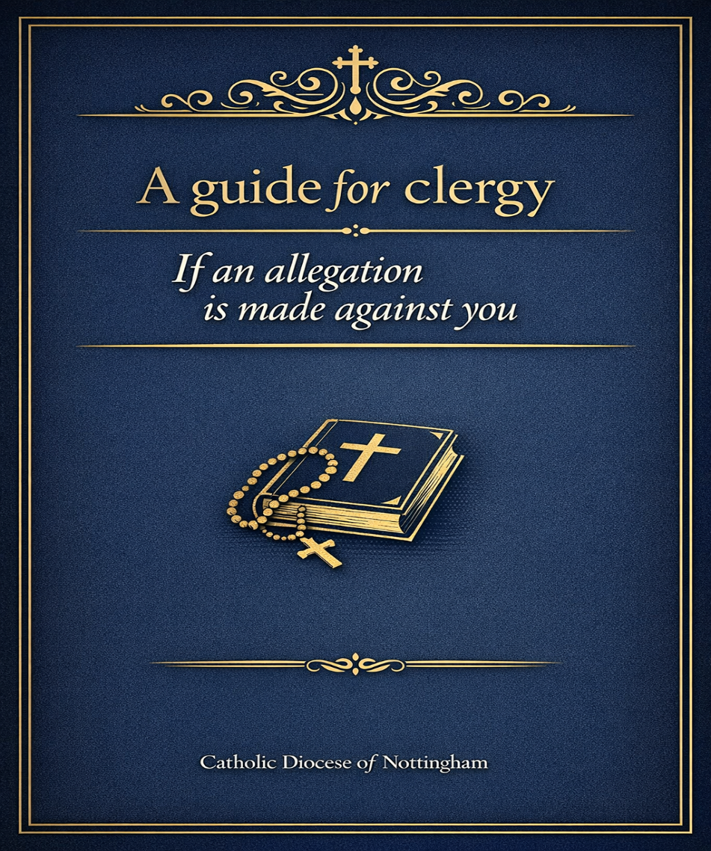

Introduction
If you have been the subject of a safeguarding concern or allegation, this information has been produced to help you understand the process by which enquiries and investigations are managed in response to safeguarding concerns.
The procedures described apply where concerns have been expressed or allegations have been made about a member of the clergy suggesting that they have:
- Behaved in a way which has harmed, or may have harmed, a child or an adult at risk; and/or
- Possibly committed a criminal offence against, or related to, a child or an adult at risk; and/or
- Behaved in a way which indicates that they may pose a risk of harm to children or adults.
The allegations or concerns may relate to the person’s behaviour in the Church, at home, or in another setting.
The Diocesan Safeguarding Policies and Procedures are used to ensure that appropriate safeguards are put in place for:
- The person making the allegation;
- Others who may be at risk; and
- You.
The full Diocesan Safeguarding Policies and Procedures can be found at: www.dioceseofnottingham.org.uk/departments/safeguarding

Involvement of Other Agencies
When an allegation of current abuse, or abuse that occurred in the past, is reported to the Diocesan Director of Safeguarding , the matter will be referred to the statutory authorities, for example:
- The police; and
- Local authority safeguarding and social care services.
All allegations of abuse against children, whether current or historic, will always be reported to the statutory authorities.

Strategy Meetings and Initial Enquiries
A Response Group meeting will be convened, which is the Internal strategy meeting within the Diocese to discuss the information about the case and any actions, including which other agencies are involved with the case. During this meeting a Link Person (Clergy)will be allocated to support you through the process. A role description of Link Person will be given to you to help you understand how they will support you.
Usually, a strategy meeting will be convened by external bodies involving:
- The Local Authority Designated Officer (LADO);
- The police;
- The Diocesan Director of Safeguarding; and
- Any other relevant parties.
The strategy meeting determines:
- Whether enquiries should take place;
- What form the enquiries should take; and
- Which agency is responsible for each action.
The strategy meeting will:
- Plan the enquiries;
- Allocate tasks; and
- Other actions, such as disciplinary processes or referral to the Disclosure and Barring Service (DBS).
Statutory agencies will provide advice to the Director of Safeguarding on the management of risk, including advice on whether it is appropriate for you to continue in your role.

Management of Allegations Process
The Diocesan Director of Safeguarding will continue to liaise closely with the statutory authorities as enquiries and/or investigations progress and will report to the Response Group and the Diocesan Safeguarding Subcommittee.
Ensuing action may include:
- A police investigation of a possible criminal offence;
- Enquiries and assessment by local authority children’s or adults’ social services; and/or
- Other actions, such as disciplinary processes or referral to the Disclosure and Barring Service (DBS).

Temporary Removal from Active Ministry
Temporary removal from active ministry will always be considered when an allegation is made. Any decision will be informed by:
- Advice from the statutory authorities; and
- Recommendations from the Diocesan Safeguarding Subcommittee.
During this time, you must not attempt to communicate with the individual who has made the allegation. Such contact could be experienced or perceived as an attempt to influence or intimidate the person and may compromise enquiries.

Outcomes of Statutory Authority Enquiries and Investigations
The outcome of enquiries and investigations may determine that allegations are:
- Substantiated – sufficient identifiable evidence exists to prove the allegation;
- Malicious – sufficient evidence exists to disprove the allegation and there has been a deliberate act to deceive;
- Unproven – sufficient evidence exists to disprove the allegation, but there is no evidence of deliberate intent to deceive; or
- Unsubstantiated – insufficient evidence exists to either prove or disprove the allegation. This does not imply guilt or innocence.
A referral to the Disclosure and Barring Service (DBS) will be considered unless the allegations have been disproved.

Internal Church Processes
Even where statutory authorities decide to take no further action, internal Church processes may still be required if concerns remain.
An independent investigation or independent risk assessment may be commissioned. This will be arranged by the Director of Safeguarding on behalf of the Bishop.
Further information can be found in the Managing Allegations and Concerns practice guidance relating to:
- Commissioning Independent Investigations; and
- Independent risk Assessments.
If you have been convicted of an offence against a child or adult at risk, or where there is no conviction, but safeguarding concerns remain, you may be supported to participate in Church life using a Safeguarding Plan. Further guidance is available in the practice guidance relating to Safeguarding Plans.

Risk Assessment and Decision Making
You should always be provided with a copy of any risk assessment report.
The Director of Safeguarding and the Diocesan Safeguarding Subcommittee will use the assessment to evaluate risk and make recommendations to the Bishop or Religious Leader.
Decisions are made by the Bishop.
If you are not satisfied with the recommendations being proposed, you may request a review of the process and recommendations before a final decision is made.

Record Keeping and Information Sharing
The Director of Safeguarding will open a confidential case file and record all relevant information. Records are:
- Kept securely and confidentially.
- Shared only with those who need to know; and
- Retained in accordance with the national Safeguarding Record Retention Schedule (unless the diocese or religious congregation has its own schedule).
Further information can be found in:
- The Safeguarding Record Retention Schedule.

Decisions about what information can be shared, and when, will be informed by advice from the police and the Local Authority Designated Officer. It may not be possible to share details of the allegation, or the identity of the person who made it, until permission is given by the police. This is to avoid adversely affecting any investigation.

Provision of Support
Where it is necessary for a member of the clergy or a religious congregation to vacate their normal place of residence, the Diocese will assist in identifying alternative accommodation, subject to the approval of the Bishop.

