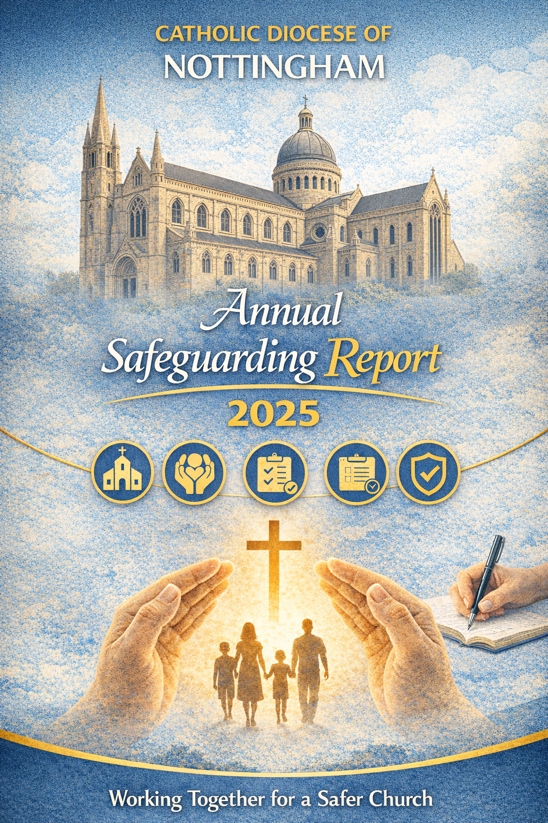

INDEX

1.0 Introduction

2.0 Governance and Accountability

3.0 Diocesan Safeguarding Policies

4.0 Safeguarding Team

5.0 Safeguarding Service Progress

5.1 Communicating the Safeguarding Message

5.2 Victim and Survivors

5.3 Parish Safeguarding Representatives

5.4 DBS and Safer Recruitment

5.5 Safeguarding Training

5.6 Casework

5.7 Complaints

6.0 Catholic Safeguarding Standards Agency (CSSA) National Audit

7.0 Looking Ahead
Training | Creating Safer environments and managing risk | Safer Recruitment | Supporting Victim and survivors | Quality Assurance
 |  |  |  | 

1.0 Introduction

The Catholic Diocese of Nottingham remains steadfast in its commitment to maintaining safe, accountable, and welcoming church communities. Throughout 2025, we have continued to consolidate and strengthen our safeguarding culture, policies, and practice—ensuring that children, young people, adults at risk, clergy, volunteers, and employees experience environments where they can grow in faith without fear of harm or exploitation.

This annual report provides a transparent overview of the progress made over the past year, the ongoing work to enhance good practice, and the areas where further development is planned. Safeguarding is a shared responsibility. The Diocese continues to collaborate closely with statutory services, partner agencies, parish communities, religious orders, and national Church safeguarding bodies to ensure standards remain robust and responsive.

Safeguarding is a dynamic task requiring continual learning, vigilance, and humility. The experiences and voices of victims and survivors continue to challenge, inform, and shape our diocesan safeguarding approach. Their insight remains essential as we strengthen our culture and maintain high standards.

As we enter the next phase of our safeguarding journey, we encourage parishes and clergy to use the findings of this report to support local improvement, celebrate progress, and recognise the ongoing need for diligence in our collective responsibility to safeguard all who worship, volunteer, and serve within the Diocese of Nottingham.

2.0 Governance and Accountability
Diocesan Board of Trustees, who are the charity’s legal entity and hold ultimate accountability for safeguarding across the Diocese of Nottingham.

The Trustees delegate day-to-day implementation and case management to the Director of Safeguarding and the Safeguarding Office, under the operational oversight of the Chief Operating Officer (COO).

However, oversight and strategic responsibility remain with the Board of Trustees, which ensures that safeguarding policies, systems, and decisions comply with civil law, canon law, and the requirements of the Catholic Safeguarding Standards Agency (CSSA).

The Diocese continues to operate with clear safeguarding governance, oversight, and accountability arrangements, ensuring compliance with national Catholic Safeguarding Standards

The Trustee safeguarding subcommittee with independent advisers provides oversight and scrutiny of the Diocese safeguarding practice.

Trustee safeguarding subcommittee members and independent safeguarding advisers 2025:

- Michael Stokes -Trustee and Chair
- Canon John Kyne – Clergy Safeguarding Lead and Trustee
- Emma Spencer – MAPPA probation Nottingham
- Julia Barker – Police Public Protection Lincolnshire
- Ross Leather – Adult Social Care Nottingham
- Maggie Clark – Safeguarding Governance Children/Health
- Peter Vellacott – Canon Lawyer
- Rachael Campion – Director of Safeguarding
- David Lawes – Chief Operating Officer

Attendance at Sub Committee Meeting | Sub Committee Meeting Register 2025
Name | 05/02/2025 | 02/07/2025 | 03/09/2025 | 25/11/2025
Rachael Campion | P | P | Postponed | Postponed
Maggie Clarke | x | P | Postponed | Postponed
David Lawes | P | P | Postponed | Postponed
Emma Spencer | x | x | Postponed | Postponed
Peter Vellacott | P | P | Postponed | Postponed
Julia Baker | P | P | Postponed | Postponed
Michael Stokes | P | P | Postponed | Postponed
John Kyne | P | P | Postponed | Postponed
Ross Leather | x | P | Postponed | Postponed

3.0 Policies and Procedures
During 2025, the Diocese has continued to embed and update safeguarding documentation, ensuring alignment with the Catholic Safeguarding Standards Agency (CSSA) requirements and best practice.
Key Diocesan Safeguarding Policies:
- Parish Safeguarding Handbook
- Safeguarding Roles & Responsibilities
- Managing Allegations & Concerns
- Safer Recruitment Procedures
- Victim & Survivor Care Charter
- Safeguarding Communication Plan
- Diocesan Training Strategy
- Safeguarding Complaints Policy
- Whistleblowing Policy
- Domestic Abuse Practice Guidance
Supporting Policies:
- Lone Working Policy
- Acceptable Behaviour Policy
- Volunteer Policy
- Updated codes of conduct for staff and volunteers
These policy updates support safer environments and reflect the Diocese’s commitment to continuous improvement.

4.0 Diocesan Safeguarding Team (2025)
- Director of Safeguarding: Rachael Campion
- Safeguarding Officer: Alan Booth
- Safeguarding Support & Volunteer Coordinator: Jane Black
The team continues to provide a strong and cohesive safeguarding service, bringing extensive professional experience from policing, social care, specialist support, and risk management. Throughout 2025, the team has further strengthened its operational capacity and shown resilience and adaptability in meeting evolving national expectations.

5.0 Safeguarding Service Progress
2025 marks our first full year operating beyond the initial three-year safeguarding implementation plan. The foundations laid between 2022–2025 have now matured into a consistently strong safeguarding culture across parishes, supported by effective governance, high-quality training, and increased engagement from clergy, volunteers, and parish safeguarding representatives (PSRs).

Parishes continue to demonstrate excellent commitment to embedding safer recruitment, risk management, and local safeguarding responsibilities—strengthened by the support of the Diocesan Safeguarding Team.

We now have strong and established foundations on which to continue developing and strengthening safeguarding practice across the Diocese of Nottingham. These foundations reinforce a safeguarding culture that is rooted in accountability, partnership, and continual improvement. The ongoing support of the Diocesan Safeguarding Subcommittee, the Bishop and Trustees, and the positive engagement of clergy, parish staff and volunteers has been essential. The commitment and time offered by Parish Safeguarding Representatives (PSRs) remains invaluable, and the safeguarding team is deeply grateful for the collaborative efforts that have enabled the delivery of diocesan safeguarding initiatives, programmes, and improvements.

5.1 Communicating the Safeguarding Message

Communication of safeguarding expectations across the Diocese remains a priority. We have developed and distributed diocesan safeguarding posters for church buildings and introduced a safeguarding pocket card for all those holding roles in the Church. These resources strengthen visibility and understanding of safeguarding responsibilities and provide clear information on how to raise concerns.

The Diocese continues to strengthen safeguarding communications through:
- Updated safeguarding posters across all churches
- Safeguarding pocket cards distributed to clergy, staff, and volunteers
- Regularly updated safeguarding website pages
- Clear guidance accessible to the public and parish teams

Safeguarding Sunday (May 2025)
All parishes participated in the annual Safeguarding Sunday, reinforcing the shared responsibility to protect and care for one another within our worshipping communities.

5.2 Victims and Survivors

The Diocese of Nottingham remains firmly committed to placing victims and survivors at the heart of its safeguarding mission. Throughout the year, we have continued to strengthen our approach to listening, responding, and learning from those affected by abuse within a church context. Our work has focused on creating safe, sensitive, and trauma-informed pathways for engagement, including opportunities for anonymous feedback, direct consultation with survivors, and ongoing involvement in shaping diocesan safeguarding practice. This year, the Diocese reaffirmed its commitment to transparent communication, survivor-led improvement, and collaborative working with statutory agencies and national safeguarding bodies. The experiences and voices of victims and survivors continue to guide our development, challenge our assumptions, and ensure that safeguarding remains rooted in accountability, learning, and meaningful change.

The Victim and Survivor Care Charter has been reviewed in 2025 and remains central to how the Diocese supports individuals impacted by abuse within a church context.
Key progress includes:
- Continued development of survivor engagement platforms
- Anonymous feedback system on the Diocesan website
- Opportunities for survivors to join reference groups or contribute to safeguarding development
- Increased visible commitment through diocesan communications

Day of Prayer
Many parishes once again dedicated time to prayer, reflection, and healing for those who have suffered abuse.
Work continues:
- Supporting fractured parishes
- Advancing the Healing Gardens initiative
- Collaborating with CSSA, RLSS, and statutory partners

5.3 Parish Safeguarding Representatives (PSRs)

Parish Safeguarding Representatives (PSRs) continue to be an essential and highly valued part of safeguarding across the Diocese. Their commitment, vigilance, and dedication ensure that safeguarding remains a visible and active priority within parish life. Throughout the year, PSRs have worked closely with parish clergy, volunteers, and the Diocesan Safeguarding Office to uphold safe recruitment, maintain parish safeguarding registers, support the completion of training, and respond appropriately to concerns raised within their communities. Their role has grown significantly in recent years, reflecting the increased safeguarding expectations placed on all Church bodies, and PSRs have risen to this challenge with professionalism, compassion, and resilience. The Diocese is deeply grateful for their ongoing service, and we remain committed to supporting them through training, guidance, networking opportunities, and regular communication to ensure they feel confident and equipped in this vital ministry.

2025 Highlights:
- Increased confidence and competence across PSRs
- Strong engagement with quarterly safeguarding registers
- Increase completion of rate of church safeguarding self-assessments
- Continued turnover, but strong recruitment of new PSRs, many with professional safeguarding experience

PSR Statistics (2025)
PSR STATISTICS 2025
Total number of PSR’s in appointment 129
Vacancies 5
In Progress 1
New Appointments 20
Resignations 7
Number of Inductions 20

5.4 DBS and Safer Recruitment
Safer recruitment remains one of the most complex yet vital areas of diocesan safeguarding and has continued to be a core safeguarding priority across the Diocese throughout 2025. Any parish role that meets the criteria for a Disclosure and Barring Service (DBS) check must have that check completed and cleared prior to appointment, ensuring that individuals are suitable for the position they will hold. All DBS checks are processed and verified through the Diocesan Safeguarding Office, in accordance with national Church and statutory requirements.
All clergy, employees, and volunteers who are eligible for a DBS check are required to maintain a current and valid certificate, renewed every three years. The Diocese has continued to work closely with parishes to support timely renewals, reduce delays, and strengthen overall compliance.

Safer Recruitment principles remain embedded within diocesan guidance and are routinely reinforced through training, parish support, and the Parish Safeguarding Handbook.
2025 achievements include:
- Continued implementation of safer recruitment packs
- Refined process for appointment of overseas volunteers and clergy
- Strengthened DBS renewal management through the central recording system
- Increased vigilance from parishes at the initial recruitment stage
Final statistics for 2025 will include DBS checks processed for:
- Clergy
- Volunteers
- Employees
- Overseas clergy
- Overseas volunteers

Volunteers | 792
Clergy | 65
Employees | 13
Overseas Clergy | 7
Overseas Volunteers | 34
Total Checks Completed (01/01/2025 to 31/12/2025) | 911

5.5 Safeguarding Training
The rollout of the National Safeguarding Training for volunteers holding roles that require a DBS check has progressed extremely well across the Diocese in 2025. Uptake has continued throughout the year, reflecting strong parish commitment and the efforts of Parish Safeguarding Representatives (PSRs) to promote and encourage completion. We will continue this momentum into 2026 to ensure that all clergy, volunteers, and diocesan staff receive the level of safeguarding training required for their role.

2025 saw a continued focus on national mandatory training with some delivery of Diocesan specialist training.
Highlights:

- National online training for DBS-required volunteers exceeded expected completion rates
- "Understanding Sex Offenders in Church Communities" remained a highly valued non-mandatory specialist course and will continue in 2026
- All clergy completed training for 2025
- Clergy National Training scheduled for February 2027

Target group | Course | Delivery by | Time length | When | Location | Number of Attendees
Clergy and Leaders | National safeguarding training | CSSA | 1 day | 12/02/25 | Holy Trinity Newark | 63
Clergy and Leaders | National safeguarding training | CSSA | 1 day | 18/02/25 | Good Shepherd Nottingham | 57
Clergy and Leaders | National Safeguarding Training | CSSA | 4 hrs | 10/04/25 | Virtual | 14
Clergy and Leaders | National Safeguarding Training | CSSA | 4 hrs | 28/05/25 | Virtual | 11
Clergy  PSR’s | Understanding Sex Offenders in Church | DS | 2.5 hrs | 5 training courses in total | Online | 9
Clergy  PSR’s | Understanding Sex Offenders in Church | DS | 2.5hrs | 4 training courses in total | Online | 8

5.6 Casework
Casework in 2025 has increased with safeguarding concerns being reported and an increase in persons of risk managed through safeguarding plans.

Case management and support for individuals subject to safeguarding plans has continued to be closely monitored. All safeguarding plans have been regularly reviewed, with annual risk assessments completed. We began the year with 14 individuals subject to safeguarding plans and ended with 18, reflecting parishioner movement, individuals being recalled to prison, and new parishioners joining our communities. Throughout the year, parishes have shown vigilance in reporting enquiries and concerns about persons who may pose a risk, demonstrating a healthy safeguarding culture. Our strong working relationships with the police, probation service, and statutory agencies have continued to support effective decision-making and risk management.

Key points:
- More safeguarding plans required
- Strong parish vigilance in reporting concerns
- Continued effective multi-agency working
- Lessons learnt review completed
- The Diocese successfully migrated to the new case recording system and began structured historical file reviews.
 | Child (current) | Child  (non-recent) | Adult | Other
Clergy open cases | - | - | 0
Safeguarding plans- Lay | - | - | 18
Safeguarding plans opened in 2025 | - | - | 5
Safeguarding plan reviews | - | - | 68
Police/Social/Lado referrals | 4 | - | 7
Low level concerns - Clergy | - | - | 10
Low level concerns- Lay | 1 | - | 44
Sex offender enquiries/breaches | - | - | 12
Clergy exploitation/victim | - | - | 1
Clergy wellbeing referral | - | - | 1
DBS Blemishes | - | - | 3
CSSA telephone consultation/advice | - | - | 0
Safe spaces referrals | - | - | 0
Safeguarding office email enquiries |  |  |  | 8339
Safeguarding office telephone enquiries |  |  |  | 1000 (average)

5.7 Safeguarding Complaints
No formal safeguarding complaints were received under the Safeguarding Complaints Policy during 2025.

6.0 Catholic Safeguarding Standards Agency (CSSA) National Audit

The Diocese continues to uphold the results of its 2024 national audit, which awarded Nottingham Comprehensive Assurance—a strong endorsement of the Diocese’s safeguarding culture and operational practice.

The next Annual safeguarding self assessment is scheduled for May 2026

The next full Inspection is scheduled for Autumn 2027.

7.0 Looking Ahead (2026 and beyond)

As we progress with a new 3-year safeguarding implementation plan, our aim is to:

- Increase resources and support for youth groups
- Adoption of new national policies and updates
- Continued development of survivor engagement platforms
- Strengthening safer recruitment and risk management
- Delivering national safeguarding training framework alongside diocesan specialist sessions
- Enhanced parish support through targeted visits and local action plans
- Annual PSR networking and learning events
- Embedding high safeguarding standards and continuous improvement across all parishes

Further reading and safeguarding information is available on the Diocese of Nottingham website https://www.dioceseofnottingham.uk/departments/safeguarding/

And CSSA website https://catholicsafeguarding.org.uk/

