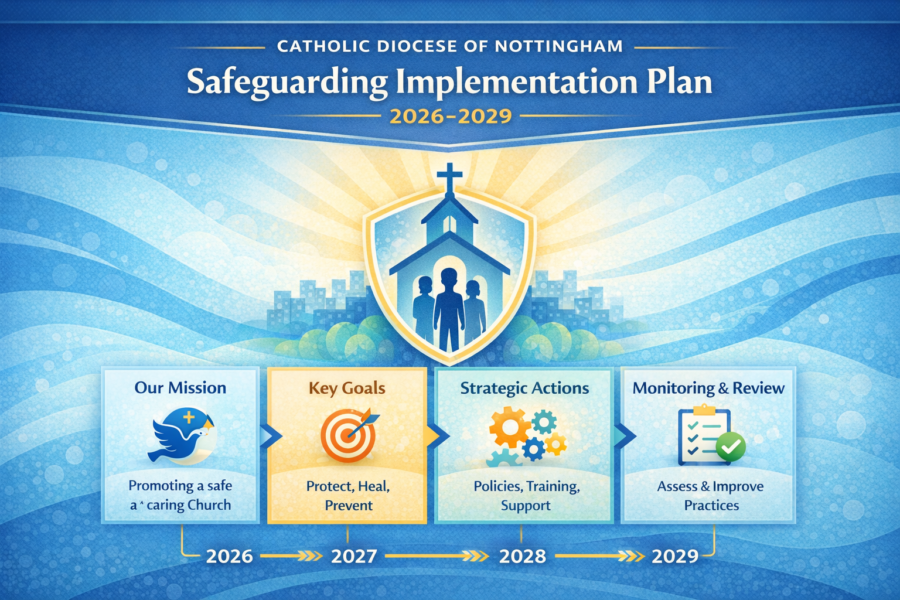

Summary of Key Safeguarding Implementation Outcomes 2026–2029
Between 2022 and 2025, the Diocese of Nottingham strengthened its safeguarding culture, systems and governance, achieving Comprehensive Assurance in its first CSSA audit. Safer recruitment became embedded across parishes, a full suite of diocesan safeguarding guidance was implemented, case management systems were modernised, and high-quality training was delivered across clergy, staff and volunteers. This progress laid strong foundations for a more mature safeguarding culture, deeper parish engagement, enhanced support for victims and survivors, and sustained alignment with national safeguarding expectations.
The 2026–2029 plan builds on these achievements, outlining clear priorities for consolidation, development, and continuous improvement.

Summary of key Safeguarding Implementation Plan outcomes for 2026 – 2029

Key Priorities and outcomes for the Safeguarding Implementation Plan 2022 – 2025
Area of 3-year plan | 3-year goals | Outcomes
Standard 1  Safeguarding is embedded in the Diocese of Nottingham | - Safeguarding is embedded in the leadership, governance, ministry, and culture of the diocese.  - Robust policies are in place to support safeguarding across the diocese.  - To maintain and evidence a mature safeguarding culture across diocesan leadership, governance, parishes, ministries, and communities. |  | - Governance structures continue to provide strong oversight and accountability.  - Policies remain aligned with CSSA standards and are regularly reviewed.  - Leaders at all levels demonstrate understanding and ownership of safeguarding responsibilities.  - A clear, transparent safeguarding culture is visible across the Diocese.  - Risk identification and mitigation is consistent and well evidenced.  - Constructive partnership with CSSA remains strong and proactive.  - Expanded safeguarding resources, guidance and support materials are accessible to all parishes.
Standard 2  Communicating the Church’s safeguarding message | - Safeguarding throughout the diocese is driven by a clear and robust communication plan.  - To ensure safeguarding information is visible, accessible, multi-platform, and accessible to non-English speakers. |  | - A diocesan safeguarding communication plan is implemented and reviewed annually.  - Updated safeguarding information is displayed across all parishes and online platforms.  - Translated safeguarding materials are available where needed.  - Stronger links with local safeguarding partners promote shared learning and safer communities.  - Communication is embedded in parish life, ministry, liturgy, catechesis, and community outreach.
Standard 3  Caring for those who report having been harmed. | - To strengthen a compassionate, trauma-informed, victim-led approach across the Diocese. |  | - Ongoing development of the Victim and Survivor Care Charter.  - Victim-centred responses embedded into safeguarding practices.  - Develop a culture of safeguarding.  - Support roles for victims.  - Develop the wider context of supporting all those who have been harmed through abuse in church.  - Support plans tailored to individual needs.  - Clergy and key roles trained to respond sensitively and appropriately.  - Effective, safe information-sharing protocols maintained.  - Enhanced signposting and pastoral support for survivors.  - Development of initiatives such as healing gardens and reflective spaces.
Standard 4  Effective management of allegations and concerns | - To ensure all allegations and concerns are managed promptly, professionally, and in line with national practice.  - Instil a culture of learning lessons to mitigate future risk. |  | - Casework continues to be timely and of high quality.  - Safeguarding team receives regular professional supervision.  - Specialist skills within the safeguarding team are used effectively.  - All respondents who pose risk are subject to risk assessment and safeguarding plans.  - Information-sharing with statutory agencies is timely and proportionate.  - Significant incidents are reviewed and learning embedded into practice.  - Regular professionals’ meetings support case progression.
Standard 5  Management and support of respondents | - To ensure respondents are supported, monitored, and managed appropriately throughout any safeguarding process. |  | - A clear system of support and monitoring for respondents is maintained across the Diocese.  - “Managing and Responding to Allegations and Concerns” guidance includes procedures for:  - appointment of a link person for respondents,  - referral to the Diocesan Wellbeing Coordinator,  - access to pastoral support.  - Risk assessments and management plans are in place during investigations.  - Ongoing support is available for clergy removed from ministry or under restrictions.  - Procedures for responding to complaints against volunteers are clear, fair, and consistently applied.  - Communication with respondents is respectful, professional, and transparent within safeguarding boundaries.
Standard 6  Robust human resource management | - To ensure all those who work or volunteer in the Diocese are safely recruited, well-supported, and uphold safeguarding standards. |  | - All clergy, staff, and volunteers continue to be subject to safer recruitment checks.  - DBS checking and verification systems remain efficient, accurate, and timely.  - Safer recruitment practices underpin all staff and volunteer onboarding across the Diocese.  - A clear understanding of the volunteer workforce informs support, training and oversight.  - Recruitment, induction and retention of Parish Safeguarding Representatives remain core priorities.  - Policies and procedures governing HR and safeguarding remain up to date and consistently applied.  - Continuous development and review of diocesan safeguarding policies ensures alignment with national requirements.
Standard 7  Training and support for safeguarding | - To ensure all church personnel are trained and supported in safeguarding appropriate to their roles |  | - Training strategy implemented covering clergy, staff and volunteers.  - Training remains high quality, role-specific, and effective in improving safeguarding across the Diocese.  - National online safeguarding packages are completed by relevant personnel when available.  - Safeguarding information and advice are accessible to parishioners.  - Communication channels for reporting concerns and accessing support are broadened and publicised.  - Bespoke training packages developed for specialist areas or emerging risks.  - Comprehensive safeguarding inductions delivered for all new roles.  - Diocesan training incorporates a training needs analysis aligned with national requirements.
Standard 8  Quality assurance and continuous improvement | - To embed a culture of reflection, review, and continuous improvement at all levels. |  | - Safeguarding Subcommittee retains oversight of safeguarding performance and compliance.  - A rolling 3-year safeguarding implementation plan remains in place and regularly reviewed.  - An annual safeguarding action plan is implemented and resourced.  - Annual parish safeguarding audits are completed, analysed, and acted upon.  - The Diocese continues full cooperation with national audits and CSSA quality assurance processes.  - Recommendations from internal and external audits are implemented promptly.  - A Diocese-wide learning culture is developed, with lessons learned informing policy, training, and practice.

