Domestic Abuse
Additional
Information



This document has been produced to provide additional information on domestic abuse and can be used in conjunction with the Diocese of Nottingham Responding to Domestic Abuse Practice Guidance

To be reviewed June 2025

Index

- Domestic Abuse Information Sheets………………..………………..………..………. page 1
1.1 Understanding Domestic Abuse……………………..…………..…..….…….. page 1
1.2 How we Define Domestic Abuse…………………………………..…....…….. page 2
1.3 Domestic Abuse Act …………………………………………………….……….…… page 2
1.4 Controlling Coercive Behaviour…………………………..………….…….…… page 3
1.5 Physical Abuse…………………………………………….…………………………….. page 5
1.6 Sexual Abuse………………………………………….………………………………….. page 6
1.7 Technological Abuse………………………………………………………..……...... page 7
1.8 Emotional or Psychological Abuse…………………….……………..….…….. page 7
1.9 Verbal Abuse……………………………………………………………………….…….. page 8
1.10 Spiritual Abuse………………………………………………………….……..………... page 8
1.11 Religious Marriage and Divorce…………………………………………………. page 9
1.12 Honour Based Abuse…………………………………………………………..…….. page 10
1.13 Economic Abuse………………………………………………..………………………. page 11
1.14 Perpetrator Tactics……………………………………………..…………………….. page 11
1.15 Impact on Children…………………………………………….…………….………… page 14
1.16 In Churches Too……………………………………………..…………………………. page 16
1.17 Domestic Abuse and the Law…………………………………..……………….. page 17

1.0 Domestic Abuse Information Sheets

1.1 Understanding Domestic Abuse

Domestic abuse is often hidden and can affect anyone, regardless of age, disability, gender identity, gender reassignment, race, religion or belief, sex or sexual orientation. Domestic abuse can also manifest itself in specific ways within different communities and each situation can add to the dynamics.

Women are disproportionately the victims of domestic abuse. Domestic abuse perpetrated on men by women and on victims in LGBT relationships is often due to the need of the perpetrator to exert power and control over their victim, which creates the imbalance in any relationship in order for abuse occur.

The year ending March 2020 estimated that 1.6 million females and 757,000 males aged 16 to 74 years experienced domestic abuse in that year.

Women are more likely to experience repeat victimisation, be physically injured or killed as a result of domestic abuse and experience non-physical abuse - including emotional and financial abuse - than men.

According to the crime survey of England and Wales (CSEW) for the year ending March 2020, around one in four women aged 16 to 74 (27.6%) had been a victim of domestic abuse in their lifetime.

274 women were killed in domestic homicides between April 2016 and March 2019.
In 263 cases (96%) the suspect was male

According to the CSEW for the year ending March 2020 around one in seven men aged 16 to 74 (13.8%) had been a victim of domestic abuse in their lifetime.

83 men were killed in domestic homicides between April 2016 and March 2019. In 44 cases (53%) the suspected perpetrator of these homicides was male.

Research published by the Home Office has estimated the social and economic costs of domestic abuse in the region of £66 billion for the victims identified in England and Wales within the year 2016/17.

The biggest component of the estimated cost is the physical and emotional harms incurred by victims (£47 billion), particularly the emotional harms (the fear, anxiety and depression experienced by victims as a result of domestic abuse), which account for the overwhelming majority of the overall costs.

The cost to the economy is also considerable, with an estimated £14 billion arising from lost output due to time off work and reduced productivity as a consequence of domestic abuse.

There are also additional barriers to services experienced by victims from protected groups and those experiencing multiple disadvantages. Black, Asian and ethnic minority women, women with insecure immigration status, deaf and disabled women and LGBT victims will experience further barriers when accessing services. Similarly, the co-occurrence of homelessness, drug and alcohol use, criminal justice system involvement and mental health will often mean that victims will face huge challenges when seeking support.

1.2 How We Define Domestic Abuse

Domestic abuse is defined as an incident or pattern of incidents of controlling, coercive, threatening, degrading and violent behaviour, including sexual violence, in the majority of cases by a partner or ex-partner, but also by a family member or carer. It is very common. In the vast majority of cases it is experienced by women and is perpetrated by men.

1.3 The Domestic Abuse Act 2021

The Domestic Abuse Act 2021 introduced the first statutory definition of domestic abuse in England and Wales. Domestic abuse is not limited to physical violence and includes:
- Physical abuse
- Sexual abuse
- Violent or threatening behaviour
- Controlling or coercive behaviour
- Economic abuse
- Psychological, emotional or other abuse
The Act applies to individuals aged 16 years and over who are "personally connected", including current or former intimate partners and family members. It also recognises that children who see, hear, experience, or are affected by domestic abuse are victims of domestic abuse in their own right.
Additional protections introduced by the Act include:
- Domestic Abuse Protection Notices (DAPNs)
- Domestic Abuse Protection Orders (DAPOs) (being implemented in stages)
- Prohibition of perpetrators cross-examining victims in family courts
- Recognition of economic abuse in legislation
- Strengthened support and accommodation duties for victims.

1.4 Controlling or Coercive Behaviour

The Serious Crime Act 2015 (section 76) introduced the offence of controlling or coercive behaviour in an intimate or family relationship in recognition of the severe impact of coercive control, economic abuse, threats and psychological and emotional abuse, whether or not accompanied by physical abuse.

The offence currently captures behaviour between current intimate partners, or between former intimate partners and family members who live together.

The 2021 Act amends the controlling or coercive behaviour offence to remove the ‘living together’ requirement, which means it may now apply to partners, ex-partners, or family members regardless of whether the victim and perpetrator live together. This amendment commenced spring 2022.

What constitutes controlling or coercive behaviour is outlined in statutory guidance issued by the government under section 77 of the Serious Crime Act 2015. Controlling or coercive behaviour is defined as:

controlling behaviour is:
a range of acts designed to make a person subordinate and/or dependent by isolating them from sources of support, exploiting their resources and capacities for personal gain, depriving them of the means needed for independence, resistance and escape and regulating their everyday behaviour; and
coercive behaviour is:
an act or a pattern of acts of assault, threats, humiliation and intimidation or other abuse that is used to harm, punish, or frighten their victim.

Below is a list of behaviours that are within the range and continuum of coercive or controlling behaviour. This list is not exhaustive:

Controlling or monitoring the victim’s daily activities, including making them account for their time, dictating what they can wear, what and when they can eat, when and where they may sleep and so on.

Isolating the victim from family, friends and professionals who may be trying to support them, intercepting messages or phone calls.

Refusing to interpret, and/or hindering access to communication.

Intentional undermining of the victim’s role as a partner, spouse or parent.

Preventing the victim from taking medication, or accessing medical equipment or over-medicating them, or preventing the victim from accessing health or social care (especially relevant for victims with disabilities or long-term health conditions).

Using substances to control a victim through dependency, or controlling their access to substances.

Using children to control their victim, for example, threatening to take the children away or manipulating professionals to increase the risk of children being prevented from having contact with the victim or having children’s social care involvement.

Using pets to control or coerce a victim, for example, harming, or threatening to harm or give away pets.

Alienating behaviours, including invidious drip feeding of negative views to a child by one parent about the other parent, or any attempt by one parent to frustrate or limit the child’s contact with the other parent, other than for reasons based on concern about the risk to that child.

Threats to expose sensitive information (for example, sexual activity, or sexual orientation) or make false allegations to family members, religious or local community including via photos or the internet.

Intimidation and threats of disclosure of sexual orientation and/or gender identity to family, friends, work colleagues, community and others
preventing the victim from learning a language or making friends outside of their ethnic/ or cultural background.

Threatening precarious immigration status against the victim, withholding documents, giving false information to a victim about their visa or visa application, for example, using immigration law to threaten the victim with potential deportation.

Threats of institutionalisation (particularly for disabled or elderly victims).

Controlling or coercive behaviour is a pattern of acts designed to make a person subordinate, dependent, isolated or fearful. The behaviour may be subtle, cumulative and difficult to identify from a single incident.
Examples include:
- Monitoring communications
- Restricting movement
- Isolation from family, friends or faith communities
- Financial control
- Gaslighting
- Intimidation
- Threats to children, pets, reputation or immigration status
- Monitoring through technology
- Post-separation abuse
Importantly, the offence now explicitly applies to coercive control that continues following separation where the parties remain personally connected. [gov.uk], [survivinge...cabuse.org]

Below is a list of behaviours that are within the range and continuum of coercive or controlling behaviour.

1.5 Physical Abuse

Physical abuse, violent or threatening behaviour, are forms of abusive behaviour. This can involve, but is not limited to:
being, or threatened to be, kicked, punched, pinched, pushed, dragged, shoved, slapped, scratched, choked and bitten;
use, or threats of use, of ‘weapons’ including knives and irons
being burned, scalded or poisoned;
objects being thrown;
violence or threats against family members and/or pets;
causing harm by denying access to medical aids or equipment – for example Deaf persons may be prevented from communicating in sign language or may have their hearing aids removed; and
harming someone whilst performing ‘caring’ duties, which are often performed by relatives - this is especially relevant for disabled victims and may involve force feeding, withdrawal of medicine or over-medication.

1.6 Sexual Abuse

Many victims of domestic abuse experience behaviour that is sexually abusive in their relationships. This can involve:
Rape;
being pressured into sex, or sexual acts, including with other people;
being forced to take part in sexual acts because of threats to others, including children;
unwanted sexual contact or demands;
‘corrective’ rape (the practice of raping someone with the aim of ‘curing’ them of being LGBT);
intentional exposure to HIV or sexually transmitted infections;
being pressurised or being tricked into having unsafe sex, including deception over the use of birth control;
forced involvement in making or watching pornography; and
hurting a victim during sex including non-fatal strangulation

Victims can also be the subject of reproductive coercion, which can involve:

restricting a partner’s access to birth control; refusing to use a birth control method; deception regarding the use of birth control including falsely claiming to be using contraception; forcing a partner to get an abortion, IVF or other related procedure, or denying access to such procedures.

There are also links between sexual abuse and sexual exploitation, including forced prostitution.

Perpetrators may force or coerce a victim into exchanging sex for drugs, alcohol or money, or committing a crime, such as theft, to pay, for example, for the perpetrator’s drugs or alcohol.

‘Rough sex’, including sadomasochistic activity, can involve the infliction of pain or violence, simulated or otherwise with the aim of providing sexual gratification for the parties involved. This type of activity can encompass a wide range of behaviours and, although it may occur in private and be consensual, section 71 of the Domestic Abuse Act 2021 states that the infliction of serious harm, which results in actual bodily harm (ABH) or other more serious injury or death, will mean that the person responsible for those injuries will be liable to a criminal prosecution, irrespective of whether consent had been given by the person in receipt of the injuries or not.

Non-fatal strangulation can also be part of sexual abuse. The 2021 Act addresses this, clarifying that a person commits the offence of strangulation or suffocation, if they intentionally strangle another person, or do any other act that affects that person’s ability to breathe and constitutes battery. Whilst it is a defence for the person responsible to show that the individual consented, this does not apply where the individual suffers serious harm as a result of the strangulation, or other act, and where there has been intent to cause harm or the person responsible was reckless as to whether that person would suffer serious harm.

1.7 Technological Abuse

Perpetrators can use technology and social media as a means of controlling or coercing victims. This happens frequently both during and after relationships with abusers and is particularly common amongst younger people. Examples of online abuse include:
placing false or malicious information about a victim on their or others’ social media;
set up false social media accounts in the name of the victim;
‘trolling’ with abusive, offensive or deliberately provocative messages via social media platforms or online forums;
image-based abuse – for example the non-consensual distribution or threat thereof of private sexual photographs and films with the intent to cause the person depicted distress (revenge porn);
hacking into, monitoring or controlling email accounts, social media profiles and phone calls;
blocking the victim from using their online accounts, responding in the victim’s place or creating false online accounts;
use of spyware or GPS locators on items such as phones, computers, wearable technology, cars, motorbikes and pets;
hacking internet enabled devices such as PlayStations or iPads to gain access to accounts or trace information such as a person’s location;
using personal devices such as smart watches or smart home devices (such as Amazon Alexa, Google Home Hubs) to monitor, control or frighten; and
use of hidden cameras.

- Tracking through mobile phones
- Spyware and stalker ware
- Monitoring social media accounts
- Password control
- Smart-home surveillance
- GPS tracking
- Image-based abuse
- Harassment through messaging platforms
- Use of children's devices to monitor a victim
Technology-facilitated abuse is increasingly recognised as a common feature of domestic abuse and often continues after separation. [assets.pub...ice.gov.uk], [gov.uk]

1.8 Emotional or Psychological Abuse

Domestic abuse often involves emotional or psychological abuse. This can include:
manipulating a person’s anxieties or beliefs;
withholding affection turning children and friends against the victim (which may have a subsequent impact on children) including falsely and without justification telling a child that the other parent abandoned them, never loved them, or never wanted them;
distorting a child’s memories about the victim parent, including telling a child the other parent will pick them up/meet them, when that was not true, falsely telling medical/school staff they have sole custody of a child so that no information is provided to the other parent, painting the other parent in a negative light to the child, including mocking their personality characteristics, job, friends, family and belittling them (including in front of the child);
being stopped from seeing friends, relatives, or care workers;
being insulted, including in front of others - this includes insulting someone about their race, gender, sexual orientation, disability, faith or belief, ability to parent and ability to work;
repeatedly being belittled;
keeping a victim awake/preventing them from sleeping;
using violence or threats towards pets to intimidate the victim and cause distress, including threatening to harm the animal as well as controlling how the owner is able to care for the animal;
using social media sites to intimidate the victim; and
persuading a victim to doubt their own sanity or mind (including ‘gaslighting’).

1.9 Verbal Abuse

Examples of verbal abuse include:

- repeated yelling and shouting;
- verbal humiliation either in private or in company;
- being laughed at and being made fun of
- insults and threats; and
- mocking someone about their disability, gender identity, religious or faith belief, sexual orientation, physical appearance and so on.

1.10 Spiritual Abuse

Spiritual abuse is commonly understood as a part of emotional and psychological abuse that uses religion and faith systems to control and subjugate a victim. It is often characterised by a systemic pattern of coercive or controlling behaviour within a religious context.
Spiritual abuse can have a deeply damaging impact on victims. The abuse may include, the following but is not limited to:

manipulation and exploitation through the influence of religion
enforced accountability;
censorship of decision making;
requirements for secrecy and silence;
marital rape and the use of religious scripture to justify that
coercion to conform or control through the use of sacred or religious texts/teaching, for example, theological justifications in sexual coercion or abuse;
causing harm, isolation and or neglect to get rid of an ‘evil force’, ‘spirit’ or ‘jinn’ that is believed to have possessed the victim. This can include accusations of witchcraft, where the term witchcraft and association with it are used in a derogatory way;
requirement of obedience to the perpetrator of domestic abuse, owing to religion or faith, or their ‘divine’ position; and
community isolation as a means of ‘punishment’;

Spiritual abuse can also involve, using, or preventing a victim from practising their faith or religious obligations. This may include:

forcing the victim to act or behave in ways which contradict religious beliefs and or spiritual rituals and practice, for example, forcing the victim to transgress religious dietary observations preventing the victim from performing prayers and/or attending communal worship forcing sexual acts which contradict religious observance and or religious law (for example, during and after menstruation or pre-marital sex); and,
forcing or limiting access to abortion, birth control or sterilisation when this will contravene religious observance.

1.11 Religious Marriage and Divorce

Religious marriages from faith communities other than Christianity are not recognised in British law. A couple need to register their religious marriage for them to access their legal rights and obligations under British law. This can be used by perpetrators to:

Actively discourage or prevent the marriage being registered in British law ensuring that women are denied their legal rights in the event of a breakdown in the marriage - this along with an insecure immigration status of the victim can act as a powerful tool for coercion and control coerce or trick women into being part of a multiple marriage where the husband can have more than one wife at the same time.

A form of spiritual abuse may include the withholding of a religious divorce, as a threat to control and intimidate victims. In some cases, it will be accompanied by other manifestations of abuse within the marriage.

In Judaism this concerns the Get], and instances whereby a recalcitrant husband may refuse to give his wife a Jewish bill of divorce (or a wife may unreasonably refuse to accept a Jewish bill of divorce). Unreasonably preventing a religious Jewish marriage being dissolved often includes the imposition of such conditions.

The ability to refuse to give a Get provides abusive husbands with power and control and will be used often to exert leverage in relation to other aspects of the divorce. The refusal will have a significant impact on the wife’s wider living conditions. She will often be severely restricted in her social and personal life. It affects her ability to re-marry and directly affects the status of any children she may have in the future.

In Islam this can involve the refusal of a Muslim husband to grant his wife a religious divorce, talaq, which is the annulment of a nikkah, as a way of prolonging the process of divorce. The threat of talaq being uttered and the arbitrary use of this by perpetrators may also often be cited by some victims.

Whilst Islamic law enabled women can obtain a religious divorce of their own accord, they may be prevented from doing so through religious courts on which they are reliant.
Refusing to let a partner practise their religion may also constitute a form of spiritual abuse, for example, restricting access to worship and their religion.

1.12 So-Called Honour-Based Abuse

So-called honour-based abuse (HBA) is a crime or incident which has or may have been committed to protect or defend the perceived honour of the family and/or community, or in response to individuals trying to break from constraining ‘norms’ of behaviour that their family or community is trying to impose.

HBA can cover emotional or psychological abuse and a range of other circumstances, not all of which represent domestic abuse under the 2021 Act, for example if the victim and perpetrator are not personally connected. However, HBA will typically be carried out by a member or members of the family and is likely to involve behaviours specified in the statutory definition of domestic abuse in the 2021 Act.

Evidence has shown - see Your choice: ‘honour’-based violence, forced marriage and domestic abuse - that victims at risk of HBA who were accessing domestic abuse services were eight times as likely to be experiencing abuse from multiple perpetrators, and had experienced abuse for an average of two years longer before accessing support than those not identified as at risk of HBA.

This type of abuse is most commonly experienced by victims from close-knit or closed communities with a strong culture of ‘honour’ and ‘shame’, such as some minority communities, travelling communities or closed ethnic/religious communities and other particularly isolated social groups. Victims may be female or male and those at risk can include individuals who are LGBT.

1.13 Economic Abuse

Economic abuse in the definition of domestic abuse - means any behaviour that has a substantial adverse effect on an individual’s ability to acquire, use or maintain money or other property, or to obtain goods or services. This can include an individual’s ability to acquire food, clothes, transportation and utilities. These behaviours can include an attempt to control through restriction, exploitation and/or sabotage.

Economic abuse can also be a form of controlling or coercive behaviour, where it is done repeatedly or continuously. It can make the individual economically dependent on the abuser, and/or create economic instability, thereby limiting their ability to escape and access safety and can result in an individual staying with an abuser and experiencing more abuse and harm as a result.

Examples of economic abuse might include the following, where they have a substantial adverse effect on the victim:

controlling the family income;
not allowing a victim to spend any money unless ‘permitted’;
denying the victim food or only allowing them to eat a particular type of food;
running up bills and debts such as credit/store cards in a victim’s name, including without them knowing;
refusing to contribute to household income;
deliberately forcing a victim to go to the family courts so they incur additional legal fees;
interfering with or preventing a victim from regularising their immigration status so that they are economically dependent on the perpetrator;
preventing a victim from claiming welfare benefits, or forcing someone to commit benefit fraud or misappropriating such benefits;
interfering with a victim’s education, training, employment and career
not allowing a victim access to mobile phone/car/utilities
damaging property; and
not allowing a victim to buy pet food or access veterinary care for their pet.

1.14 Perpetrator Tactics

There are many reasons why an individual may become a perpetrator of domestic abuse and these can include: a desire to exert power and control over someone; misogyny; low self-esteem; or learned and replicated behaviour as a result of experience of abuse in their childhood (although the majority of children who experience abuse in their childhoods do not go on to become perpetrators). Evidence also shows that more than a third of the service users of one perpetrator programme had employment, training or educational needs, just over a quarter had mental health needs, around a quarter misused alcohol, and just under a quarter had housing needs, with some service users having needs across multiple categories.

Factors such as alcohol and drugs misuse can increase the likelihood and severity of domestic abuse. In the context of perpetrators, up to 60% of men in perpetrator programmes have problems with alcohol and/or drugs. However, there is not a causal relationship between substance misuse and domestic abuse. Substances can act as a disinhibitor, rather than a cause of violence and abuse. Many people believe that alcohol and/or drugs increase aggression and physical violence and therefore perpetrators are likely to use this as an excuse for their abusive behaviour.

However, there is never any justification for perpetrating domestic abuse and although the perpetrator and others may blame the victim for causing their behaviour, it is never the victim’s fault. Some perpetrators do not recognise that their behaviour constitutes domestic abuse, however all perpetrators are responsible for their behaviour and should be held accountable for it.

An abuser may manipulate their victim or those around them to make their abuse invisible, even to their victims. Domestic abuse perpetrators can be particularly adept at manipulating professionals, agencies and systems and may use a range of tactics in order to perpetuate contact with and control over the victim. These can include:

disguised compliance, missing or cancelling appointments, non-attendance, playing different professionals off against one another;
making false or vexatious allegations against victims and convincing professionals that their controlling tactics are for the victim’s own safety and/or for the safety of their children;
using the courts to continue abuse, for example not turning up to court dates, sending unnecessary and repeated legal letters and making threats around contact;
making counter-allegations against the victim;
exploiting interpretations of religion or faith to maintain control of victims and perpetuate harm;
using children as a form of control – for example, access visits, seeking to manipulate children’s feelings towards ex-partner (victim);
attempting to frustrate or interfere with a police investigation, including attempting to undermine the victim’s statements by claiming they are mentally ill;
telling the victim that they will not be believed because they have mental health issues, learning difficulties or disabilities, or issues with substance abuse;
threatening to ‘out’ the victim as a form of coercive control, telling the victim that they will not be believed because they identify as lesbian, gay, bisexual and/or trans, or manipulating the victim’s knowledge of what support is available for LGBT people and using myths and stereotypes around LGBT domestic abuse to make professionals believe that abuse between same-sex couples doesn’t exist;
exploiting the communication needs of the victims or manipulating the victim’s knowledge of what support is available and making professionals believe that the victim does not have capacity;
using threats in order to manipulate the victim - for example, by telling the victim they will not be believed by the police or other agencies, that they will inform social services, that their children will be taken away;
manipulating the victim’s immigration status as a form of coercive control, including withholding ID, passports and visas from victims, lying about their status, purposely letting a victim’s visa lapse or failing to act on sponsorship duties for immigration purposes;
a victim’s substance use can be presented as an excuse for violence by the perpetrator;
perpetrators may control or withhold substances as a means of abuse;
perpetrators may abuse the victim by forcing them to use substances against their will, or by administering them without their knowledge;
perpetrators may sabotage victims undergoing treatment for substance use; and
perpetrators may force or coerce a victim into exchanging sex for drugs, alcohol or money, or committing a crime, such as theft, to pay for the perpetrator’s drugs or alcohol.

Addressing a perpetrator’s drug or alcohol use alone is unlikely to reduce or solve the problem of their abusive behaviour. It is important that any alcohol or drugs treatment programme for perpetrators, as well as addressing the causes of the substance abuse, also addresses the complex dynamics and power and control which underpin domestic abuse.

Across England comprehensive provisions for responding to domestic abuse are available through the courts and through protection orders and notices. These cover matters dealt with in the criminal, civil and family courts. Advice about any of these matters should be without charge from solicitors, using public funding.

1.15 Impact on Children

Children can experience both short and long term cognitive, behavioural and emotional effects as a result of witnessing domestic abuse. Each child will respond differently to trauma and some may be resilient and not exhibit any negative effects.

Children’s responses to the trauma of witnessing domestic abuse may vary according to a multitude of factors including, but not limited to, age, race, sex and stage of development. It is equally important to remember that these responses may also be caused by something other than witnessing domestic abuse.

Children are individuals and may respond to witnessing abuse in different ways. These are some of the effects described in a briefing by the Royal College of Psychiatrists (2004):

They may become anxious or depressed.
They may have difficulty sleeping.
They have nightmares or flashbacks.
They can be easily startled.
They may complain of physical symptoms such as tummy aches and may start to wet their bed.
They may have temper tantrums and problems with school.
They may behave as though they are much younger than they are.
They may become aggressive or they may internalise their distress and withdraw from other people.
They may have a lowered sense of self-worth.
Older children may begin to play truant, start to use alcohol or drugs, begin to self-harm by taking overdoses or cutting themselves or have an eating disorder.
Children may also feel angry, guilty, insecure, alone, frightened, powerless or confused. They may have ambivalent feelings towards both the abuser and the non-abusing parent.

Do children grow up to be abusers and/or victims?

The “cycle of violence” otherwise known as the “intergenerational theory” is often referred to when considering the effects of domestic abuse on children; however research findings are inconsistent, and there is no automatic cause and effect relationship.

It is believed that this theory is disempowering and ineffective when working with children. A boy who has witnessed domestic abuse does not have to grow up to be an abuser and a girl does not have to become a victim of domestic abuse later in life.

Educational programmes focusing on healthy relationships, and challenging gender inequality, sexual stereotyping, and domestic abuse, should be integrated with work on anti-bullying and conflict resolution as a mandatory part of the PHSE curriculum in all schools. These would act as important preventive measures.

Abuse through child contact
Unfortunately, even after separating from their abusers, many mothers find it extremely difficult to protect their children from ongoing abuse as a result of their requirement to comply with contact orders made by the family courts. This can cause ongoing conflicts and trauma.

1.16 In Churches Too: Responses to Domestic Abuse
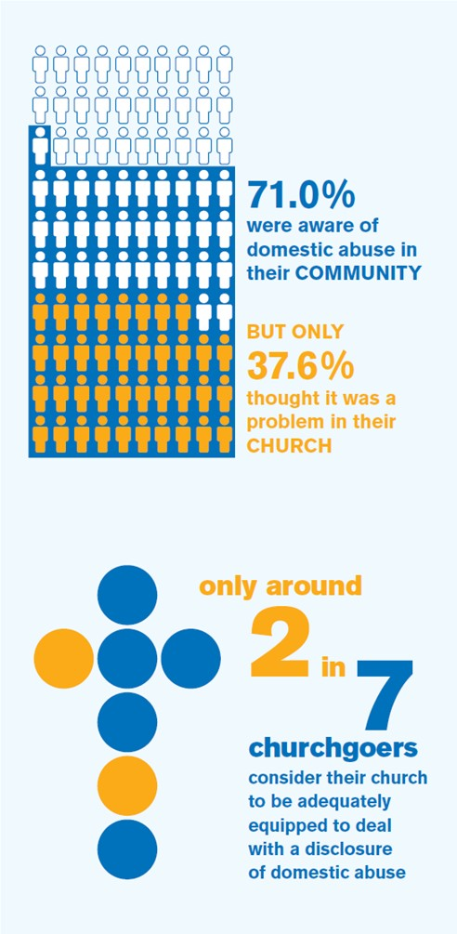
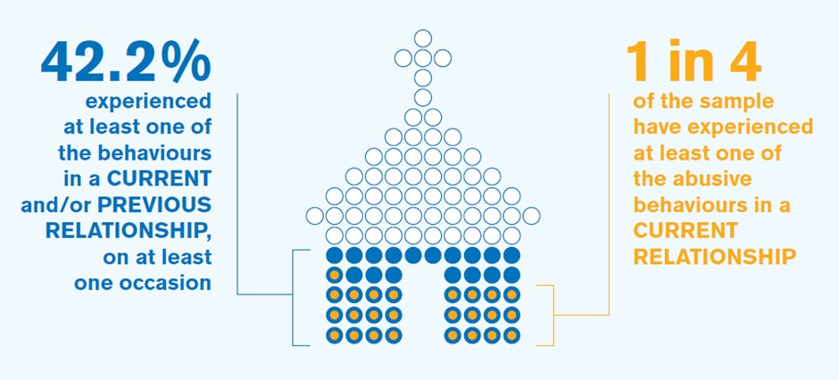
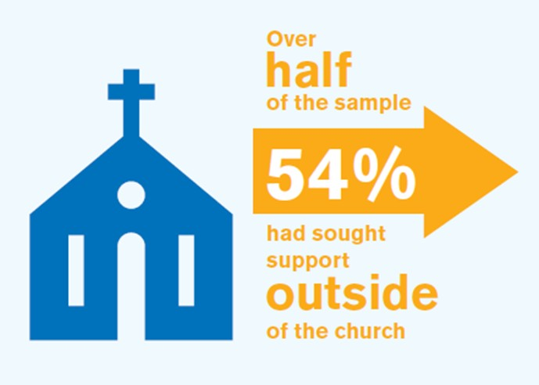
– A case study of Cumbria in March 2018
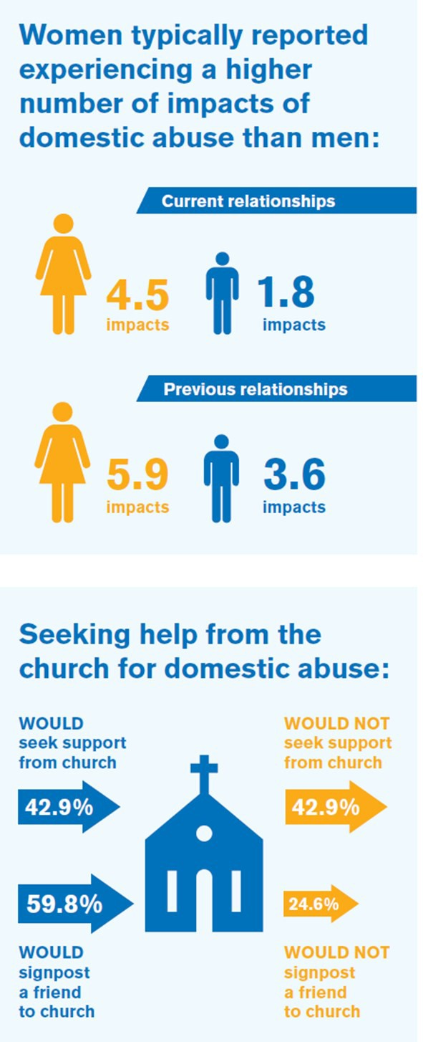
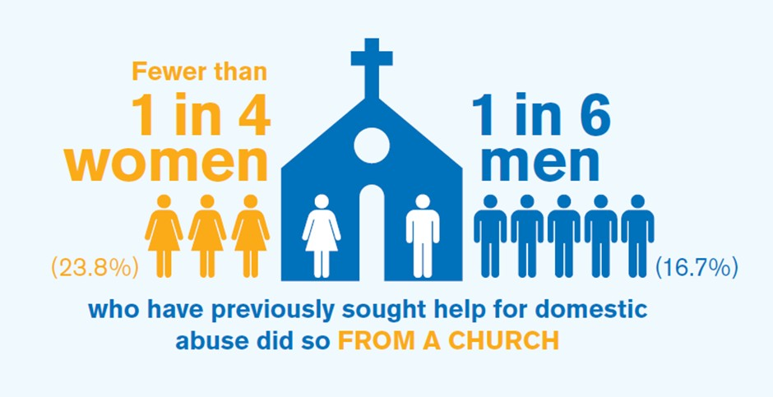
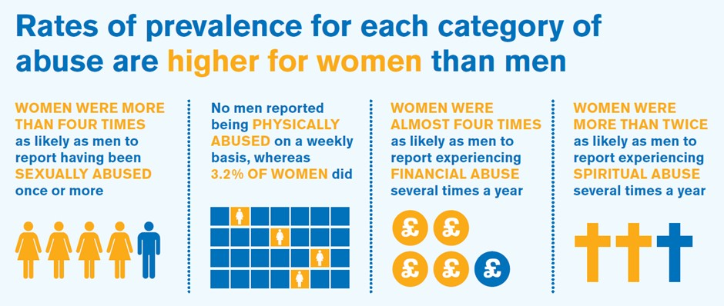
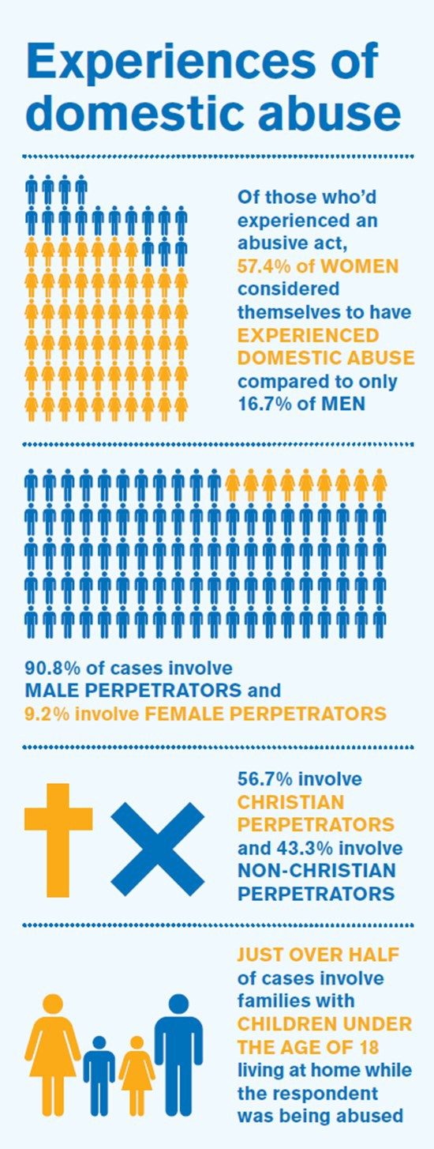
Respond and refer people to sources of help

Emotional abuse was the most commonly experienced form of abuse

.

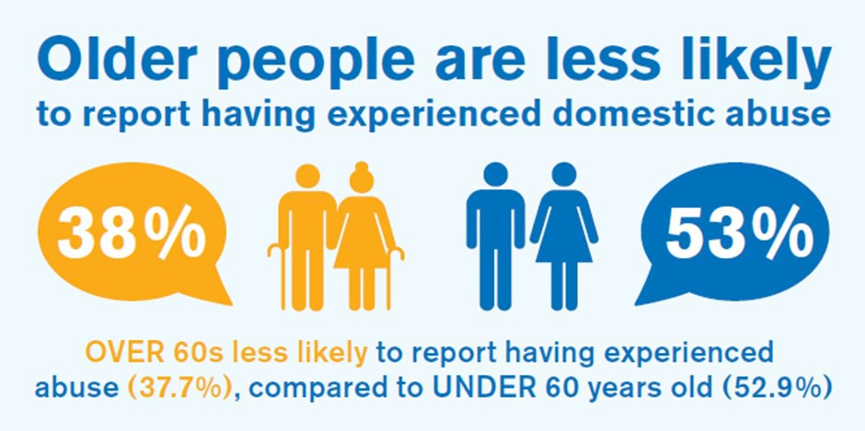
Churchgoers in this study were much more aware of domestic abuse the church than within it

These infographics reflect some of the findings of the ‘In Churches Too’ research

Reasons why victims would not seek support from the church in relation to domestic abuse;

In churches too – information

Reason* Number %**
I was not involved with a church at the time 24 32.4%
I felt too embarrassed or ashamed 24 32.4%
I felt that it was my duty to make the relationship work 20 27.0%
There was no one that I knew or trusted well enough 19 25.7%
I blamed myself for my partner’s behaviour 16 21.6%
I wasn’t aware that I was experiencing domestic abuse 15 20.3%
I was worried about confidentiality and other people at church finding out 15 20.3%
I felt it was wrong to talk negatively about my spouse/partner to someone at church14 18.9%
They might have made things worse 14 18.9%
I didn’t think anyone would believe me 13 17.6%
They would not have had the right expertise to help 11 14.9%
My partner/spouse had a position of responsibility and this made it difficult to confide in others4 5.4%
I had a position of responsibility and this made it difficult to confide in others 4 5.4%
I was worried that anything I said might be reported to another organisation 2 2.7%
Other 10 13.5%

*The figures in this table are based on the 74 people who answered this question. Due to the very small number of men answering this question, separate figures for women and men have not been provided.
**These percentages do not add up to 100% as respondents could tick multiple reasons.

1.17 Domestic Abuse and The Law

Criminal law
Many acts that are commonly perpetrated by an abuser, such as physical violence, sexual abuse and threats of violence towards a victim, are criminal acts. If enough evidence can be gathered, the police may be able to build a case and the Crown Prosecution Service (CPS) proceed to prosecute an abuser for criminal actions, even if the victim withdraws their consent or does not want to press charges.

There is a high standard of proof in most criminal cases, and although the police and CPS work hard to investigate reported incidents, they are subject to limited resources and therefore cannot pursue every case. If there is an element of domestic abuse in a criminal case, a criminal court can impose a ‘restraining order’ on an offender, which makes it an automatic offence for them to contact or visit their victim and/or children for a specified period of up to five years.

Civil law
Some types of abuse are not crimes in themselves: If, for example, an abuser tries to control a survivor by continuously contacting them and communicating with them in ways that cause emotional or psychological damage, or by refusing to leave the property.

However, repeated unwanted contact can amount to harassment or malicious communications, which are both criminal offences. Where such issues are present, or where there is stronger evidence of abuse, but it has not led to criminal prosecution, the family court can grant a ‘non-molestation order’. This order can be phrased to forbid an abuser from contacting, abusing or visiting a survivor or a child of the family, or from approaching the family home. Once the order is served on an abuser, it is then an automatic criminal offence for them to breach it. This means that actions such as repeatedly calling the survivor, which would not normally be considered criminal, could become sufficient for the police to bring a criminal prosecution. If the abuser was subject to the order and is found guilty, acts that were already criminal, such as violence towards the survivor, can also be punished more severely.

If a perpetrator is still living with their victim, the civil courts have the power to order the abuser out of the family home. The civil courts have to balance the housing options available to both parties and be satisfied that the level of risk to the victim justifies the risk of making the perpetrator homeless.

MARAC (Multi-Agency Risk Assessment Conferences) operate across the UK in the highest risk cases of domestic abuse. Key agencies, including the police, probation, social care, health, housing and voluntary sector organisations, attend these meetings. The primary focus of the MARAC is to safeguard the adult victim. The victim does not attend, but is represented by an Independent Domestic Violence Adviser (IDVA). Representatives share all known information about a victim and an action plan is then developed to help manage the risk and keep the victim safe. The action plan is monitored and reviewed.

Churches cannot refer directly to ask for a MARAC. Therefore, contact The Director of Safeguarding who may decide to carry out a Domestic Abuse, Stalking and Honour Based Violence (DASH) risk assessment, prior to liaising with the statutory authorities who then decide if a MARAC is warranted.

National Centre for Domestic Violence (0800 970 2070)
Survivors of domestic abuse can call this organisation for free, confidential advice. The organisation can make referrals to numerous organisations across the country that offer support and guidance. They can also refer survivors to a panel of solicitors who specialise in dealing with emergency cases to obtain civil non-molestation orders or occupation orders at short notice. An occupation order allows the court to decide who should live, or not live, in the home or any part of it. The order can also exclude the other person from an area around the home. They can advise on whether or not a survivor is eligible to have their legal costs, for obtaining the protection of the courts, paid for by the state.

Independent Domestic Violence Advisors (IDVA) are advocates who focus on high-risk clients by providing support to people who have been assaulted or abused by their partner or a family member. The IDVA can explain the criminal justice process, attend court, and provide support on a range of things such as the emotional impacts of domestic abuse, housing and legal matters. The IDVA service is central to a Multi-Agency Risk Assessment Conference (MARAC).

Independent Sexual Violence Advisors (ISVA) are trained to provide emotional and practical support to survivors of rape, sexual abuse and sexual assault, who have reported to the police or are considering reporting to the police.

Sexual Assault Referral Centre (SARC) is a special facility where victims of rape or sexual assault can receive immediate help and support. This includes access to a forensic medical examination, which is carried out by an experienced and qualified doctor, and the opportunity to speak to the police about what has happened.

Clare’s Law or the Domestic Abuse Disclosure Scheme
Under this scheme, launched in March 2014, parties have the right to ask the police whether a new or existing partner has a violent past. If police checks show that a person may be at risk of domestic abuse from their partner, the police will consider disclosing the information Clare’s law has two functions:

1. The ‘right to ask’ – This enables someone to ask the police about a partner’s previous history of domestic violence or violent acts. A precedent for such a scheme exists with the Child Sex Offender Disclosure Scheme.
2. The ‘right to know’ – Police can proactively disclose information, in agreed circumstances. NB It is important to note that the police do not know most perpetrators of abuse, because the abuse has not been reported or they have not been prosecuted.

Protection orders and notices
If someone has suffered from, or been threatened with, domestic abuse, the police can issue a Domestic Violence Protection Notice and then apply to the magistrates’ court for a Domestic Violence Protection Order. This can protect the survivor from further abuse and, if they live with the perpetrator, ban the abuser from returning home and contacting them. If the perpetrator does not keep to the order, they can be arrested and brought before the court.

A Domestic Abuse Protection Order lasts for up to 28 days and can give the survivor time to explore their options and obtain further support.

Third party reporting centres
There are many barriers to reporting domestic abuse. Third Party Reporting Centres (TPRC) aim to overcome these barriers. They are based in community locations where the survivor can make a report of domestic abuse without having to visit a police station. Staff at the centres are trained to deal sensitively with survivors and, if survivors request it, the report they complete will be forwarded to the police and/or council on the victim’s behalf.

Stalking and harassment
There is no strict legal definition of stalking, but it includes following a person, watching/spying on them, or forcing contact on them through any means, such as social media. The effect of the behaviour is to curtail a survivor’s freedom, leaving them feeling that they constantly have to be careful. In many cases, the conduct may appear innocent (particularly if taken in isolation), but when carried out repeatedly it may cause significant harm, harassment or distress to the survivor.

Harassment of an individual can also occur when a person is harassing others connected with the individual, knowing that this behaviour will affect the survivor as well as the others knowing that this behaviour will affect the survivor as well as the others involved. This is known by the CPS as ‘stalking by proxy’. Family members, friends and employees of the survivor may be subjected to this.

Revenge porn
This is the umbrella term for the sharing of private sexual material, either photos or
videos involving another person, without their consent and for the purpose of causing embarrassment or distress. It is now illegal to share such material without the consent of the person involved. They may have agreed to be filmed, but may not have consented to it being made public. If a person is concerned about an abuser threatening to release materials of this nature, a non-molestation order may be obtained from the courts that could include a condition forbidding an abuser from releasing material and making it an offence to do so. If such material is placed on any social media platform, this can also be reported directly to the provider, who should assist with removal of the images.

People with no recourse to public funds
Many people come to the UK legally, in the hope of improving their lives. One of the conditions for permitting immigration into the UK can be that the person arriving is not permitted to use public funds, and this can be stamped on their passport on arrival, as part of their visa. This can deny them access to certain state benefits, including housing benefit and income support, even if the person marries a UK citizen. If the person is ever subject to violence, the lack of those benefits can deny them the ability to live independently should they be forced out of their home and in need of refuge.
26
Those on a UK partner visa, who entered the UK as a partner of a British citizen or person
settled in the UK, can access the destitution domestic violence (DDV) concession.25

This provides time-limited access to financial and housing support, while they apply for indefinite leave to remain under the domestic violence concession rule. This enables them to access a place at a refuge or other form of safe accommodation. These provisions are not, however, accessible to people on other types of visa, and it is important to understand the significant barriers to escaping and accessing safety that face people in this position.

Legal aid
A victim of domestic abuse might be able to get legal aid if there is evidence that they or their children have been victims of domestic abuse or financial control (for example, if they are stopped from accessing a joint bank account). A survivor does not have to produce evidence before talking to a legal aid solicitor or getting Civil Legal Advice (CLA),26 but it will need to be shown before they can be granted legal aid. Evidence could come from various sources, including the courts, police, a refuge, a health/social care professional or a church minister.

