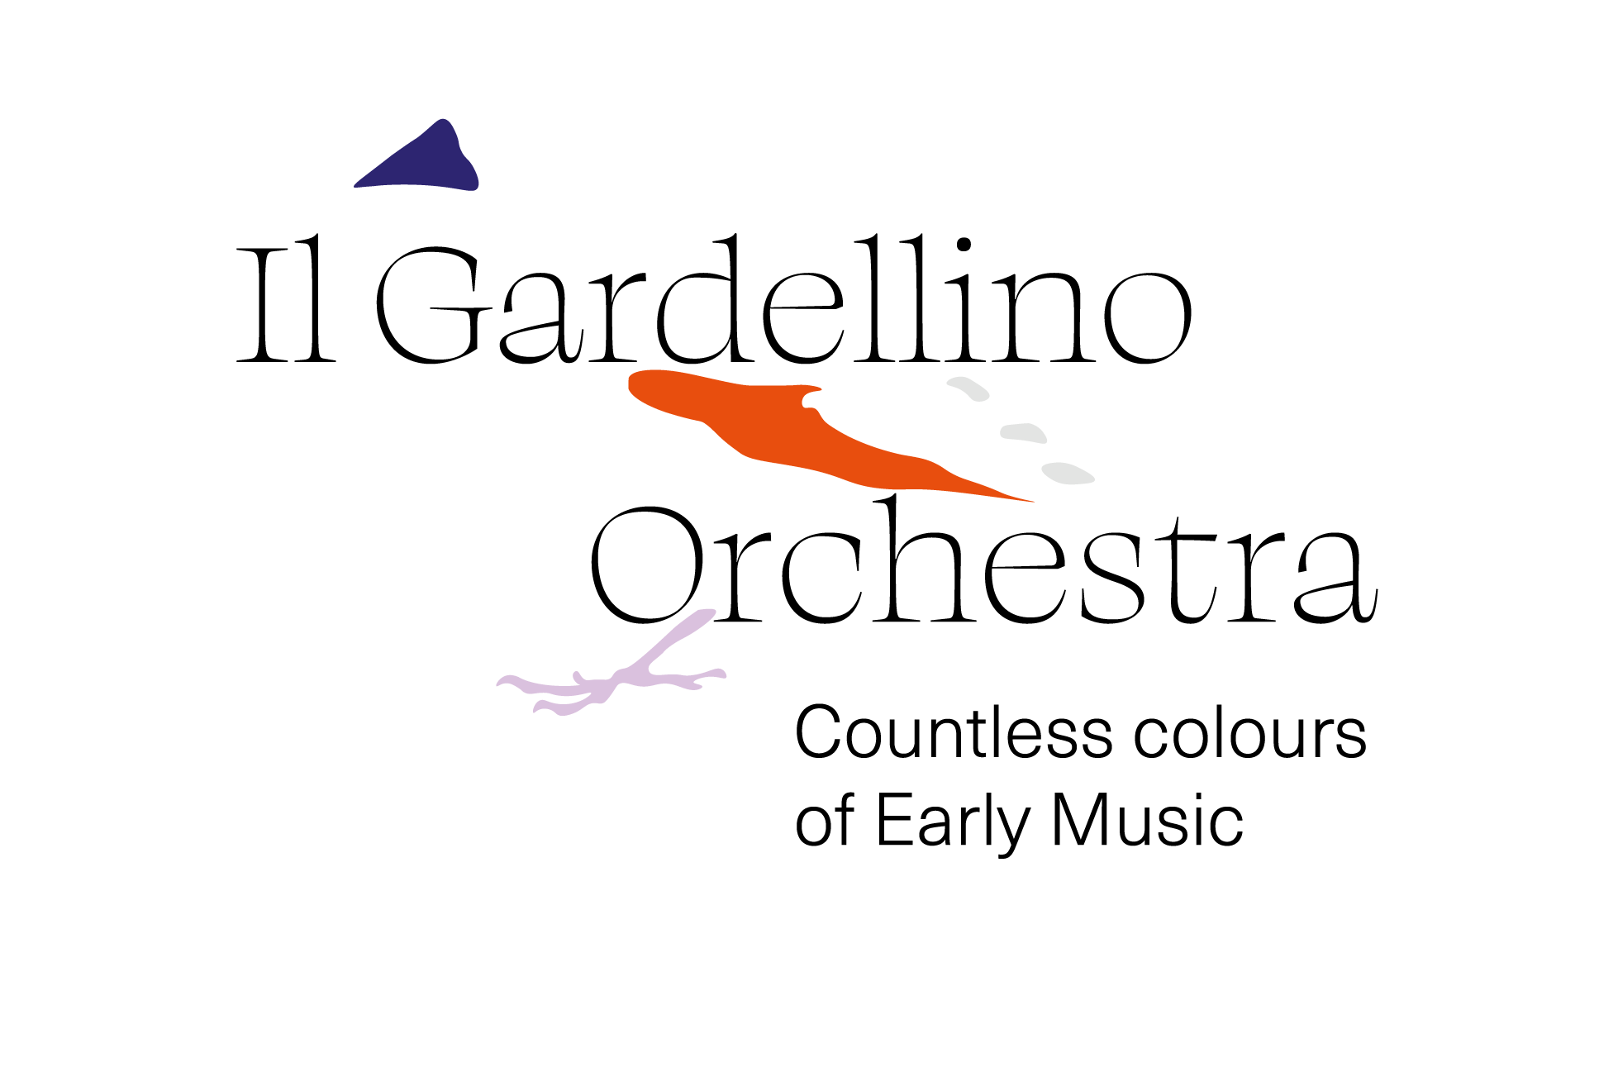
Friends & Patrons
Il Gardellino has guaranteed quality and innovation for more than 35 years. To further develop a strong artistic and social story, Il Gardellino has launched an attractive friends and patronage program.
Become a Friend for €50 per year (duo €80) Info
Under 30: €30 Bernard Claeys
IBAN BE04 7370 0420 8631 (BIC KREDBEBB) friends@ilgardellino.be
+32 475 65 98 80
“Becoming a Friend” means:
- Cultural commitment: by becoming a Friend of Il Gardellino you show your involvement and attachment to cultural activities. You support an orchestra devoted to music from Monteverdi to Mozart, recognized worldwide as one of the highest-quality early-music ensembles.
- Collaboration: as a Friend of Il Gardellino you have the opportunity to become more involved in the orchestra’s workings and to discover the Il Gardellino family from the inside.
- Social network: friendship with Il Gardellino connects you with other music lovers and (baroque) enthusiasts who share your interests.
- Support for the ensemble: by becoming a Friend of Il Gardellino you contribute to the orchestra’s and its musicians’ long-term survival and help us pursue their musical dreams.
- Privileges: as a Friend of Il Gardellino you receive various benefits, such as discounts and/or free tickets for concerts, or exclusive access to rehearsals and events.
In addition to being a friend, also become a Patron and receive a tax certificate for your donation (min. €40).
Name: ______________________________________ First name: ____________________
National register or company number: _________________________________________
Address
Street & number: ____________________________________________________________
City: ____________________________ Postal code: ______ Country: _______________
Email: _______________________________________
I wish to receive / do not wish to receive* the Il Gardellino newsletter sent by email.
I become a Friend and/or Patron (Tick the box or boxes of your choice)
( ) Solo Friend — pay €50 with the reference "Friend"
( ) Duo Friend — pay €80 with the reference "Friend"
( ) Young Friend — pay €30 with the reference "Friend"
( ) Patron Bronze — pay €100 or more
( ) Patron Silver — pay €250 or more
( ) Patron Gold — pay €500 or more
( ) Patron Platinum — pay €1,000 or more
with the explicit reference “Donation”
IBAN BE04 7370 0420 8631 (BIC KREDBEBB)
I prefer that my name be / not be* included in the list of donors.
(Cross out the inapplicable option*)
non-profit organization
Il Gardellino Orchestra
c/o Kerkedelle 41
1200 Brussels
Belgium
Bernard Claeys
bernard.claeys@ilgardellino.be
+32/475.65.98.80

