Contact
Contact for Accessibility Enquiries: The LBC Bookings Manager
 bookings@lbc.org.uk
 020 8709 9978
www.londonbuddhistcentre.com/retreats
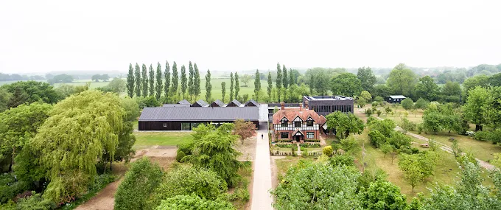

At a Glance
 Level Access
  - There is level access to all parts of the retreat centre
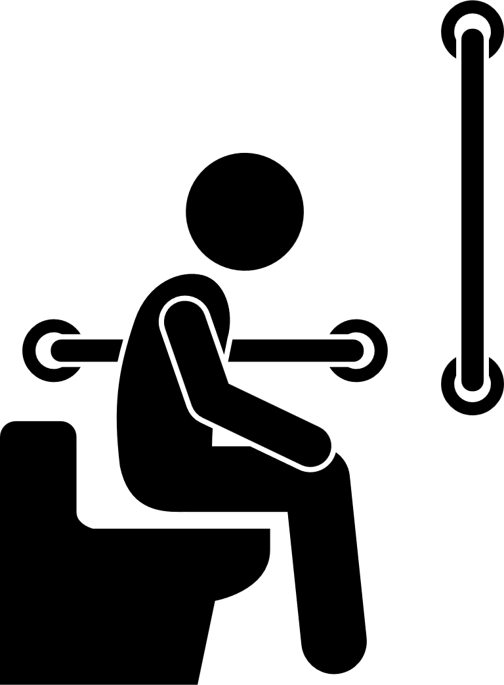 Accessible Toilets
  - Accessible toilets are available in the Dining block and Shrine blocks
Accessible Bedrooms
  - There are 3 accessible bedroom spaces that are served by level access shower rooms
 Hearing
  - The Shrine room is fitted with a hearing loop; speak to the bookings team in advance of the retreat about this equipment
 Mental Health
  - Please contact us in advance to discuss any mental health issues

Getting Here

Site Address
Vajrasana Retreat Centre
Walsham le Willows
Bury St Edmunds
IP31 3AR

Public Transport - Trains
- Stowmarket station - 11.5miles from our site
- Bury St Edmunds station - 11miles from our site
- Thetford station - 12 miles from our site
- All of these stations are served by Greater Anglia Railways. Please refer to their site for further details https://www.greateranglia.co.uk/
- Elmswell is the nearest train station which is around 6 miles from our site. However, as there are no taxi services based here we recommend you alight at the stations listed above.

Public Transport – Buses
- If you plan to use a bus to arrive on site, ensure that you plan your journey well in advance and ensure that you speak with the bus company on the phone a week before the retreat starts to ensure the following information is up to date.
- The nearest bus stop is in the centre of Walshaw le Willows (Six Bells) around 1.5miles from our site. The route is set relatively level with some gently sloping sections. The route is not generally served by a pavement.
- This stop is served by the 73 bus route operated by Simonds Coaches. Refer to there website for a timetable https://www.simonds.co.uk/local-bus-times
- At the discretion of the driver you may be able to arrange a stop half way up Reading’s Lane (where Vajrasana Retreat Centre is situated), between Walsham le Willows (Six Bells) and Sheperds Grove (Cafe) bus stops. We suggest you ask the driver when you get on the bus.

Coaches
- National Express coaches stop at Bury St Edmunds. Refer to their website for a timetable www.nationalexpress.com/en
- You will need to catch a taxi from here – see below.

Taxis
- Taxi services are limited so we advise booking well in advance. Please mention when booking if you will require assistance. They do not have wheelchair accessible vehicles, but can assist if the wheelchair can be folded.
      - Stowmarket – Cost around £25
Gold Star Taxis - 01449 676 767
      - Thetford – Cost around £40
A2B Taxis - 01842 755 222
      - Bury St Edmunds – Cost around £25
A1 Cars - 01284 766 777

Parking
- A car park is available on site which includes one accessible bay
- The car park can also be used for drop off
- The surface of the car park is compacted gravel
- The car park is set around 100metres from our reception building
- The route from the car park to our buildings is set level on a compacted gravel path
- Lighting along the path is limited

Arrival

Approach Route
- The route from the car park/drop off point to reception is around 100metres long. If needed, you can be dropped off at reception using the path
- The path is surfaced in compacted gravel and is at least 1.5metres wide
- The route is set level
- There is no seating along the route
- There is limited lighting to this route

Entrances
- All entrances achieve level access except the main reception doors which have a raised threshold of around 60mm deep. Alternative level access is available within a few metres of this door.
- Entrance doors generally achieve a clear width of at least 840mm
- The external door to the dining room is power assisted. All other doors are manual.
- Our doors are relatively large so may require more force than normal to pull open of up to 50Newtons
- Entrance doors tend to be of a similar colour to external walls

Reception
- We do not operate a formal reception point. You will be welcomed upon arrival by your hosts who will book you in and show you to your accommodation.

Getting Around Inside

General
- Our facilities are contained in 4 separate buildings generally laid out in a courtyard arrangement
- One block contains the Dining Room, Communal Lounge and the Shradda bedroom pod, The second block contains the Virya, Smrti, Samadi and Prajna bedroom pods, the third the Shrine Room and ancillary facilities and the fourth our office and a multi-purpose room.
- All are laid out within close proximity of each other with hard surfaced paths laid level linking them together

Dining block
- There are multiple entrances to this block. As set out above the reception entrance has a raised threshold but there are 3 alternative entrances with level thresholds one of which is power assisted
- This block contains a reception lobby and two large open plan rooms, one containing a lounge space the other the communal dining room
- Lounge and dining rooms incorporate kitchenettes. These do not incorporate kneespaces
- Internal doors achieve a clear width of at least 800mm
- Doors are not power assisted
- It also contains the Shradda bedroom pod
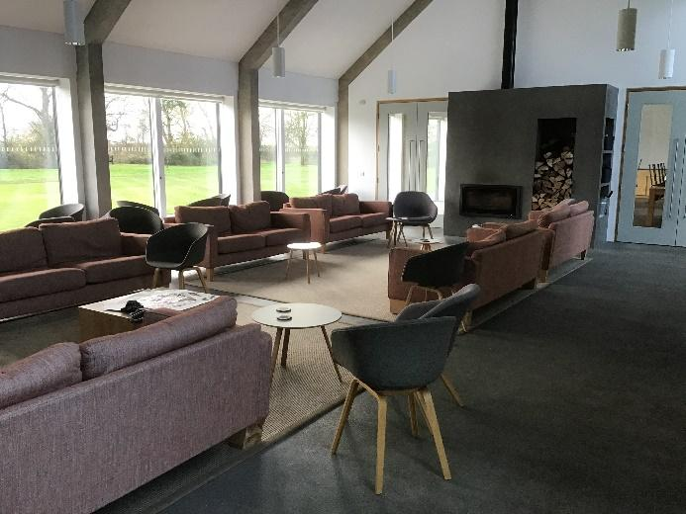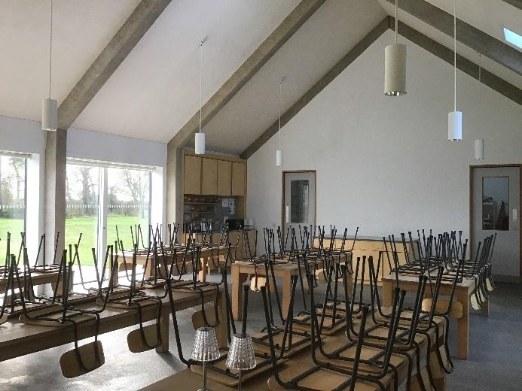

Bedroom Pods (Shradda, Virya, Smrti, Samadhi, Prajna
- Bedrooms are housed in 5 ‘Pods’ containing a mixture of 1, 2, 3, 4 and 5 bed rooms with communal washrooms and Accessible linked washrooms to Shraddha, Virya and Prajna pods
- Corridors to the bedroom pods are at least 1300mm wide serving doors achieving a clear width of at least 800mm
- Doors are not power assisted

Shrine block
- This block houses the shrine room which can be accessed directly from the Stupa courtyard or via a large lobby from which is accessed a changing area including toilets and a small meeting room
- The meeting room double doors achieve a limited clear width through a single leaf of 655-665mm
- Doors are not power assisted
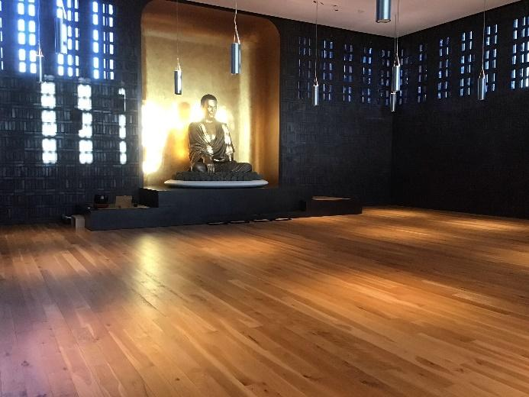

Staff block
- This block incorporates our office, a multi-purpose room and the ‘stable’ bedrooms
- The multi-purpose room and office are accessed from the entrance lobby
- Doors achieve a clear width of at least 800mm
- Doors are not power assisted

Toilets and Changing Facilities

Accessible Toilets - General
- Accessible toilets are available in the Reception lobby of the Dining Block and to the changing area of the Shrine Block
- The cubicle doors achieve a clear width of at least 835mm
- The toilet seats are set around standard chair height at 460mm above floor level
- The cubicles are fitted with pull cord alarms

Accessible Toilets – Reception lobby
- The cubicle achieves overall dimensions of 2050mm deep by 1470mm wide
- The clear space to the side of the pan is 945mm wide
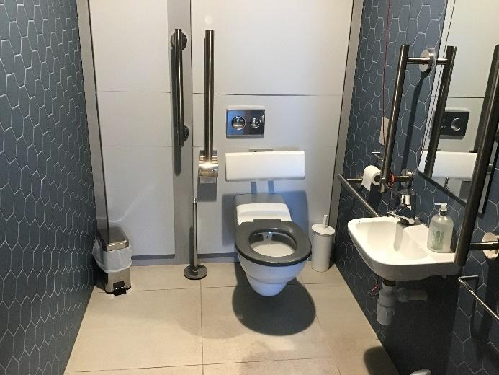

Accessible Toilets – Shrine
- The cubicle achieves overall dimensions of 2370mm deep by 1500mm wide
- The clear space to the side of the pan is 1000mm wide
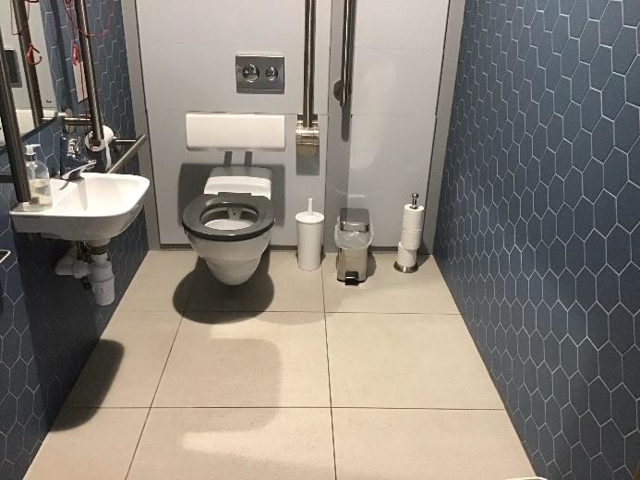

Standard Toilets
- Standard toilets are available alongside the accessible cubicles.

Accessible Accommodation

Accessible Bedrooms
- Accessible washrooms incorporating a level access shower and corner layout accessible WC are available in the Shradda, Virya and Prajna bedroom pod units
- These washrooms are served by bedrooms containing 4 single beds
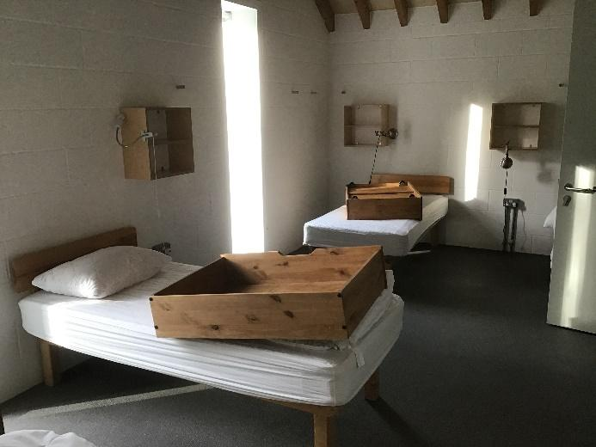
- The Accessible Bedroom doors achieve a clear width of 845mm.
- A transfer space of 1500mm by 1500mm can be created to the side of one bed. Please let us know your requirements in advance and, where possible we will set up the room to suit your needs.
- There is a clear aisle of at least 1350mm at the ends of the beds.
- The mattresses are set 570mm above floor level. There is clear space in excess of 200mm beneath the bed base. Bed raisers are not available.
- The window cills are set around 80mm above floor level. Controls are set 1100mm above floor level within a 390mm deep window reveal.
- The bedrooms are not fitted with an alarm system.
- Simple wall mounted shelves are available at the bedhead
- A pull out storage unit is also located under each bed. If you require alternative storage please let us know in advance.
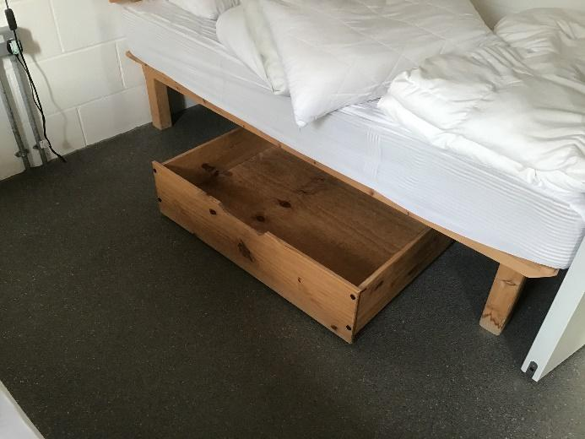
- The accessible washroom doors achieve a clear width of around 855mm.
- The washrooms generally achieve overall dimensions of around 2495mm deep by 2985mm wide with a clear turning circle in excess of 1800mm
- The toilet seats are set around standard chair height at 460mm above floor level
- The shower seats are set slightly higher than a standard chair height at 495mm above floor level
- The washrooms are fitted with pull cord alarm system with cords set adjacent to WC and shower seat.
- Accessible washrooms have low lighting levels
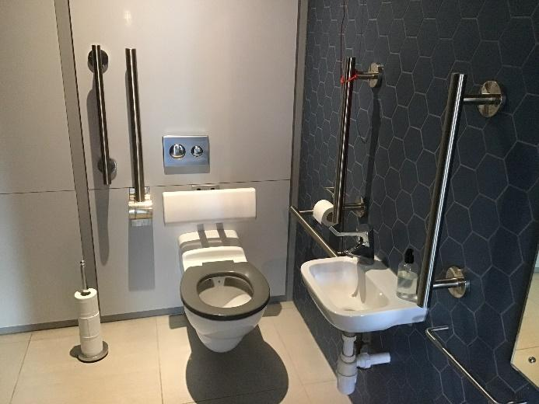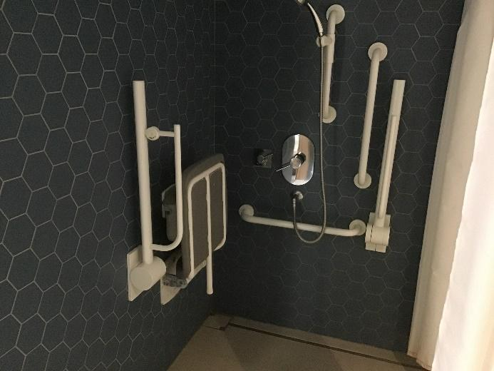

Getting Around Outside

Formal Gardens/Courtyards
- The formal gardens set in and around the buildings are accessed from hard surface paths or timber decking. All routes are set level and are step free.
- Formal and informal seating opportunities are available in all areas
- Seating to the Akshobhya and Stupa courtyards next to the Shrine are informal with no back or armrests. If you would like a chair with back and armrests please ask a member of our team.

Gardens and Grounds
- The wider grounds are laid to lawn with grass paths cut where weather allows
- A selection of seating is provided at regular intervals around the gardens

Information

Dietary requirements
- Provide details of any dietary requirements when booking or in advance of the retreat. The organiser or cooking team will inform you at the start of the retreat the arrangements for collecting meals.

Customer Care & Support

Booking Procedures
- Our accessible bedroom units incorporate 4 single beds but may be able to be set up to suit your specific needs. Please contact us in advance to discuss your requirements.

Evacuation
- The fire alarm has visual beacons fitted to accessible toilets and washroom areas only. All other areas are provided with audible alarms.
- The team will advise you of the evaluation procedure at the start of the retreat.

Mental Health
- We do not offer therapeutic support, so when you book, we will ask that you let us know about any mental health difficulties including serious trauma and also tell us if you’re on medication.
- If you’re unsure how you’ll manage on retreat, you can contact us before booking and through discussion we can establish if the retreat is suitable for you.

Assistance Dogs/Animals
- Assistance dogs are welcome
- There is no designated spending area on site but there are extensive grounds laid to lawn

