Reducing Staff Turnover Risk in Ambulatory Care: A Survey-Based Analysis of
Workload, Leadership Trust, Well-Being, and Intent to Stay

Abstract
Workforce turnover in healthcare threatens operational stability, staff well-being, and the quality and continuity of patient care. Ambulatory care settings are especially sensitive to turnover because lean staffing models amplify workload strain and disrupt team-based workflows. This cross-sectional study analyzed a staff experience survey administered in an adult ambulatory care setting (N = 86; response rate = 43%). The survey assessed current work experience, intent to stay, scheduling and workload, leadership presence and trust, stay conversations, well-being signals, and growth and recognition. Results showed that 69.8% of respondents reported workloads that were frequently or unsafely overwhelming, and 76.7% reported very little or no control over their schedules. Perceptions of leadership engagement were low; 74.4% disagreed that leaders are regularly present to understand barriers, and 69.8% reported that feedback is rarely or never acted upon. Nearly all respondents (97.7%) reported no recent stay conversation with a supervisor about what helps them want to stay. Burnout signals were prominent: 58.1% reported emotional exhaustion often or almost always in the prior two weeks. Collectively, the findings indicate a substantial retention risk and support the need for multifaceted retention strategies that target staffing and workload, scheduling flexibility, leadership follow-through, and scalable well-being supports.

Keywords: turnover, ambulatory care, workload, burnout, leadership engagement, retention, scheduling flexibility
Introduction
Healthcare workforce turnover remains a persistent challenge that affects staffing stability, organizational costs, morale, and patient outcomes. Turnover can reduce continuity of care and increase workload for remaining staff, which may contribute to burnout and subsequent turnover intentions. In ambulatory care, staffing continuity is particularly important because high patient throughput and coordinated workflows depend on stable, experienced teams.
Prior research indicates that turnover is multifactorial, often driven by workload and staffing conditions, scheduling practices, leadership engagement, professional development opportunities, and well-being resources. Umbrella and systematic reviews emphasize that retention improves most reliably when interventions address multiple drivers rather than relying on a single program or policy (Halter et al., 2017; Wynendaele et al., 2025).
Many organizations lack local evidence about which drivers matter most in their context. Without baseline data, leaders may implement interventions that are misaligned with staff needs. Staff surveys provide a practical method for identifying modifiable factors (e.g., workload manageability, schedule control, leadership trust) and prioritizing retention strategies.
Accordingly, the purpose of this study was to examine staff experience survey results in an adult ambulatory care setting and to quantify key indicators of turnover risk, including workload manageability, schedule control, leadership presence and follow-through, stay conversations, and burnout-related signals. By describing these factors and their prevalence, this study informs the design of targeted retention strategies and establishes a baseline for future evaluation.
Research Question and Hypotheses
Research Question: What do staff experience survey results reveal about workload, scheduling control, leadership trust, well-being, and intent to stay among staff in an adult ambulatory care setting?

Hypotheses:
H1: More than half of respondents will report an overwhelming workload (frequently or overwhelmingly overwhelming).
H2: Intent-to-stay responses will show meaningful variation across categories, indicating a non-uniform retention outlook.
H3: Perceptions of leadership engagement, feedback follow-through, and well-being will reflect conditions associated with elevated turnover risk.
Literature Review
Turnover in healthcare is widely recognized as a complex outcome shaped by structural, relational, and individual factors. Research shows that workload intensity and work environment conditions are among the most reliable factors influencing employees' intentions to leave — or their actual departure (Halter et al., 2017; Wynendaele et al., 2025).
When workload increases due to inadequate staffing or inefficient processes, emotional exhaustion rises, and job satisfaction declines, increasing the likelihood of leaving.
Retention is also affected by work schedules and how much control employees feel they have over those schedules. Studies show that poor schedules and long hours increase turnover and burnout, especially when staff lack autonomy and face unpredictable changes (Bae, 2023; Bae, 2024). Increasing flexibility and limiting mandatory overtime are common strategies to improve retention.
Leadership engagement is another recurrent theme. Leader presence, meaningful listening, and follow-through on staff concerns are associated with better safety culture and retention-related outcomes. In a quality improvement initiative focused on high reliability, structured leader rounding was associated with improved engagement processes and safety-related outcomes (Murray et al., 2025). In contrast, unresponsiveness quickly reduces trust and leads to disengagement.
Burnout is a crucial factor linking workload and leadership climate to employee turnover. Large observational studies and national surveys show that burnout and reduced well-being are associated with intent to leave and patient safety concerns (Aiken et al., 2023). Importantly, burnout is modifiable. Randomized and follow-up studies of the WISER intervention demonstrate that brief, web-based well-being programming can reduce burnout symptoms among healthcare workers when implemented with appropriate organizational support (Profit et al., 2021; Profit et al., 2024; Sexton et al., 2022).
Retention is also shaped by access to professional growth opportunities and transitional support. Systematic reviews examining interventions among early career nurses indicate that mentorship, comprehensive onboarding programs, and positive workplace environments are associated with higher retention rates (Brook et al., 2019). Research indicates that a mix of staffing, workload management, scheduling autonomy, leadership engagement, and accessible well-being resources improves retention more than individual interventions (Halter et al., 2017; Wynendaele et al., 2025).
Methods
Design
A cross-sectional survey design was used to assess staff perceptions associated with turnover risk in an adult ambulatory care setting.
Participants and Setting
All staff in the setting were invited to participate (N = 200). A total of 86 staff completed the survey (response rate = 43%).
Survey Instrument
The survey included seven sections: (1) Current experience and intent to stay, (2) Scheduling and workload, (3) Leadership presence and trust, (4) Stay conversations and voice, (5) Well-being and burnout signals, (6) Growth/onboarding/feeling valued, and (7) Open-ended retention prompts. Response formats included single-choice items, 4-point Likert items, frequency items, multi-select items, and open-ended questions (Appendix A).
Data Analysis
Closed-ended items were summarized using frequencies and percentages. Multi-select items are reported as the percent of respondents selecting each option (totals may exceed 100%). Key themes were identified from open-ended responses to provide context for the quantitative results.
Results
A total of 86 staff responded to the survey. The following tables and figures display the main quantitative results.

Table 1
Current Experience: How Coming to Work Feels (N = 86)

Response Option | n | %
Energizing | 2 | 2.3
Neutral/manageable | 15 | 17.4
Draining but necessary | 40 | 46.5
Unsustainable | 7 | 8.1
It varies a lot week to week | 22 | 25.6

Table 2
Intent to Stay: Current Job Outlook (N = 86)

Response Option | n | %
I plan to stay here and grow | 44 | 51.2
I plan to stay for now, but I am unsure long-term | 21 | 24.4
I am actively considering leaving within the next year | 10 | 11.6
I am unsure | 11 | 12.8

Table 3
Workload Manageability (N = 86)

Response Option | n | %
Very manageable | 5 | 5.8
Mostly manageable | 21 | 24.4
Frequently overwhelming | 51 | 59.3
Unsafely overwhelming | 9 | 10.5

Table 4
Perceived Schedule Control (N = 86)

Response Option | n | %
A great deal | 10 | 11.6
Some | 10 | 11.6
Very little | 48 | 55.8
None | 18 | 20.9

Table 5
Leadership Presence to Understand Barriers (N = 86)

Response Option | n | %
Strongly agree | 8 | 9.3
Agree | 14 | 16.3
Disagree | 46 | 53.5
Strongly disagree | 18 | 20.9

Table 6
Belief That Feedback Leads to Action (N = 86)

Response Option | n | %
Almost always | 2 | 2.3
Sometimes | 24 | 27.9
Rarely | 31 | 36.0
Never | 29 | 33.7

Table 7
Emotional Exhaustion Frequency (N = 86)

Response Option | n | %
Never | 9 | 10.5
Occasionally | 27 | 31.4
Often | 30 | 34.9
Almost always | 20 | 23.3

A significant proportion of respondents, 60 out of 86 (69.8%), indicated that their workload was often or excessively overwhelming, as shown in Figure 1.

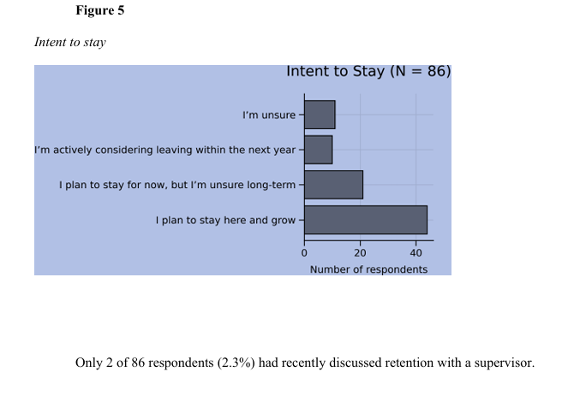
Figure 1 — Workload Manageability
Most respondents — 66 out of 86, or 76.7% — reported having minimal or no control over their schedules (see Figure 2).

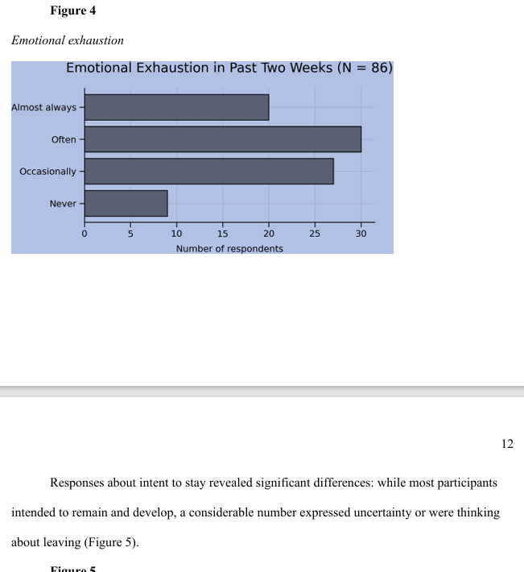
Figure 2 — Perceived Schedule Control
Most respondents (74.4%, 64 out of 86) disagreed that leaders are regularly present to understand barriers (see Figure 3).

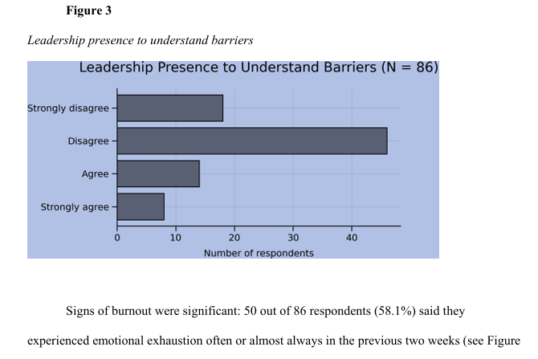
Figure 3 — Leadership Presence to Understand Barriers
Signs of burnout were significant: 50 of 86 respondents (58.1%) reported experiencing emotional exhaustion often or almost always in the previous two weeks (see Figure 4).

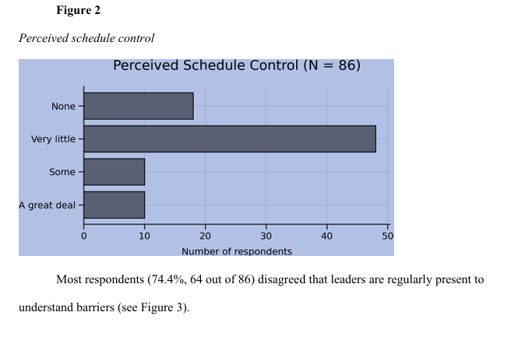
Figure 4 — Emotional Exhaustion Frequency
Responses regarding intent to stay revealed significant differences: while most participants intended to remain and develop, a considerable number expressed uncertainty or were considering leaving (Figure 5).

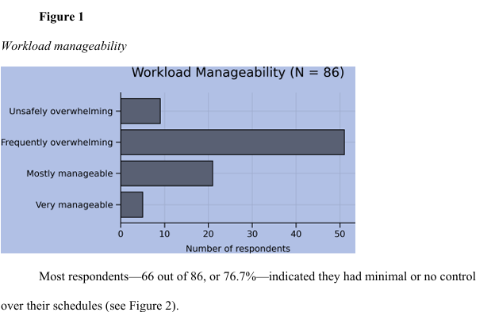
Figure 5 — Intent to Stay
Only 2 of 86 respondents (2.3%) had recently discussed retention with a supervisor.
Discussion
The study identified several indicators of increased retention risk within an adult ambulatory care environment. Approximately 70% of participants reported experiencing an overwhelming workload, while over 75% cited constrained schedule flexibility. These results align with previous research demonstrating the connection between workload, schedule constraints, burnout, and turnover intentions (Bae, 2023; Bae, 2024; Halter et al., 2017).
Leadership engagement emerged as a critical concern. Around 75% of respondents felt that leaders are not often present to identify obstacles, and roughly 70% said feedback is seldom or never addressed. Research on retention highlights leadership visibility and responsiveness as key factors in improving engagement and safety culture (Murray et al., 2025; Wynendaele et al., 2025).
Burnout was common, with over half of respondents frequently feeling emotionally exhausted and reporting limited access to support. Burnout correlates with intent to leave and patient safety risks (Aiken et al., 2023). Research shows that scalable well-being interventions can lower burnout when organizations provide adequate support (Profit et al., 2021; Sexton et al., 2022).
The lack of stay conversations is a missed opportunity. Stay interviews and structured check-ins can highlight concerns and build psychological safety when leaders follow up transparently. Survey responses indicate staff appreciate leaders who listen, address issues, and remove obstacles, underscoring the value of responsive leadership.
Taken together, findings support a multifaceted retention strategy: workload and staffing stabilization, increased schedule autonomy, structured leader rounding with feedback loops, routine stay conversations, and accessible well-being supports. Future work should evaluate these strategies using longitudinal designs and operational outcomes — such as turnover rates and vacancy rates — to assess their impact and sustainability.
Limitations
The study is limited by its cross-sectional design, which prevents causal inference. The findings represent perceptions specific to a particular time period and may be affected by concurrent events or recent staffing changes.
Survey results are based on individuals' own reports, which introduces the possibility of nonresponse bias, as those with stronger views may have been more inclined to participate. Furthermore, since only summary data were available, it was not possible to examine how variables relate to one another for each person.
Finally, the study was conducted in an ambulatory care setting, which may limit generalizability to other departments or organizations.
Future Research
Future research should use pre-post or longitudinal designs to evaluate whether targeted retention strategies reduce workload strain, improve leadership trust, and increase intent to stay over time.
Whenever possible, subsequent research should connect survey findings to operational metrics such as turnover rate, vacancy rate, and time-to-fill. Future studies should also examine subgroup variations to promote equitable improvement across roles and shifts.
Qualitative methods (e.g., focus groups) could further clarify drivers of workload strain and identify feasible interventions to improve workflow, staffing, and psychological safety.
Conclusion
The survey shows that ambulatory care faces significant risks of staff turnover due to overwhelming workloads, lack of control over schedules, low leadership engagement, and clear signs of burnout. While many employees plan to remain, uncertainty persists, and some are considering leaving, making retention a meaningful concern. Organizations can use these insights to prioritize comprehensive retention strategies that improve staffing levels, increase scheduling flexibility, strengthen leadership involvement, and provide accessible well-being support.
References
Aiken, L. H., Lasater, K. B., Sloane, D. M., et al. (2023). Physician and nurse well-being and preferred interventions to address burnout in hospital practice: Factors associated with turnover, outcomes, and patient safety. JAMA Health Forum, 4(7), e231809. https://jamanetwork.com/journals/jama-health-forum/fullarticle/2807049

Bae, S.-H. (2023). Association of work schedules with nurse turnover: A cross-sectional national study. International Journal of Public Health, 68, 1605732. https://www.ssph-journal.org/journals/international-journal-of-public-health/articles/10.3389/ijph.2023.1605732/full

Bae, S.-H. (2024). Nurse staffing, work hours, mandatory overtime, and turnover in acute care hospitals affect nurse job satisfaction, intent to leave, and burnout: A cross-sectional study. International Journal of Public Health, 69, 1607068. https://www.ssph-journal.org/journals/international-journal-of-public-health/articles/10.3389/ijph.2024.1607068/full

Brook, J., Aitken, L., Webb, R., MacLaren, J., & Salmon, D. (2019). Characteristics of successful interventions to reduce turnover and increase retention of early career nurses: A systematic review. International Journal of Nursing Studies, 91, 47–59. https://www.sciencedirect.com/science/article/abs/pii/S0020748918302591

Halter, M., Pelone, F., Boiko, O., Beighton, C., Harris, R., Gale, J., Gourlay, S., & Drennan, V. (2017). Interventions to reduce adult nursing turnover: A systematic review of systematic reviews. The Open Nursing Journal, 11, 108–123. https://opennursingjournal.com/VOLUME/11/PAGE/108/

Murray, J. S., Clifford, J., Scott, D., Kelly, S., & Hanover, C. (2025). Assessing the effectiveness of leader rounding for high reliability: A quality improvement initiative. BMJ Open Quality, 14(1), e003101. https://bmjopenquality.bmj.com/content/14/1/e003101

Profit, J., Adair, K. C., Cui, X., et al. (2021). Randomized controlled trial of the "WISER" intervention to reduce healthcare worker burnout. Journal of Perinatology, 41(9), 2225–2234. https://www.nature.com/articles/s41372-021-01100-y

Profit, J., Cui, X., Tawfik, D., Adair, K. C., & Sexton, J. B. (2024). "WISER" intervention to reduce healthcare worker burnout: 1-year follow-up. Journal of Perinatology, 44, 1719–1723. https://www.nature.com/articles/s41372-024-01993-5

Sexton, J. B., Adair, K. C., Cui, X., Tawfik, D., & Profit, J. (2022). Effectiveness of a bite-sized web-based intervention (WISER). Frontiers in Public Health, 10, 1016407. https://www.frontiersin.org/journals/public-health/articles/10.3389/fpubh.2022.1016407/full

Wynendaele, H., Clays, E., Peeters, E., DeJonghe, Y., Van Hecke, A., & Trybou, J. (2025). Understanding turnover in healthcare and welfare sectors of high-income countries: An umbrella review. BMC Health Services Research, 25, 806. https://link.springer.com/article/10.1186/s12913-025-12966-5

Appendix A
Staff Experience Survey Questions

Your Current Experience
Q1. Right now, how does coming to work usually feel for you? (Single choice)
Energizing / Neutral / manageable / Draining but necessary / Unsustainable / It varies a lot from week to week.

Q2. Which statement best reflects how you are feeling about your job at this moment? (Single choice)
I plan to stay here and grow / I plan to stay for now, but I am unsure about the long term / I am actively considering leaving within the next year / I am unsure.

Q3. If you imagine yourself six months from now, where do you most hope to be? (Single choice)
In this role, feeling supported / In this organization, but a different role / Somewhere else entirely / I am not sure yet.

Scheduling & Workload
Q1. How much control do you feel you have over your work schedule? (Single choice)
A great deal / Some / Very little / None

Q2. When your schedule works well, what makes that possible for you? (Multi-select)
Better work-life balance / Less burnout or fatigue / Better focus at work / More consistency for patients / It has not made a noticeable difference yet.

Q3. Which scheduling challenges, if any, affect you most? (Single choice + Other)
Short notice changes / Limited ability to swap shifts / Overtime expectations / Staffing gaps / None of the above / Other

Q4. On most days, how manageable does your workload feel? (Single choice)
Very manageable / Mostly manageable / Frequently overwhelming / Unsafely overwhelming

Leadership Presence & Trust
Q1. I regularly see leaders in my work area who genuinely want to understand the barriers we face. (4-point Likert)
Strongly agree / Agree / Disagree / Strongly disagree.

Q2. When leaders ask for feedback, I believe it is acted on. (Frequency)
Almost always / Sometimes / Rarely / Never

Q3. What matters most to you when leaders check in? (Multi-select, up to 2)
Being listened to without judgment, / Follow-up on issues raised, / Recognition for good work, / Help removing barriers, / Transparency about decisions

Stay Conversations & Voice
Q1. Have you had a recent conversation with a supervisor about what helps you want to stay? (Single choice)
Yes / No / Not yet, but planned

Q2. If yes, how did that conversation feel? (Single choice)
Honest and meaningful / Mostly positive / Neutral / Uncomfortable or rushed

Q3. What would make these conversations more valuable to you? (Open-ended)

Well-Being & Burnout Signals
Q1. In the past two weeks, how often have you felt emotionally exhausted by your work? (Frequency)
Never / Occasionally / Often / Almost always

Q2. I feel able to pause, reset, or ask for support when work becomes overwhelming. (4-point Likert)
Strongly agree / Agree / Disagree / Strongly disagree.

Q3. Which support helps you most when work is stressful? (Multi-select)
Supportive coworkers / Supervisor support / Schedule flexibility / Short well-being activities or breaks / I do not currently have effective supports

Growth, Onboarding & Feeling Valued
Q1. I understand what growth looks like for me in this organization. (4-point Likert)
Strongly agree / Agree / Disagree / Strongly disagree.

Q2. I feel my skills and contributions are recognized. (Frequency)
Often / Sometimes / Rarely / Never

Q3. If you could improve one thing about how new or existing staff are supported, what would it be? (Open-ended)

The Question We Do Not Ask Enough
Q1. What is one thing that, if it changed, would make it easier for you to stay here? (Open-ended, optional)

