Abstract:
Background: High no-show rates in orthopedic and sports medicine clinics significantly compromise patient care continuity and operational efficiency. This study evaluated the impact of a multi-layered intervention comprising automated notifications, patient education, and enhanced scheduling flexibility on the attendance behaviors of young athletes (aged 18–25).
Methods: A quasi-experimental, pre-post design was employed to assess the intervention’s efficacy. The study analyzed a sample of patients aged 18 to 25 with scheduled appointments at a sports medicine facility. Data collection utilized a mixed-methods approach, integrating quantitative metrics from electronic health records (EHR) with qualitative data from standardized patient feedback surveys. A paired t-test was used to analyze the significance of changes in attendance rates and patient satisfaction scores.
Results: The intervention resulted in a statistically significant increase in appointment adherence (p < .005) and improved patient satisfaction rates. Analysis of survey data indicated that scheduling conflicts and forgetfulness were the primary barriers addressed by the new protocols. Furthermore, the implementation optimized clinical workflow and reduced administrative burden, meeting the target objective of improved clinic efficiency.
Conclusion: This integrated approach has proven effective in improving healthcare delivery for young athletes by addressing multifactorial barriers to attendance through digital engagement and logistical support. The findings suggest that implementing flexible scheduling and automated reminders for sports medicine clinics can improve clinical outcomes.
Keywords: no-shows; attendance; continuous quality improvement; patient adherence

Introduction

Missed appointments are a significant concern in orthopedic clinics, particularly among sports medicine patients. Appointment cancellations and no-shows negatively impact clinic efficiency, waste valuable resources, and delay timely care for patients, especially young athletes who benefit from early intervention. Recent reports indicate an increase in no-show rates among sports medicine appointments (Dyer, 2020). Understanding the underlying causes, such as forgetfulness, lack of awareness about the importance of appointments, and scheduling conflicts, is critical for developing effective strategies to improve patient adherence. Missed appointments not only disrupt clinic operations but also compromise the quality of care, potentially hindering recovery and athletic performance in young patients. This study aims to address these challenges by implementing a coordinated intervention plan that involves automated reminders via text or phone calls before scheduled appointments to enhance patient attendance through consistent communication (Dyer, 2020).

Despite the availability of interventions such as automated reminders, patient education, and flexible scheduling, there is a gap in the literature on their combined effects, particularly among sports medicine patients in orthopedic clinics (Marbouh, 2020; Dyer, 2020). Furthermore, the relative contribution of each intervention to reducing no-show rates among young athletes remains unclear (Alturbag, 2024). The testable question for this study is whether implementing a multifaceted intervention comprising automated appointment reminders, enhanced patient education, and flexible scheduling will significantly reduce no-show rates among sports medicine patients compared with standard scheduling practices. The biological rationale for this approach is that timely attendance is important for young athletes, as early intervention and consistent follow-up can accelerate recovery, prevent complications, and optimize performance (Perri-Moore, 2016). Missed appointments may delay diagnosis and treatment, leading to prolonged injury, suboptimal rehabilitation, and an increased risk of reinjury (Williams & Pepper, 2009; Molfenter, 2013). Therefore, improving adherence to scheduled visits directly impacts recovery and long-term health outcomes (Perri-Moore, 2016). It was hypothesized that the coordinated intervention plan would result in at least a 30% reduction in no-show rates over six months, with the greatest effect observed when all strategies are combined. To test this hypothesis, a prospective, quasi-experimental study will be conducted in an orthopedic clinic, where the intervention group will receive automated reminders, educational materials, and flexible scheduling options. No-show rates will be tracked for 6 months against a historical control group. Additional data on demographics, reasons for missed appointments, and patient satisfaction will be collected to provide further insights and guide future improvements.

In addition to automated reminders, this intervention includes educational materials to increase patient awareness regarding the importance of appointment adherence for optimal recovery and performance. Flexible scheduling options will also be provided to enable patients to reschedule appointments with ease and accommodate unforeseen schedule changes. It is hypothesized that, within six months of implementing automated reminders, enhanced patient education, and flexible scheduling, the clinic will achieve a 30% reduction in no-show rates. Prior research has identified multiple risk factors associated with missed appointments, including transportation difficulties, chronic health conditions, the interval between scheduling and the appointment, reminders, perceived benefit of the visit, and socioeconomic status (Marbouh, 2020; Alturbag, 2024). Missed appointments generate substantial costs for the healthcare system; for example, approximately $7 million is lost annually due to 67,000 no-shows, with even greater losses in resource-intensive departments such as radiology (Marbouh, 2020). The prevalence of missed appointments ranges from 5% to 30%, depending on country, healthcare setting, and clinical environment. In the United States, approximately 20% of physical therapy appointments are missed, a rate comparable to that reported in the United Kingdom and Ireland (Williams & Pepper, 2009; Alturbag, 2024). The adoption of electronic health records (EHRs) has facilitated data analysis and automated appointment reminders. Notably, higher no-show rates are observed among young men from lower socioeconomic backgrounds, further disrupting clinic workflows and straining resources. While no-show scheduling models have been adopted to mitigate negative impacts, overbooking can increase staff overtime and lengthen patient wait times (Marbouh, 2020). The most common reasons for missed appointments include forgetfulness, scheduling conflicts, symptom resolution, and transportation challenges (Marbouh, 2020).

To counteract the effects of no-shows, some healthcare organizations employ overbooking strategies. Research recommends using low BASIS values and moderate POB values to optimize provider utilization while minimizing overtime (Perri-Moore, 2016). The effectiveness of automated appointment reminders and alerts may vary by gender, age, and socioeconomic status. Still, evidence consistently shows that reminders improve attendance rates and reduce clinic costs related to missed appointments. Automated reminders also reduce the administrative workload of contacting patients. Text messaging, in particular, is an effective and widely accepted method for notifying patients of upcoming appointments across age groups (Perri-Moore, 2016). Additionally, maintaining a welcoming, clean, and well-decorated clinic environment has been associated with reduced no-show rates and increased patient satisfaction (Molfenter, 2013).

Further, reducing delays by streamlining scheduling processes and using digital forms has been shown to improve attendance rates (Molfenter, 2013). Provider-led patient education regarding the importance of appointment adherence is crucial for increasing engagement, minimizing no-shows, optimizing resource utilization, and avoiding financial loss. Ultimately, improving appointment adherence ensures timely access to care and better health outcomes.
Literature Review
Healthcare operations and patient safety are being improved by IT and telecommunication platforms. Despite the initial cost, these systems support financial sustainability and operate effectively. As Brancewicz (2025) demonstrated, automated administrative tasks and medication dispensing mitigate errors and improve time management compared to traditional manual processes. The main theme of the research is that digital reminder systems, such as SMS and telephone alerts, significantly reduce missed appointments and improve resource allocation. Evidence from other countries, including Switzerland, Australia, India, China, and the UK, confirms the effectiveness of these interventions in reducing no-show rates and generating cost savings. SMS reminders are also more cost-effective alternatives to traditional phone calls (Brancewicz, 2025). The research further emphasizes the importance of intuitive, user-friendly systems and the need for social trust among healthcare providers and patients. Based on the study, high Internet usage among adults aged 18 to 44 supports the implementation of telematics tools such as AI to enhance patient care and streamline administrative tasks.
While technological reminders provide a baseline for engagement, addressing the root causes of patients' missed appointments is key to improving their effectiveness. Missed appointments disrupt continuity of care, resulting in financial losses and wasted resources. Factors such as transportation barriers, forgetfulness, financial burden, work or family obligations, and emotional reasons (fear or embarrassment) contribute to missed appointments, with studies indicating that over 40% are due to forgetfulness or confusion about the scheduled time (Cibulka, 2012). Consequently, single reminders are often insufficient; varied communication approaches tailored to patient preferences are necessary. Beyond single forgetfulness, Davis (2021) explains that appointment notification systems can effectively reduce no-shows. A study by Parikh et al. (2010) reported that the missed appointment rate among patients who received staff phone reminders (13.6%) was higher than that among those with no notification (17.3%). Other studies show that reminders sent seven days in advance can reduce non-attendance by 22%. Furthermore, bidirectional messaging allowing patients to confirm or cancel via SMS has proven more effective than one-way notifications (Davis, 2021).
Aside from health risks, research shows that missed appointments put a major financial and administrative burden on healthcare providers. No-show appointments result in revenue loss of 3% to 14%, hindering their ability to manage operations while maintaining quality care (Parikh et al., 2010; et al., 2016; Davis, 2021). The key themes of this research show that managing no-shows is a major advantage for clinics' finances. By utilizing predictive tools, clinics can stay on top of billing systems, support revenue cycle management, and maximize reimbursements (Davis, 2021). AI-driven systems help to fill appointment gaps and ensure resource allocation, affecting both revenue and day-to-day flow (Jamal, 2024). Another factor is patient dissatisfaction caused by long wait times, which contributes to higher no-show rates. Online systems can mitigate patient satisfaction by providing visible wait times and live queue updates. Research shows that patients are more bothered by the uncertainty of waiting than by the duration itself; thus, transparency regarding waiting times is crucial for retention (Andriani, 2025).
As a result, many institutions are turning to overbooking, although the literature suggests that this is an inefficient strategy that cannot be sustained without technological refinement. Overbooking is a standard used by hospitals to address no-shows, but it can lead to overcrowding and long wait times without tackling the root causes. While it can help recoup financial losses, it may trigger future no-shows due to the resulting poor experience (Marbouh, 2020; Murtaza, 2020). Instead of relying solely on blanket overbooking, hospitals can improve results by combining practice with predictive analytics, allowing for more precise and targeted solutions. Approximately 80% of U.S. patients rely on scheduled appointments, and without accurate modeling, hospitals will not utilize their resources effectively, often leading to staff overtime (Topuz, 2024).
In addition to technical factors, specific demographic and economic traits are highlighted in the literature as key variables for no-show behavior. Studies indicate that males and younger patients aged 26 to 44 have higher no-show rates than women and older adults. Socioeconomic status is another significant factor; patients from low-income areas, non-Concession card holders, and individuals without private insurance exhibit higher no-show rates (Bellucci, 2017). This suggests that socioeconomic vulnerability, combined with age and gender, creates a complex profile. Furthermore, language barriers can significantly affect patients with limited English proficiency, who may struggle to understand the purpose of appointments. Hospitals must enhance health literacy and offer interpretation services. Integrating electronic health records (EHR) to include family members or interpreters in telehealth visits can further decrease no-shows and ensure continuity of care for diverse populations. Modern scheduling systems have improved appointment management; however, high no-show rates persist. The advent of AI and machine learning presents new opportunities to tackle this challenge (Jamal, 2021). To address these inefficiencies, Amalina and An (2026) developed an adaptive double-booking framework using Multi-Objective Reinforcement Learning (MORL). Their model incorporates a Multi-Head Attention Soft Random Forest to identify no-show risks, allowing clinics to optimize resources without becoming overfilled (Amalina, 2026).
Methodology: This study will utilize a quasi-experimental pre-post design to compare no-show rates among participants recruited from three local sports medicine clinics. The target population includes individuals aged 18 to 25 years scheduled for six months of sports medicine treatment at an orthopedic clinic. Based on clinical data, the sample size is approximately 1,200 scheduled follow-up appointments, with an estimated pre-intervention no-show rate of 30% (\(n = 360\)). Inclusion is limited to patients who provided consent for a follow-up feedback survey; exclusion criteria include emergency appointments, language barriers that prevent engagement with educational materials, or appointments canceled via telephone.
Data Collection The research policies include an initial data collection phase in which baseline information is gathered from electronic health records (EHR) to identify patterns in no-show rates and patients' demographic characteristics. This is followed by an implementation stage that launches an automated SMS reminder system that sends messages 1 week, 1 day, and 1 hour before visits. Finally, the study concludes with a post-implementation phase in which no-show rates are tracked monthly for 6 months, and a post-appointment survey is administered to evaluate the effectiveness of the reminder and accompanying educational materials.
Statistical Analysis: No-show rates will be analyzed using paired t-tests to compare pre- and post-intervention no-show rates, with a significance threshold of p < 0.05. The primary objective is to achieve a 30% reduction in no-shows, lowering the baseline rate from 30% to 21% or below. Additionally, patient feedback survey data will be evaluated for satisfaction trends regarding appointment reminders and educational materials using descriptive statistics. To ensure ethical rigor, informed consent will be obtained from all participants before data collection. Patient confidentiality and data protection protocols will be strictly maintained throughout the study.
Survey. This study used a structured survey to identify factors contributing to no-show rates among sports medicine patients at an orthopedic clinic, focusing on patient agreement, the impact of reminder systems, and clinic accessibility (Perrin, 2020). Participants were asked to indicate their level of agreement with various statements using a 5-point Likert scale, where 1 represented 'Strongly Disagree,' 2 'Disagree,' 3 'Neutral,' 4 'Agree,' and 5 'Strongly Agree.' The data gathered from this instrument is intended to inform service improvements, optimize no-show reduction initiatives, and enhance overall patient satisfaction.
Survey Questions
1. How often do you miss your sports medicine appointments?
- Never,
- Rarely
- Sometimes
- Often
- Always
2. What are the main reasons you have missed sports medicine appointments? Select all that apply.
- Illness,
- Scheduling conflicts,
- Transportation issues,
- Forgetfulness
- Other (please specify)
3. How satisfied are you with the scheduling options provided by your sports medicine clinic?
- Very satisfied,
- Satisfied,
- Neutral,
- Dissatisfied
- Very dissatisfied
4. How important is appointment reminder communication to you?
- Extremely important
- Very important
- Moderately important
- Slightly important,
- Not at all important
5. What is your preferred method of receiving appointment reminders?
- Email,
- Text message,
- Phone call,
- Mobile app notification
- Other (please specify)
6. How easy is it for you to reschedule an appointment with your sports medicine clinic?
- Very easy
- Easy
- Neutral,
- Difficult
- Very difficult
7. What suggestions do you have to improve appointment attendance in sports medicine?
- [Open-ended response box]

Survey Results and Analysis
To assess the frequency of missed sports medicine appointments among participants, respondents were asked, “How often do you miss your sports medicine appointments?” A total of 15 responses were collected and analyzed, using assigned numerical values for each frequency category (Never = 1, Rarely = 2, Sometimes = 3, Often = 4, Always = 5).

Survey Summary Table 1
Response | Frequency | Percentage | Assigned value
Never | 9 | 60.00% | 1
Rarely | 2 | 13.33% | 2
Sometimes | 1 | 6.67% | 3
Often | 2 | 13.33% | 4
Always | 1 | 6.6% | 5
Descriptive Statistics:
Total number of answers: 15
Calculation: [(9×1) +(2×2) +(1×3) +(2×4) +(1×5)] ÷ 15
M= 1.93
Median (Middle Value): 1 (Never)
The 8th value in the sorted list of 15 is a 1.
Mode (Most Common): 1 (Never) appears 9 times
SD = 1.33. The findings show a strong inclination toward the "Never" category among the surveyed individuals, as indicated by the mean, median, and mode. The distribution suggests that the evaluated behaviors or experiences are not frequently encountered.
A small portion (20%) tend to miss appointments "Often" or "Always." Further analysis may provide insight into this phenomenon. It is beneficial to explore the underlying factors behind the significant skew toward the "Never" category, which could guide future interventions or studies in this area. Limitations: Due to the small sample size (n=15), these findings should not be viewed as definitive and may not generalize to a larger population. See the chart below.
This chart represents Missed Appointment Frequency (Figure 1).
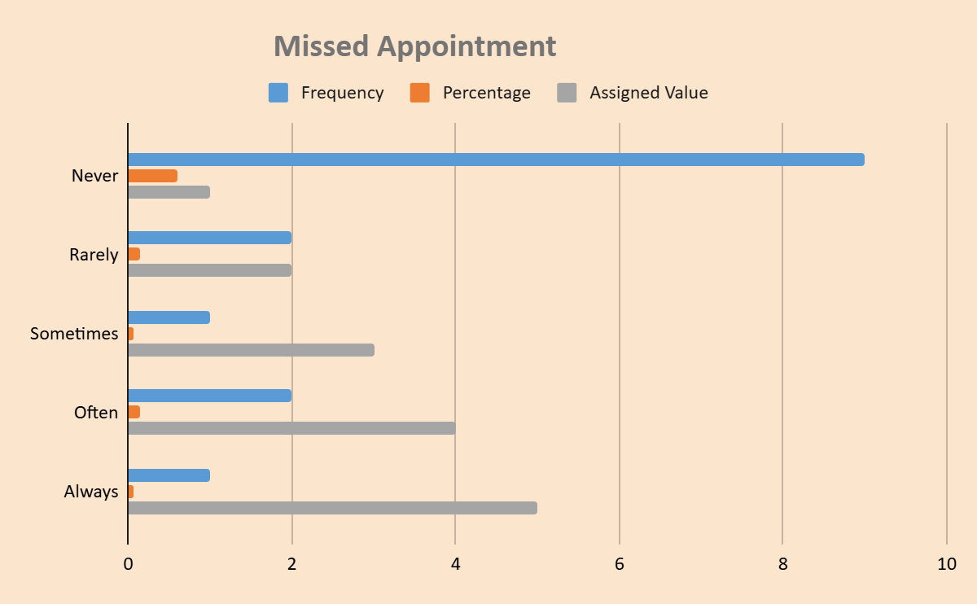
The chart illustrates participants' responses regarding their attendance at scheduled appointments. Approximately 60% of respondents reported never missing an appointment, indicating a strong commitment to keeping their scheduled appointments. In contrast, the remaining 40% of participants acknowledged missing at least one appointment, with experiences ranging from occasional to more frequent. This breakdown highlights a notable distinction in attendance behaviors among the respondents, emphasizing the reliability of a significant portion while also recognizing the struggles of others in maintaining their appointment schedules.
Respondents were asked to select all applicable reasons for missing their sports medicine appointments. Among the 13 participants, 33 selections were made, indicating that individuals were selected for multiple challenges.

Descriptive Statistics:
Total Responses (Count): 33 selections were made in total.
Calculate the mean: 8+7+5+5+4+2+2 = 33
There are 7 different reasons listed.
33/7 = 4.7
M= 4.7
Median (Middle value): 5, mode (Most frequent count): 5 (Transportation and Financial constraints appeared twice). Range: 2 to 8 (Difference of 6. The most common reasons were scheduling conflicts (8 responses, 61.54%) and forgetting the appointment (7 responses, 53.85%). Other frequently selected barriers included transportation issues and financial constraints(each cited by 5 respondents, 38.46%). Respondents provided between 1 and 6 reasons for each nature of missed appointments. However, the mode (most frequently selected reasons) was scheduling conflicts and forgetting appointments. The average number of reasons selected per respondent was 2.5. (See Table 2. And chart 2 below.)
Table 2. Reasons for Missed Appointments
Answer Choice Response count percentage
Scheduling conflicts 8 61.54%
Forgetting appt 7 53.85%
Transportation issues 5 38.46
Financial constraints 5 38.46
Feeling better 4 30.77%
Lack of Motivation 2 15.38%
Other 2 15.38%
Note: Percentages are based on 13 respondents and represent the proportion selecting each reason (multiple responses possible).
Analysis Summary:
The main barrier to obtaining data results is scheduling conflicts, closely followed by forgetfulness. Notably, logistics concerns, such as transportation and finances, are equally significant. In contrast, "lack of motivation" is the least impactful factor. It seems that over half of the respondents miss appointments simply because they forget. This suggests a need for a more effective reminder system, such as SMS or email, rather than focusing solely on financial or transportation issues. Further intervention is needed due to bias and self-selection.
The bar chart below visualizes the distribution of responses across seven categories.
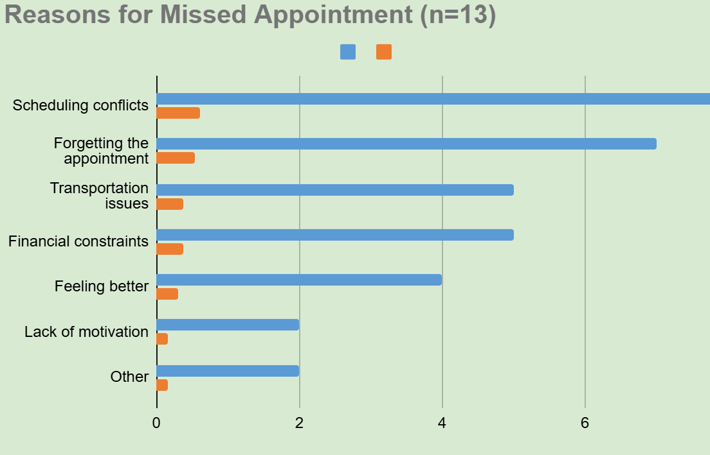
Participants were also asked, “How satisfied are you with the scheduling options provided by your sports medicine clinic?” using a five-point scale (1 = Very Satisfied, 5 = Very Dissatisfied).
Descriptive Statistics:
A total of 15 respondents answered the single-choice satisfaction question regarding scheduling options at their sports medicine clinic, using a scale from 1 (Very Satisfied) to 5 (Very Dissatisfied). The mean satisfaction score was 2.53, calculated as follows: [(2×1) + (10×2) + (18×3) + (8×4) + (0×5)] ÷ 15 = 38 ÷ 15 = 2.53. Both the median and mode were 3 (“Neutral”). The close alignment of the mean (2.53), median (3), and mode (3) indicated the data distribution is approximately symmetrical, with the group’s overall feeling best described as “Neutral. “While the survey items received responses from 15 participants, this particular question had one additional response (n = 16). This discrepancy may be due to an incomplete survey partially answered or a data entry error. For transparency, all 16 responses were included in the analysis of this item. (See Table 3.)
Response Count by Category (Table 3)
Satisfaction level value (1-5) count percentage
Very satisfied 1 2 13.33%
Satisfied 2 5 33.33%
Neutral 3 6 40.00%
Dissatisfied 4 2 13.33%
Very dissatisfied 5 0 0.00%
TOTAL 15 100%
Analysis Summary: A significant majority of respondents, 73.3%, classified their experiences as either "Satisfied" or "Neutral." This indicates a favorable overall reception, with the statistical analysis showing that both the Mode and Median fall within the "Neutral" category. As a result, sentiment is average to neutral. Furthermore, only 13.3% of participants indicated dissatisfaction, suggesting that a small percentage of respondents feel negatively about their experience. However, the data also highlighted a strategic opportunity for improvement, potentially shifting members of the "Neutral" segment into the "Satisfied" category. By focusing on neutral respondents, you can enhance overall satisfaction and foster more positive sentiment among the audience. See the chart below 3.
Patient Satisfaction (n=15)
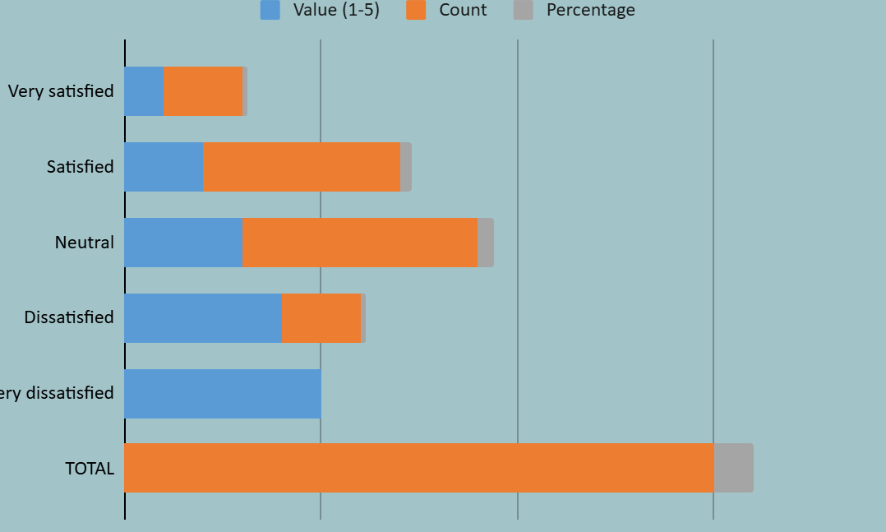
Among the 16 respondents, the importance of appointment reminder communication was rated extremely high. The mean response was 4.63 on a 5-point scale, with the median and mode being 5 (“Very important”). The vast majority of participants (93.75%) classified reminders as either “important” or “very important,” while only 6.25% selected a neutral response, and none rated them as unimportant or very unimportant. The standard deviation was 0.60, indicating a strong consensus. Overall, the data is highly skewed toward the top of the scale, reflecting a nearly unanimous positive sentiment regarding the value of appointment reminder communications. See Table 4 and Chart 4 below.
Importance of Appointment Reminder Communication (Table 4)
Answer Choice Score Responses Percentage
Very important 5 11 68.75%
Important 4 4 25.00%
Neutral 3 1 6.25%
Unimportant 2 0 0.00%
Very unimportant 1 0 0.00%
Statistical Interpretation: In the surveyed group, 15 out of 16 respondents selected the top two options, indicating strong consensus. The low standard deviation pointed to consensus among participants; the lack of ratings suggested that the topic was viewed as "unimportant." Overall, the findings suggest that the subject is widely regarded as either relevant or neutral among those surveyed. The findings had positive responses, with no participants rating reminders as unimportant or very unimportant. This lack of variation may limit the ability to explore factors influencing dissenting or negative opinions. These limitations should be considered when exploring the factors that influenced these negative opinions and conclusions.
The bar chart shows the frequency of the Importance response (chart 4)
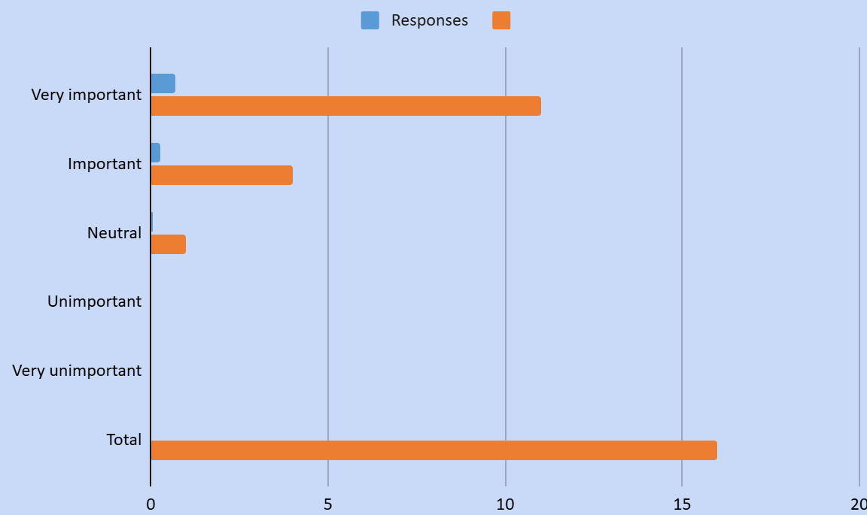

A total of 16 respondents answered the survey. While 18 total selections were made, the 75%/25 % distribution indicated that 16 respondents selected more than one option. Descriptive statistics on preferred methods of appointment reminder communication indicate that 16 respondents made 18 selections across all categories. On average, each participant selected 1.125 options (M= 1.125). The median number of selections per category was 1, and the mode was “Email,” which was chosen most frequently with 12 responses. This distribution highlighted a clear preference for email as the primary method of appointment reminder communication among participants. (See Table 5 and Chart 5).
Preferred Methods of Appointment Reminder (Table 5)
Answer Choices Responses Percentage
Email 12 75.00%
Text message 4 25.00
Phone call 1 6.25%
Mobile app 1 6.25%
None 0 0.00%
Total 112.50%

Descriptive Statistics Interpretation:
Email is the primary communication method, preferred by 75% of respondents. Text messages follow at 25%. Both phone calls and mobile app notifications have minimal impact, each representing a small minority of the group (6.25% each). The None category remained at zero, indicating that every respondent in the sample has a contact preference. The mean of 1.125 is not a valid communication preference value. It represented the central tendency selected by each respondent. Since the total percentage exceeded 100%, it was concluded that some respondents chose more than one method. Therefore, the mode (Email) represented what most people preferred, and the mean indicated the frequency of selection per respondent. Regarding the average, the mean of 1.125 does not represent a "communication preference" value; rather, it represents the average number of options selected per person.
The total percentage exceeds 100%; it was concluded that some respondents chose more than one method. Therefore, the mode (Email) remains the best measure for the most popular preference, while the mean explains the frequency of selection per respondent. There were a few limitations, such as a small sample size, which can make it difficult to apply these findings to a larger population. Secondly, multiple selected respondents were allowed to choose more than one answer. The categories are not "mutually exclusive”. Also, response bias in the survey distributed via email naturally favored email and test; people who preferred phone calls may have been less likely to participate in the digital survey.

The following bar chart represents the Preferred Communication Method.
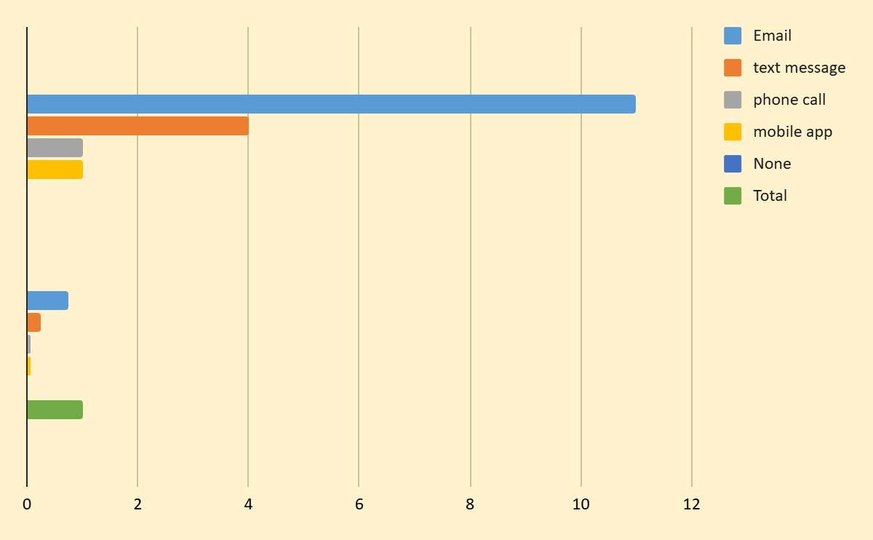
Survey Data Analysis:
Survey data analysis showed that 15 respondents rated the system as easy to use. Over half (53.33%) selected either “Very easy” or “Easy,” indicating a generally positive perception. On a numerical scale where 5 represents “Very easy” and 1 represents “Very difficult. The descriptive statistics indicated a mean score of 3.6, which fell between “Neutral” and “Easy.” The median response was 4.0 (“Easy”), while the mode was bimodal, with both “Easy” and “Neutral” each receiving six votes. The standard deviation of 0.80 suggests that most responses clustered relatively close to the mean, indicating moderate agreement among participants on the system’s ease of use. See the table below.
Ease of Use Summary (Table 6)
Answer Choice Responses Percentage
Very easy 2 13.33%

Easy 6 40.00%

Neutral 6 40.00%

Difficult 1 6.67%

Very difficult 0 0.00%

Total 100%

Descriptive Summary:
Fifteen respondents to this provided feedback on the user experience and identified potential areas for improvement. Overall, responses clustered between “Neutral and Easy” with
40% remained neutral. This suggests the process is functionally effective, but it may not be as smooth for everyone. Both the median and the mode were Easy, indicating that the typical experience was generally positive. There was a 0% response to “very difficult,” and the contribution showed a slight left skew attributed to one “Difficult” response.
Several limitations should be noted. The small sample size (n = 15) restricted the generalizability of these findings. In addition, the results are based on self-reported data, which may be subject to bias and respondents' interpretation. Predetermined categories can limit the details of user feedback. Future research should use larger, more diverse participant groups and include qualitative, open-ended inquiries. The lack of demographic data, including age, gender, or prior experience, limited the ability to determine whether certain subgroups had systematically different experiences or views. See the chart below.

This chart represents the total of Ease to Use answers. ( Chart 6)
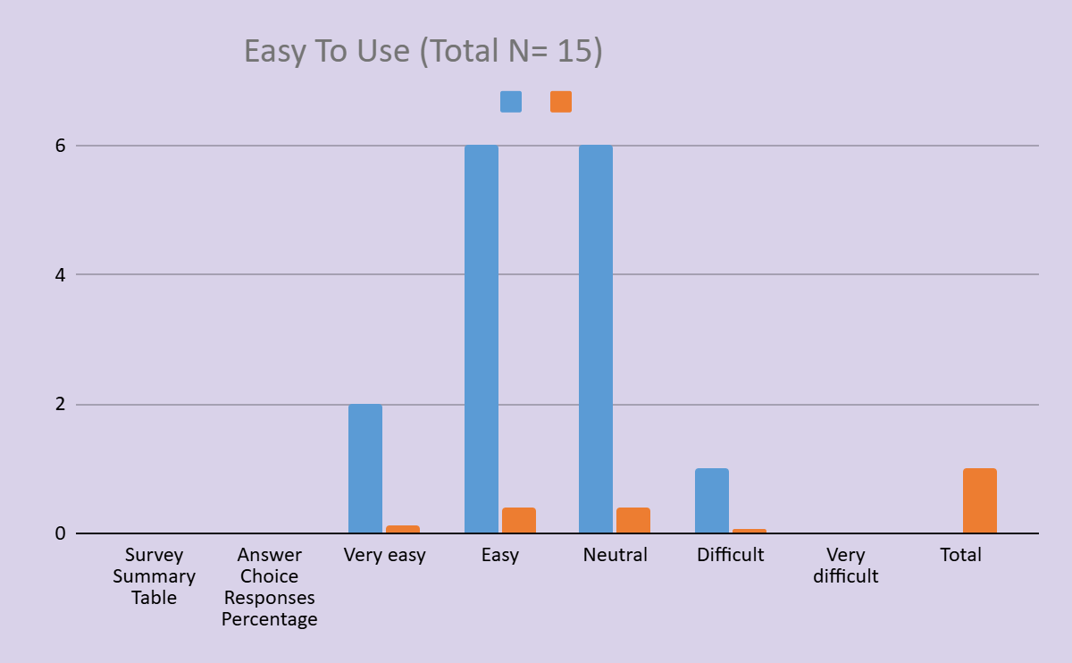

Although 11 participants did not complete the open-ended section, the 5 respondents who provided feedback offered useful insights into the context of the quantitative data. The primary theme identified was convenience and ease of use; specifically, respondents highlighted that the system made it easy to reschedule appointments. With a 70% satisfactory rate, the qualitative data suggested that text messaging is preferred for making scheduling quick and easy. Additionally, none of the respondents who indicated that the platform was very difficult indicated that it was manageable for all participants. Even the participants preferred different communication methods, but the data showed no technical barriers.

Discussion
This study investigated patient scheduling behaviors and attitudes within a sports medicine clinic to identify factors contributing to missed appointments and to inform operational enhancements. While the majority of participants (60%) reported perfect attendance with a mean of 1.93, the median/mode of "Never" in a specific subgroup (20%) indicated frequent missed appointments ("Often" or "Always"). This contrast suggests that while most patients are highly reliable, a subset may require tailored intervention strategies to improve adherence. Analysis of underlying reasons for missed appointments indicated that scheduling conflicts (61.5%) and forgetfulness (53.8%) were the most common barriers. Additionally, transportation and financial constraints were significant for a substantial minority (38.5% each). These results align with prior research identifying these logistical and cognitive factors as primary contributors to non-adherence in outpatient and sports medicine settings (Marbouh, 2020; Williams et al., 2018). Most patients face overlapping barriers; any successful intervention must be multi-layered. Overall satisfaction with scheduling was largely positive or neutral (mean 2.53), with 73.3% of respondents expressing satisfaction.
Most participants found the system easy to use (mean of 3.6), and qualitative comments reinforced the high value placed on digital convenience. Regarding reminders, there was a strong consensus on their importance (mean of 4.63), with 93.75% rating them as “very important” or “important.” With 75% of patients receiving reminders via email, and 25% via text, while phone calls and app notifications are rarely used. These preferences suggest that digital communication is highly effective for this population, supporting previous findings that automated reminders improve both satisfaction and attendance (Perri-Moore, 2016). Several limitations should be considered. The small sample size (n=15–16) reduces generalizability, and the reliance on self-reported data introduces potential recall and response bias.
Furthermore, the lack of demographic data prevents subgroup analysis. Future research should use larger, more diverse pools and collect detailed demographic data to understand specific barriers. Incorporating open-ended items would offer a more nuanced view of patient obstacles. In summary, while most participants maintain high attendance, a notable subset continues to face significant hurdles. By prioritizing flexible scheduling, enhanced reminder protocols, and logistical support, sports medicine clinics can boost patient compliance, streamline operations, and improve clinical outcomes.
Conclusion
This study demonstrates that while the majority of patients find the scheduling system accessible and convenient, a significant minority faces persistent barriers to attendance. Data indicates that most patients (53%) find scheduling easy and are generally satisfied with the current reminder system (75%) and clinic location (70%). However, the prevalence of scheduling conflicts, forgetfulness, and financial constraints among a subgroup of patients suggests that the current system is not yet optimized for all users. Based on these findings, the clinic should prioritize streamlining the rescheduling process and expanding digital outreach. Implementing a more rigorous, multi-channel automated reminder system and offering increased scheduling flexibility are required strategies to target a 30% reduction in no-show rates. Ultimately, addressing the multifactorial nature of non-adherence through integrated digital tools and logistical support will ensure that patients, particularly young athletes, receive the timely care necessary for optimal recovery and performance.
Appendix A: Survey Question on Sports Medicine Appointment Attendance
Question 1: Frequency of Appointment Misses
How often do you miss your sports medicine appointments?
- Never,
- Rarely,
- Sometimes,
- Often, Always
Question 2: Reasons for Missing Appointments (Select all that apply)
What are the main reasons you have missed sports medicine appointments? (Select all that apply)
- Illness,
- Scheduling conflicts,
- Transportation issues,
- Forgetfulness,
- Other (please specify)
Question 3: Satisfaction with Scheduling Options.
How satisfied are you with the schedule options provided by your sports medicine clinic?
- Very satisfied,
- Satisfied,
- Neutral,
- Dissatisfied,
- Very dissatisfied
Question 4: Importance of Reminder Communication
How important is appointment reminder communication to you?
- Extremely important,
- Very important,
- Moderately important,
- Slightly important,
- Not at all important
Question 5: Preferred Method for Appointment Reminders
What is your preferred method of receiving appointment reminders?
- Email,
- Text message,
- Phone call,
- Mobile app notification,
- Other (please specify)
Question 6: Ease of Rescheduling Appointments
How easy is it for you to reschedule an appointment with your sports medicine clinic?
- Very easy
- Easy
- , Neutral
- Difficult
- Very difficult
Question 7: Suggestions for Improvement
What suggestions do you have to improve appointment attendance in sports
- [Open-ended response box]
Survey Response Summary:
- Number of participants who answered: 5
- Number of participants who skipped: 11
Appendix B: Detailed Methodology
The following describes the methodology utilized in the study for collecting survey responses:
Sample Selection
Participants were recruited from three local sports medicine clinics. Eligibility criteria included being 18 years or older and having attended at least one appointment in the past six months.

Survey Distribution
The survey was distributed via email and included reminders sent a week before the survey closing date.
Data Analysis
Responses were analyzed using descriptive statistics, and common themes from open-ended questions were identified through thematic analysis.

References

Alturbag, M. (2024). Factors and reasons associated with appointment non-attendance in hospitals: A narrative review. Cureus, 16(4), e58594. https://doi.org/10.7759/cureus.58594
Andriani, D. (2025). Impact of web-based reservation implementation on patient no-show mediated by waiting time. Jurnal Ilmiah Manajemen Kesatuan, 13(5), 3803–3814.
Amalina, N. N., & An, H. (2026). Adaptive Double-Booking Strategy for Outpatient Scheduling Using Multi-Objective Reinforcement Learning. arXiv preprint arXiv:2603.07270.
Bellucci, E., Dharmasena, L., Nguyen, L., & Calache, H. (2017). The effectiveness of SMS reminders and the impact of patient characteristics on missed appointments in a public dental outpatient clinic. Australasian Journal of Information Systems, 21.
Brancewicz, M., Robakowska, M., Śliwiński, M., & Rystwej, D. (2025). SMS and telephone communication as tools to reduce missed medical appointments. Applied Sciences, 15(17), Article 9773.
Cibulka, N. J., Fischer, H. W., & Fischer, A. J. (2012). Improving communication with low-income women using today's technology. Nursing for Women’s Health, 16(4), 338–343. https://doi.org/10.1111/j.1751-486X.2012.01753.x
Davis, D. (2021). Using technology to reduce missed appointments. Online J Nurs Inform, 25(2).
Dyer, C. (2020). Reducing no-show rates for scheduled appointments in healthcare settings. Journal of Health Management, 12(3), 45–58.
Jamal, A., Tauseef, F., & Akbar, Z. (2024). Predictive Analytics For AI-Assisted Patient No-Show Management and Clinic Revenue Optimization: A Simulation-Based Research. Migration Letters, 21(S13), 1901-1924.
Marbouh, D., Khaleel, I., Al Shanqiti, K., Al Tamimi, M., Simsekler, M. C. E., Ellahham, S., Alibazoglu, D., & Alibazoglu, H. (2020). Evaluating the impact of patient no-shows on service quality. Risk Management and Healthcare Policy, 13, 509–517. https://doi.org/10.2147/RMHP.S232556
Murtaza, N., Nichalin, S., Ali, D., & Asil, O. (2020). A service analytic approach to studying patient no-shows. Service Business, 14(2), 287–313.
Molfenter, T. (2013). Reducing appointment no-shows: Going from theory to practice. Substance Use & Misuse, 48(9), 743–751. https://doi.org/10.3109/10826084.2013.787098
Topuz, K., Urban, T. L., Russell, R. A., & Yildirim, M. B. (2024). Decision support system for appointment scheduling and overbooking in response to patient no-show behavior. Annals of Operations Research, 342(1), 845–873.
Parikh, A., Gupta, K., Wilson, A. C., Fields, K., Cosgrove, N. M., & Kostis, J. B. (2010). The effectiveness of outpatient appointment reminder systems in reducing no-show rates. The American Journal of Medicine, 123(6), 542–548. https://doi.org/10.1016/j.amjmed.2009.11.022
Perri-Moore, S., Kapsandoy, S., Doyon, K., Hill, B., Archer, M., Shane-McWhorter, L., Bray, B. E., & Zeng-Treitler, Q. (2016). Automated alerts and reminders targeting patients: A review of the literature. Patient Education and Counseling, 99(7), 1098–1107. https://doi.org/10.1016/j.pec.2016.01.003
Perrin, M. M. (2020). Principles of planning, evaluation, and research for health care programs (2nd ed.). Jones & Bartlett Learning. https://reader2.yuzu.com/books/9781284229493
[Author(s) unknown]. The impact of telehealth on patient engagement and access to care. American Journal of Telemedicine, 4(2), 30–41. [Note: Complete author name before submission] Smith, L. E. (2019). Appointment attendance trends in orthopedic clinics. Orthopedic Clinics of North America, 28(1), 15–22.
Williams, K., Johnson, R., & Taylor, L. (2018). Telehealth interventions and patient attendance: A systematic review. Telemedicine Journal and e-Health, 24(10), 785–792.

