The Effectiveness of CBT in Treating Mandated Clients
Abstract
This study evaluates the effectiveness of Cognitive Behavioral Therapy (CBT) in reducing criminogenic thinking among justice-involved adult males participating in a community-based behavioral health program. The study population consisted primarily of African American and Hispanic men mandated to treatment as a condition of probation or parole. Given the limited timeframe of the study, direct measurement of recidivism was not feasible; therefore, changes in criminal thinking, measured using the Texas Christian University Criminal Thinking Scales (TCU CTS 3.0), were used as a proxy indicator of recidivism risk.
A quasi-experimental, one-group pretest–posttest design was employed. Data were collected from 26 participants (n = 15 pre-treatment; n = 11 post-treatment) and analyzed using descriptive statistics, effect size calculations (Cohen’s d), and distributional analysis. Results indicated substantial reductions across all five criminogenic thinking domains, with large-to-very-large effect sizes (d = 1.24–1.62). Distributional analyses revealed reductions in variability and attenuation of high-risk outliers following treatment.
Findings suggest that CBT is effective in reducing criminogenic thinking in real-world, mandated treatment settings. However, outcomes are influenced by engagement, motivation, and broader social determinants of health affecting marginalized populations. The study highlights the importance of culturally responsive program design, integrated support services, and evidence-based program evaluation within community behavioral health systems.
Keywords: cognitive behavioral therapy, criminal thinking, recidivism, justice-involved populations, healthcare administration, health equity
Introduction
The effectiveness of behavioral health interventions for justice-involved populations is a critical issue at the intersection of clinical practice, public health, and healthcare administration. In the United States, African American and Hispanic men are disproportionately represented within the criminal justice system and often face systemic barriers to accessing high-quality behavioral health care. These disparities raise important questions about the equity, accessibility, and effectiveness of interventions aimed at reducing recidivism and supporting successful community reintegration.
Community-based organizations such as Community Renewal Team (CRT) play a vital role in addressing these challenges by providing integrated behavioral health and reentry services. CRT’s Health & Wellness program serves individuals with substance use and mental health needs, including those transitioning from incarceration back into the community. A significant proportion of these clients are mandated to participate in treatment as a condition of probation or parole, creating a unique context in which engagement, motivation, and treatment outcomes may differ from voluntary populations.
Cognitive Behavioral Therapy (CBT) is widely used in correctional and community supervision settings due to its focus on modifying maladaptive thinking patterns associated with criminal behavior. From a healthcare administration perspective, CBT is a key intervention that requires effective program design, implementation, and evaluation. Administrators must ensure that such programs are not only evidence-based but also responsive to the complex needs of marginalized populations. This includes addressing social determinants of health, ensuring cultural responsiveness, and integrating supportive services that enhance treatment effectiveness.
The purpose of this study is to evaluate the effectiveness of CBT in reducing criminogenic thinking among justice-involved adult males in a real-world, community-based setting. By using changes in criminal thinking as a proxy for recidivism risk, this study contributes to the evidence base supporting CBT. It addresses the practical and methodological aspects of the
Literature Review.
A substantial body of research supports the effectiveness of CBT as an intervention for reducing criminal behavior and recidivism. Meta-analyses indicate that CBT-based programs can reduce recidivism by approximately 20–30%, particularly when targeted toward high-risk individuals and implemented with fidelity (Lipsey et al., 2007). These findings are grounded in the Risk-Need-Responsivity (RNR) model, which emphasizes that interventions are most effective when they target criminogenic needs such as antisocial cognition and are delivered in a manner responsive to individual characteristics (Bonta & Andrews, 2024). Recent studies continue to support the effectiveness of CBT in offender populations (Saxena & Sahai, 2024).
Central to CBT’s effectiveness is its focus on cognitive processes as dynamic and modifiable risk factors. Criminal thinking patterns, including entitlement, justification, and externalization of blame, contribute to antisocial behavior and are strongly associated with recidivism (Walters, 2012; Syasyila et al., 2024). CBT facilitates change by helping individuals identify, challenge, and restructure distorted thinking patterns through cognitive restructuring and behavioral interventions. These changes reduce impulsivity, improve decision-making, and promote prosocial behavior (Folk et al., 2016). Similar shifts in criminal thinking have been observed in CBT-based correctional programs (Warner et al., 2017).
The Texas Christian University Criminal Thinking Scale (TCU CTS) is widely used to measure these cognitive patterns and has demonstrated strong reliability and validity (Sease et al., 2022). Normative CTS data provide a benchmark for evaluating criminogenic thinking relative to justice-involved populations (Garner et al., 2007). These cognitive patterns are considered dynamic risk factors that are responsive to intervention and directly linked to criminal behavior and recidivism risk (Walters, 2012). The inclusion of the CTS provides a means of measuring changes in these maladaptive cognitive styles as a key outcome of CBT treatment. The six CTS scales are: Insensitivity to Impact of Crime, Response Disinhibition, Justification, Power Orientation, Grandiosity, and Social Desirability.
The CTS assesses six key domains of criminogenic thinking: insensitivity to the impact of crime, response disinhibition, justification, power orientation, grandiosity, and social desirability. Insensitivity reflects diminished empathy and minimization of harm, while response disinhibition captures impulsivity and poor behavioral regulation (Martin et al., 2019; Tangney et al., 2012). Justification represents cognitive rationalizations that reduce personal accountability, and power orientation reflects dominance and control-based interpersonal attitudes. Grandiosity captures inflated self-perception and entitlement (Bogaerts et al., 2021). Social desirability functions as a validity scale, indicating potential response bias (Bezemer et al., 2024). Together, these domains reflect both cognitive distortions and deficits in behavioral regulation associated with criminal behavior.
Because recidivism is a long-term outcome, criminal thinking is frequently used as a proxy measure in applied research. However, reliance on self-report measures introduces potential bias, particularly among mandated populations where social desirability may influence responses (Bezemer et al., 2024).
Despite strong evidence supporting CBT, variability in outcomes has been observed. Research suggests that program fidelity, treatment intensity, and post-treatment support significantly influence effectiveness (Mitchell et al., 2012). Furthermore, mandated clients often demonstrate lower intrinsic motivation, which can impact engagement and outcomes (Hachtel et al., 2019). Self-Determination Theory highlights the importance of intrinsic motivation in sustaining behavioral change (Jochems et al., 2017).
Equity considerations are central to understanding treatment effectiveness. These structural and systemic factors are not separate from treatment outcomes; they interact directly with engagement, retention, and responsiveness to interventions such as CBT, particularly among mandated populations. African American and Hispanic individuals face systemic barriers, including socioeconomic disadvantage and limited access to culturally responsive care, which can affect engagement and outcomes (Alegría et al., 2023). These disparities highlight the need for healthcare administrators to design programs that are both evidence-based and equity-focused.
Taken together, the literature suggests that while CBT is effective, its success depends on multiple factors, including engagement, program design, and social context. These findings underscore the importance of evaluating CBT in real-world settings where these variables are present.
Hypothesis / Research Question
The following hypothesis guides this study:
Mandated clients receiving CBT will demonstrate statistically significant reductions in criminogenic thinking patterns, as measured by pre- and post-treatment TCU CTS scores. Additionally, it is hypothesized that reductions in criminal thinking will be associated with decreased risk of recidivism, consistent with research identifying criminal thinking as a key dynamic risk factor for reoffending.
Methods
Study Design
This study employed a quasi-experimental, one-group pretest–posttest design to evaluate the effectiveness of CBT in a community-based setting. Quasi-experimental designs are commonly used in applied healthcare research where randomization is not feasible (Capili & Anastasi, 2024). A purposive sampling strategy was used to recruit participants enrolled in the CRT Health & Wellness program. This approach is appropriate in applied research settings where the goal is to examine outcomes within a specific, information-rich population (Palinkas et al., 2015). However, this sampling method may limit generalizability and introduce potential selection bias.
Participants
Participants (N = 26) were African American and Hispanic adult males mandated to treatment as part of probation or parole requirements.
Instruments
The TCU Criminal Thinking Scale 3.0 was used to assess criminogenic thinking across six domains. The instrument consists of 36 items across six scales: Insensitivity to Impact of Crime, Response Disinhibition, Justification, Power Orientation, Grandiosity, and Social Desirability. This validated instrument assesses cognitive and behavioral patterns associated with criminal behavior.

Procedure
Participants completed assessments at intake and after a 12-week CBT intervention consisting of weekly group sessions.
Data Analysis
Descriptive statistics, effect sizes, and distribution analyses were conducted. The one-group pretest–posttest design has limitations in internal validity, including the absence of a control group, potential maturation effects, and regression to the mean. While these factors limit causal inference, the design remains appropriate for evaluating the effectiveness of interventions in real-world service settings (Campbell et al., 2020). In addition, raw score data were examined to assess distributional patterns, including variability, skewness, and outliers.
Ethical Considerations
This study involves justice-involved individuals, many of whom are mandated to participate in treatment, raising important ethical considerations related to informed consent, autonomy, and potential coercion. Although participation in CBT services was required as part of probation or parole conditions, participation in the research component was voluntary. Participants were informed that their decision to participate or decline would not affect their treatment, legal status, or relationship with supervising authorities.
This approach aligns with ethical standards outlined by the National Association of Social Workers, which emphasize informed consent, client self-determination, and protection of vulnerable populations (National Association of Social Workers [NASW], 2021). Special care was taken to ensure that participants understood the purpose of the study and their right to withdraw at any time without penalty.
Confidentiality was maintained by de-identifying all participant data and securely storing records. Given the sensitive nature of behavioral health and criminal justice information, safeguards were implemented to ensure that data were not shared beyond the research context except as required by law.
Results
Results indicated consistent reductions in criminogenic thinking across all measured domains following participation in the CBT intervention. Findings are summarized in Tables 1–3 and illustrated in Figures 1–6. The pre-treatment group included 15 participants, and the post-treatment group included 11 participants.
Descriptive Statistics
Table 1 presents the pre-treatment and post-treatment means and standard deviations for each criminogenic thinking domain. Across all five domains, post-treatment mean scores were substantially lower than pre-treatment scores, indicating reductions in criminal thinking following participation in the CBT intervention. The largest absolute reductions in mean scores were observed in Insensitivity to the Impact of Crime (M = 25.5 pre-treatment; M = 13.8 post-treatment) and Response Disinhibition (M = 30.5 pre-treatment; M = 19.5 post-treatment). Reductions were also observed in Justification (28.1 → 17.3), Power Orientation (28.3 → 16.7), and Grandiosity (25.7 → 16.9).
Standard deviations decreased across all domains, indicating reduced variability in post-treatment scores. Lower scores on all criminogenic thinking scales indicate reduced endorsement of pro-criminal attitudes and therefore reflect improvement.

Table 1
Descriptive Statistics for TCU Criminal Thinking Scales (Pre- and Post-Treatment)
CTS Scale | Pre M (SD) | Pre N | Post M (SD) | Post N
Insensitivity | 25.5 (9.2) | 15 | 13.8 (3.7) | 11
Response Disinhibition | 30.5 (9.2) | 15 | 19.5 (5.4) | 11
Justification | 28.1 (9.3) | 15 | 17.3 (6.5) | 11
Power Orientation | 28.3 (9.5) | 15 | 16.7 (6.0) | 11
Grandiosity | 25.7 (7.5) | 15 | 16.9 (6.7) | 11

Note. Pre-treatment N = 15; post-treatment N = 11.
Effect Size Analysis
Table 2 presents effect sizes (Cohen’s d) for pre- to post-treatment changes across all domains. Effect sizes ranged from 1.24 to 1.62, indicating large to very large effects. All effect sizes were calculated using pooled standard deviations for independent samples.
The largest effect size was observed for Insensitivity to the Impact of Crime (d = 1.62). Other effect sizes included Response Disinhibition (d = 1.40), Power Orientation (d = 1.36), Justification (d = 1.26), and Grandiosity (d = 1.24).
These values exceed the conventional threshold for large effects (d ≥ 0.80), indicating substantial changes between pre- and post-treatment scores. The consistency of large effect sizes across all domains suggests a robust pattern of change rather than isolated improvements in specific cognitive areas.

Table 2
Effect Sizes (Cohen’s d) for Pre- to Post-Treatment Changes
CTS Scale | Mean Difference | Cohen’s d
Insensitivity to the Impact of Crime | -11.7 | 1.62
Response Disinhibition | -11.0 | 1.40
Justification | -10.8 | 1.26
Power Orientation | -11.6 | 1.36
Grandiosity | -8.8 | 1.24
Note. Negative values indicate reductions in criminogenic thinking.
Comparison to Normative Data
Table 3 compares pre-treatment study scores to normative data derived from Garner et al. (2007), based on a large sample of justice-involved individuals. Across all domains, pre-treatment mean scores in the study sample were higher than normative means, indicating elevated levels of criminogenic thinking at baseline. For example, Response Disinhibition and Justification scores were notably higher than normative averages. Similar patterns were observed across all other domains. Notably, post-treatment scores shifted from above-average levels at baseline to at or below normative means across all domains, reflecting a decline from higher to lower levels of criminogenic thinking relative to normative benchmarks. This shift represents movement from elevated criminogenic thinking relative to national norms toward levels consistent with or below those observed in broader justice-involved populations.

Table 3
Comparison of Study Scores to Normative Data (Garner et al., 2007)
CTS Scale | Pre Mean | Post Mean | Norm Mean | Interpretation
Insensitivity to the Impact of Crime | 25.5 | 13.8 | 17.1 | Below norm post
Response Disinhibition | 30.5 | 19.5 | 27.2 | Below norm post
Justification | 28.1 | 17.3 | 19.6 | Near/below norm
Power Orientation | 28.3 | 16.7 | 21.2 | Below norm post
Grandiosity | 25.7 | 16.9 | 19.6 | Below norm post

Note. Normative data derived from Garner et al. (2007), N = 3,244 justice-involved individuals.
Distributional Analysis
In addition to mean-level changes, distributional analysis provides insight into how CBT affected the spread and shape of criminogenic thinking scores. Figures 1–6 present histograms comparing the distribution of pre- and post-treatment scores across selected criminogenic thinking domains. They consistently demonstrate reductions in both central tendency and variability across criminogenic thinking domains, except for Social Desirability. These distributional changes are illustrated in Figures 1–6.

Figure 1
Distribution of Insensitivity to Impact of Crime Scores (Pre- vs. Post-Treatment)
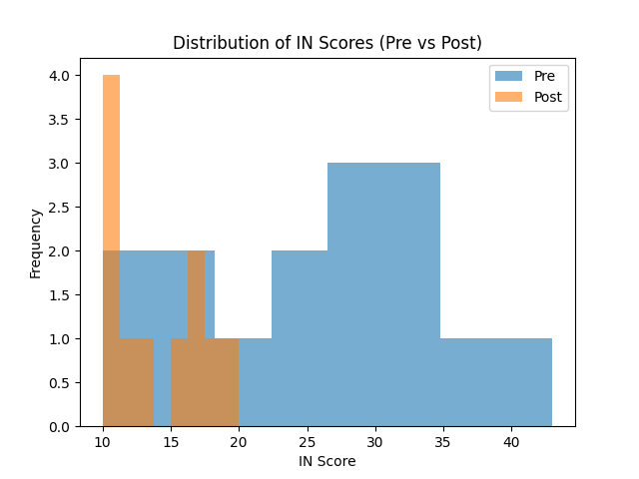
Note. Post-treatment scores demonstrate reduced variability and a lower overall distribution than pre-treatment scores.
Figure 2
Distribution of Response Disinhibition Scores (Pre- vs. Post-Treatment)
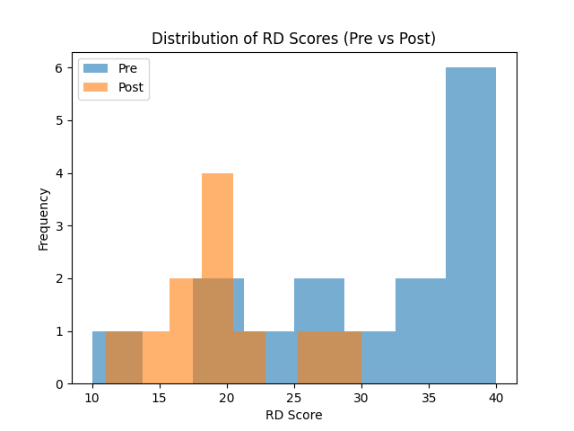
Note. Post-treatment scores demonstrate a shift toward lower values and reduced dispersion, indicating improved behavioral regulation and decreased impulsivity following the intervention.

Figure 3
Distribution of Justification Scores (Pre- vs. Post-Treatment)
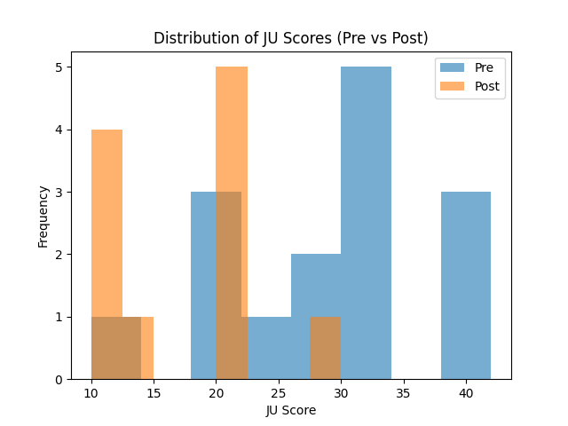
Note. Post-treatment scores show a downward shift and reduced variability, suggesting decreased reliance on cognitive distortions and rationalizations supporting criminal behavior.

Figure 4
Distribution of Power Orientation Scores (Pre- vs. Post-Treatment)
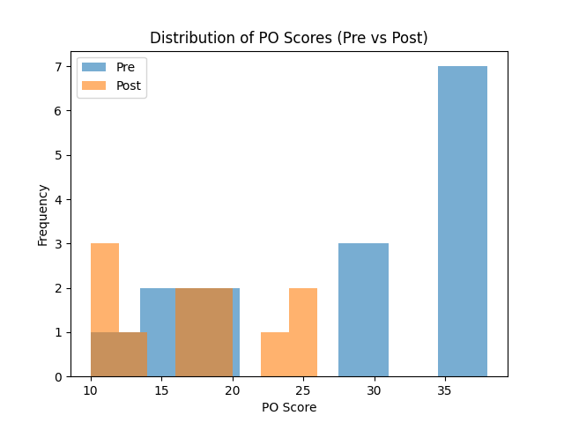
Note. Post-treatment scores indicate a reduction in higher-end values and a more compact distribution, reflecting decreased endorsement of dominance and control-oriented attitudes.

Figure 5
Distribution of Grandiosity Scores (Pre- vs. Post-Treatment)
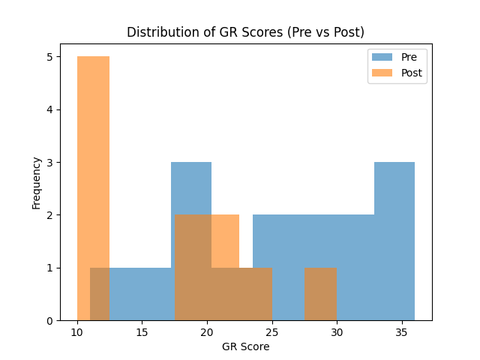
Note. Post-treatment scores demonstrate a general shift toward lower values with fewer extreme scores, suggesting reductions in entitlement and inflated self-perception.
Figure 6
Distribution of Social Desirability Scores (Pre- vs. Post-Treatment)
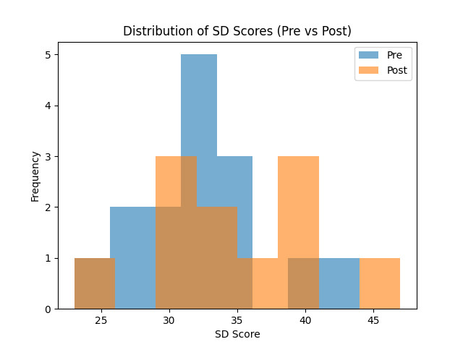
Note. Increased post-treatment scores may reflect heightened socially desirable responding.
Across descriptive, effect size, and distributional analyses, findings consistently indicate reductions in criminogenic thinking following treatment.
Summary of Results
Across all criminogenic thinking domains, results indicate lower mean scores following treatment, reduced variability in post-treatment distributions, large-to-very-large effect sizes, and elevated baseline scores relative to normative data. In contrast to other domains, Social Desirability scores increased from pre- to post-treatment, indicating a potential shift toward more socially acceptable responding.
These findings are presented without interpretation and are examined further in the Discussion section. Collectively, these findings demonstrate consistent reductions in criminogenic thinking across multiple analytical approaches.
Discussion
The findings of this study provide strong evidence that participation in CBT is associated with meaningful reductions in criminogenic thinking among mandated clients. The magnitude of change is particularly important in this context, as CBT effectiveness in justice-involved populations is often evaluated by the size of cognitive and behavioral change rather than by statistical significance alone. Large effect sizes indicate not only statistical improvement but also meaningful clinical change in criminogenic thinking patterns, which are directly associated with recidivism risk (Bonta & Andrews, 2024). There were substantial reductions across all five primary criminogenic thinking domains, including insensitivity to the impact of crime, response disinhibition, justification, power orientation, and grandiosity. These results align with the RNR model, which emphasizes targeting dynamic risk factors such as criminal thinking.
Examination of the raw score distributions provides additional insight into the effects of the CBT intervention beyond mean differences. Pre-treatment scores across all criminogenic thinking scales demonstrated substantial variability, with several high-end outliers indicating elevated levels of criminogenic cognition among a subset of participants. This pattern suggests a heterogeneous sample with varying baseline risk levels. In contrast, post-treatment distributions showed a clear compression of scores toward the lower end of each scale, with reduced variability and fewer extreme values. This shift indicates that CBT not only reduced average levels of criminogenic thinking but also attenuated extremely high-risk scores and promoted greater uniformity in prosocial cognitive patterns. Additionally, post-treatment distributions appeared less positively skewed, suggesting a normalization of cognitive functioning. However, Social Desirability scores increased and showed a broader spread in the post-treatment group, suggesting increased impression management or response bias. Overall, the distributional changes support the conclusion that CBT was associated with both a reduction in criminogenic thinking and a stabilization of cognitive patterns across participants. The convergence of findings across descriptive statistics, effect sizes, normative comparisons, and distributional analyses strengthens confidence in the observed outcomes.
From a healthcare administration perspective, the findings highlight the importance of program fidelity, engagement strategies, and integrated services addressing social determinants of health. Equity considerations are particularly important, as marginalized populations face systemic barriers that may influence treatment outcomes. The findings suggest that reductions in criminogenic thinking cannot be fully understood without considering the broader structural context in which participants live. Factors such as housing instability, employment barriers, and limited access to culturally responsive services may influence both baseline risk levels and the sustainability of treatment gains.
Implications for Healthcare Administration and Practice
From a healthcare administration perspective, these findings have important implications for the design and management of behavioral health programs serving justice-involved populations. The demonstrated effectiveness of CBT supports its continued use as a core intervention within community-based reentry programs.
However, the variability in outcomes and the influence of engagement and social determinants highlight the need for integrated service delivery models that address both behavioral health and social needs. Administrators must prioritize program fidelity and staff training, culturally responsive care for marginalized populations, and coordination with housing, employment, and social services.
These findings also underscore the importance of data-driven program evaluation, including the use of proxy measures such as criminal thinking when long-term outcomes are not immediately available.
Limitations
Several limitations should be considered. These findings should be interpreted with caution due to potential threats to internal validity, including maturation, testing effects, and regression to the mean. First, the use of purposive sampling limits generalizability beyond the study population. Second, the one-group pretest–posttest design lacks a control group, limiting causal inference and introducing potential threats to internal validity. Third, reliance on self-reported measures may introduce social desirability bias, particularly among a mandated population. Additionally, the use of independent pre- and post-treatment samples limits the ability to assess individual-level change. Finally, the 12-week timeframe is insufficient to measure recidivism directly. While changes in criminal thinking serve as a validated proxy, they do not replace long-term behavioral outcomes.
Future Research
Future studies should aim to strengthen methodological rigor by incorporating paired longitudinal designs, control or comparison groups, larger and more diverse samples, and direct measures of recidivism outcomes. Tracking actual recidivism would allow for validation of criminogenic thinking as a proxy indicator, thereby strengthening the practical implications of the findings.
Conclusions
CBT is an effective intervention for reducing criminogenic thinking among justice-involved populations. While causal conclusions cannot be definitively established, the magnitude, consistency, and theoretical alignment of the results provide compelling evidence for the continued use of CBT in community-based rehabilitation programs. These findings underscore the importance of integrating evidence-based, equity-focused, and data-driven approaches in the design and evaluation of behavioral health programs serving justice-involved populations.

References
Bezemer, W. E., Born, M. P., & Leerkes, A. S. (2024). Addressing ethnic differences in the validity of self-reported criminal behavior through a social desirability measure. Journal of Quantitative Criminology. https://link.springer.com/article/10.1007/s10940-023-09567-y
Bogaerts, S., Garofalo, C., De Caluwé, E., & Janković, M. (2021). Grandiose and vulnerable narcissism, identity integration, and self-control are related to criminal behavior. BMC Psychology, 9(1), 191. https://doi.org/10.1186/s40359-021-00697-1
Bonta, J., & Andrews, D. A. (2024). The psychology of criminal conduct (7th Ed.). Routledge.
Campbell, S., et al. (2020). Purposive sampling: Complex or simple? Research case examples. Journal of research in nursing: JRN, 25(8), 652–661. https://doi.org/10.1177/1744987120927206
Capili, B., & Anastasi, J. K. (2024). An introduction to types of quasi-experimental designs. Journal of Clinical Nursing. https://pmc.ncbi.nlm.nih.gov/articles/PMC11741180/
Folk, J. B., et al. (2016). Effectiveness of a self-administered intervention for criminal thinking: Taking a Chance on Change. Psychological Services, 13(3), 272–282. https://doi.org/10.1037/ser0000079
Garner, B. R., Knight, K., Flynn, P. M., Morey, J. T., & Simpson, D. D. (2007). Measuring offender attributes and engagement in treatment using the TCU Criminal Thinking Scales. Criminal Justice and Behavior, 34(7), 906–925.
Hachtel, H., Vogel, T., & Huber, C. G. (2019). Mandated Treatment and Its Impact on Therapeutic Process and Outcome Factors. Frontiers in psychiatry, 10, 219. https://doi.org/10.3389/fpsyt.2019.00219
Jochems, E. C., Duivenvoorden, H. J., van Dam, A., van der Feltz-Cornelis, C. M., & Mulder, C. L. (2017). Motivation, treatment engagement, and psychosocial outcomes in outpatients with severe mental illness: a test of Self-Determination Theory. International journal of methods in psychiatric research, 26(3), e1537. https://doi.org/10.1002/mpr.1537
Lipsey, M. W., Landenberger, N. A., & Wilson, S. J. (2007). Effects of cognitive-behavioral programs for criminal offenders. Campbell Systematic Reviews, 3(1), 1–27. https://onlinelibrary.wiley.com/doi/full/10.4073/csr.2007.6
Martin, S., Zabala, C., Del-Monte, J., Graziani, P., Aizpurua, E., Barry, T. J., & Ricarte, J. (2019). Examining the relationships between impulsivity, aggression, and recidivism for prisoners with antisocial personality disorder. Aggression and Violent Behavior. https://www.sciencedirect.com/science/article/abs/pii/S1359178919300357
National Association of Social Workers (NASW). (2021). Code of Ethics of the National Association of Social Workers. https://www.socialworkers.org/About/Ethics/Code-of-Ethics/Code-of-Ethics-English
Palinkas, L. A., Horwitz, S. M., Green, C. A., Wisdom, J. P., Duan, N., & Hoagwood, K. (2015). Purposeful sampling for qualitative data collection and analysis in mixed-method implementation research. Administration and Policy in Mental Health, 42(5), 533–544. https://doi.org/10.1007/s10488-013-0528-y
Saxena, K., & Sahai, A. (2024). Understanding the effectiveness of cognitive behavioral therapy: A study on offenders. Annals of Neurosciences, 32(4), 309–314. https://doi.org/10.1177/09727531241288609
Sease, T. B., Joe, G., Pankow, J., Lehman, W. E. K., & Knight, K. (2022). A psychometric reevaluation of the TCU criminal thinking scales (CTS). Journal of Offender Rehabilitation, 61(3), 135–147. https://doi.org/10.1080/10509674.2022.2045528
Syasyila, K., Gin, L. L., Abdullah Mohd Nor, H., & Kamaluddin, M. R. (2024). The role of cognitive distortion in criminal behavior: a systematic literature review. BMC Psychology, 12(1), 741. https://doi.org/10.1186/s40359-024-02228-0
Tangney, J. P., Stuewig, J., Furukawa, E., Kopelovich, S., Meyer, P., & Cosby, B. (2012). Reliability, validity, and predictive utility of the 25-item Criminogenic Cognitions Scale (CCS). Criminal justice and behavior, 39(10), 1340–1360. https://doi.org/10.1177/0093854812451092
Walters, G. D. (2012). Criminal thinking and recidivism: Meta-analytic evidence on the predictive and incremental validity of the Psychological Inventory of Criminal Thinking Styles (PICTS). Aggression and Violent Behavior. https://www.sciencedirect.com/science/article/abs/pii/S1359178912000225
Warner, C., Conley, T., & Murphy, R. (2017). Criminal thinking shifts among male prisoners participating in a cognitive-based education program. Criminal Behavior and Mental Health. https://research-ebsco-com.cosc.idm.oclc.org/c/463svu/viewer/pdf/hamwmivepz

Appendix A
TCU Criminal Thinking Scales (CTS 3.0) 