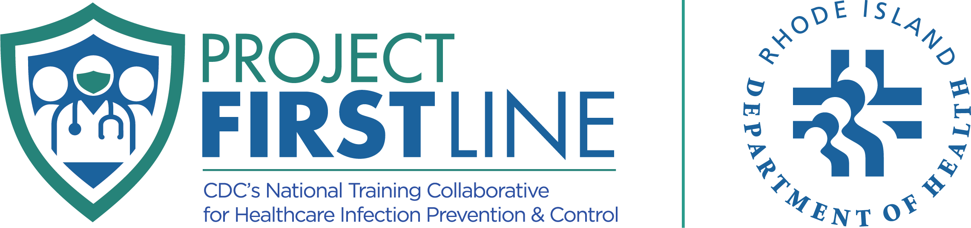

Preventing Healthcare Associated Infections (HAI):
Infection Prevention
and Control Training Packet


A curated collection of
Project Firstline Rhode Island webinars and print materials
for healthcare personnel

Webinars
Preventing Catheter-Associated Urinary Tract Infection (CAUTI) | English: https://www.youtube.com/watch?v=hbfjTukduGY
Preventing Central Line-Associated Bloodstream Infections (CLABSI) | English: https://www.youtube.com/watch?v=-qLREEVQqXA
Preventing Ventilator-Associated Events (VAE) | English: https://www.youtube.com/watch?v=KhZPi6I53T4
Preventing Surgical Site Infections (SSI) | English: https://www.youtube.com/watch?v=XzeaOpPf5jA
Preventing Candida auris Infections | English: https://www.youtube.com/watch?v=atgyfDsbxbg  Spanish: https://www.youtube.com/watch?v=PWQUM3k_s9s
Preventing Clostridioides difficile Infections | English: https://www.youtube.com/watch?v=_2TBicxpHyE  Spanish: https://www.youtube.com/watch?v=XlnLS5ja7hw
Preventing Methicillin-Resistant Staphylococcus aureus (MRSA) | English: https://www.youtube.com/watch?v=6aKavWQ_xWU
Preventing Sepsis Part 1: Infection Prevention and Control | English: https://www.youtube.com/watch?v=LNDSGIWI0MI
Preventing Sepsis Part 2: Core Elements of a Sepsis Program | English: https://www.youtube.com/watch?v=lwvVoP8XV1s

Print Materials

C. difficile and C. auris in Healthcare | English:  - C. difficile in Healthcare  - C. auris in Healthcare
Hand Hygiene and Personal Protective Equipment | English:  - Clean Hands Count for Healthcare Poster  - Clean Hands Count for Healthcare Brochure  - 5 Moments for Handwashing Poster  - Choosing the Right PPE Throughout Your Workday  Spanish:  - Información básica sobre las infecciones urinarias  - Como usar un desinfectante de manos correctamente  - Las manos limpias cuentan
Micro-Learns | English:  - https://www.projectfirstlineri.com/training-resources#micro-learns  Spanish:  - https://www.projectfirstlineri.com/training-resources#micro-learns-ES
Where Germs Live Booklets | English:  - https://cdn.prod.website-files.com/61f86b3873144056f134bdcf/629685fabe58442e44c44165_where-germs-live.pdf  Spanish:  - https://cdn.prod.website-files.com/61f86b3873144056f134bdcf/63867552479fff9fd2a862b5_donde-esta-el-riesgo.pdf
Preventing Infections  Posters and Infographics | English:  - https://www.projectfirstlineri.com/training-resources#posters  - https://www.projectfirstlineri.com/training-resources#infographics  Spanish:  - https://www.projectfirstlineri.com/es#afiches  - https://www.projectfirstlineri.com/es#infografias

Visit www.projectfirstlineri.com/training-resources for more IPC resources!
Email us at RIDOH.ProjectFirstline@health.ri.gov for basic IPC refresher trainings and Certificate of Training options for your Healthcare personnel!

FREE Infection Prevention and Control Trainings for Healthcare Personnel!

Visit our websites and contact us!
English: https://projectfirstlineri.com
Spanish: https://projectfirstlineri.com/es
Email: RIDOH.ProjectFirstline@health.ri.gov
