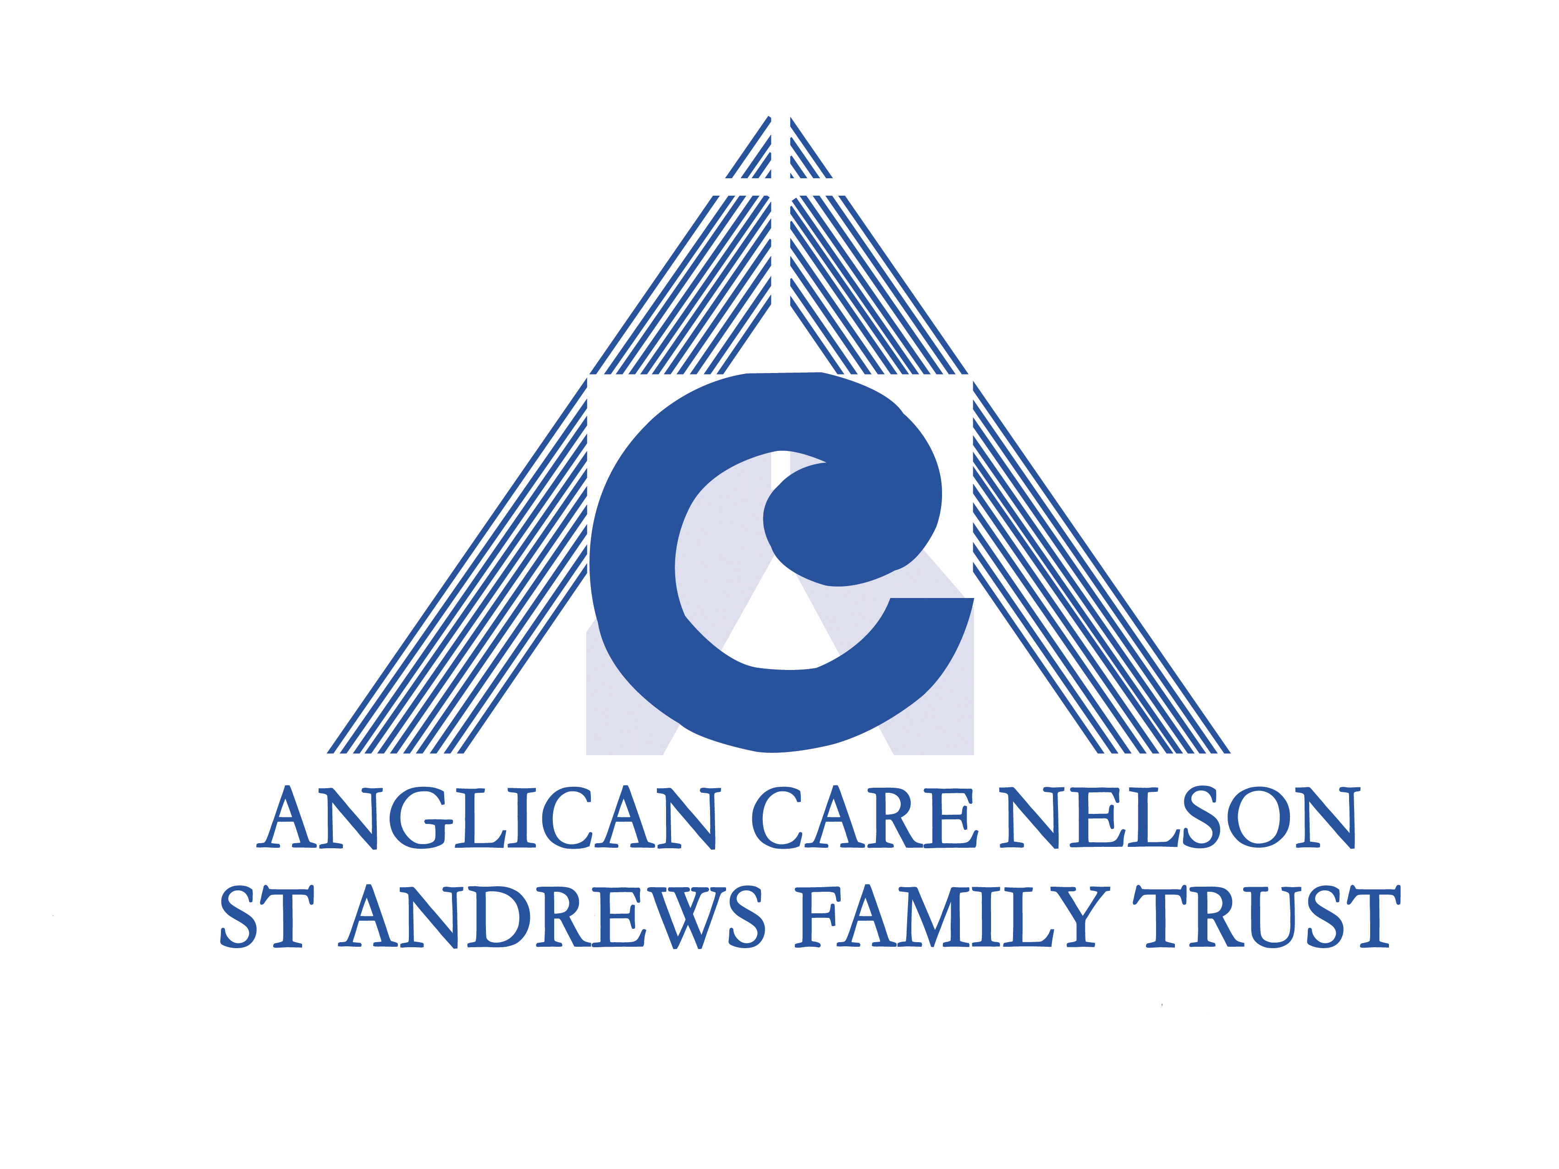**Application for Funding PROJECT GRANTS**

For assistance with this application, please contact the Ministry Coordinator – Social Services

Office: 03 548 3124 Mobile: 0212893669 Email: socialservices@nelsonanglican.nz

* + - Limited funds are available.
* Any grant made is intended as a contribution only to projects/programmes and does not guarantee ongoing funding.
* Applicants may choose to direct money towards payment of wages or salary, but responsibility for payment of any employee remains that of the applicant.

|  |  |
| --- | --- |
| Date of Application: |  |
| Application from Parish(es)/Organisation |  |
| Application made by: (name) |  |
| Position Title: |  |
| Email Address for Notification: |  |
| Bank Acc No for payment if grant approved |  |
| How much are you applying for |  |
| For how many years (1-3)? |  |

**I confirm:**

**Y/N** A resolution from the parish vestry/vestries or other governing body approving the project/programme is attached to this application.

**Y/N** That the Anglican Care or St Andrew’s Family Trust Logo will be used on promotional material.

**Y/N** That the ACC project/programme will comply with the Anglican Care Code of Ethics.

Available at - www.nelsonanglican.nz/grants-funding

**Y/N** An accountability report will be provided by due date each year (St Andrew’s Family Trust 31 December /Anglican Care grant 31 March). This will be notified on the grant approval letter. The Accountability Report form is available at - [www.nelsonanglican.nz/grants-funding](http://www.nelsonanglican.nz/grants-funding)

**CATEGORY (please indicate):**

Note: Criteria for each of these categories are listed on the back of the application form.

* ACC (Whakarewa Trust) Project Funding
* Mary Foster-Barham Project Funding (applications due 1 July)
* Older Persons Ministry Funding
* Whareama Funding
* St Andrew’s Family Trust Project Funding (applications due 1 September)

**New or repeat Application (please indicate)**

* New Application
* Reapplication

1. **Project/Programme Name**
2. **Project/Programme Background**
   1. **What community need is being addressed and how was it identified?**
   2. **Who has been consulted about the need for this project/programme? (Please indicate)**

* Community groups/agencies. Describe
* Community Ministries Co-Ordinator
* Other.

Describe :

* 1. **Please outline how consultation and collaboration with other parishes or organisations has been considered and how it will be implemented.**

1. **Description of Project/Programme**
   1. **Describe the project/programme and how it meets the criteria of the fund.**
   2. **How, when, where will the project/programme be delivered?**
   3. **What contribution is the parish/organisation making to the project/programme and how does it plan for the project/programme to be resourced over the coming 1-3 years, especially if ACC is no longer able to provide financial support?**
2. **Managing the Project/Programme**
   1. **What are the expected outcomes of the project/programme?**
   2. **How will you know you have achieved them? For example, questionnaire, results, feedback/stories, number of people reached etc.**
   3. **What training and support will be offered to paid staff and/or volunteers?**

**[For parish programmes in the Diocese staff/volunteers must be police checked and comply with SafeHere Training]**

**PLEASE OMIT QUESTION 5 IF THIS IS A NEW FUNDING APPLICATION.**

1. **Project Development**
   1. How has the initial grant changed or developed the project/programme? If equipment or travel has been funded, how has this helped grow the project/programme?
   2. How have paid staff or volunteers been trained, supported and cared for? Have new and/or potential leaders emerged?
   3. What steps has the parish(s)/organisation taken to increase its own financial contribution to the project/programme and/or to seek alternative funding? Please list alternative funding applied for, how much was applied for and whether the application was successful or is still pending.
2. **Budget**
   1. **Please provide a breakdown of how the funds will be used and attach a project/programme budget.** Give annual or total cost. No “Sundry/Miscellaneous” or unspecified amounts. If there are mileage costs, please email socialservices@nelsonanglican.nz for the “per kilometre” amount.

|  |  |
| --- | --- |
| **Item** | **Cost $** |
|  |  |
|  |  |
|  |  |
|  |  |
|  |  |
|  |  |
| **Total** |  |
| **Parish/Community Contributions** |  |
| **Total ACC request** |  |

* 1. **Do you hold parish/organisation trust funds that are not being used for this project/programme? If they are not being used, please explain why.**

1. **If you are a Parish, please answer the following questions.**
   1. **What one section of the five marks of mission does this project/programme mainly fit into?**

**Tell** – To declare the Gospel of the Kingdom.

**Teach** – To instruct, baptise, and foster the growth of new believers in Christ.

**Tend** – To address human needs through compassionate service.

**Transform** – To challenge and transform unjust societal structures, denounce all forms of violence, and actively seek peace and reconciliation.

**Treasure** – To diligently protect the integrity of creation, sustain and rejuvenate the vitality of the Earth.

* 1. **How does the project/programme fit into this mark and how will the gospel message be shared?**

**Project Funding Criteria**

**ACC Funding (Whakarewa trust)**

* There are 3 opportunities to apply for funding. Applications **must** be received by 1 February,1 June or 1 October for consideration in the upcoming funding round
* The ACC will give wide consideration to the need for funding to benefit the social services work of the Anglican Church in the Diocese of Nelson
* New and innovative projects are encouraged
* Projects/programmes that provide a “help up” are likely to be favoured
* Projects/programmes are generally parish-based, but this is not compulsory
* Projects/programmes can benefit any/all people, regardless of age, values, religion, gender, etc.
* Project/programme may be finite or ongoing
* Evaluation of community needs in planning is encouraged
* No large capital items or building expenses will be funded
* Employees are the responsibility of the applicant and funding is a contribution only to the project
* All involved in service delivery in the Diocese must be police checked and comply with SafeHere
* Applicants must plan to increase their own financial support of project/programme over time and/or seek alternative funding

**Mary Foster Barham Trust Project Funding**

* For the care of children in a disadvantaged position
* Must be within the Nelson and Richmond municipal boundaries
* Application **must** be received by 1 July or will not be considered
* Employees are the responsibility of the applicant and funding is a contribution only to costs, including salary
* All involved in service delivery in the Diocese must be police checked and comply with SafeHere
* Applicants must plan to increase their own financial support of project/programme over time and/or seek alternative funding
* Applications include a written application and a short presentation to Trustees

**St Andrew’s Family Trust Project Funding**

* For the care of children (and families)
* Preference is given to fund work which occurs at an early intervention level.
* New and innovative projects which provide a “help up” are encouraged.
* Programmes which invest in and strengthen community are viewed positively
* Evidence of an evaluation of community needs in program planning is desirable.
* No large capital items or building expenses will be funded.
* Funding is not automatically ongoing

**Whareama Trust Funding**

* For the provision of chaplaincy services and support for elderly Anglicans in rest homes, distributed on application and according to need.
* For grants to assist the elderly in situations not covered by other trust funds (eg. grandparents raising grandkids, Menz Shed etc) both for individual needs grants and for project grants

**Older Persons Ministry Funding**

* For the care of older persons over the age of 65, with discretion to include those over 50 if their needs align with those over 65
* Applications for contestable funding are considered 3-yearly and **must** be received by 1 August or will not be considered
* Applications for non-contestable funding may be received at any time
* The Anglican Church must be involved in the governance of the project/programme
* Applicants are encouraged to consult with neighbouring parishes over the possibility of a joint project/programme, especially if they are in close proximity
* Projects/programmes must be community facing and in response to community needs identified through consultation within the community. Eldercare activities/services are intended to care for people in such a way that they are drawn into relationship and, through relationship, are gently and sensitively introduced to the good news of Jesus in a way best suited to their character and context.
* Paid employees must intentionally encourage a voluntary team to work alongside them
* Capital works not considered for funding unless extenuating circumstances
* All involved in service delivery in the Diocese must be police checked and comply with SafeHere. ACC funding will only be available to ministries that undertake to have all those assisting police vetted and trained in SafeHere modules 1 and 2.
* Employees are the responsibility of the parish and funding is a contribution only to costs, including salary, but the ACCT will consider the need for continuity of funding for up to 3 years where workers are employed
* Parishes must plan to increase their own financial support of project/programme over time and/or seek alternative funding
* No new or ongoing funds are granted if applications/accountability reports contain insufficient information or evidence of effectiveness to support a grant

**Office Use Only**

Date Application Received: _______________________________________________________

Meeting date considered: ________________________________________________________

Outcome: _____________________________________________________________________