**KINGDOM OF CAMBODIA**

**Nation Religion King**



# REQUEST FOR QUOTATIONS

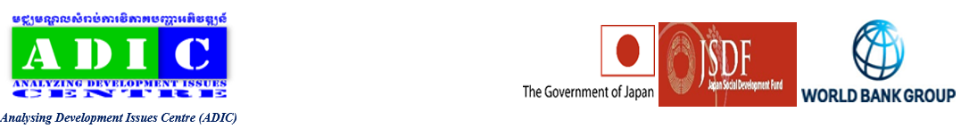

Analyzing Development Issues Center

Cambodia Sustainable Livelihood for Indigenous Communities Project JSDF Grant No. World Bank, TF B6238

RFQ №: ADIC-CSLICP-NS-G-003-B

Wishes to Purchase for a Supply, Delivery and Installation of Materials for School Bio-Gardens

Date: May 22, 2025

1. The Kingdom of Cambodia has received a JSDF Grant No. TF B6238 Cambodia Sustainable Livelihood for Indigenous Communities Project from the World Bank toward the cost of the Cambodia Sustainable Livelihood for Indigenous Communities Project (CSLICP), and it intends to apply part of the proceeds of this Grant to payments under the Contract for the Supply, Delivery and Installation of Materials for School Bio-Gardens
2. The goods are required by **60 calendar days** from the date of contract signing.
3. Interested qualified eligible suppliers are invited to obtain the Quotation documents free-of-charge, from the address given below by submitting a written application. Except for the submission of a written application, there shall be no other conditions for obtaining the bidding documents.
4. To be considered eligible and qualified a bidder must:
   1. Meet the eligibility criteria of World Bank.
   2. Have completed at least two contracts for supply of similar goods in the preceding 3 years of a value not less than 50% of estimate contract price.
   3. Have completed contracts with a total cumulative value equal to at least two times estimated contract price in the preceding 2 years.
   4. Not be under any notice of suspension or disbarment issued by the Government or World Bank.
5. Quotations must be delivered to the address given below on or before **10th June 2025 at 15:00pm local time**. Late Quotations will be rejected. Quotations will be opened in public immediately thereafter at the address given below in the presence of the Bidders' representatives who choose to attend.
6. The Purchaser shall award the Contract to the Bidder whose offers has been determined to be the lowest evaluated quotation and is substantially responsive to the Quotation Document, provided that the Bidder is determined to be qualified to perform the Contract satisfactorily.
7. The quotations must be accompanied by **performance securing declaration** as described in the Quotation documents. Any quotation not accompanied by one will be rejected as noncompliant.
8. A completed set of Quotation Documents in English can be downloaded for free by Interested Eligible Bidders as from the project web site: http:/[/info@adicentre.org](mailto:info@adicentre.org) / <https://www.adicentre.org/cslicp-project>.
9. In case of any difficulty in obtaining the Quotation Document, interested Bidders may contact in writing to **Mr. OEUR IL** on E-mail: [iloeur2@gmail.com](mailto:iloeur2@gmail.com) and copy to [info@adicentre.org](mailto:info@adicentre.org) and  [channakchhun@gmail.com](mailto:channakchhun@gmail.com) or call Ms. Yen Sophen, Administrator, via her cell phone: +855 10 66 00 20/ 017 511 151.
10. The quotation must be submitted on or before **10th June 2025 at 15:00pm local time** at the following address: Cambodia Sustainable Livelihood for Indigenous Communities Project Office, Analyzing Development Issues Centre, #PA59, St. Railway, Borey Piphop Thmey Chouk Va 2, Phum Kakab, Sangkat Kakab 2, Khan Posenchey, Phnom Penh, Cambodia.
11. The government/ Development Partner will declare a firm ineligible either indefinitely or for a stated period of time, to be awarded a contract financed by the Government and/or the Development Partner respectively, if it at any time determines that the firm has engaged in fraud and corruption during the procurement and execution of this contract as described in ITB Clause 4.
12. A complaint may be made by any party at any stage of the procurement process. The procedure is described in Instructions to Bidders, Clause 21 of the Bidding Documents.