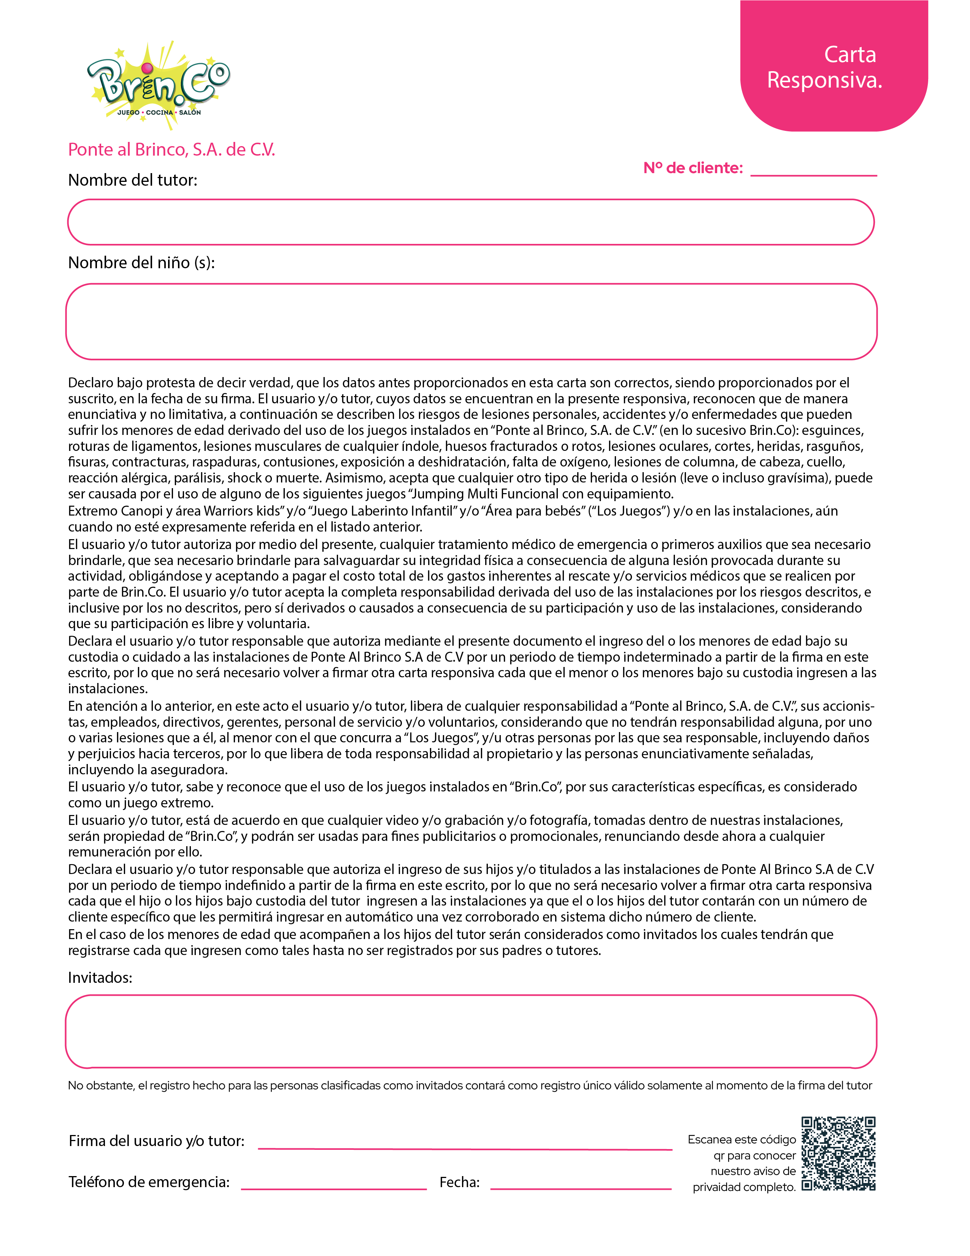

Iliana Reyes Chavez

Emiliano Reyes Ayala / Carolina Reyes Ayala Naomi

8/9/2025 5:39:02 PM
5518321778

