Fethr Health for Digital Health Companies (Health Technology Companies)
Accelerate time-to-production, reduce engineering costs, and connect to a single EHR-agnostic system.

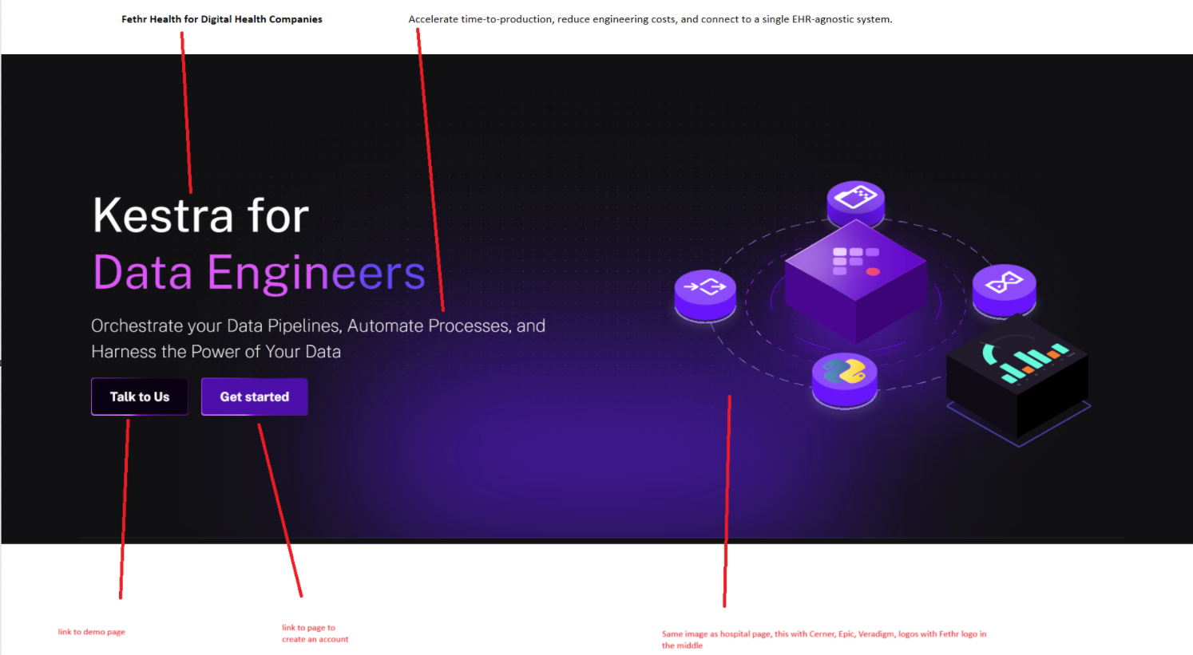

Simplify Your Interoperability Challenges
From automating data integration processes to enhancing real-time patient data exchange, Fethr Health streamlines complex workflows across healthcare systems. Explore the diverse range of use cases that Fethr Health effectively addresses to improve interoperability and patient care.
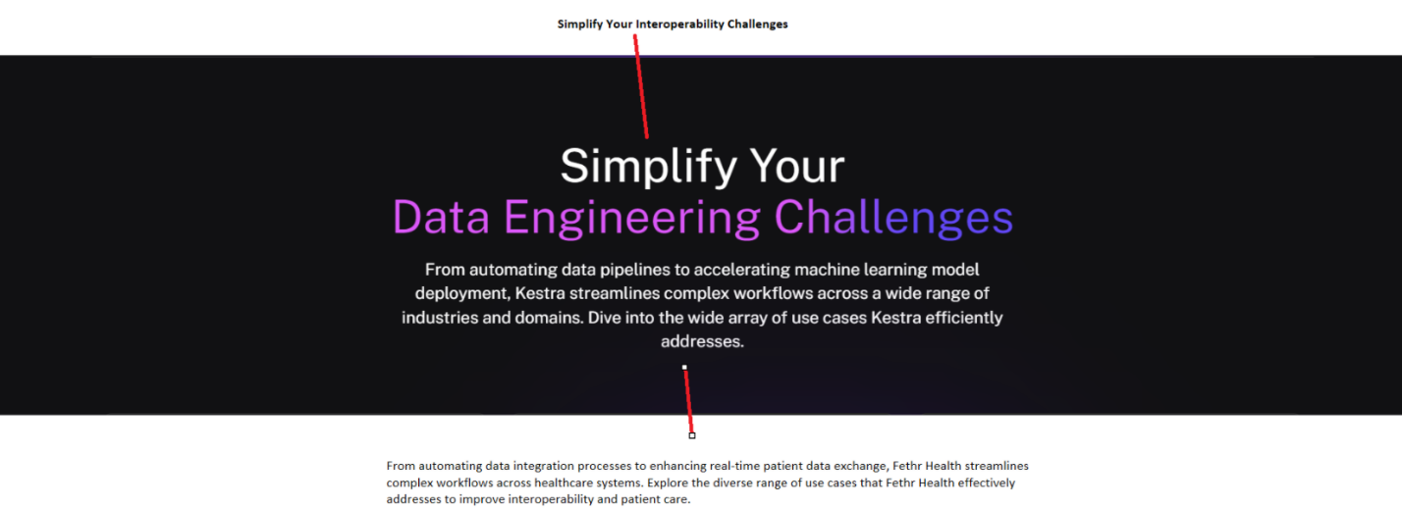

- Accelerate Time-to-Production
Rapidly integrate by using our pre-built connectors designed to reduce development time. Setup a workflow in under 60 minutes. That's less time than it takes to decide what’s for lunch!
- One Link to Multiple EHRs
Connect to a single endpoint and eliminate the cost of maintaining multiple EHR connections. Our EHR-agnostic system simplifies data access and management, letting you focus on delivering a quality product.
- Get Data the Way You Need It
Retrieve your data seamlessly by polling endpoints or tapping into real-time feeds
- Embrace Modern Technology
It's time to level up from HL7—use modern solutions like webhooks to send and receive data. Don't worry, we still support FHIR, HL7, CSV, CCDA, SFTP, X12, and XML and many others.
- Cut Costs, Fuel Growth
You are a digital health innovator, not an integrator, so stop trying to be one. Use the savings on integration costs and re-invest that into the growth of your company.
- Scalability Made Easy
As your business grows, so will your integration needs. Fethr scales with you, allowing the addition of new connections and features without major overhauls.

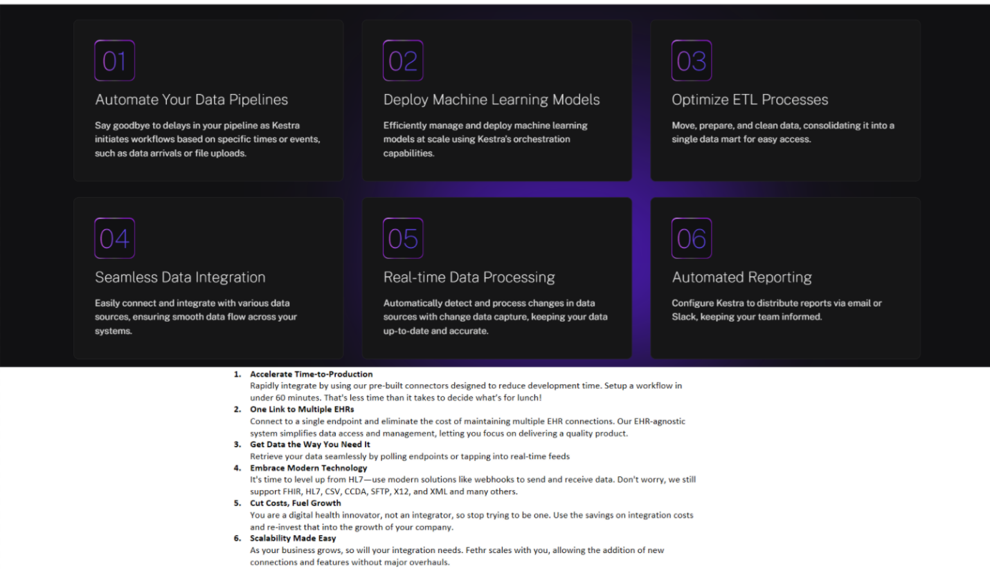

Explore Fethr's Capabilities

- Pre-built Connectors
- …(come up with new use-case not for hospitals)
- …(come up with new use-case not for hospitals)

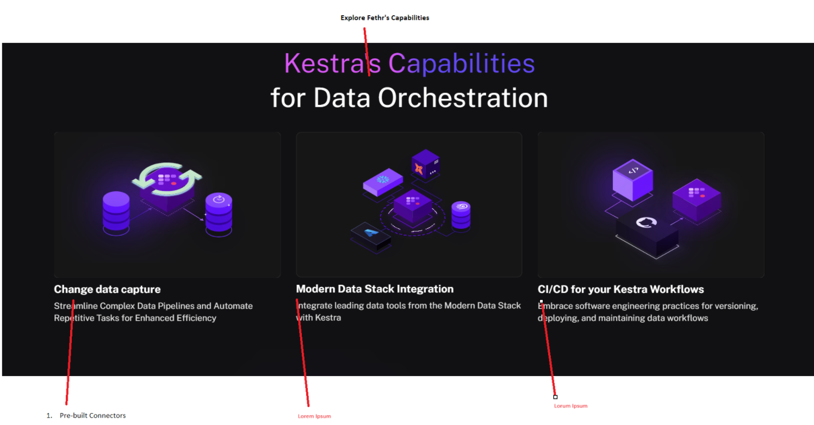

Take Fethr to the next level with our Integration as a Service Offering
Save time and resources with our integration as a service, eliminating the need for an in-house integration team. Focus on your core business while we manage the complexities of healthcare integration with our tools and 24/7 support.
