WILLIAMSTOWN CHAMBER OF COMMERCE

**2021-2024**

BUSINESS PLAN

horizontal line

# Placeholder image

Photo Credit : Chris Cincotta of @melbourneiloveyou

The purpose of this document is to outline a 3 year Strategic Business Plan for the period of July 2021 to June 2024, for the Williamstown Chamber of Commerce and it’s Business Community. The document is designed to outline and define the Marketing Strategies and Objectives of the Precinct ongoing. This report was prepared by the current Committee Members, following a survey to all members in July 2021, in the interest of the Members, current and future.

# Introduction

The marketing and business development program, supported by the Hobsons Bay City Council Precinct Levy Funding has been in place in Williamstown for over 25 years, and covers 195 members, with a broader reach in the past 2 years to over 300 businesses who have been included in the support from this program.

The membership is open to all businesses to join, currently there is no individual financial contribution to the program. Funding has been sought from various local and state Grant Applications and via the Council Special Traders Group Funding, for all initiatives driven through the Chamber Marketing, Events and Support Program. The program is driven by the Williamstown Chamber of Commerce Committee for the benefit of all local business, and residents.

There are 4 main districts covered by the program:

1) The main commercial precinct covers Stevedore Street, Douglas Parade, Ferguson Street and Nelson Place (retailers, professional services, hospitality services, health & beauty services, banking and Grocery Suppliers independent and chains).

2) The Kororoit Creek Road Shopping Centre (Woolworths, newsagency, & various food businesses)

3) The industrial area along Champion Road & Akuna Drive - housing many lifestyle businesses from activity based (dance, swim, acrobatics, karate, playcentre, indoor skate park) to specialised service businesses (coffee roasters, styling businesses, gyms, events and art suppliers).

4) The industrial area off Kororoit Creek Road which also includes many lifestyle and activity based businesses (health & fitness, storage facilities, car workshops, event hire businesses).

There have been many challenges in the 2020-2021 period of the program, but the initiatives provided to all have been very successful. The visitors/tourists may not have been as present, but the local community (residents/workers) has been far more engaged with local providers, than the previous years.

Williamstown offers a unique precinct with its beaches, parks, waterfront/boating, shopping, dining and historic offerings.

The increased marketing & liaison programs have resulted in a better profile for not only the main Dining and Shopping district within the precinct, but also the other areas captured under the Chamber of Commerce umbrella totaling 12 specific trading areas. The consistent support and promotion of events, activations, offers and general news has created more customer loyalty, more opportunities for local businesses and a voice for all local business owners, operators and residents. The continuation of this funding in its current or other forms, is very important to the ongoing marketing of the precinct, especially over the next 2 years post Covid-19 trading.

The Purposes of the Williamstown Chamber of Commerce are as follows:

• To engage with the business owners and operators, represent their interests and work with them for the collective benefit of the Precinct;

• To generate and manage marketing, promotion, events/activations and business development activities for Williamstown Traders;

• To manage the affairs of the Chamber;

• To develop positive relationships with our key stakeholders who impact and influence the role and function of the Precinct;

• To engage in activities that benefit the traders, visitors and the Williamstown community.

Continuation of Council Funding is very important to the ongoing marketing and support of the Williamstown Precinct, especially after the last 2 years through the Pandemic.

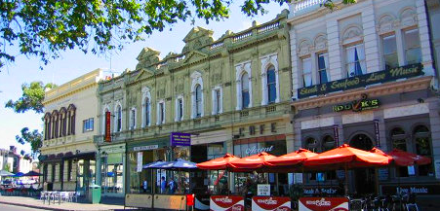

### 

### 

### 

### 

### 

### 

### 

### 

### 

### 

### 

### 

### 

### Key Achievements

* Organisation of the successful annual Christmas Festival which went from a single Event Night over the past 6 years to a week long Activation Program during the 2020-2021 pandemic years.
* Online promotions for calendar events such as Mother’s Day, Father’s Day, Easter, Christmas and Lunar New Year as well as continuous weekly local offers/whats on
* Branding Shop Decals
* Creation and maintenance of the existing website, Facebook and Instagram pages
* Weekly News Updates for business support programs from grants available to rent relief and how to manage staffing issues
* Strong contacts with local and State levels of government
* Strong relationships with the community and community groups
* A successful applications for local and State Government Grants to enable the forthcoming marketing activities to strengthen the existing program

### 

### 

### Marketing & Business Support Continuation

* Ongoing marketing, branding and promotion of the Precinct
* Effective and up to date communications with all businesses
* Strong relationship between Council and Traders through the Chamber Committee Liaisons to voice and address issues such as Outdoor Dining Program, Mobile Traders Permit, Parking, Traffic, Lighting, Rates Reductions & Permit Waivers
* A strong voice to advocate issues of importance to the business community to both local and State Government

Marketing Strategies will focus on the following areas:

* Development of new WCC Logo
* Launch of the “I am Williamstown” Campaign - a project to bring the community together across the various audiences who ‘work, live, play, stay’ - residents, traders, workers who frequent the Williamstown Precinct. The campaign extends to the creative development of a campaign slogan and release of shop decals, bumper stickers, tshirts, shopping bags and photographic/videography to capture iconic people and places.
* Development and launch of a new interactive website with a traders portal, to release news and communications, host traders database, providing a platform to establish a future paid membership by traders. Branding of the website to match the new WCC logo tones.
* Ongoing Digital Marketing through our dedicated Social Media Manager
* Building and Strengthening the community focus
* Ongoing communication with local businesses via our dedicated Liaison Officer
* Christmas Event - Activation or Festival will be dependent on restrictions and traders feedback each year.

The Funding provided by Hobsons Bay City Council, and the subsequent grants programs has enabled the business support and marketing initiatives outlined in this report. The business plan sets out the path for the future which relies on the continuation of these programs.

In July 2021, Traders were asked to complete an online survey - the strategic business planning sessions were delayed on several occasions due to the restrictions imposed under the State Government Pandemic laws. The survey provided an opportunity to gain a broader position, and the committee represented a more direct point of contact about the outcomes of the survey and future position. The survey questions discussed the role of the Williamstown Chamber of Commerce, it’s Committee, areas of support valued by the traders, geographical area of support and types of businesses represented. The survey also covered feedback from traders of Williamstown Precinct strengths, weaknesses, opportunities and threats with a focus on areas of development and areas of elimination specifically relating to :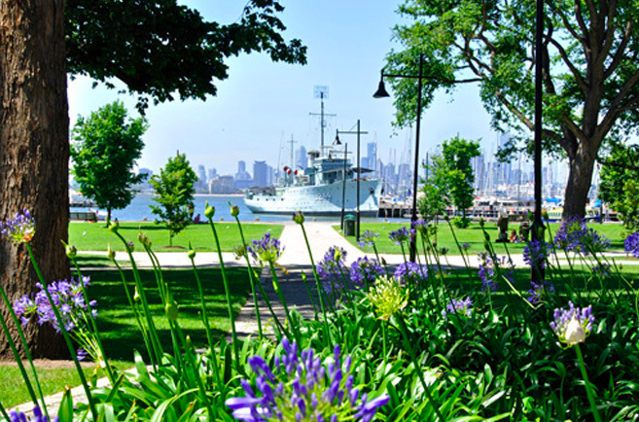

* Physical Image
* Community Activities/Events
* Parking/Traffic
* Marketing Activities
* Business Mix

The outcome of both the survey and the subsequent monthly committee meetings are the basis for the business plan going forward.

**Key Findings Include:**

**Strengths**

* Valued the dedicated WCC Committee and its work
* The Precincts atmosphere, history, community feel, diversity and culture
* The variety and appeal of the beach, maritime, history, small local events and combined diversity of the area as a key draw card for locals to stay and play local as well as bringing in visitors from surrounding suburbs
* The image of the Precinct has improved over the last 2 years, in line with the low vacancy rate which now exists, dropping across the main commercial areas
* The majority of traders are long established quality businesses, single owned providing unique and varied offerings
* Strong local community support with a strong sense of belonging - loyal customers
* The introduction of several large retail chains had supplemented the current retail offer especially during a very trying time, which may have seen a much higher vacancy rate
* The prime commercial district of Fergusson and Douglas regarded the Christmas Festival/Activation with window decals and street activities as important
* Valued the advocacy roles the WCC Committee Members provide and recognised the roles of both the liaison officer and social media manager as key to the traders voice to the community and key stakeholders such as Council/State Government
* The outdoor trading zones extending local business areas during a very challenging time as a valuable resource for diners and also for the safety of pedestrians
* Regarded the role of WCC is that of advocacy and small targeted marketing/event campaigns and must not extend to or be responsible for large scale high risk events.

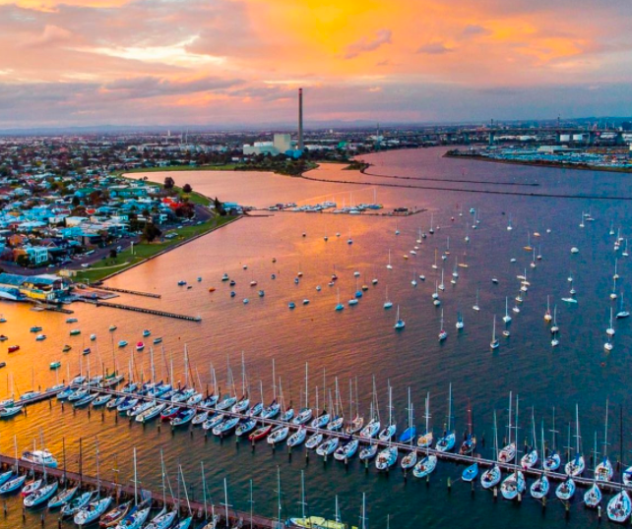

Photo Credit : [@mdmujeeb](https://www.instagram.com/mdmujeeb/)

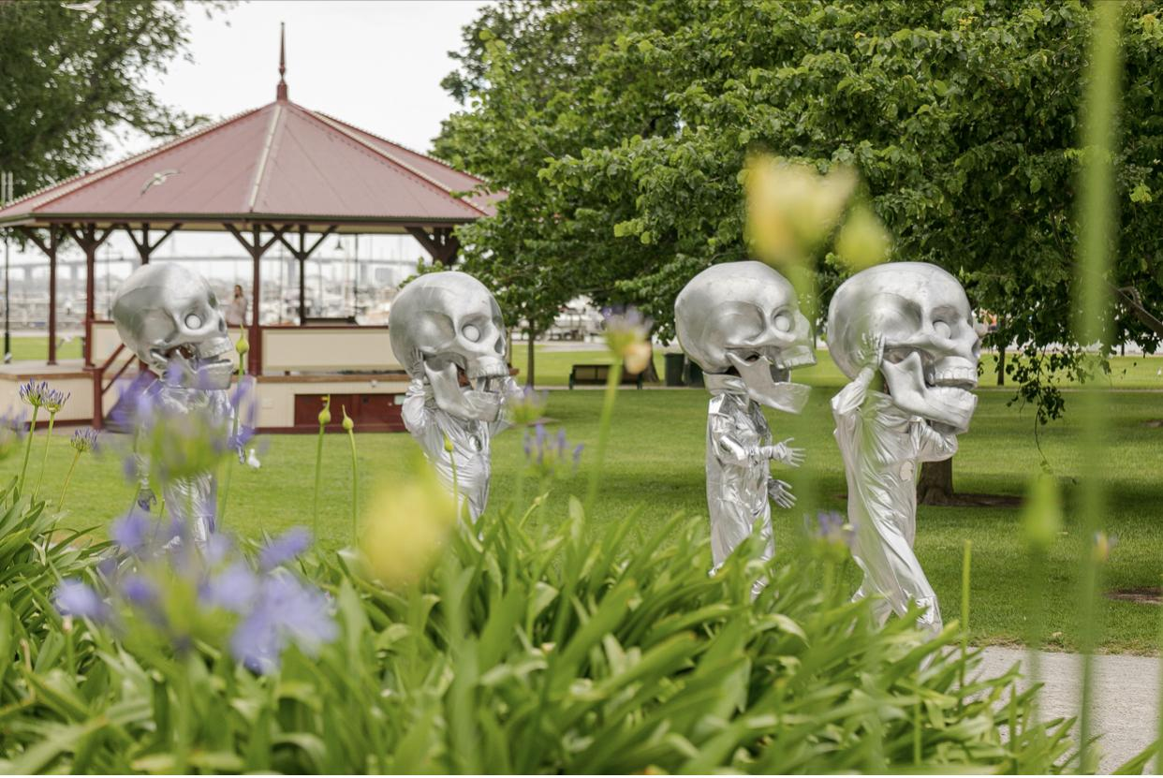

Photo Credit : @JPEvermorephotography

**Weaknesses**

* The website being in need of a more engaging platform for both traders and users alike, needed upgrades to the visual presence of the traders
* In several areas, there is insufficient lighting - made more apparent with the different trading patterns and trading offerings during the pandemic
* The loss of the “Tourist” having an impact on the larger festivals and some of the dining suppliers being at risk for having relied on this audience in the past
* Unused outdoor dining trading areas causing challenges for adjoining retail businesses who need the car parking for customers
* The removal of the train crossing has had a major impact on residents being able to easily access the services in Williamstown and the ongoing traffic issues continue to create many frustrations.
* Trader involvement/willingness to join the committee - were not forthcoming in actively wanting to participate in any physical role and many were struggling to maintain or hold on to their own business needs.

Respondents reported that the continuation of the Special Traders Funding to enable the Marketing Programs and Grant Applications Processes as very important for the ongoing development and success of the Precinct.

**Future Direction - Strategic Objectives and Vision**

*“To sustain and develop our vibrant and diverse range of traders, give business support, develop strong partnerships and provide the community with a range of exceptional services”*

The Williamstown Chamber of Commerce will continue to provide the services required to support the communications and marketing needs of the traders. The Williamstown Precinct will continue to distinguish itself as the diverse historic maritime village offering extraordinary experiences for all customers, be they local residents, surrounding suburbs, workers and those from afar once they are once again able to visit. The character of the precinct will be maintained and enhanced by providing a vibrant mix of traders and continuous advocacy support by the WCC Committee to key stakeholders.

**Goals**

* To maintain a productive partnership with Council to improve infrastructure and precinct presentation
* To help maintain an attractive mix of businesses
* To maintain regular communication with members and the community
* To develop more interest and enthusiasm by traders to promote the precinct and become involved in the Committee
* To market and promote the diverse range of members within the WCC
* To introduce a paid membership platform to increase the economic sustainability of the Chamber of Commerce

| **Action** | | **Measure of Achievement** | **Priority** | **Responsibility** | **Timeline** | **Cost per annum** |
| --- | --- | --- | --- | --- | --- | --- |
| **trategic Objectives that promote & assist in supporting Williamstown traders** | | | | | | |
| 1 | **Branding and Marketing**  To develop a new logo in line with a modern take on the precinct.  To promote the brand through all media (digital & print) as well as the Chambers website and communications to all stakeholders/members.  To develop a new website, with a member only portal, increasing the value of the WCC, content managed in house to ensure all details are kept current for traders directory and events.  To maintain the social media accounts (Facebook, Instagram) promoting Williamstown & local traders services and offers, to residents other traders and visitors | Feedback from Traders  Feedback from all Stakeholders  Feedback from Traders, Public, Analytics of Visitation, Page Views via google analytics  Increase engagement & followers of pages with dedicated weekly posts and stories. | High  High  Medium / High  High | WCC Committee - Liaison Officer - Taliana Design  WCC,  WCC Committee - Liaison Officer - Taliana Design  Karen - Salty Pretzel | July-Aug 21  Sept - Ongoing  Sept - Feb  Daily posts promotions and stories | $1,500  N/A  $5,500  $12,000 |
| 2 | **Membership**  To increase membership to all the new traders through visits to local traders, outlining the work of the WCC.  Introduce a two tiered membership to traders   1. Free limited support & 2. $120 p/annum Fee with associated benefits   To increase membership to all the new traders through visits to local traders, outlining the work of the WCC.  Increase Membership of the Williamstown North Businesses which cover precincts of Kororoit Creek Road, Champion Road Light Industrial park and Maddox Road | Achieve a membership base of 250  Launch Member Only Portal with new website, Introduction of Membership Fee  Achieve a membership base of 300  Increase membership base by a further 20%  Increase membership base by a further 20% | Medium  Medium  Medium  Medium | WCC Committee & Liaison Officer  WCC Committee & Liaison Officer  WCC Committee & Liaison Officer  WCC Committee & Liaison Officer | By Dec 2022  June 2022  June 2023  2022 - 2024 |  |
| 3 | **Events**  Plan, organise & hold the Williamstown Christmas Festival/Activation Week each year.  Purchase & install Christmas Decals/ Decorations for the Williamstown precincts of Douglas Parade & Ferguson Street  Development and Launch of the “I am Williamstown” campaign including campaign brand, merchandise, photographic/videography of what and who are part of Williamstown - People and Places - iconic, historic, memorable, classic! | Host & Increase Community Engagement over specified period  Installation of Christmas Decals  Bumper Stickers, Tshirts, Shopping Bags for sale to community, Gallery of images/videos for social media presence | High  High  High | Liaison Officer & Specific Retail Committee Members  WCC/  Liaison Officer  Liaison Officer & Specific Committee Members | Nov/Dec Annually  Nov/Dec Annually  Jan/Feb to Dec 2022 | $15,000  $2,000  $700 logo  $4000 bags  $4000 imagery  $2000 other printables - all saleable |
| 4 | **Communications / Administration**  Maintain and build the database. Introduce emailing via Mailchimp linked to website  ***Employment of Part Time Liaison Officer -***  Communications with all businesses in the precinct through newsletters, emails and personal visits to business premises  Maintain strong relationships with local community groups and residents  Inform businesses about support & training programs to motivate and educate them on opportunities and make improvements to their businesses  Investigate new funding opportunities (sponsorships, grants)  Face-to-face engagement with Trader Members to encourage support and input for events  To develop communication with the local community groups and schools to support the member events and programs | Members increase from current 195, member engagement rate with emails  Feedback from Traders, Communications to Member Base, Membership Growth & Grant Application Submissions | High  High  High  High  High  Medium  Medium | Liaison Officer  Liaison Officer  Liaison Officer  Liaison Officer  Liaison Officer  Liaison Officer  Liaison Officer - WCC Committee | Monthly | $10,000 |
| 5 | **Local Business Networking Events**  Held bi-annually to build connections, collaborations and inform members of updates. Strengthening ties with traders and committees to engage and entice traders to be more active in the WCC. | Hosting event & attendance rates at event  Feedback from members | Medium | Liaison Officer - WCC Committee | March & Sept Annually | Cost Neutral |
| **6** | **Build relationships with strategic partners** HBCC, Other Trader Presidents, Councilors,  Attendance at President Breakfast Monthly Meetings  Strategic Meetings with Key Council Stakeholders | Positive relationship developed with strategic partners  Monthly updates on Trader Issues / Opportunities  Keeping updated on Business Developments | Medium | President WCC | Monthly | NA |

| **7** | **Education**  Attendance at relevant educational/business programs provided by HBCC or other relevant bodies | Keeping informed on the current local government requirements and regulations. e.g Governance, Event planning, Funding proposals etc | Medium/High | WCC | As required during 2022 - 2024. | NA |
| --- | --- | --- | --- | --- | --- | --- |