Mariengold Gluhwein
Mulled Wine
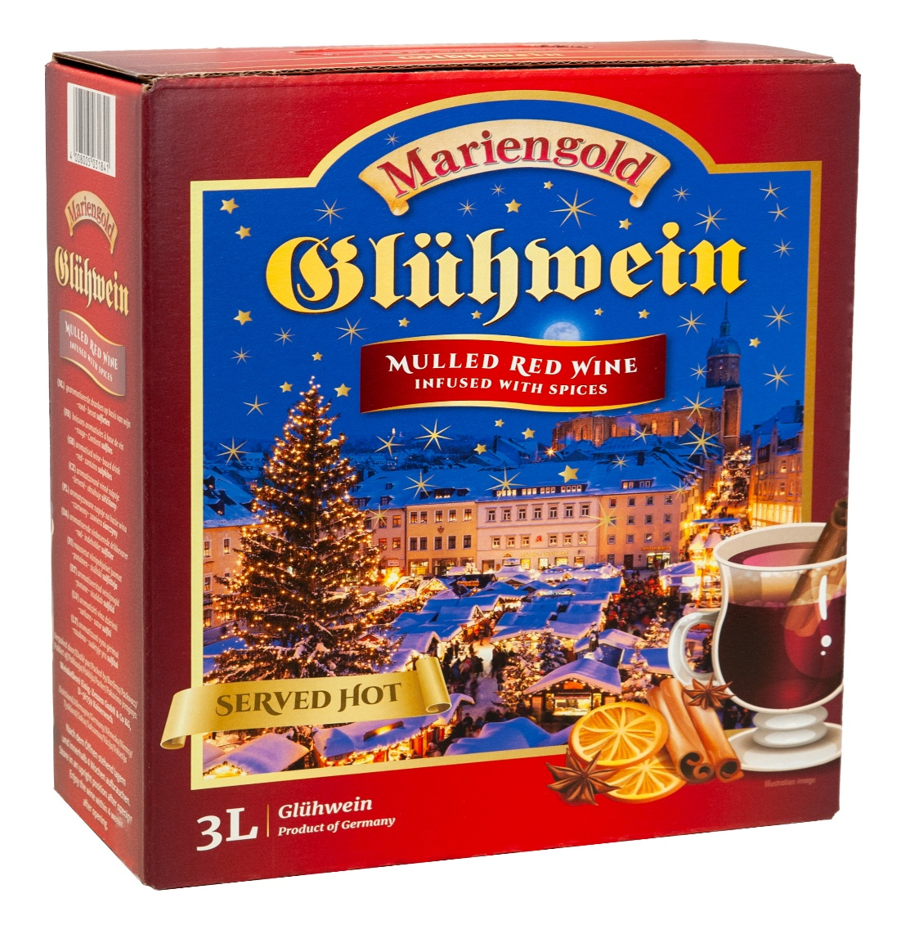
Background: Sweet and warming, infused with ripe red fruit, orange citrus, cinnamon and clove. Soft and full-full-bodied with a lingering festive spice finish.
Grape Varietal: Aromatized cocktail beverage. Ripe spiced red wine.
Country of Origin: Germany
Technical data:
Type: BIB 3 liter box
UPC: 4008005031841

Analytical data:
Alcohol content: 10 %vol
Residual Sugar: 84 g/l
Gluten: Gluten Free

Tasting Notes: A masterful blend Gluhwein spice. Best served Hot or Warm, but do not boil.

Food Suggestion: A seasonal favorite, but can be enjoyed year round. Enjoy with a meal, but is also ideal for times spent with friends in front of a roaming fire. Delicious!

CSPC # 153967

SLGA ID # 50161

