Dr Zenzen DE-ALCOHOLIZED Riesling
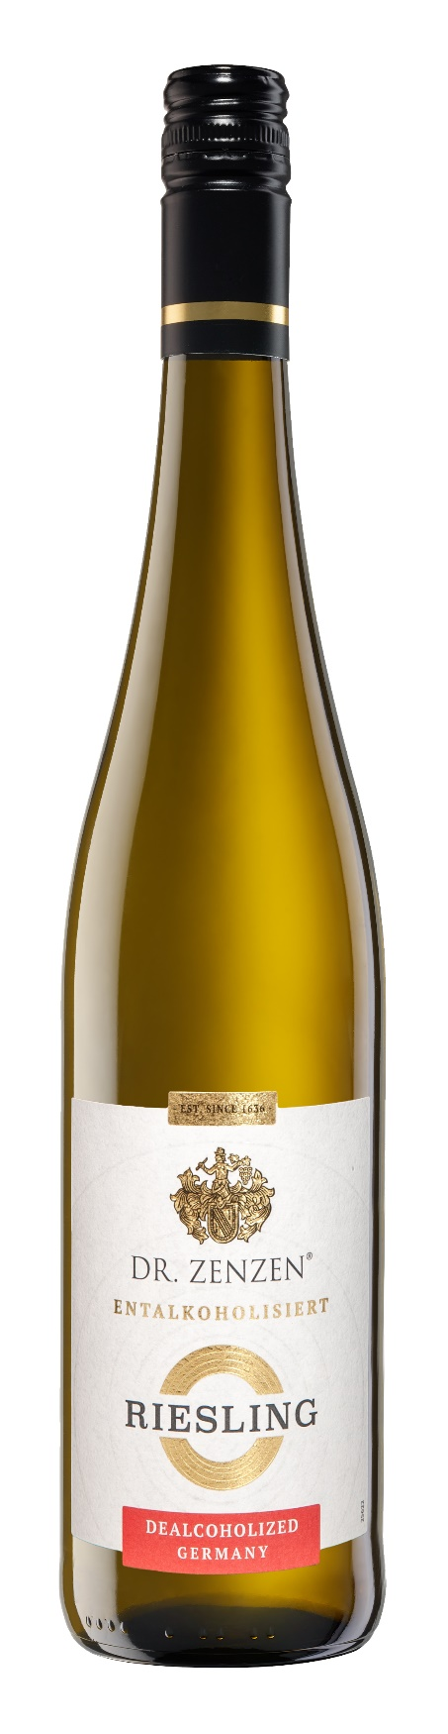
Background : The house of Dr Zenzen have since 1636 been wine growers in Germany. This family tradition of more 385 years stands for great experience and exclusiveness concerning the quality of wines.
Grape Varietal : Riesling Grape
Background: Riesling is the Queen of German white wine grapes-The purity of the fruit aroma such as apple, citrus, peach and apricot combined with unique fruit acidity and minerality make Riesling into one of the greatest grape varieties in the world.A DE-ALCOHOLIZED RIESLING all the flavor and finesse but none of the calories or alcohol.
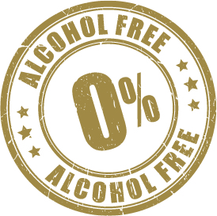
Country of Origin : German

Technical data :
Type of bottle: 750 ml bottle
Type of Closure: Stelvin closure
UPC: 4008005042014

Analytical data :
Alcohol content: 0.0 % vol.
Gluten : Gluten Free
Tasting Notes : Delicate floral aromas combined with a sharp concentration of citrus and peach notes. Fragrant, fresh and vivid with aromas of fine fruits and flowers.

Tasting Notes : : Pairs well with light meat ,fish, poultry and salads. Very versatility with food.
CSPC # 126547



