Children report to the Tangi Fair Building at 12:30 to check-in.
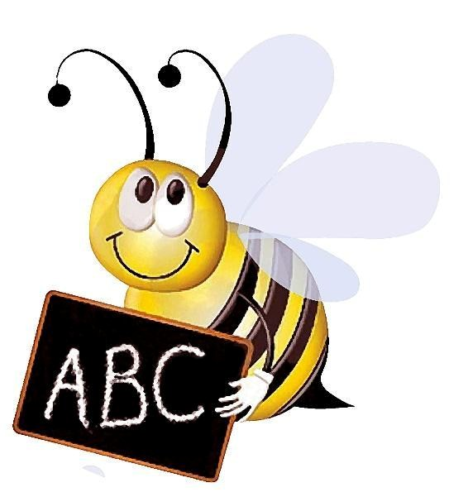
Tangipahoa Parish Free Fair Spelling Bee
Grades 3, 5 & 7
Once again, the Tangipahoa Parish Free Fair is hosting the annual Spelling Bee.
Please enter your top spellers at this year’s event.
We look forward to seeing everyone at the Fair this year.
Spelling Bee will be on Friday, October 2, at 1:00 PM. www.tangifair.org
Please contact Faith Liuzza Faust 985-517-7164 for further questions

