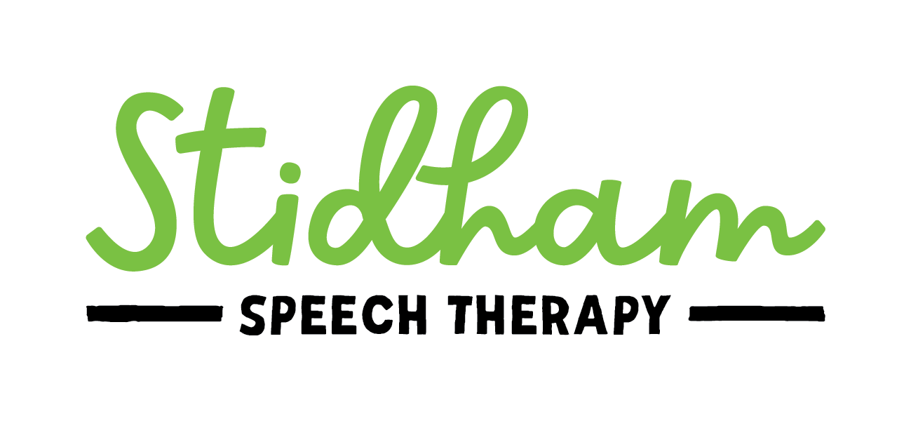

**Authorization to Photograph, Video, and/or Audio Record**

Stidham Speech Therapy, LLC may utilize photographs, video, and/or audio recordings for the purposes of evaluation and treatment. These recordings will be viewed only by Prentiss Stidham, SLP and owner of Stidham Speech Therapy, and the client and/or parents/guardians of the client.

I grant permission to Stidham Speech Therapy, LLC to utilize photographs, video, and/or audio recordings while providing services to me/my child.

Signature: ____________________________________________ Date: ___________________

Printed Name: ________________________________________

If signing as parent/guardian, name of client: ________________________________________

Relationship to client: __________________________________