Parish Development Strategy
towards the future with hope



Implementing the Pastoral Plan

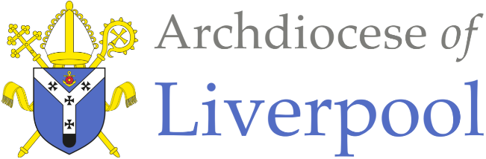

Now on that same day two of them were going to a village called Emmaus, about seven miles from Jerusalem, and talking with each other about all these things that had happened. While they were talking and discussing, Jesus himself came near and went with them, but their eyes were kept from recognizing him. And he said to them, ‘What are you discussing with each other while you walk along?’ They stood still, looking sad. Then one of them, whose name was Cleopas, answered him, ‘Are you the only stranger in Jerusalem who does not know the things that have taken place there in these days?’ He asked them, ‘What things?’ They replied, ‘The things about Jesus of Nazareth, who was a prophet mighty in deed and word before God and all the people, and how our chief priests and leaders handed him over to be condemned to death and crucified him. But we had hoped that he was the one to redeem Israel. Yes, and besides all this, it is now the third day since these things took place. Moreover, some women of our group astounded us. They were at the tomb early this morning, and when they did not find his body there, they came back and told us that they had indeed seen a vision of angels who said that he was alive. Some of those who were with us went to the tomb and found it just as the women had said; but they did not see him.’

Then he said to them, ‘Oh, how foolish you are, and how slow of heart to believe all that the prophets have declared! Was it not necessary that the Messiah should suffer these things and then enter into his glory?’ Then beginning with Moses and all the prophets, he interpreted to them the things about himself in all the scriptures.

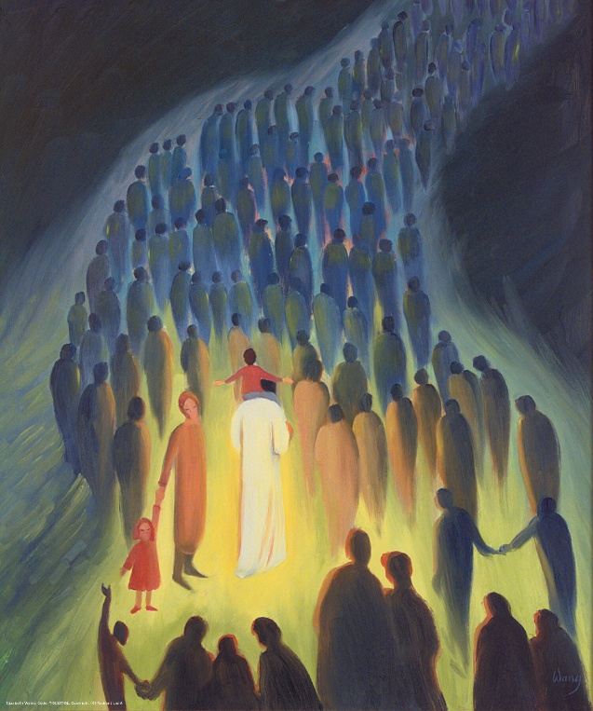

As they came near the village to which they were going, he walked ahead as if he were going on. But they urged him strongly, saying, ‘Stay with us, because it is almost evening and the day is now nearly over.’ So he went in to stay with them. When he was at the table with them, he took bread, blessed and broke it, and gave it to them. Then their eyes were opened, and they recognized him; and he vanished from their sight.

They said to each other, ‘Were not our hearts burning within us while he was talking to us on the road, while he was opening the scriptures to us?’ That same hour they got up and returned to Jerusalem; and they found the eleven and their companions gathered together. They were saying, ‘The Lord has risen indeed, and he has appeared to Simon!’ Then they told what had happened on the road, and how he had been made known to them in the breaking of the bread.

Luke 24:13-35
“How do we ensure that the decisions we make about the future and about priests and people working together are made in an authentically synodal manner?”

Archdiocesan Pastoral Plan

Introduction

Purpose

We are not just responsible for the Church today. Rather, we have a fundamental responsibility to hand a healthy and sustainable Church on to the next generation.

Our missionary priorities have been given to us by the Synod process and the Pastoral Plan:

  - Becoming a Church that accompanies people through life.
  - Becoming a Church that honours the vocation of all the baptised.
  - Becoming a Church where synodality is embedded.
  - Becoming a Church that renews its organisational structures and administers its property to serve its mission.
  - Becoming a Church where young people and young adults flourish.
  - Becoming a Church that cares for its priests.

It is an exciting prospect that if we are delivering effectively on these today, or can develop effective delivery, then we will indeed be able to pass on a vibrant and mission focussed church in liturgical, evangelistic and social action terms

In mapping the way forward, the Pastoral Plan set out four signposts to the future:

- be immersed in the joys and hopes, griefs and anxieties of humanity today;
- be brave and creative in renewing local structures;
- develop leadership to attend to changing needs;
- embed synodality in every aspect of archdiocesan life.
The Pastoral Plan sets out these ambitious, high-level missionary aspirations, which need to be delivered at local level in the parishes of the archdiocese.

These issues have been discussed at the Archdiocesan Synodal Council, and at the archdiocesan strategy day held in September of 2024. There were many questions about the process which is being followed to achieve and support the delivery, at the local level, and how can we support the local church to be “bold and creative”. There was also an obvious enthusiasm for faster progress on delivery.
Translating plan to concrete action by being “BOLD”
Start Doing- Making things happen
Start Doing - Create a 5-year plan (RADICAL ACTION) to sell surplus assets to enable future investment in mission
Start Doing - Resourcing Families of Parishes to be more strategic
Pastoral Plan Strategy Day 2024

“It is clear that many people felt that we are trying to talk the talk, but not walking the walk! We are not being as bold and creative as we have been encouraged to be.”
“Are buildings more important that people and mission?”
“What is our mission? What is the reason we do all we are doing? We are being called to make this clear for everyone.”
Archdiocesan Synodal Council Report, 2023

This is a complex task: we have to affirm and support the great work which is currently taking place, promote positive development at local level where it is required and seek to remove the barriers which can frustrate effective working.

If we accept that the resources we have - including the number of priests, deacons and lay volunteers - are declining and the number of building we have (in this case at parish level) cannot be sustained, then we need to embrace a mechanism by which the local church accepts that reality and embraces the possibility of change. That is a developmental process – it will only come about properly if there is a local acceptance of the need to change and a willingness to help shape a healthy and sustainable future.
Instead, we will need to leave behind a lot of things that are familiar. We need to learn the art of lamentation.
Archdiocesan Pastoral Plan

The drivers of change are:

- A deep desire to live out our missionary purpose: to proclaim Christ, worship, evangelise, and serve.
- The hope for greater cooperation between parishes and deaneries to strengthen our mission and support one another.
- A sobering truth: the number of diocesan priests will fall from 100 today to fewer than 60 within seven years.
- The aspirations of a vibrant future for our children and young people.
- The flourishing life of Catholic schools and families.
- The urgent need to attract more vocations to priesthood, diaconate, and religious life.
- The call for all the baptised to actively serve the mission of the Church.
- The financial strain of maintaining too many buildings, leading to years of overspending.
- The burden of stewardship falling on fewer priests and parishioners.
- The challenge of engaging those indifferent or hostile to the Church.

Discernment

As the archdiocese seeks to deliver on the areas developed by the pastoral plan, local discernment would help parishes, families of parishes (FoP) and deaneries (and the archdiocese overall) form plans for a Church shaped by and for mission: a clear sense of God’s vision for the Church – what God is calling the Church to be and do in this local context. The local context will vary so, while there can be common aspects to plans, it is recognised that needs will vary according to area.

Our task is to give support to the local church by which they can determine a local plan for the future: a plan they can own. This must be firmly rooted in the Pastoral Plan. And it is equally essential that those plans are focussed on the missionary imperatives of the Church and - while they would help the church to determine what resources are necessary, including buildings, to support and deliver such a mission - they are a vision of hope. The most important thing is that the starting point is mission – the rest flows from that.

This would both provide a mechanism for “bold and creative” options to emerge and be a genuinely synodal approach.

Stages

The general proposed model is outlined below (though this will vary according to the context as noted above):

It is proposed that the process be established at parish, family of parishes (FoP) and deanery levels.

Proposals from the deaneries would be fed into the Pastoral Organisation Sub-Committee so that a comprehensive, integrated picture could be held for the archdiocese and for recommendation to the Archbishop.

It is envisaged that the whole process below would take place over three years in each deanery – with decisions being implemented as they are made over that period.

Detailed Process

This framework proposes a 5-stage cyclical process for the local church to engage in 5 (Cyclical) stages:
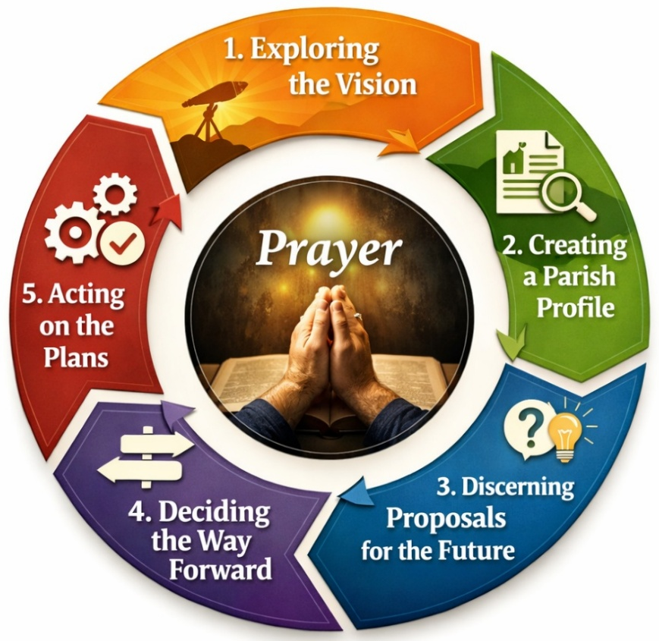

Stage 1 and 2 will be completed by each parish separately
Stage 3 onwards will be completed at family of parishes level

Stage 1: Parish Vision and Stage 2: Parish Profile

The starting point is to reflect on the vision of the church that will drive us toward the future that God wants for us. This is done by reflecting upon Archbishop Sherrington’s Vision Statement and on the reality of the pastoral life of our parishes based on the six areas of the Pastoral Plan.

“The Church exists to proclaim Jesus Christ to all peoples. This is her mission. Christ loves us, has saved us, walks with us and offers the hope of eternal life. As Pope Leo XIV said to the young people at the Jubilee of Youth in Rome, 'Encounter Christ. The Lord is gently knocking at the window of your soul.'

We are pilgrims of hope who wish to share the hope of Jesus Christ with others. I invite you to actively engage in the discussions about the Parish Development Strategy (PDS) to shape the future of the Church and our pastoral plan for the archdiocese. The mission today, for tomorrow, needs realistic and forward-looking structures because people have moved, the cost of maintaining too many buildings is prohibitive and the number of clergy has reduced. We need the means that help us proclaim Jesus Christ to all people and help them to participate in the life and mission of the Church. This is the calling of all the baptised. Our hope in Jesus Christ, our culture of vocation, and our participation in the life of the Church will then foster faith in the family, attract more men to serve the Church as priests, and enable all members of the Church to proclaim Jesus to the world and serve others through faith in action.

We ask the help of the Holy Spirit to be with us and the prayer of Mary, Star of Evangelisation.”

Archbishop John Sherrington January 2026

This stage of the process assesses where we are – what are our strengths, weaknesses and opportunities. A number of meetings using Conversation in the Spirit will enable each community to assess where they are in a realistic way in responding to their mission.

Parishes will also be asked to consider other aspects such as buildings, geography, community outreach so that a full narrative can be created. Using local knowledge, data supplied by archdiocesan staff and others, the church is asked to review its own context. The exact nature of that process is deliberately not defined but will be designed locally. Staff will be available to support these processes and events. Overall, the sort of review envisaged includes:

Parish
- Liturgy | Evangelisation | Attendance | Social Action
Schools
- Primary | Secondary | Sixth Form | Parish Engagement | Chaplains
Demography
- What is the demographic of the community | church ?
- What are the demographic trends? (For example, immigration patterns)
Community
- What are the social and pastoral needs of the local community?
- How is the church involved in the life of the community and what other opportunities are there?
- Prisons | Hospitals | Care homes
Church Partnerships
- Geographical (within and beyond the deanery)
- Ecumenical
- Thematic (Spirituality networks for example.)
Geography
- Describe the geography of the parish.
- Does the geography work well for mission where you are?
- What are the significant features?
- Any distinctive, problems, opportunities, issues arising from geography?
Buildings
- Use(s)
- Suitability for its purpose and mission (including environmental impact)
- Maintenance
- Heritage
- Strategic Location (transport links, geographical prominence, boundaries etc.)
Finances
- Maintenance
- Running Costs
- Parochial expenses

At the end of these two stages, having discussed a vision (and having pondered it) and now having looked at some of the realities of your own parish you will be invited to submit a description of your parish in a 500 word narrative that will be used to present to the whole deanery in the next stage.

These will be shared, deanery-wide, in a meeting organised by the Archdiocese.

Stage 3: Discernment

In the light of all that has been discovered in Stage 1 and 2, how does your parish, family of parishes and deanery make realistic proposals for the future?

Parish strategy groups will now work in family of parish groupings. They will initially discern up to three proposed ways forward.
These will be taken to the first deanery meeting of the steering groups.
Having heard what each FoP in the deanery has proposed, a second round of discernment will take place at FoP level. The revised proposal(s) will then be brought to a further deanery meeting. After this it is hoped that a common set of proposals will have emerged. (If not the process may need to be repeated.)

Parish Discernment

Discernment and consultation of the agreed proposals will then be opened to the wider community: parish meetings, school involvement, ecumenical meetings, proposals displayed in church for comment and an online portal will be developed.
- In line with the 6 development areas of the pastoral plan, what is its local Vision for the future?
- Proposals for the future of the deanery

Stage 4: Deciding the way forward

Having discerned the proposals for the future, these are presented to the Archbishop for decisions to be made.

Stage 5: Acting on the plans

The church implements the plans to the agreed timetable

- Action – do the agreed tasks
- Monitor
- Celebrate

Implementation and support

As noted above, this process will be initiated and overseen at local level – Families of Parishes and DSCs - with staff input and support.

Steering Group

A steering group in each parish will be established to set up and oversee the process. The steering group will comprise the following representatives from each parish (or possibly church community depending on local arrangements): the parish clergy, the parish DSC representative and up to 4 parishioners.

Role of the Steering Group

- To be willing to be part of developing a clear vision of the church
- To bring the voices of all the different parishioners to the table (including those who are not regular church attenders.)
- To ensure that the Parish Development Strategy is taking place in each parish/community.
- To be an ambassador for the plans for the future that are generated
- To engage with archdiocesan support staff to facilitate the strategy.

Members of the Steering Group will need to:

- have hope and faith that God can and will do greater things – need to be positive about the future
- have openness to grasp the reality of our situation and consider the radical changes that might be necessary to ensure sustainability and the mission of the wider church
- be realistic and honest
  - In assessment of where the church is now
  - In planning for the future – radical but deliverable
- able to devote time
- have honesty as a team to support and speak truthfully, but positively
- recognise that plans don’t stand alone – they need to connect and contribute towards achieving the mission goals of the deanery and the diocese
- be committed to a sense of the whole church and not simply ‘parochial’
- be committed to involve and support other churches and the wider community.
- be committed to see it through

Supplied Resources and Inputs
Parishes will be supplied with background data; from several sources, resources to carry out the stages and facilitation support to enable the use of them.

- Seven-year Pastoral Census Data
- Quinquennial reports
- Seven-year Financial Summary

You will be asked to complete the following:
- Parish Vision and Profile
Where possible the profile will be pre-populated by the archdiocese.

Dedicated personnel:
- Fr Matthew Nunes (Clergy Facilitation)
- Chris Higgins (Parish & Deanery Development Adviser)
- Fr Philip Inch (Episcopal Vicar)
- Ian Parrott (Pastoral Plan Administrator)

Proposed Timeline for Stages 1, 2 and 3
Suggested Time | Meeting Activity
Stages 1 and 2 Parish Vision | Parish Profile
1 month | Gathering of Steering Groups within each parish.
Steering Group Launch
Clergy and Lay representatives for parishes meet with archdiocesan team.
Weekend Launch in Parishes
Homily at all Masses and leaflet distributed.
3 months | Parish Vision - Clergy, steering group person and a small group of relevant people to collate. This will take a number of meetings.
3 months | Parish Profile - Clergy, steering group person and a small group of relevant people to collate. This will take a number of meetings.
 | Parish Vision and Parish Profile returned to archdiocese.
1 month | Data from parishes collated by the archdiocese to form a FoP/deanery-wide picture
Deanery Data Presentation
The archdiocese will present the deanery situation and give instructions for Stage 3: listening and discernment.
Stage 3 Discernment onwards
6 months +  This stage is guided by the Holy Spirit – a limited time cannot be placed on this crucial part of the process | Discernment period at parish level – this will involve a number of meetings. Parishes will present back, at either FoP or deanery level, their proposals – this is a cyclical process. During this stage, discernment will be opened up to whole parish communities:
Discernment 1 & 2
Two meetings of the steering groups to create initial proposals through listening and discernment. At these meetings each parish or FoP will present proposals to wider deanery.
Parish Discernment
Discernment and consultation opened to wider community (includes parish meetings, proposals displayed in church for comment and online portal for comments).
 | 3 deanery proposals presented to the Archdiocese
 | Proposal presented to Archbishop Sherrington to consider with appropriate groups.

