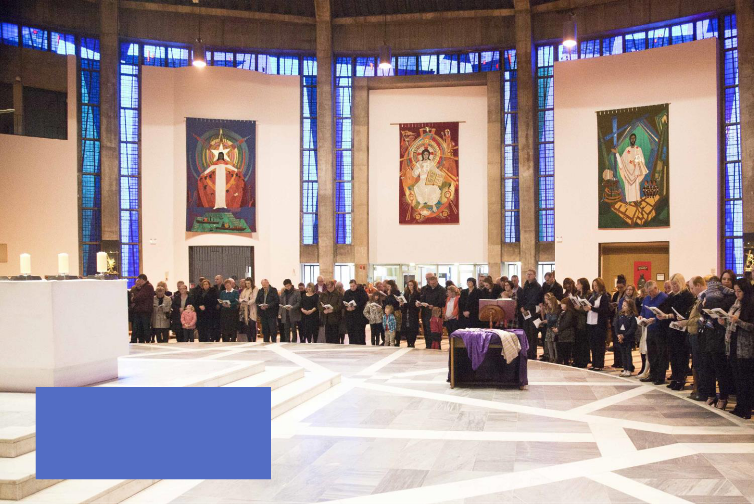

RCIA

CELEBRATING THE RITE OF ELECTION AND CALL TO CONTINUING CONVERSION

Information for Parishes 2026
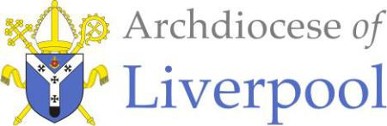

Elizabeth Parsons
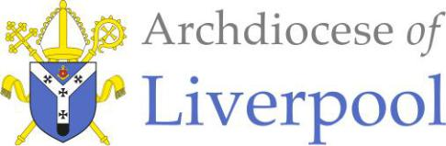

Director of Pastoral Development

Pastoral Development Department

Telephone: 0151 522 1023

Email: rcia@rcaol.org.uk

January 2026

Dear Father / RCIA Coordinator,

Rite of Election 2026

We are nearly at the Rite of Election and are very much looking forward to welcoming you all at the Liverpool Metropolitan Cathedral. The Rite of Election is taking place on Sunday 22 February at 3pm. We would appreciate it if Catechumens and Candidates could arrive no later than 2.40pm to ensure there is enough time to register their attendance. Attached, is the form to register their application to for full admission into the Catholic Church. We would appreciate it if these forms could be sent to Aaron Kiely (a.kiely@rcaol.org.uk) by Wednesday 18 February at the latest. We have just one form for those who are to be fully initiated (baptism, confirmation and first eucharist) and for those whose Christian initiation is to be completed (either confirmation and/or first eucharist). Please ensure this information is directed to the person responsible for registering names for the Rite of Election.

There will be a retreat day for our Catechumens, Candidates and RCIA Catechists in March. We are finalising the details and will send through a confirmation in the next week.

If you have any questions about RCIA, or if you are new to the process, or would like to receive support in preparing a team, please do not hesitate to contact me.

I look forward to meeting you all this year.

Kind regards

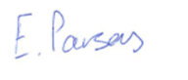
Elizabeth Parsons
Director of Pastoral Development

Archdiocese of Liverpool

A charitable incorporated organisation (registered charity number 1199714)
Principal office: Liverpool Archdiocesan Office, St Margaret Clitherow Centre, Croxteth Drive, Liverpool, L17 1AA


APPLICATION FOR ADMISSION INTO FULL

COMMUNION WITH THE CATHOLIC CHURCH

For Chancery use: Prot No ................................... Date of grant: ……………………………..……………

* TICK AS APPROPRIATE

CATECHUMEN * ☐

CANDIDATE * ☐

THIS FORM CAN ALSO BE USED IN THE CASE OF A CATHOLIC GOING THROUGH RCIA AND NOW SEEKING CONFIRMATION

CONFIRMATION OF A BAPTISED CATHOLIC * ☐

Surname (in block capitals): …………………………………………….……………………………………………………………………………………………………….….

First names: ……………………………………..……………………………………………………………………………………………………………………………………….

Sex: …….........… Age: …….….. If under 18, indicate whether parents or guardians have given their consent: Yes ☐ No ☐

(NB: Petitions need only be sent for those aged 14 years and over.)

Marital status: Single ☐ Married ☐: Widowed ☐ Separated ☐: Divorced ☐ Remarried * ☐
* The validity of a second marriage should be investigated to ensure it does not require validation before baptism/reception/confirmation.

To what denomination, religion or sect has the person belonged? ………………………………………………………………………………..………..

……………………………………………………………………………………………………………………………………………………………………………..……………………

Has the person been baptised? ………………………………………………………………………………………………………………..………………………...…….

If so, please state:

- In what Church: ………………………………………………………………………………………………………………………………..………………………….…….

- Date: ……………………………………………………………………………………………………………………………………………………………..……………….….

- Is there any reasonable doubt about the validity of the baptism? ……………………………………………………..…………………….………..

What preparation has the catechumen/candidate received? ………………………………………………………………………………….…………….....

…………………………………………………………………………………………………………………………………………………………………………..………………………

Are you satisfied that the candidate is ready to be received into full communion with the Catholic Church?

…………………………….………………………………………………………………………………………………………………………………………………..…………………..

Please provide the name of a Catholic who will sponsor and support the new member:

……………………………………………………………………………………………………………………………………………………………………..……………………………

Signature of priest/deacon: ……………………………….………………………………………………………………………………………………………….………….

Countersignature of parish priest: ……………………………………………………………………………………………………………………..……………………..
(Required when a deacon is making the application.)

Parish name and address: ……………..…………….…………………………………………………………………………………………………………………………….

……………………………………………………………………………………………………………………………………………………………………………................………

01.22 Page 1 of 2

Archdiocesan Chancery, St Margaret Clitherow Centre, Croxteth Drive, Liverpool, L17 1AA

PETITION FOR ADMISSION INTO FULL

COMMUNION WITH THE CATHOLIC CHURCH

It is my sincere and carefully considered conviction that God is asking me to find the fullness of truth in the Catholic Church.

I believe in what the Catholic Church holds and teaches, and I hope to grow in my faith and understanding.

I wish to shape my life in accordance with the teaching of Jesus Christ expressed through the life of the Church.

I have been supported by the faith, prayer and example of my sponsor(s):

……………………………………………………………………………………………………………………………………………………………………………………………..……

…………………………………………………………………………………………………………………………………………………………………………………………..………

I now of my own free will ask to be welcomed into the Catholic Church through the sacraments of initiation.

I accept that these documents will be retained by the Church solely to fulfil the regulations of canon law.

Signature: ……………………………………………………………….………………

Date: ……………………………………………………………............................

01.22 Page 2 of 2

Archdiocesan Chancery, St Margaret Clitherow Centre, Croxteth Drive, Liverpool, L17 1AA

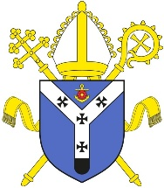
A Parish Celebration for sending Catechumens for Election

and Candidates for Recognition by the Archbishop

Adapted from the Rite of Christian Initiation of Adults.

This rite offers the local parish community the opportunity to send its catechumens and candidates to the cathedral celebration assured of the prayer and support of all.

It is a practical way in which the community “…can show by their concern that the initiation of adults is the responsibility of all the baptised”.

It will have its greatest impact if celebrated immediately after the homily during the Saturday Vigil Mass or a Morning Mass on the First Sunday of Lent.

Presentation of the Catechumens

The RCIA coordinator or a catechist or other member of the RCIA team presents the catechumens using the following or similar words:

Reverend Father, these catechumens, N and N., [each one stands as their name is called]

are beginning their final period of preparation and purification leading to their initiation. They have found strength in God’s grace and support in our community’s prayers and example. Now they ask for an assurance of our blessings and prayers as they go forth to the Rite of Election celebrated by Archbishop Sherrington at the cathedral.

Celebrant: My dear catechumens, this community gladly sends you to the Rite of Election where our Archbishop, in the name of Christ, will call you to the Easter sacraments. May God bring to completion the good work begun in you and may our prayers and continuing support go with you.

[The catechumens remain standing during the presentation of the candidates]

Presentation of the Candidates

The RCIA coordinator or a catechists or other member of the RCIA team presents the candidates using the following or similar words:

Reverend Father, I now present to you these candidates N and N., [each one stands as their name is called]

They are beginning their final period of preparation for the sacraments of confirmation and eucharist (and/or: reception into the full communion of the Catholic Church.) They have found strength in God’s grace and support in our community’s prayers and example. Now they ask for an assurance of our blessings and prayers as they go forth for recognition at the cathedral celebration.

Celebrant: My dear friends, these candidates, already one with us by reason of their baptism in Christ, have asked to be able to participate fully in the sacramental life of the Catholic Church. This community gladly sends you forth to Archbishop Sherrington who will exhort you to live in deeper conformity to the life of Christ with an assurance of our prayers and continuing support.

Celebrant, with arms outstretched over the catechumens and candidates:

Father of love and power,

it is your will to establish everything in Christ

and to draw us into his all-embracing love.

Guide these catechumens and candidates

in the days and weeks ahead:

strengthen them in their vocation,

build them into the kingdom of your Son,

and seal them with the Spirit of your promise.

We ask this through Christ our Lord.

All: Amen.

All are seated and Mass continues.

