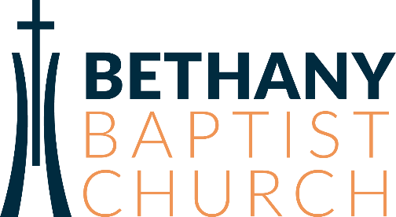

PASTORAL RESIDENT Job Description
ROLE SUMMARY
The Bethany Pastoral Residency program exists to equip faithful and healthy pastors to serve faithful and healthy churches in the Pacific Northwest and beyond. Reporting directly to the Lead Pastor, the Resident’s role is to participate in our mission of “Making Disciples and Sending Leaders” by helping lead and serve at Bethany in preparation for future church ministry.
This is an intense 2 year equipping program designed to teach, apprentice, and immerse the candidate in all major aspects of leading and overseeing a church. The residency will focus on developing competencies in preaching, leadership, shepherding, discipleship, and mission.
The Resident must be called to ministry, be versatile in his skill set, creative, and enjoy working within a church culture that values walking, working and worshipping Christ together. The ideal candidate will deeply know the Lord, demonstrate maturity, and have a passion for seeing Jesus’ church flourish.
QUALIFICATIONS
- Knows personal life change through the gospel.
- Wants to be a leader of leaders.
- Desires to build relationships with others and invest in others so they flourish.
- Loves Jesus’ church, longs to see it flourish.
- Loves to collaborate with others, including people who are different.
- Is a lifelong, humble learner.
- Gets their identity in Christ, not from their position
- Agrees to fulfill the expectations of Bethany membership found in our covenant.
- Fulfills the calling and character qualifications of an Elder as taught in the Scriptures.
- Is able to teach God’s word in its proper context.
- Has prior experience in casting vision, equipping leaders, building teams/ministries and multiplying disciples.
- Masters-Level Seminary graduate or currently enrolled.

SPIRITUAL AND PRACTICAL GIFTING REQUIREMENTS
- Service
- Leadership
- Preaching and Teaching
- Administration/Organization
- Faith
- Communication (written and verbal)
- Discernment
- Shepherding
SCOPE
The Lead Pastor Resident will engage in a rigorous program that will focus on equipping through teaching (reading and learning in community), apprenticeship (practice with hands-on experience as an apprentice in ministry), and immersion (functioning and leading in ministry). Within the program there will be time spent with various pastors and teams, written assignments, goals with deadlines, and team participation. Other requirements include:
- Commit to membership at Bethany.
- Participate in our annual Leadership Course.
- Complete learning assignments.
- Preach, teach and lead in ministry.
- Develop leaders and hand off ministry upon completion of residency.
SCHEDULE
- 40+hours per week.
- Sunday all day, Mondays off, Tuesday staff meetings.
- Various cohorts, classes, and meetings.
- All other hours Tuesday-Saturday: flexible to meet job requirements.
PAY AND BENEFITS
- Competitive salary based on experience and education.
- Assistance with Health insurance and copays.
- Assistance with moving costs.
- Professional expense and Conference funds.
- 2 weeks paid vacation annually.
- Paid Holidays include New Year’s Day, Memorial Day, Independence Day, Labor Day, Thanksgiving Day, and Christmas Day.

