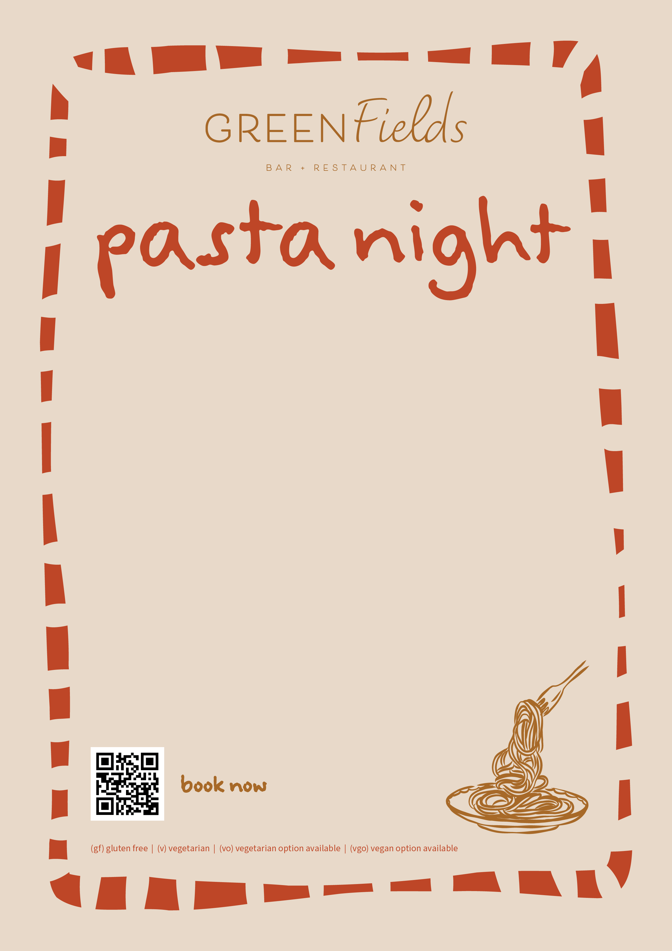
Entrees $8 ea
House baked focaccia, olive oil and balsamic
Green cerignola olives

Pasta, gnocchi and risotto $25 ea
Butternut pumpkin risotto, stracciatella, gremolata (v, vgo, gf)
House made gnocchi, mushroom ragu, parmigiano Reggiano (v)
Spaghetti carbonara, pancetta, parmesan
Parpadelle, lamb ragu, peas, pecorino Romano
Gluten free pasta + $4

Sides $15 ea
Rocket, pear and parmesan salad, lemon and olive oil dressing
Shoestring fries, parmesan and truffle oil

Desserts $17 ea
Affogato
Chocolate mousse, extra virgin olive oil, sea salt

