# INTERCEPTORS

## Fats, Oil and Grease Interceptors (FOG)

The District requires a properly sized external interceptor for any business that introduces fats, oils and grease through food preparation, serving or cleanup.

## *Are there any exceptions?*

The District will allow beverage establishments such as breweries, bars, coffee and juice shops to sell and serve prepackaged pastries, cakes, cookies and breads or snack items such as crackers, pretzels (hard or soft) and popcorn. Specialty coffee drinks or juice drinks that do not include ice cream, yogurt or frozen yogurt (fats) are acceptable without an interceptor.

The introduction of any menu product generally considered meal items such as sandwiches, burgers, burritos, salads etc. will trigger the interceptor requirement.

Paper plate service with solid waste disposal is a requirement of all non-interceptor applications. Washing coffee containers or blender containers in three compartment sinks or dishwasher is an acceptable clean up practice.

## *Why are interceptors required?*

Fats, oil and grease can have negative impacts on wastewater collection and treatment operations. Most wastewater plants are not designed to remove FOG and their performance will suffer as a result. Many wastewater collection blockages can be traced to grease. Plugged sewer lines can be serious, resulting in backups to homes and businesses.

## *Who pays for the interceptor install?*

All costs associated with the installation of the interceptor are the responsibility of the business. Food service establishments that were in operation prior to the interceptor requirement (2001) are eligible for a $2500 rebate from the District for the installation.

## *What size of interceptor is required?*

The size of the interceptor depends on the type and quantity of plumbing fixtures that must be connected to the interceptor. Not all plumbing fixtures drain to an interceptor. The minimum allowable size is 1000 gallon.

An interceptor requires a separate drain line from the balance of the sanitary waste. Only fixtures that are involved in food preparation and cleaning shall be connected. Contact the office (970) 586-2866 to properly determine sizing requirements.

## *How often are interceptors cleaned?*

Our staff members monitor the interceptor to determine the cleaning requirements – they measure the level of fats, oil, grease and food particles in the basin. The minimum cleaning requirements are once per year. Many businesses are on a quarterly schedule. The better your staff is at preventing FOG and food particles from entering the interceptor the less it will require cleaning.

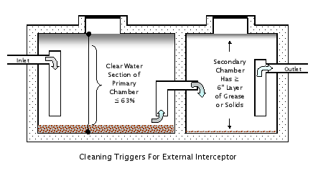

## *Who cleans the interceptor?*

Only District approved pumping vendors can clean interceptors. The District has very thorough cleaning requirements and vendors must agree to these rules. Incidentally, the better your interceptor is cleaned, the less it will require cleaning. Contact our collection department (970) 586-3516 for a list of approved vendors.