This week, in lieu of reading, I would like you to watch the Michael Lindsay-Hogg adaptation of Waiting for Godot on YouTube. Link is below.

<https://www.youtube.com/watch?v=YuxISg9tjHk>

[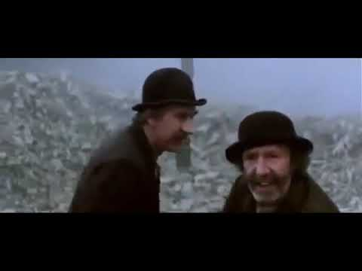](https://www.youtube.com/watch?v=YuxISg9tjHk)