WILL THE REAL PAUL PLEASE STAND UP?
Paul’s vision of Jesus
¹⁵ But when God, who had set me apart before I was born and called me through his grace, was pleased ¹⁶ to reveal his Son to me,^{[e]} so that I might proclaim him among the Gentiles, I did not confer with any human being, ¹⁷ nor did I go up to Jerusalem to those who were already apostles before me, but I went away at once into Arabia, and afterwards I returned to Damascus. (Gal 1:15-17; cf 1 Cor 9:1; 15:8).
⁶ For it is the God who said, ‘Let light shine out of darkness’, who has shone in our hearts to give the light of the knowledge of the glory of God in the face of Jesus Christ. (2 Cor 4:6)

IN THE THIRD HEAVEN
12 It is necessary to boast; nothing is to be gained by it, but I will go on to visions and revelations of the Lord. ² I know a person in Christ who fourteen years ago was caught up to the third heaven—whether in the body or out of the body I do not know; God knows. ³ And I know that such a person—whether in the body or out of the body I do not know; God knows— ⁴ was caught up into Paradise and heard things that are not to be told, that no mortal is permitted to repeat. ⁵ On behalf of such a one I will boast, but on my own behalf I will not boast, except of my weaknesses. (2 Cor 12: 1-5)
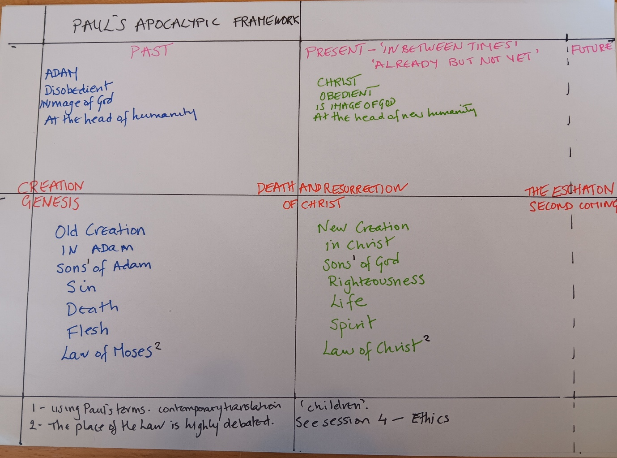
Eschatological transformation
¹⁷ Now the Lord is the Spirit, and where the Spirit of the Lord is, there is freedom. ¹⁸ And all of us, with unveiled faces, seeing the glory of the Lord as though reflected in a mirror, are being transformed into the same image from one degree of glory to another; for this comes from the Lord, the Spirit. (2 Cor 3:17-18)
²⁹ For those whom he foreknew he also predestined to be conformed to the image of his Son, in order that he might be the firstborn within a large family.^{[v]} ³⁰ And those whom he predestined he also called; and those whom he called he also justified; and those whom he justified he also glorified. ( Rom 8:29-30)
¹⁹ My little children, for whom I am again in the pain of childbirth until Christ is formed in you, (Gal 4:19)
² Do not be conformed to this world,^{[c]} but be transformed by the renewing of your minds, so that you may discern what is the will of God—what is good and acceptable and perfect. (Rom 12:2)

